NAME: AKANO ONYEKACHI M.
MAT/NO: 18/SCI01/012
COURSE CD: MAT204
LVL: 200
DEPRMNT: COMPUTER SCIENCE
Assignment
Question 1:
Vector space can be defined as a vector space on which two operations (+) and (●) are defined called addition and scalar multiplication.

Question 2:
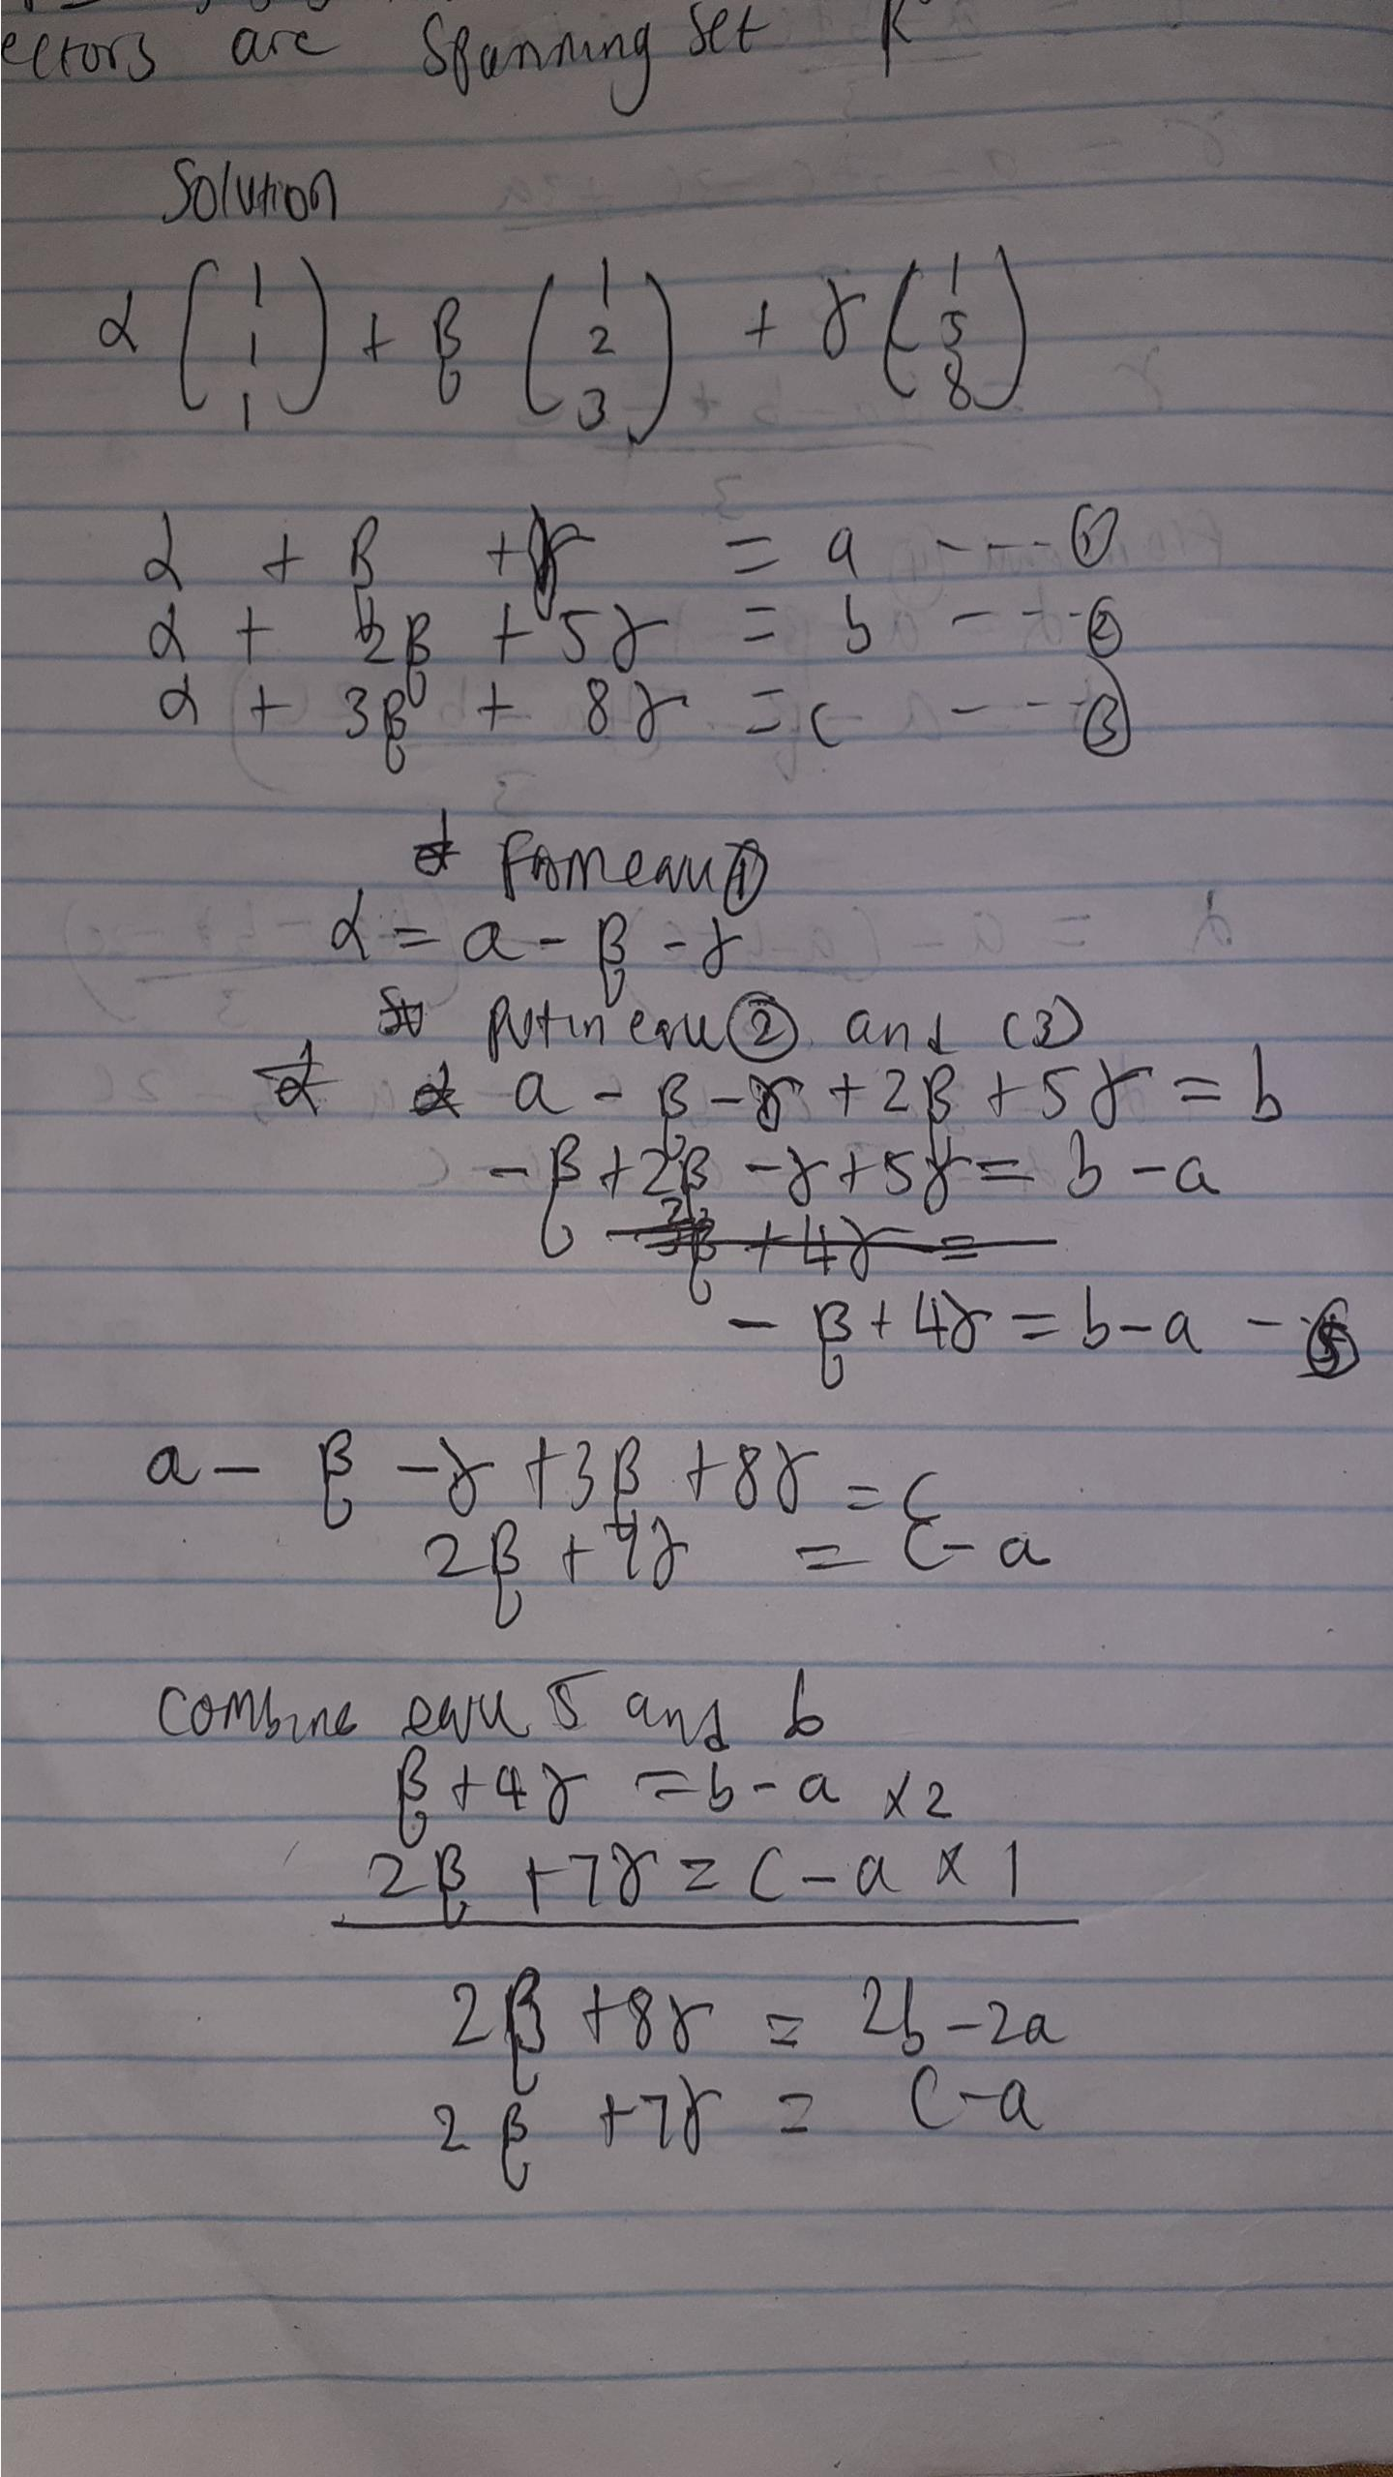

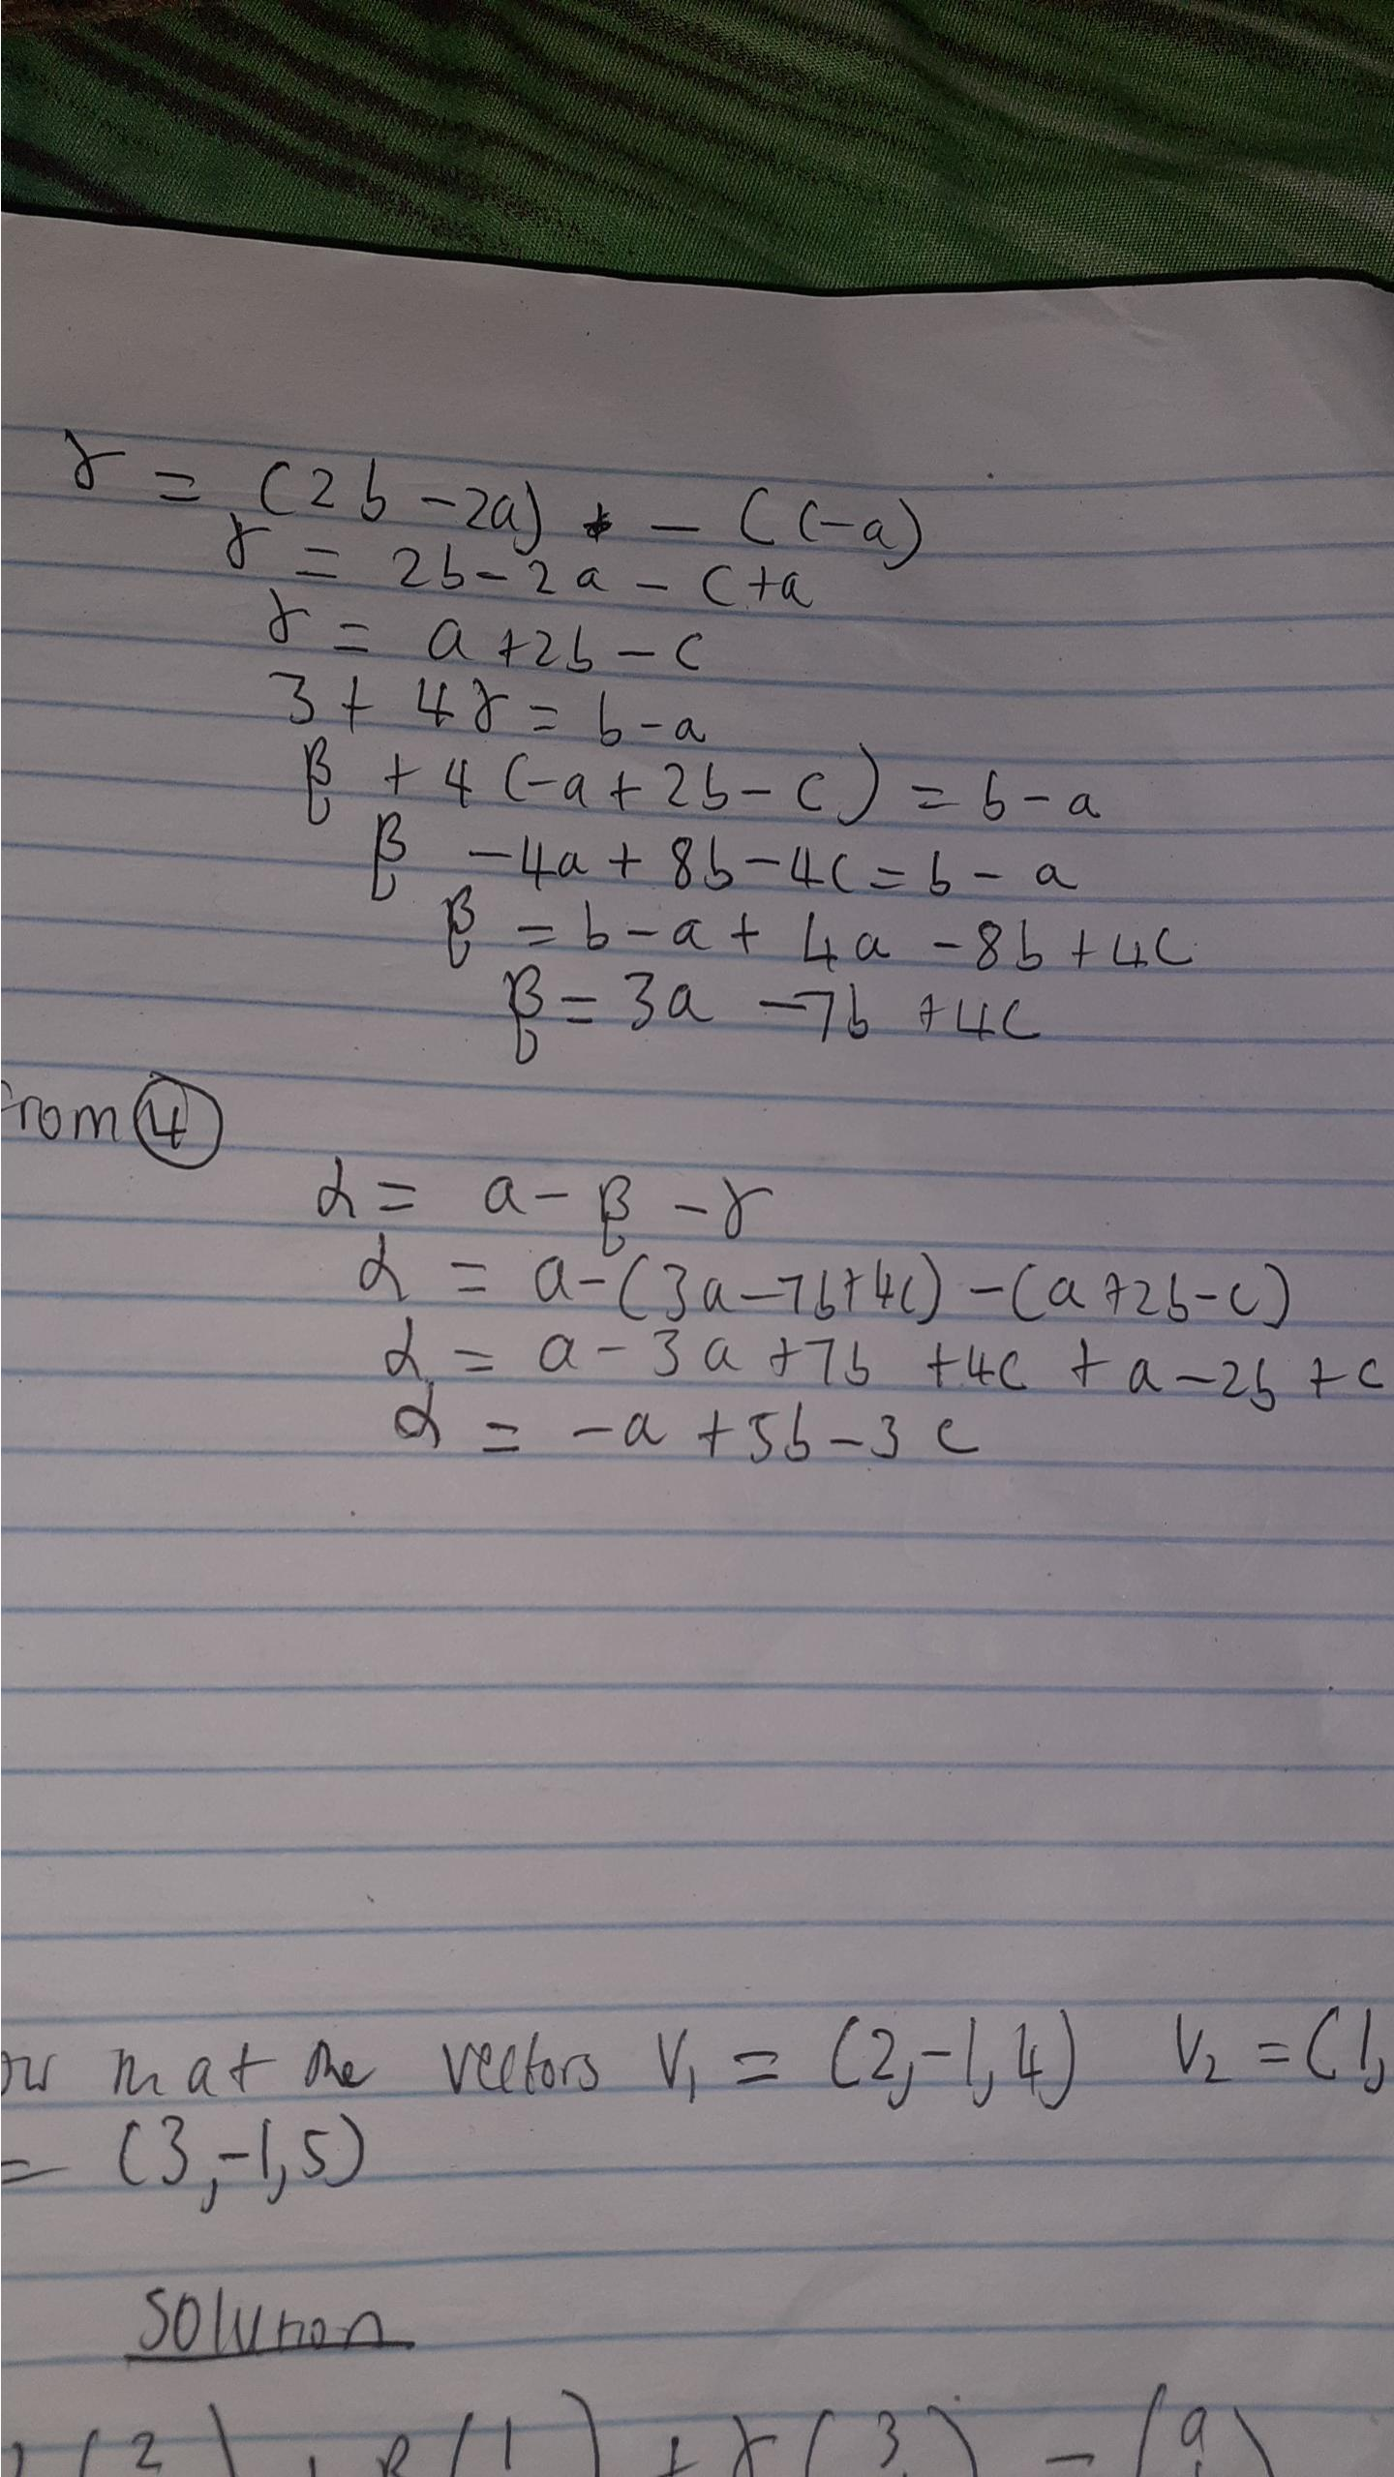

Question 3
