NAME: MFONOBONG ABASIENYENE MBONG
MATRIC NO: 16/MHS06/031
COURSE TITLE: BIOMEDICAL ENGINEERING
COURSE CODE: MLS410
ASSIGNMENT
1 DISCUSS THE PHYSICS OF THE LIGHT MICROSCOPE DIAGRAMS AND ILLUSTRATIONS NEEDED.
2 WRITE NOTES ON THE FOLLOWING BIOMEDICAL EQUIPMENT. ADD NOTES ON PRINCIPLE, BRAND, CARE AND MAINTAINANCE AND COST. A. CENTRIFUGE B. AUTOMATIC TISSUE PROCESSOR C. MICROTOME.
ANSWERS
THE PHYSICS OF THE LIGHT MICROSCOPE DIAGRAM AND ILLUSTRATION NEEDED:
The light microscope is a type of microscope that commonly uses visible light and a system of lenses to generate magnified images of small objects. It is used to study living cells and for regular use when relatively low magnification and resolution is enough. Samples for light microscopy are prepared in an ever-increasing number of techniques, and can range from sliced biological organisms and tissue cultures to materials science and geological samples. Light and electron microscopes share many similarities in their optical principles. In microscopy we take advantage of waveform properties of light. These waves when produced at a particular source vibrate at right angles to the line of propagation. Each wave has a peak and trough. The distance traveled forward by the light ray is one wavelength. Wavelength varies with the color and intensity of the source.

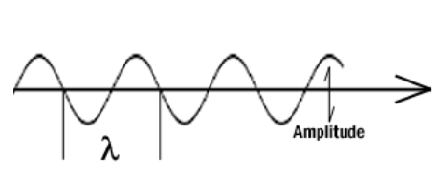
The structure of the light microscope is called upon to resolve exert only a small influence on the light they transmit. What is c hanged is the phase of momentary vibration. Conventional brightfield illumination will lack contrast and the details of the sample remain invisible. When the emerging waves have acquired a larger phase difference due to changes in refractive index, greater contrast is produced. This manifests itself by an edge effect (diffraction, refraction, and reflection). Sample details may be resolved in a number of ways. When light passes through stained structures intensity is reduced selectively depending on the color and density of the sample as the light is absorbed. Selective absorption of wavelengths of white light produces colored light. Refraction changes the direction of a light ray as it passes from one medium to another. The shorter the wavelength, the greater the refractive angle. Diffraction is the bending of light rays around objects with sharp edges. A new wave front is created at this edge. Diffraction can be useful, but can also reduce resolution. When light is dispersed it is separated into its constituent wavelengths as a result of refraction on entering a transparent medium, contrast can be defined as a steep slope between bright and dark image points. And adequate contrast must be achieved before specimen can be resolved. Magnification and resolution is the degree by which dimensions in an image are, or appear to be, enlarged with respect to the corresponding dimensions in the object. Resolution is the act or result of displaying fine detail in an image. Magnification without resolution is meaningless. The theoretical resolution of the light microscope was first defined by Abbe in the following equation
d=1.22 × λᴑ/n sin µ
d= distance of resolution
λ= wavelength of incident light
µ = ½ angle of incoming light
The objective lens is the first part of the imaging system; the objective lens forms a primary, enlarged image of the object. Very fine details are distinguished with the objective lens. The eyepiece sometimes called ocular lens, is the second lens, which forms a secondary, further enlarged image. By multiplying the magnifying power of the ocular the final magnification is found. A substage condenser lens is the third optical component. It is placed on a platform beneath the object. Light is directed through the substage condenser and converges to a point at the position of the specimen. The light rays diverge as they pass through the specimen and form an inverted cone, whose base is just large enough to fill the aperture of the objective. The size of the light beam is controlled by the diaphragm beneath the condenser called the aperture diaphragm.

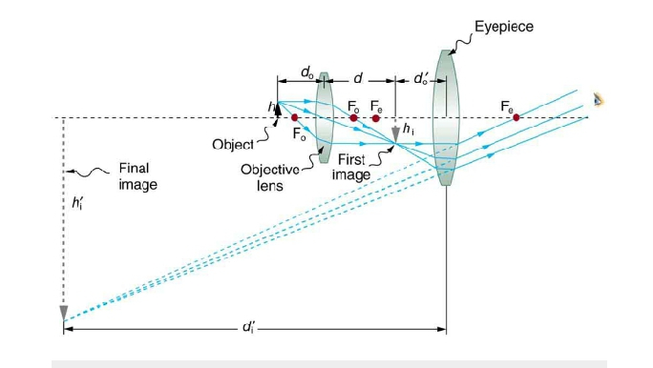

2 THE PRINCIPLE, BRAND, COST AND MAINTAINANCE OF THE FOLLOWING BIOMEDICAL EQUIPMENT ARE:
CENTRIFUGE:
Centrifuge is a piece of equipment that puts an object in rotation around a fixed axis, applying a force perpendicular to the axis of spin that can be very strong.
THE PRINCIPLE OF THE CENTRIFUGE ARE:
- In a solution, particles whose density is higher than that of the solvent sink(sediment), and particles that are lighter than it floats to the top
- The greater the differences in density, the faster they move. If there is no difference in density (isopycnic conditions), the particles stay steady.
- To take advantages of even tiny differences in density to separate various particles in a solution, gravity can be replaced with the much more powerful “centrifugal force” provided by a centrifuge.
- The centrifuge works using the sedimentation principle, where the centripetal acceleration causes denser substances and particles to move outward in the radial direction.
- At the same time, objects that are less dense are displaced and move to the center.
- In a laboratory centrifuge that uses sample tubes, the radial acceleration causes denser particles to settle to the bottom of the tube, while low-density substances rise to the top.
THE COST
A centrifuge costs about $1,000 to$ 5,000
THE BRANDS OF A CENTRIFUGE ARE:
- Unico C- MH30
- Heathrow HS120301
- Bio Lion Centrifuge XC-4610K
- Hettich 2300-01
- C & A Scientific premiere XC-800
THE MAINTENANCE AND CARE OF THE CENTRIFUGE
- Clean both the exterior and interior part of the centrifuge with warm water and a mild detergent.
- Do not use caustic detergent or a product that contains chlorine ions.
- A plastic scrub brush should be used to avoid damaging the coatings.
- When finished with the cleaning, use a centrifuge lubricant to lubricate the bucket grooves and rubber seals.
- A regular preventative maintenance with a trained technician is vital because it increases the durability and functionality.
- Regular preventive maintenance also ensures accurate results and reliable performance.

AUTOMATIC TISSUE PROCESSOR
Tissue processor is a device that prepare tissue samples for sectioning and microscopic examination in the diagnostic laboratory.
THE PRINCIPLE OF A TISSUE PROCESSOR
To embed the tissue in a solid medium firm enough to support the tissue and give it sufficient rigidity to enable to support the tissue and give it sufficient rigidity to enable thin sec tion to be cut and soft enough not to be damage the knife or tissues.
THE COST OF A TISSUE PROCESSOR
The cost of a tissue processor is $250-$49,900
THE BRANDS OF A TISSUE PROCESSOR
- Leica ASP3003
- Asp6025
- Histo-care
- Archine
- Leica TP 1020
THE MAINTENANCE AND CARE OF A TISSUE PROCESSOR
- Clean the retort daily
- Make sure that fluid levels are filled
- Make sure bottles are inserted properly
- Call a technician if it is a complicated fault.
MICROTOME
A microtome is a tool used to cut extremely thin slices of material, known as sections. Microtomes are used in microscopy, allowing for the preparation of samples for observation under transmitted light or electron radiation.
THE PRINCIPLE OF MICROTOME
Microtome is a sectioning instrument that allows the cutting of extremely thin slices of a material known as a section. These sections are stained using suitable staining techniques followed by observing them under the microscope.
THE COST OF A MICRTOME
The cost of a microtome is $3000-$10,000
THE BRANDS OF A MICROTOME ARE:
- Ana-med
- Agd biomedicals
- Breukhoven
- Auxilab
THE MAINTENANCE AND CARE OF A MICROTOME
- Dust accumulation must be prevented by putting a cover when not in use.
- Wipe the moving parts regularly with good neutral oil (coconut oil) to lubricate and avoid rust.
- After cutting clean frequently from accumulated paraffin using a soft brush with xylene.
- Never adjust the screws too tightly that they may cause binding.

