Harry Jim Sarah
16/mhs06/024
Biomedical equipments
Biomedical Engineering
MLS 410
Question
1. Discuss the physics of the light microscope diagrams and illustrations needed
Answer
Light microscopes play an important role in many research laboratories, including electron microscopy facilities. They can be used as a primary visualization tool or in support of electron microscopy. Samples for light microscopy are prepared in an ever-increasing number of techniques, and can range from sliced biological organisms and tissue cultures to materials science and geological samples. Light and electron microscopes share many similarities in their optical principles. Understanding how a light microscope works is not only critical for obtaining optimum light images, but also for understanding electron microscopy.
Principles of Light microscopy:
In microscopy we take advantage of waveform properties of light. These waves when produced at a particular source vibrate at right angles to the line of propagation. Each wave has a peak and trough. The distance traveled forward by the light ray is one wavelength (lambda). Wavelength varies with the color and intensity of the source.
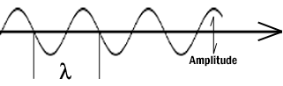

Figure 1: Schematic diagram of a wave.
How the image is formed:
The structures the light microscope is called upon to resolve exert only a small influence on the light they transmit. What is changed is the phase of momentary vibration. Conventional brightfield illumination will lack contrast and the details of the sample remain invisible. When the emerging waves have acquired a larger phase difference due to changes in refractive index, greater contrast is produced. This manifests itself by an edge effect (diffraction, refraction, and reflection). Sample details may be resolved in a number of ways. When a light passes through stained structures intensity is reduced selectively depending on the color and density of the sample as the light is absorbed. Selective absorption of wavelengths of white light produces colored light. Refraction changes the direction of a light ray as it passes from one medium to another. The shorter the wavelength, the greater the refractive angle. Diffraction is the bending of light rays around objects with sharp edges. A new wave front is created at this edge. Diffraction can be useful, but can also reduce resolution. When light is dispersed it is separated into its constituent wavelengths as a result of refraction on entering a transparent medium. Contrast can be defined as a steep slope between bright and dark image points. Adequate contrast MUST be achieved before the specimen can be resolved.
Two terms that are often confused, but are central to microscopy are magnification and resolution. Magnification is the degree by which dimensions in an image are, or appear to be, enlarged with respect to the corresponding dimensions in the object. Resolution is the act or result of displaying fine detail in an image. Magnification without resolution would be meaningless.
The theoretical resolution of the light microscope was first defined by Abbe in the following equation.
Abbe's equation for theoretical resolution of the light microscope:
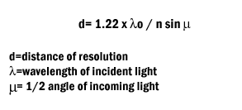

The actual resolution achievable with a light microscope is not as great. We will discuss the reasons for this later.
It is important to understand and to recognize the various components of the light microscope. The first and perhaps the most important element are the lenses.

Figure 2: The six simple lenses. A, B, & C are converging or positive lenses. D, E, & F are concave or negative lenses.
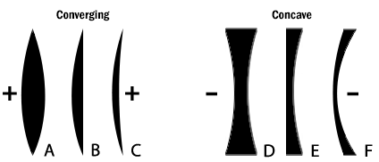

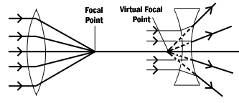
Figure 3: Converging and diverging lenses. Parallel rays enter a convex lens converge and meet at the principle focus. The distance between the center of the lens and the principal focus is the focal length. Parallel rays entering a concave lens diverge and never meet.

The Objective Lens is the first part of the imaging system; the objective lens forms a primary, enlarged image of the object. Very fine details are distinguished with the objective lens. The eyepiece sometimes called the ocular lens, is the second lens, which forms a secondary, further enlarged image. By multiplying the magnifying power of the objective lens and the magnifying power of the ocular the final magnification is found. A Substage Condenser lens is the third optical component. It is placed on a platform beneath the object. Light is directed through the substage condenser and converges to a point at the position of the specimen. The light rays diverge as they pass through the specimen and form an inverted cone, whose base is just large enough to fill the aperture of the objective. The size of the light beam is controlled by a diaphragm beneath the condenser called the aperture diaphragm.
The light source should contain both a lens to project an image of the lamp filament called a field condenser and a diaphragm to control the size of the illuminated field called a field diaphragm.
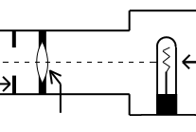

Figure 4: Typical lamp for light microscope.
Kohler Illumination is the most common method of illumination. In Kohler illumination the image of the source is projected by the field condenser onto the substage condenser, to the top of the plane of the object. This method assures even illumination.
Modern light microscopes use several different modes of operation depending on the needs of the investigator. The most common of these being brightfield microscopy in which direct light passes through the objective aperture and illuminates the background against which the image is seen. Since the structural elements being resolved have little variance in refractive index, the image will lack contrast and the details remain invisible. Small structure detail can be revealed by changing the absorption of the object by means of staining.
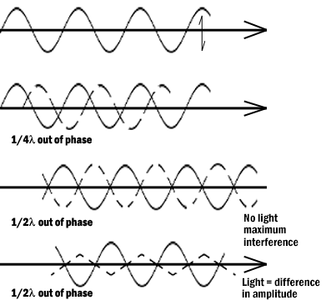
Many microscopes have special lenses that allow an investigator to image using phase-contrast. This method reveals details in specimens possessing very slight differences in optical path or refractive index in the surrounding media. Phase contrast requires no staining and can be used with living tissue. Contrast is produced in this method by phase differences in the light leaving the object to amplitude differences in the image. A phase plate alters the optical path length traveled by diffracted light from that traveled by direct light.

Figure 5: Light waves in brightfield and phase contrast after passing through an object. Pathway A represents the lightwave before encountering the object. Wave B represents the wave phase after passage in brightfield (unstained mode). C compares the wave phase of an object veiwed with phase contrast.
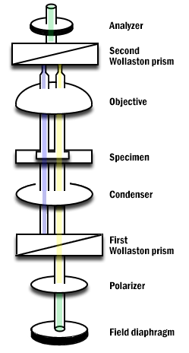
Differential interference contrast (DIC) differs from phase contrast in that the image has a strong relief and three-dimensional appearance. It must be remembered that the impression of surface details are the results of the optics and not the specimen for most biological samples. The optics for DIC consist of a polarizer at the light source and Wollaston prisms in the condenser and above the objectives. The beam passes through the polarizer, enters the first prism where it is split in two. One beam vibration is parallel to the prism and one is perpendicular. Both beams pass through the specimen in parallel in close proximity and are recombined in the second prism.

Figure 6: Differential Interference Contrast Schematic.
Darkfield microscopy is a mode in which direct light is prevented from passing through the objective aperture, but a hollow cone of light forms an apex in the plane of the specimen. The image is formed by light scattering from features of the object. Details appear bright white against a dark background. Darkfield can also be used for living bacteria, algae and plankton.
Some materials produce light when excited by short wavelengths of radiation. This effect is called fluorescence or auto-fluorescence. Specimens that do not fluoresce by themselves may be treated with fluorochromes which produce a secondary florescence. By illuminating with a high intensity mercury or xenon source and filtering out all but the desired excitation wave length to contact the specimen, the resulting longer (less energetic) wavelengths of emission from the specimen its self veiwed. Fluorescence microscopy can be used to enhance particular organelles, immunocytochemistry, in-situ hybridization, enzyme cytochemistry and elemental localization.

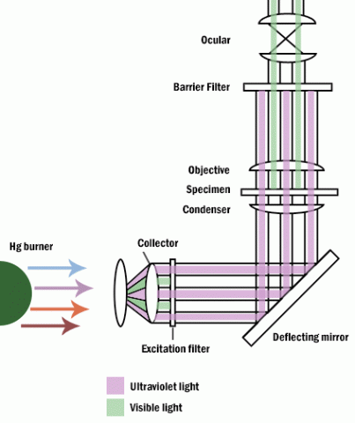

Figure 7: Fluoresence microscope.

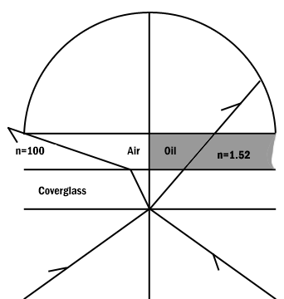

Figure 8: Comparison of a dry and an oil immersion objective.
Abbe in order to ease in identification of lens quality devised an equation for numerical aperture. Numerical aperture numbers can assist in comparing angles of dry, water immersion, and oil immersion objectives. Note the similarity to Abbe’s equation for theoretical resolution. This number is found on all objective lenses.
N.A. = n sin u
n = refractive index of medium
u = 1/2 the angle of light rays taken in when focused on the object.
When choosing an objective another consideration is depth of field. Depth of field is the distance from the nearest part of the subject in acceptable focus to the farthest part of the subject in acceptable focus. The efficiency (resolution) of a lens is inversely proportional to the depth of field.
Two aberrations within lenses detract from Abbe's equation of theoretical resolution. These aberrations are called spherical aberration and chromatic aberration. Spherical Aberration occurs when outer rays entering a lens are diffracted differently from those entering near the center. A solution for reducing spherical aberration is introducing a diaphragm or aperture.

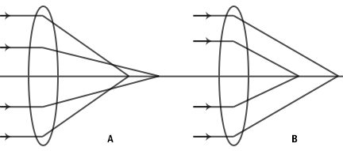

Figure 9: Spherical aberration of a simple lens. A. Under correction. B. Over correction.
The thickness of the cover glass should be chosen according to specifications of a particular objective. Deviation from the required thickness results in over correction or under correction of spherical aberration.
Chromatic Aberration occurs as white light entering a lens is broken into a spectrum from red to violet. Violet rays (more energetic) are refracted more than the red rays (less energetic). Consequently an uncorrected lens will be surrounded by color fringes. The more expensive lenses have a higher degree of correction.

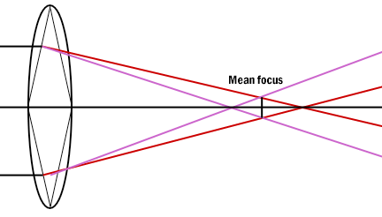

Figure 10: Chromatic aberration of a simple lens. Each spectrum color has a separate focus.
Definitions
Abbe's equation- Theoretical resolution of the light microscope.
Absorption- Light reduced selectively depending on color and density of the medium it passes through.
Brightfield microscopy- Light passes directly through the specimen and usually requires staining.
Chromatic Aberration- Caused by light waves of different energies passing through a lens.
Condenser Lens- Focuses the beam onto the specimen
Contrast- The slope between white and black. More slope, more contrast.
Converging lens- Refraction of light to a focal point on the opposite side of the lens.
Darkfield microscopy- Direct light is prevented from passing through a specimen, but a hollow cone of light is alloweed to form an apex in the specimen plane resulting in a bright specimen in a dark background.
Depth of field- The distance between the nearest to farthest points on a sample that are in acceptable focus.
Differential interference contrast- The mode of operation which gives the most relief in an unstained sample.
Diffraction- Bending light rays around objects.
Dispersion- Separation of light into its constituent wavelengths.
Diverging lens- Refraction of light outward by a lens from a focal point on the same side of the lens as the illuminating light.
Fluorescence microscopy- Samples produce light when excited by short wavelengths of radiation.
Field aperature- An adjustable diaphragm placed near the condenser lens to help direct light to the specimen.
Kohler illumination- A mechanism of alignment used to optimize even illumination of a specimen.
Magnification- The degree by which dimensions in an image are or appear to be enlarged with respect to the corresponding dimensions in the object.
Objective lens- The primary lens for image magnification.
Phase contrast microscopy- Reveals details in specimens by changing wavelengths phases in the light path.
Resolution- The act or result of displaying fine detail in an image.
Refraction- The change in direction of light rays as it passes from one medium to another.
Spherical aberrations- Outer rays entering a lens are refracted differently than rays passing through the center of the lens.
Wavelength- Distance traveled by a light ray from peak to peak or trough to trough. A light microscope is a biology laboratory instrument or tool, that uses visible light to detect and magnify very small objects, and enlarging them.
They use lenses to focus light on the specimen, magnifying it thus producing an image. The specimen is normally placed close to the microscopic lens.
Microscopic magnification varies greatly depending on the types and number of lenses that make up the microscope. Depending on the number of lenses, there are two types of microscopes i. e Simple light microscope (it has low magnification because it uses a single lens) and the Compound light microscope (it has a higher magnification compared to the simple microscope because it uses at least two sets of lenses, an objective lens, and an eyepiece). The lenses are aligned in that, they can be able to bend light for efficient magnification of the image.
The functioning of the light microscope is based on its ability to focus a beam of light through a specimen, which is very small and transparent, to produce an image. The image is then passed through one or two lenses for magnification for viewing. The transparency of the specimen allows easy and quick penetration of light. Specimens can vary from bacterial to cells and other microbial particles.As mentioned earlier, light microscopes visualize an image by using a glass lens and magnification is determined by, the lens’s ability to bend light and focus it on the specimen, which forms an image. When a ray of light passes through one medium into another, the ray bends at the interface causing refraction. The bending of light is determined by the refractive index, which is a measure of how great a substance slows the speed of light. The direction and magnitude of the bending of the light are determined by the refractive indexes of the two mediums that form the interface.
A medium with a lower refractive index such as glass to air, it normally speeds up the light penetration and making light bend away from the normal and when light is passed through a medium with a greater refractive index such as air to glass, it normally slows down and bends towards the normal, perpendicularly to the surface.
If an object is put between these two mediums i.e between water and air, in this case, a prism, the prism will bend the light at an angle. This is how the microscopic lenses work, they bend the light at an angle. The lens (convex) on receiving the light rays, it focuses the rays at a specific point known as the focal point (F-point). The measure of distance from the center of the lens and the focal point is known as the focal length.
A microscope uses lenses whose strength is predetermined, in that, the strength of a lens is directly related to the focal length i.e short focal length magnifies objects more than lenses with a long focal length.
Microscopy works strictly with a factor of resolution whereby resolution being the ability of a lens to be able to differentiate small objects that are closely packed together. The resolution of a light microscope is determined by a numerical aperture of its lens system and by the wavelength of the light it employs; a numerical aperture a definition of the light wavelengths produced when the specimen is illuminated.
A minimum distance (d) between two objects that distinguishes then to be two separate entities, determined by the wavelengths of the light can be calculated by an Abbe equation using the wavelength of the light that illuminated the specimen (Lambda, λ) and the numerical aperture (NA, n sin Ɵ) i.e. d=0.5 λ/n sin Ɵ
What is seen in the microscope as an enlarged clear image of the specimen is known as the virtual image. To calculate the magnification, multiply the objective and eyepiece objective magnification together. The magnification is standard, i.e not too high nor too low, and therefore depending on the magnification power of the lenses, it will range between 40X and 100oX.
Calculation of magnification = Magnification of objective lens/magnification of the eyepiece lens.
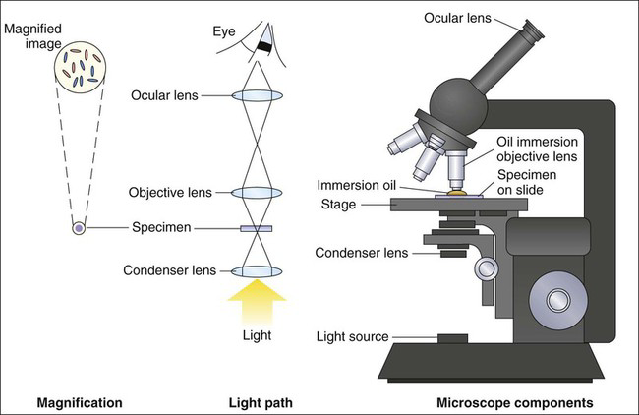

The basic principle of the light microscope is: the microscope consists of two lens systems, the objective and the eyepiece. The objective forms a real image of the specimen, and this image is
viewed through the eyepiece forming a virtual image at infinity.
The overall magnification of a multiple-element system (like an optical microscope) is the product of the magnifications of its individual elements. The simplest compound microscope is constructed from two convex lenses; The first lens is called the objective lens, and has typical magnification values from 5× to 100×. In standard microscopes, the objectives are mounted such that when you switch between objectives, the sample remains in focus. Objectives arranged in this way are described as parfocal. The second, the eyepiece, also referred to as the ocular, has several lenses which slide inside a cylindrical barrel. The focusing ability is provided by the movement of both the objective lens and the eyepiece. The purpose of a microscope is to magnify small objects, and both lenses contribute to the final magnification. Additionally, the final enlarged image is produced in a location far enough from the observer to be easily viewed, since the eye cannot focus on objects or images that are too close.

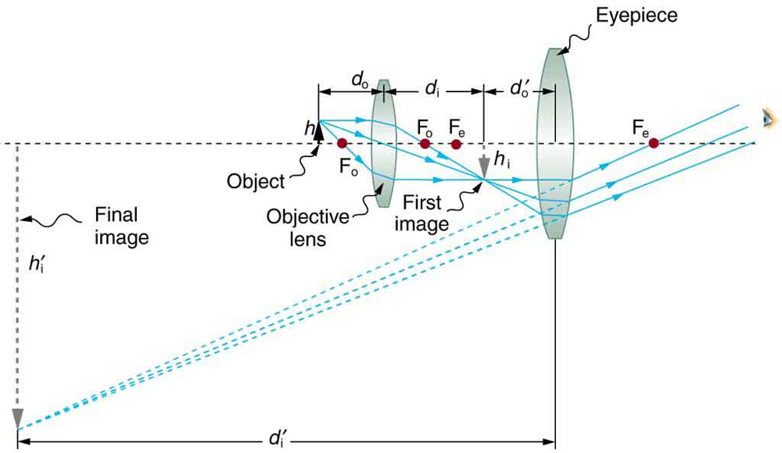

A compound microscope composed of two lenses, an objective and an eyepiece. The objective forms a case 1 image that is larger than the object. This first image is the object for the eyepiece. The eyepiece forms a case 2 final image that is further magnified.

The object is slightly farther away from the objective lens than its focal length fo, producing a case 1 image that is larger than the object. This first image is the object for the second lens, or eyepiece. The eyepiece is intentionally located so it can further magnify the image. The eyepiece is placed so that the first image is closer to it than its focal length fe. Thus the eyepiece acts as a magnifying glass, and the final image is made even larger. The final image remains inverted, but it is farther from the observer, making it easy to view (the eye is most relaxed when viewing distant objects and normally cannot focus closer than 25 cm). Since each lens produces a magnification that multiplies the height of the image, it is apparent that the overall magnification m is the product of the individual magnifications: M = MoMe, where mo is the magnification of the objective and me is the magnification of the eyepiece. This equation can be generalized for any combination of thin lenses and mirrors that obey the thin lens equations, such as for a microscope.
The total magnification of a microscope is obtained by multiplying the objective and eyepiece magnifications. The image formed is (usually) not presented as a real image, but rather as a virtual image viewed through the eyepiece. The somewhat arbitrary definition for microscope magnification is the following:

Magnification = The angle subtended by a (small) object as seen through the microscope
The angle when the same object is viewed by the naked eye at a distance of 250 mm.
we can express the magnifications of the objective, Mo, and eyepiece, Me, as
Mo= H/h = b/a,

Me = 250(mm)/ fe(mm).
The numerical aperture is defined by: N.A. = nsin a
where n is the refractive index and α the angle of acceptance.
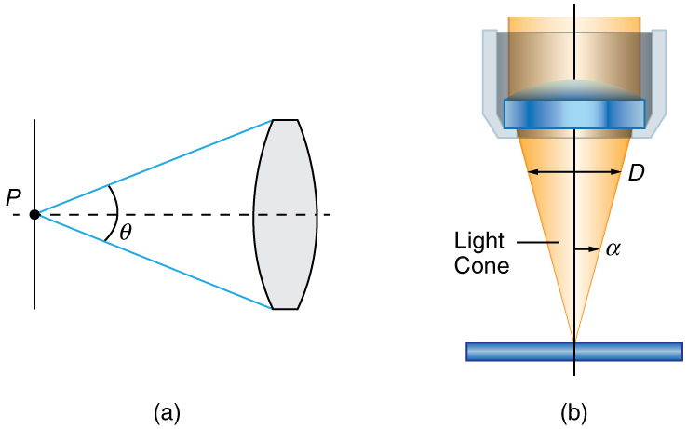

(a) The numerical aperture of a microscope objective lens refers to the light-gathering ability of the lens and is calculated using half the angle of acceptance . (b) Here, is half the acceptance angle for light rays from a specimen entering a camera lens, and is the diameter of the aperture that controls the light entering the lens.

Immersion techniques are often used to improve the light gathering ability of microscopes. The specimen is illuminated by transmitted, scattered or reflected light though a condenser.
The f/# describes the light gathering ability of a lens. It is given by :
f/# = f/D ≈ 1/2NA

2. Write notes on the following biomedical equipment. Add notes on principle, brand, care and maintainance and cost
A. Centrifuge
B. Automatic Tissues processor
C.Microtome
Answer

A.) Centrifuge:
A centrifuge is a piece of equipment that puts an object in rotation around a fixed axis (spins it in a circle), applying a potentially strong force perpendicular to the axis of spin (outward).Centrifugation is a technique of separating substances which involves the application of centrifugal force.The particles are separated from a solution according to their size, shape, density, the viscosity of the medium and rotor speed.There are multiple types of centrifuge, which can be classified by intended use or by rotor design:
Types by rotor design:
1.)Fixed-angle centrifuges are designed to hold the sample containers at a constant angle relative to the central axis.
2.)Swinging head (or swinging bucket) centrifuges, in contrast to fixed-angle centrifuges, have a hinge where the sample containers are attached to the central rotor. This allows all of the samples to swing outwards as the centrifuge is spun.
3.)Continuous tubular centrifuges do not have individual sample vessels and are used for high volume applications.
Types by intended use:
1.)Laboratory centrifuges, are general-purpose instruments of several types with distinct, but overlapping, capabilities. These include clinical centrifuges, superspeed centrifuges and preparative ultracentrifuges.
2.) Analytical ultracentrifuges are designed to perform sedimentation analysis of macromolecules using the principles devised by Theodor Svedberg.
3.) Haematocrit centrifuges are used to measure the volume percentage of red blood cells in whole blood.
4.) Gas centrifuges, including Zippe-type centrifuges, for isotopic separations in the gas phase.
Principle:
In a solution, particles whose density is higher than that of the solvent sink (sediment), and particles that are lighter than it floats to the top.The greater the difference in density, the faster they move. If there is no difference in density (isopycnic conditions), the particles stay steady.To take advantage of even tiny differences in density to separate various particles in a solution, gravity can be replaced with the much more powerful “centrifugal force” provided by a centrifuge.The centrifuge works using the sedimentation principle, where the centripetal acceleration causes denser substances and particles to move outward in the radial direction.At the same time, objects that are less dense are displaced and move to the center.In a laboratory centrifuge that uses sample tubes, the radial acceleration causes denser particles to settle to the bottom of the tube, while low- density substances rise to the top.
Brands of centrifuge:
a.)LW scientific
b.)Thermo scientific
c.)Unico
d.)Beckman
e.)SorVall
f.)Clayadams
g.)Vision scientific
h.)HFS
i.)Olayer
j.)Beckman
k.)Argos
l.)Digtor 22
m.)Plasma 22
o.)Vetcen
p.)Microcen 22
q.)Biocen 22
Care and Maintenance of centrifuge:
i.)Avoiding Rotor Failures:
The centrifugal field which accelerates the separation process also exerts large forces on the rotor material. If a rotor fails, the centrifuge is severely damaged as well. For this reason, some simple precautions should be observed
Rotors are designed to be run up to their maximum speed with a load of a specific weight. One should never attempt to run a rotor at a speed higher than the one designated by its manufacturer. Also, if high density solutions (greater than 1.2 g/mL, for instance) are used, the run speed must be reduced to prevent undue stress on the rotor. Consult your instruction manual for exact directions.
ii.)Tube Breakage:
Glass tubes can break during centrifugation, due either to improper loading or inherent defects. Any glass fragments must be removed from the buckets, adapters, rubber liners, and rotor chamber before the next run is made. If you find gray dust, which results from sandblasting of the rotor chamber by glass particles, it must be cleaned up too. You should make several dry runs without samples, and clean the chamber between each run to be sure this dust is eliminated from the centrifuge.
iii.)Chemical Resistance:
If you plan to centrifuge any uncommon solvents or solutions, consult your manual to be sure they are compatible with the various plastics and metals comprising the centrifuge, the rotor, the tubes, and other accessories. These same precautions must be observed with any solvents used for sterilization purposes. A table of 19 chemical resistances for common centrifuge materials is available from Beckman Coulter.
iv.)Aerosol Generation:
If any liquid is spilled on a rotor, it will be dispersed as a particulate mist when the centrifuge is run. Part of this mist will be fine enough to form a relatively stable aerosol which will tend to be dispersed throughout the laboratory. Such spills should be thoroughly cleaned up before running the centrifuge.
V.)Handling Human Samples:
Human blood or blood components can transmit an infectious disease or virus if the patient or donor carries these. Blood should be handled with respect for this possibility during all laboratory manipulations, including centrifugation.
When in doubt, refer to your instruction manual:
From time to time, you’ll have questions about the actual operation and maintenance of your centrifuge. The instruction manual provided with each instrument is designed to answer these questions. It should be read before making your first run, and kept handy for future reference.
Cost of centrifuge:
Hematocrit centrifuge cost ranges from 180,000 naira to 400,000naira.
The cheapest bucket centrifuge costs about 50,000naira; with the most advanced and expensive ranging from about 300,000 to 500,000 naira. An average centrifuge will cost from about 250,000 to 300,000 naira.

B.) Automatic tissue processor:
A tissue processor is a device that prepares tissue samples for sectioning and microscopic examination in the diagnostic laboratory. Microscopic analysis of cells and tissues requires the preparation of very thin, high quality sections (slices) mounted on glass slides and appropriately stained to demonstrate normal and abnormal structures.
The ATP machine plays a big role in the preparation of the tissue by passing them through various chemicals; a major process called TISSUE PROCESSING which involves:
(i) FIXATION – this is the process of preserving or fixing tissues by passing them through chemicals called fixatives. The fixatives will help protect the tissue from decay and autolysis. Routine fixative of use is 10% formalin
(ii) DEHYDRATION – this is the process of removing water molecules from the tissue by passing the tissue through ascending grades of alcohol. E.g methanol, acetone, 70-100% alcohol
(iii) CLEARING – this is the process of removing alcohol from the tissue by passing it through chemicals that will remove the alcohol molecules. These agents are called clearing agents. Xylene is mostly used for clearing.
(iv) INFILTRATION – this is the process of filling intracellular spaces left in the tissue by paraffin wax. This will help confer a bit of rigidity to the processed tissue.
(v) EMBEDDING- this last step is manually done. This has to do with immersing the processed tissue into a mould containing liquid paraffin wax. This is for external support so that the tissue won’t crumble during microtomy
Parts of the automatic tissue processor machine:
(i) Oscillating tissue basket.
(ii) 10 beakers or jars
(iii) 2 thermostatically controlled beakers.
(iv) An electric rotor at the base
(v) Lifting mechanism
(vi) Time disc and alarm system
(vii) Control unit - with display screen and control buttons
Principle:
The tissue basket oscillates up and down in each station at three-second intervals to ensure thorough and even mixing of the reagents and optimum tissue infiltration.Infiltration time is separately programmable for each station. Up to nine programs may be run with immediate or delayed starting times.When it’s time for tissue to be transferred to the next beaker or jar, the cover of the machine is raised up, and the lifting mechanism carefully removes the tissue basket and gently transfers it to the next beaker. When the infiltration time for any particular station is exceeded, a warning message will display, indicating the station number and excess time. Controls are arranged by functionality with an LCD to indicate operational parameters. Reagent container lids have seals to minimize operator exposure to hazardous fumes.
Tissue basket immediately immerses in a station in the event of power loss to protect samples from drying out. When power is restored, program will resume. In the event of long-term power failure, wax is liquified. Capacity of tissue basket is 80 cassettes.Vacuum configurations hasten infiltration, allowing pressure to be applied to any station in either manual or automatic operation. Fume control configurations extract fumes with a fan and pass them through an internal carbon filter.For added efficiency, these models feature a two-part containment shield surrounding the reagent container platform.
Brand:
1.)ASP6025 S
2.)HistoCore PELORIS 3 Premium Tissue Processing System
3.)HistoCore PELORIS 3
4.)ASP6025
5.)Leica ASP300S
6.)RemoteCare
7.)Leica TP1020
8.)Archive
9.)Hacker
10.)Innovative
11.)Leica ASP 300S
12.)Sakura Finetek
13.)Shandon Lipshaw
14.)Carl Zeiss.
15.)Tissue-tek
16.)Slee
17.)Biobase
18.)Keedee
Care and Maintenance:
▪︎Replace all reagents every 2 weeks with fresh reagent.
▪︎Check the solutions and paraffin level, if needed add it.
▪︎Lubricate reagent bottle "O" rings and check for damage.
▪︎Clean exterior of instrument with soft cloth and minimal amount of xylene daily.
▪︎Remove residual paraffin from inner surface of wax bath lid daily.▪︎Inspect and, if necessary, clean inside reagent bottles.
▪︎Check that the bottle caps and seals of the reagent bottles are in place and tight.
▪︎Inspect and empty condensate bottle. Clear inlet holes if necessary.
• Any spillage or overflow should be cleaned immediately
• Accumulation of wax on any surface should be removed
• Timing should be checked when placing the cassette processor
• The Temperature of the paraffin wax should be set above 3°c above the melting point of waxed
Cost:
Automated tissue processor ranges at a cost of 500,000naira to about 1.4million naira.

C.) Microtome:
Microtome use steel , glass and diamond blades depending upon the the specimen being sliced and the desired thickness of the section being cut . steel blades are used to prepare sections of animals or plant tissues for light microscopy histology. Glass knives are used to slice sections of light microscopy and to slice very thin sections for electron microscopy. Industrial grade diamond knives are used to slice hard materials such as bones , teeth and plant matter for both light microscopy and for electron microscopy gem quality diamond knives are used for slicing thin sections of electron microscopy. Types of microtome.
1.) Rotary microtome: is so-called because of a Rotary action of the handwheel responsible for the cutting moment. The block holder is mounted on a steel carriage, which makes up and down in groves this type of instrument is the most ideal for routine and research work it is excellent for cutting serial sections.
Parts of the rotary microtomes: Block holder, Knife clamp screw, Knife clamps, Block adjustment, Thickness gauge, The angle of tilt adjustment, Operating handle
2.) Sliding or Base Sledge Microtome: This is a large heavy instrument with a fixed knife beneath which the object moves mounted on a heavy sliding base containing the feed mechanism used primarily for cutting the sections of cellulose nitrate embedded tissues with an obliquely set knife.
Parts of Base-sledge microtome: Angular tilt adjustment, Knife clamps, Block holder, Coarse feed adjustment, Operating handle, Thickness gauge, Adjustment locking nut, Block adjustment screw, Split nut clasp.
3.) Cambridge rocking microtome: The instrument is so named because the arm has to move in a rocking motion while cutting the sections. It is also known as the Cambridge rocking microtome. It is a simple machine in which the knife is held by means of microtome thread. The rocking microtome was designed primarily for cutting paraffin wax sections but in an emergency use frozen section by inserting a wooden block in which the tissue is frozen.
Parts of the rocking microtomes: Knife holder, Block holder or chuck, Upper arm, Screw, Lever, Pawl, Ratchet wheel, Mil head microtome screw, Sleeve, Lower Arm, Scale
4.) Freezing microtomes: This type has been designed for the production or preparation of frozen sections of fluid and non-fluid tissues usually without preliminary embedding. The object stage is connected to the cylinder of compressed carbon dioxide for the rapid cooling of the tissues and provisions are also made for the cooling of the knife.
Part of freezing type microtome: Knife clamps, Operating handle, Thickness gauge, Stage, Stage valve, Coarse adjustment
Principle:
Microtome is a sectioning instrument that allows the cutting of extremely thin slices of a material known as section.Microtome are used in microscopy , allowing for the preparation of sample for observation under transmitted light or electrons radiation.It is a method for the preparation of thin section for materials such as bones, minerals, and teeth.
Brands of microtome:
-Histoline
- Leica
- Histocore
- DiaPath Galileo
- Tanner Scientific
- Microm
- Cuttec
- Sakura
- Thermo
-AGD Biomedicals
-Alltion (Wuzhou)
-Amos scientific
-ANA-MED
-Auxilab S.L
-Boeckeler Instruments, Inc
-Breukhoven
-Bright Instruments
Care and Maintenance of microtome:
-Section waste should be removed with a dry brush. Any mild detergent may be used for cleaning. The microtome can also be cleaned with alcohol or xylene. Disinfectant can also be used after cleaning.
▪︎ All moving parts should be lubricated once a month. This includes the clamping levers and their shafts screws, slide ways of the knife holder, base, sliding surface between knife holder bases.
▪︎ Change the blade if visible scratch or lines along the section are seen, and nicks on the blade edge.
▪︎ To avoid contamination/ carryover, change daily the water in the float bath.
▪︎ Store microtome knife in its case to prevent oxidation from occurring.
▪︎ Use a dry, lint-free, facial tissue to wipe your knife clean. DO NOT USE GAUZE or any other coarse material; it will destroy the edge of your knife.
• When leaving the microtome, even for a short time, ensure that the blade guard is in place.
• Before using your knife, take a lint-free facial tissue saturated in either zylene, benzene or acetone to remove the protective oil coating on the knife. C. Use a dry, lint-free, facial tissue to wipe your knife clean. DO NOT USE GAUZE or any other coarse material; it will destroy the edge of your knife
Cost of microtome:
The cheapest microtome costs about 100,000 naira; and the most advanced and expensive costs about 18,000,000 naira. Basically, an average microtome costs 1.5 million naira.

