NAME: IKEH EBUBECHUKWU DANIEL
MATRIC NO: 15/ENG06/039
COURSE: MEE 510
ASSIGNMENT TITLE: ASSIGNMENT 1

CASE STUDY: A DEVELOPMENT OF A BRIQUETTING MACHINE USING SANDWITCHED PALM KERNEL/GROUNGNUT SHELL TO PRODUCE A SOLID FUEL

- PROJECT DESIGN

Justification of Selected Design
In spite of the countless designs available, the manual hydraulic briquetting machine was selected for design and production, thus having the selection criterion as listed below:
- Easy design and fabrication was a primary factor during the selection phase, as complexity was aimed at being annulled.
- Easy operability by either a domestic or an industrial user gives the machine a universal application. Unlike other designs, little knowledge is needed in operating the machine.
- Availability of materials eases the fabrication process, as not all component(s) suitable for design is easy to fabricate nor gets available for purchase.
- Cost though not the primary factor of design, but plays a very important factor to consider alongside attaining a good quality. As would be seen later on in this write up, the machine was produced under a low cost budget boundary.

Working Principle of Selected Design
The operating principle of the manual hydraulic briquetting machine can be shown with the aid of Chart 1.0

Chart 1.0. Working Principle
In order to understand the above chart:
- The first stage is the preparation of the mixture, in this case groundnut shell of palm kernel shell and its respective binder (starch) all together in one basin;
- After which it gets evenly loaded in all channels (16 cubicle) of the mould;
- The mould is then closed tight (a perforated lid) with the use of fasteners on all sides of to help oppose the upward pressure.
- Pressure from the hydraulic system is then applied manually to the base of the piston, there by compacting the mixture as the moisture escapes via the perforation on its lid.
- At full compaction, the lid is then released open, to obtain the briquettes of the mould.
- After the ejection of briquette, hydraulic pressure is released in turn, lowering the piston via a spring arrangement.

MATERIALS SELECTION
Upon fabrication kick off, further considerations was put in place in other to fabricate a machine that would get the job done properly. Initially, I wanted to produce a circular mould with a radius ranging from 80mm to 105mm, but considering cost of producing a circular die and the durability, I opted for a change in design to a cubic die, which also got the job done equally. The major materials utilized all through the fabrication process are listed below:
- Rectangular die: This serves the mould for the machine. As shown in the diagram below, the mould made of mild steel, houses sixteen (16) rectangular spaces having a minimum thickness of 3mm on each wall side (details of specifications is properly discussed in this chapter).
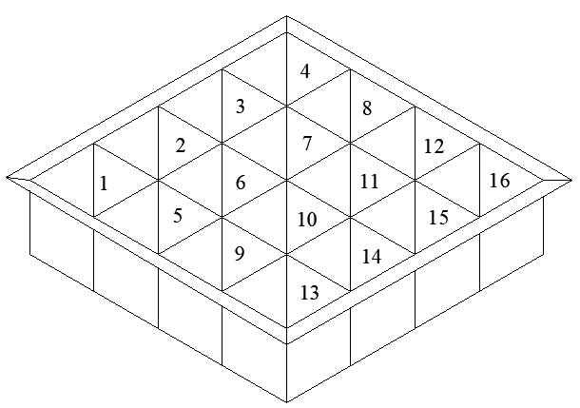
Fig. x 16 spaced Rectangular die
- Piston press: Each mould opening has an alternate mild steel piston press conveying the pressure from the hydraulic press, thus evenly distributing all pressure to the extremities of the mould edges as shown below.
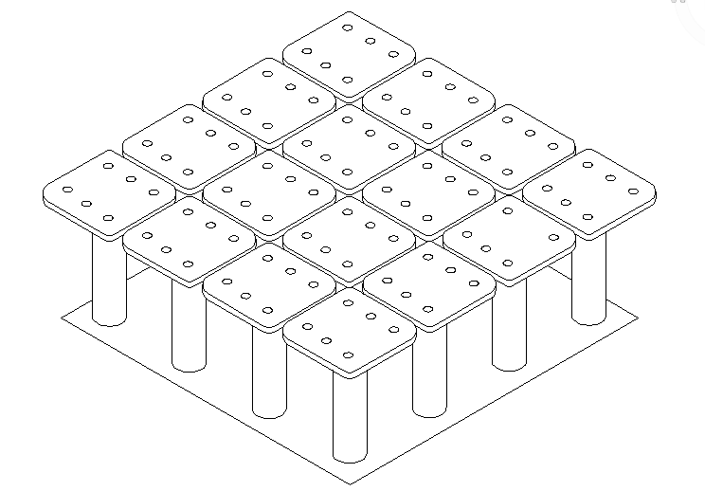
Fig. x Piston press
- Hydraulic Jack: The pressure is induced by a hydraulic system, in this case a hydraulic jack of a minimal capacity of 5 tons (details of specifications is properly discussed in this chapter). This makes it possible for a reduced effort to be translated to producing a larger pressure in compliance with the hydraulic principle (Pascal’s law).
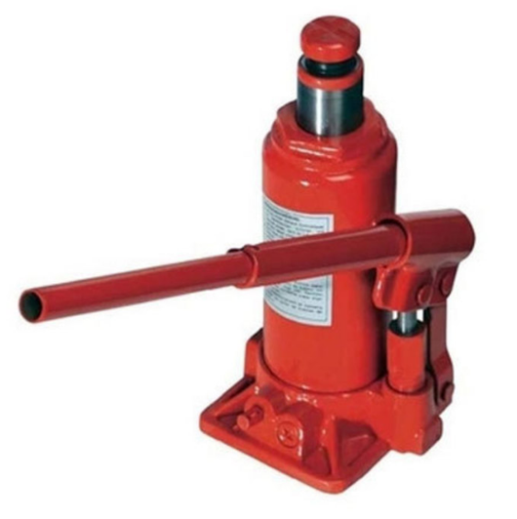
Fig. x Hydraulic Jack
- Spring: Having a machine operating in a compression manner, there has to be a chasm for a tension scenario. This I did with the introduction of the spring. As the hydraulic system compacts the briquettes, the spring allows the downward movement of the hydraulic jack be uniform, in turn bringing down slowly the piston press.
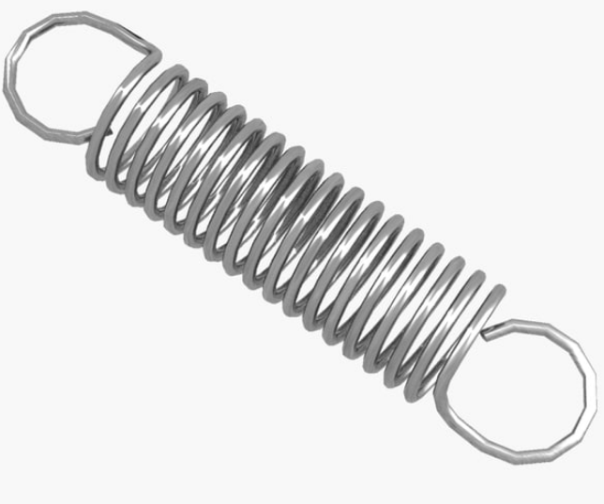
Fig. xSpring
- Frame: This houses the entire stability of the process. This was put together using mild steel angle iron materials for rigidity and stability.
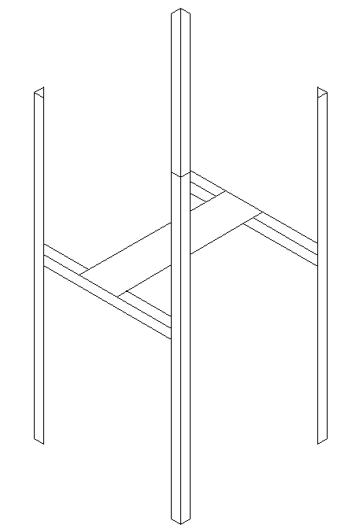
Fig. x Frame
- Clamps: Attaching clamps on all sides of the machines allows for a spread of upward force coming from the piston press. This strengthens the mould cover by inhibiting the passage of the briquette while compression is taking place allowing only the passage of moist.
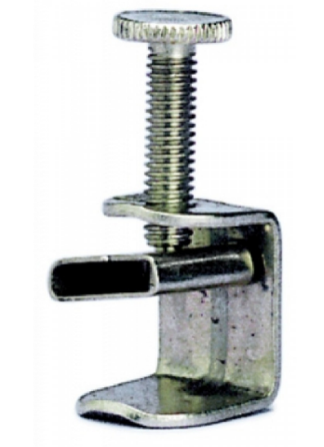
Fig. x Clamp
- Cover Plate: With the use of two high capacity hinges, this piece of mild steel material alongside the clamps functions as a repellant to the hydraulic upward force. This has a number of holes on it, which allows the ejection of moisture.

METHODOLOGY
A number of processes came to play in the fabrication phase as the chart below shows.

Chart 2. Fabrication sequence

DESIGN SPECIFICATION AND CONSIDERATION
In other to design a machine with a low propensity of failure, important features of the machine design such as the determination of the: briquette size, allowable tensile stress in the mould, load / weight on the jack, and capacity of the hydraulic jack to be used.

- DESIGN SPECIFICATIONS

Determination of the briquette size
The briquette size is seen to be key in determining the machine’s mould dimensions. For the rectangular briquette, a length of 4 inches, width of 4 inches and height of 1 inch was aimed at getting. This was aimed at,to fit in easily not only in industrial ovens but also in a domestic kitchen charcoal stove.

Derivation of allowable tensile stress
The allowable tensile stress also known as hoop stress is derived with the relationship below:
$$σc= \frac{Tensile strenght}{factor of safety}$$
Having satisfied the tensile strength of mild steel 400Mpa – 4400Mpa and using a safety factor of 4 (due to intense loading and reliability of material)
$$σc= \frac{400}{4}$$
Or
$$σc=\frac{440}{4}$$
$σc=100N/{mm}^{2}$ Or $110N/{mm}^{2}$
Taking the mean of both values, we have $σc=105N/{mm}^{2}$

- DESIGN CALCULATIONS

Weight of the piston compression plate
To get this, the following needs to be outlined;
$$Density \left(ρ\right)of mild steel=7850 kg/m^{3}$$
$$Dimension of compression plate=90mm ×90mm ×5mm$$
With this derivation, we use the formula$W_{lp}=l ×w ×h × ρ ×g$ to get the weight (given$g=9.81m/s^{2}$)
$$W_{cp}=0.09 ×0.09 ×0.005 ×7850 ×9.81$$
$$W_{cp}=3.1188 ≈3.12N$$
Having 16 pistons, the total weight of the entire compression plate is
$$W_{Tcp}=3.12 ×16$$
$$W_{Tcp}=49.92N$$

Weight of the piston connecting rod
Since the weight of the compression plate is already derived, the weight of the connecting rod can be derived using similar formula, but considering the cylindrical nature;
$$Radius \left(r\right)=12.7mm$$
$$Height\left(h\right)=150mm$$
$$π=3.142$$
$$W_{pc}=πr^{2}×h × ρ ×g$$
$$W_{pc}=3.142 ×{0.0127 }^{2}×0.15 ×7850 ×9.81$$
$W_{pc}=5.85$N
Having 16 pistons, the total weight of the entire piston is
$$W_{Tpc}=5.85 ×16$$
$$W_{Tpc}=93.66N$$

Weight of the lower compression plate
$$Dimension of compression plate=500mm ×500mm ×3mm$$
With this derivation, we use the formula$W_{lp}=l ×w ×h × ρ ×g$ to get the weight
$$W_{lp}=0.5 ×0.5 ×0.003 ×7850 ×9.81$$
$$W_{lp}=57.756 ≈57.8N$$

Determination of briquette weight
The individual rectangular briquette having length, width and height (after compaction)
of 100mm, 100mm and 25mm respectively, the weight of individual briquette can be calculated with similar formula having the density of the briquette approximated at $710 kg/m^{3}$– $890kg/m^{3}$ (Y Yuliah et al, 2012).
$$W_{b}=l ×w ×h × ρ ×g$$
$$W_{b}=0.1×0.1 ×0.025 ×710 ×9.81$$
$$W_{b}=1.74N$$
Therefore, the weight of the entire briquette that would be produced in one process is:
$$W_{Tb}=1.74 ×16$$
$$W_{Tb}=27.86N$$
- Total weight to be lifted by the hydraulic jack can be expressed by adding all weights derived above
$$W_{T}=W_{Tb}+W_{Tpc}+W_{lp}+W_{Tcp}$$
$$W_{T}=27.86+57.8+93.66+49.92$$
$$W_{T}=229.24N$$

Determination of the compaction force
To determine the particular tonnage of hydraulic jack usable, we take the Compaction force to be 35.7kN ( Nordiana, 2009). Thus, the required force can be estimated as:
$$F_{C}+ W_{T}=W$$
$$W=35700+229.24=35,929.24N$$
Therefore, the minimum required tonnage for the hydraulic jack would be:
$$\frac{35,929.24}{9.81}=3,662.5Kg ≈4.037 ton$$
This value influenced the use of a 5-ton hydraulic jack, to get a desirable result.

