NAME: OKAFOR CHIAMAKA MARIAN
MATRIC NO: 16/MHS06/042
COURSE CODE: MLS 410
COURSE TITLE: BIOMEDICAL ENGINEERING

ANSWER TO ASSIGNMENT
1. DISCUSSION ON THE PHYSICS OF LIGHT MICROSCOPE:
INTRODUCTION:
A light microscope is an optical instrument that is used in the laboratory. It is used to view very tiny particles that cannot be seen with the naked human eye.
Although the eye is marvellous in its ability to see objects large and small, it obviously has limitations to the smallest details it can detect. Human desire to see beyond what is possible with the naked eye led to the use of optical instruments. The purpose of a microscope is to magnify small objects, and both lenses contribute to the final magnification. Additionally, the final enlarged image is produced in a location far enough from the observer to be easily viewed, since the eye cannot focus on objects or images that are too close.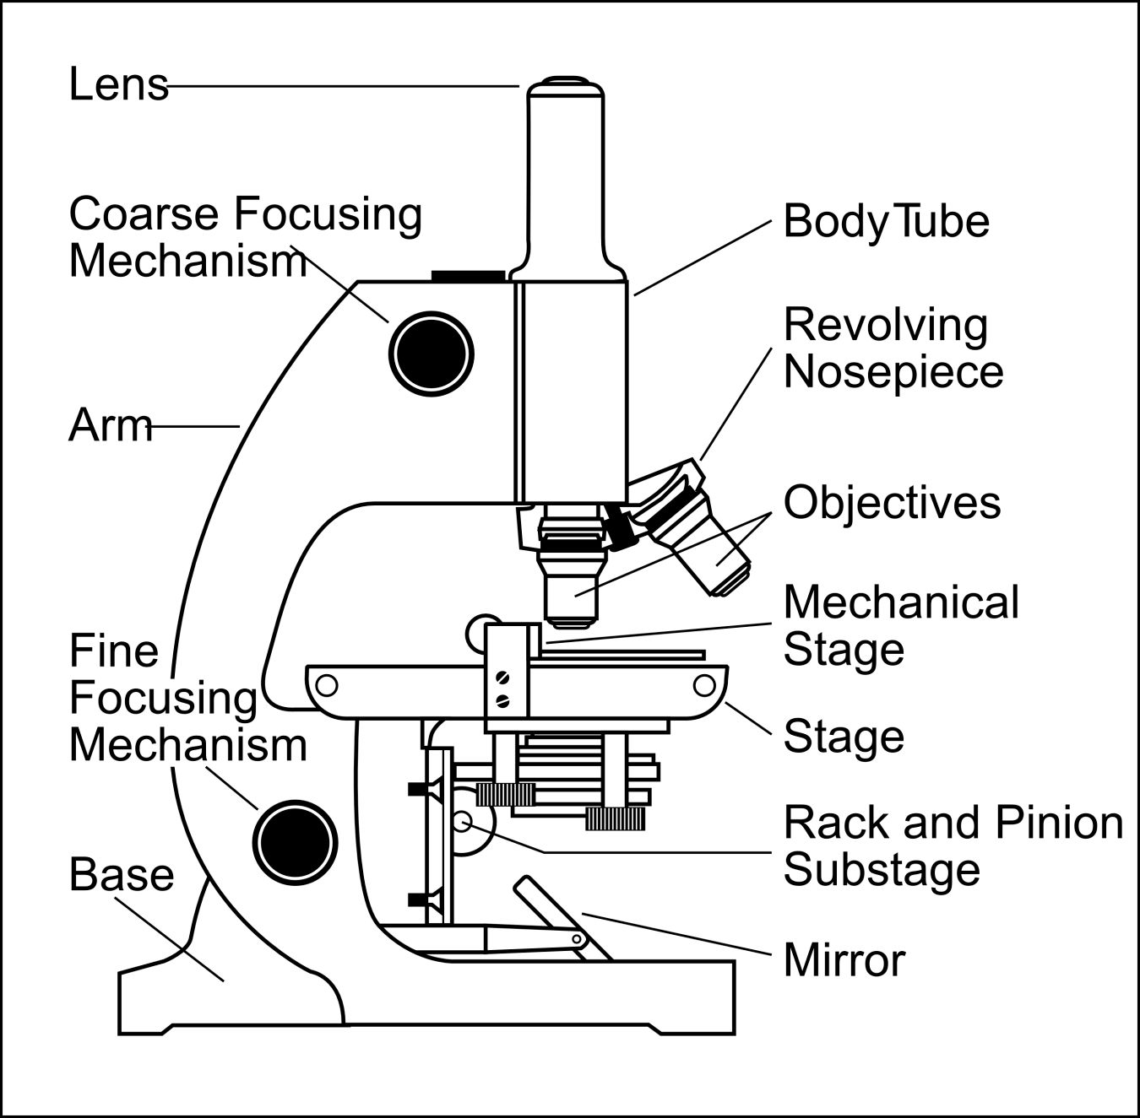
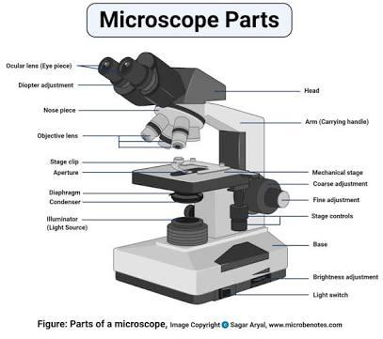

The optical microscope which is also known as a light microscope is a type of microscope which uses visible light and a system of lenses to magnify images of small samples. Optical microscopes are the oldest and simplest. They use lenses to focus light on the specimen, magnifying it thus producing an image. The specimen is normally placed close to the microscopic lens. The functioning of the light microscope is based on its ability to focus a beam of light through a specimen, which is very small and transparent, to produce an image. The image is then passed through one or two lenses for magnification for viewing. The transparency of the specimen allows easy and quick penetration of light. Specimens can vary from bacterial to cells and other microbial particles. The diagram of a light microscope is thus shown below:
PRINCIPLE/PHYSICS OF LIGHT MICROSCOPE: When a ray of light passes through one medium into another, the ray bends at the interface causing refraction. The bending of light is determined by the refractive index, which is a measure of how great a substance slows the speed of light. The direction and magnitude of the bending of the light are determined by the refractive indexes of the two mediums that form the interface. A medium with a lower refractive index such as glass to air, it normally speeds up the light penetration and making light bend away from the normal and when light is passed through a medium with a greater refractive index such as air to glass, it normally slows down and bends towards the normal, perpendicularly to the surface. If an object is put between these two mediums i.e. between water and air, in this case, a prism, the prism will bend the light at an angle. This is how the microscopic lenses work, they bend the light at an angle. The lens (convex) on receiving the light rays, it focuses the rays at a specific point known as the focal point (F-point). The measure of distance from the centre of the lens and the focal point is known as the focal length. A microscope uses lenses whose strength is predetermined, in that, the strength of a lens is directly related to the focal length i.e. short focal length magnifies objects more than lenses with a long focal length. Microscopy works strictly with a factor of resolution whereby resolution being the ability of a lens to be able to differentiate small objects that are closely packed together. The resolution of a light microscope is determined by a numerical aperture of its lens system and by the wavelength of the light it employs; a numerical aperture a definition of the light wavelengths produced when the specimen is illuminated. A minimum distance (d) between two objects that distinguishes then to be two separate entities, determined by the wavelengths of the light can be calculated by an Abbe equation using the wavelength of the light that illuminated the specimen (Lambda, λ) and the numerical aperture (NA, n sin Ɵ) i.e. d=0.5 λ/n sin Ɵ.
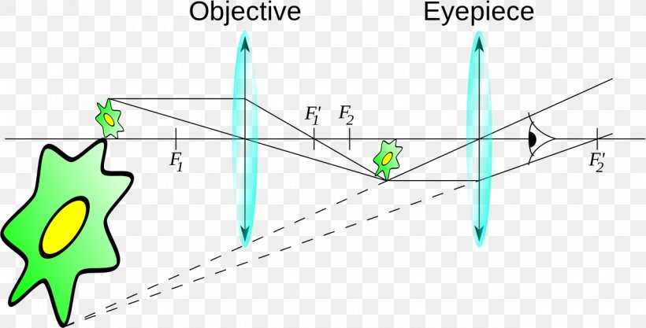

Microscopic magnification varies greatly depending on the types and number of lenses that make up the microscope. Depending on the number of lenses, there are two types of microscopes i. e Simple light microscope (it has low magnification because it uses a single lens) and the Compound light microscope (it has a higher magnification compared to the simple microscope because it uses at least two sets of lenses, an objective lens, and an eyepiece). The lenses are aligned in that, they can be able to bend light for efficient magnification of the image.
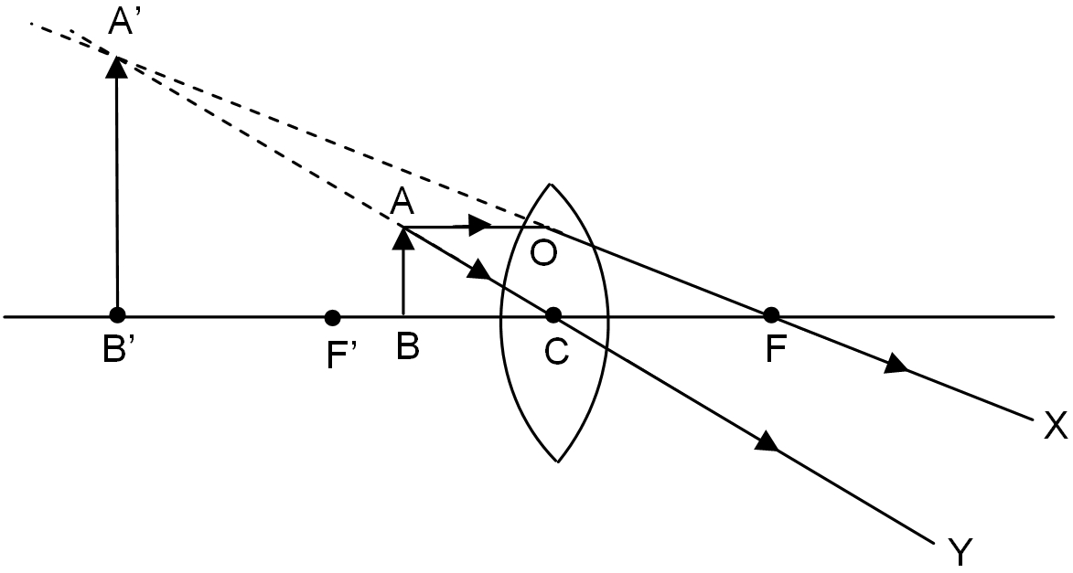

PRINCIPE OF SIMPLE OPTICAL MICROSCOPE: A simple microscope works on the principle that when a tiny object is placed within its focus, a virtual, erect and magnified image of the object is formed at the least distance of distinct vision from the eye held close to the lens.
WORKING OF SIMPLE MICROSCOPE : A object AB which is to be magnified is placed between the principal focus F’ and optical centre C of the convex lens. Now, a ray of light AO parallel to principal axis which is coming from the point A of the object passes through the focus F along the straight line OX after getting refracted by the convex lens. A second ray of light AC coming from the point A of the object passes through the optical centre C of the convex lens along the straight line CY. As is clear from the figure that the two rays i.e. OX and CY are diverging rays so these rays can intersect each other only at point A’ when produced backward. Now, on drawing A’B’ perpendicular from point A’ to the principal axis, we get the image A’B’ of the object which is virtual, erect and magnified.
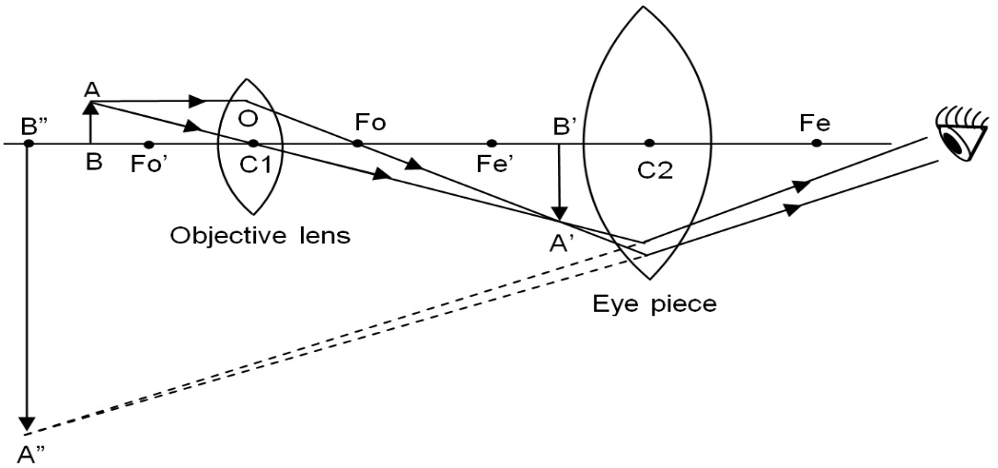
PRINCIPLE OF COMPOUND OPTICAL MICROSCOPE: A compound microscope works on the principle that when a tiny object to be magnified is placed just beyond the focus of its objective lens, a virtual, inverted and highly magnified image of the object is formed at the least distance of distinct vision from the eye held close to the eye piece.

WORKING OF COMPOUND OPTICAL MICROSCOPE: A tiny object AB to be magnified is placed in front of the objective lens just beyond its principal focus fo’. In this case, the objective lens O of the compound microscope forms a real, inverted and enlarged image A’B’ of the object. Now A’B’ acts as an object for the eye piece E, whose position is adjusted so that A’B’ lies between optical centre C2 and the focus fe’ of eye piece. Now the eye piece forms a final virtual, inverted and highly magnified image A”B”. this final image A”B” is seen by our eye hold close to eye piece, after adjusting the final image A”B” at the least distance of distinct vision of 25 cm from the eye.

2. NOTES ON THE FOLLOWING BIOMEDICAL EQUIPMENTS:

CENTRIFUGE: A centrifuge is a machine that separates particles according to their size, shape, density and viscosity of the medium, by subjecting them to artificially induced gravitational fields. This can be used as a preparative approach to separate complex mixtures present in samples or analytically, to determine the mass, shape or density of particles. Materials with higher particle density will sediment towards the axis of centrifugation (down the tube), while materials with a lower particle density will sediment away from the axis of centrifugation. Cells, subcellular components, virus particles and precipitated forms of proteins and nucleic acids are commonly separated by this method
THE PRINCIPLE: The centrifuge mainly works on the principle of sedimentation, where the acceleration at centripetal force causes denser substances to separate out along the radial direction at the bottom of the tube. The word ‘centrifugal force’ is derived from two Latin words, centrum which means “centre” and fugere, which means “to flee”. It is basically the apparent force that draws a rotating body away from the centre of rotation which is caused by the inertia of the body as the body’s path is continually redirected. The acceleration achieved by centrifugation is expressed as a multiple of the earth’s gravitational force (g). Based on the acceleration values they can reach, centrifuges are categorized into bench top (up to 15000 g), high speed refrigerated centrifuges (50000 g) and ultracentrifuges (500000 g). As ultracentrifuges can operate under cold conditions and in the vacuum, they are ideal for separating macromolecules like proteins, nucleic acids and carbohydrates. The radial force produced by the spinning rotor can also be expressed relative to g, as Relative centrifugal force (RCF) or g-force.
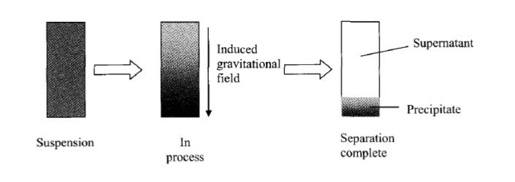

CARE AND MAINTENANCE OF A CENTRIFUGE: It is important to note that the body of the centrifuge is usually made from metals that can corrode in the presence of moisture, chemicals, or strong cleaning agents. For proper maintenance of the centrifuge, it is recommended to carefully follow the manufacturer's instructions for cleaning and maintenance. Other than that, a few general measures for maintenance to be kept in mind are as follows:
⁃ The centrifuge should always be kept clean and dry.
⁃ Any kind of spills should be immediately cleaned.
⁃ The rotor should be decontaminated after use with biological and radioactive materials. It is recommended to use 10% bleach for 30 min followed by 70% ethanol, letting the rotor air dry.
⁃ Abrasive brush wires should never be used to clean the rotor and associated parts.
⁃ The rotor should be inspected after each use by the operator and at least annually by manufacturer inspector.
⁃ A log book should be maintained for each centrifuge to keep a record of users, samples, and service history. Additionally, copies of any warranty-related materials can be included in this log book.

BRAND AND COST OF A CENTRIFUGE:
⁃ BRANDS: Vision scientific, HFS, Olayer, Beckman, Argos, Digtor 22, Plasma 22, Vetcen, Microcen 22, Biocen 22, etc.
⁃ COST: Haematocrit centrifuge cost ranges from 180,000 naira to 400,000naira. The cheapest bucket centrifuge costs about 50,000naira; with the most advanced and expensive ranging from about 300,000 to 500,000 naira. An average centrifuge will cost from about 250,000 to 300,000 naira.

AUTOMATIC TISSUE PROCESSOR: A tissue processor is a device that prepares tissue samples for sectioning and microscopic examination in the diagnostic laboratory. Microscopic analysis of cells and tissues requires the preparation of very thin, high quality sections (slices) mounted on glass slides and appropriately stained to demonstrate normal and abnormal structures. The ATP machine plays a big role in the preparation of the tissue by passing them through various chemicals; a major process called TISSUE PROCESSING.

PRINCIPLE: The principle of tissue processing is to remove the extractable water from tissue specimens and replace it with a medium that solidifies to allow sectioning. It consists of 3 stages which are dehydration, clearing and infiltrating. The purpose of dehydrating is to remove water from the tissue using graded alcohols from a lower to a higher concentration. Clearing is to remove alcohol from the tissue with a solvent that is miscible with paraffin wax such as xylene. Infiltrating is to infiltrate the tissue with paraffin wax to allow sectioning of tissues.

CARE AND MAINTENANCE OF AN AUTOMATIC TISSUE PROCESSOR:
1. Fluid and wax beakers must be filled up to appropriate mark and located in their correct position in the machine.
2. Any spillage of the fluid should be wiped away.
3. Accumulations of wax must be removed from beaker, covers, lids and surrounding areas.
4. Wax bath thermostats should be set at satisfactory levels usually 2-3°C above the melting point of wax.
5. Particular attention should be paid to fastening the processing baskets on the crousel type of machines, if the baskets are shed they will remain in one particular regent for a long period till it gets noticed.
6. Timing should be set with utmost care when loading the machine.
7. Paraffin wax baths should be checked to ensure that the wax is molten.

BRAND AND COST OF AN AUTOMATIC TISSUE PROCESSOR:
• BRANDS: Hacker, Innovative, Leica ASP 300S, Sakura Finetek, Shandon Lipshaw, Carl Zeiss, Tissue-tek, Slee, Biobase, Keedee.
• COST: Automated tissue processor ranges at a cost of 500,000naira to about 1.4million naira.

MICROTOME: Microtome is an instrument with the help of which sections of tissues are cut and the process of cutting thin sections is known as Microtomy. The thickness of sections produced during microtomy may be between fractions of 50-100 nm, in ultramicrotomy, to several 100 microns. The common range is between 5-10m but both the maximum and minimum thickness is limited by the consistency of relation of the thickness of sections to the nature of tissues. These sections are stained using suitable staining techniques followed by observing them under the microscope.

PRINCIPLE: Microtome is a common instrument . this device operates with a staged rotary action such that the cutting is part of the rotary motion . in a rotary microtome ,blade is fixed in horizontal position . through the motion of the sample holder, the sample is cut by the knife position , at which point the fresh section remains on the knifes , at the highest point of the rotary motion , the sample holders is advanced by the same thickness as the section that is to be made , allowing for the next section to be made. The flywheel is many microtomes can be operated by hands . this has the advantages that clean cut be made , as the relatively large mass of the fly wheel prevents the sample from being stopped during the sample cut. It cuts thickness between 1 and 60 micron meter. For hard material , its cuts a semi thin section with a thickness of as low as .5 micron meter.

CARE AND MAINTENANCE OF A MICROTOME:
• Clean all components daily particularly the knife holder and specimen holder.
• Make sure that anything requiring locking down is locked down properly.
• The microtome knife has been coated with an oil mixture to prevent rust and corrosion when not in use.
• Before using the knife, take a lint-free facial tissue saturated in either xylene, benzene or acetone to remove the protective oil coating on the knife.
• Use a dry, lint-free, facial tissue to wipe the knife clean. DO NOT USE GAUZE or any other coarse material; it will destroy the edge of the knife.
• Keep the edge of the knife clean at all times.
• Spray or brush any household oil on the knife to prevent rust when not in use.
• Store the knife in its case to prevent oxidation from occurring.
BRAND AND COST OF A MICROTOME:
• BRANDS: Histoline, Leica, Histocore, DiaPath Galileo, Tanner Scientific, Microm, Cuttec, Sakura, Thermo.
• COST: The cheapest microtome costs about 100,000 naira; and the most advanced and expensive costs about 18,000,000 naira. Basically, an average microtome costs about 1.5 million naira. That is why all biomedical equipments are being treated with care because they are expensive.

