NAME: OGOMUEGBUNAM FAVOUR CHIDI
MATRIC NO: 17/ENG01/021
COURSE TITLE: CHE 362
ASSIGNMENT
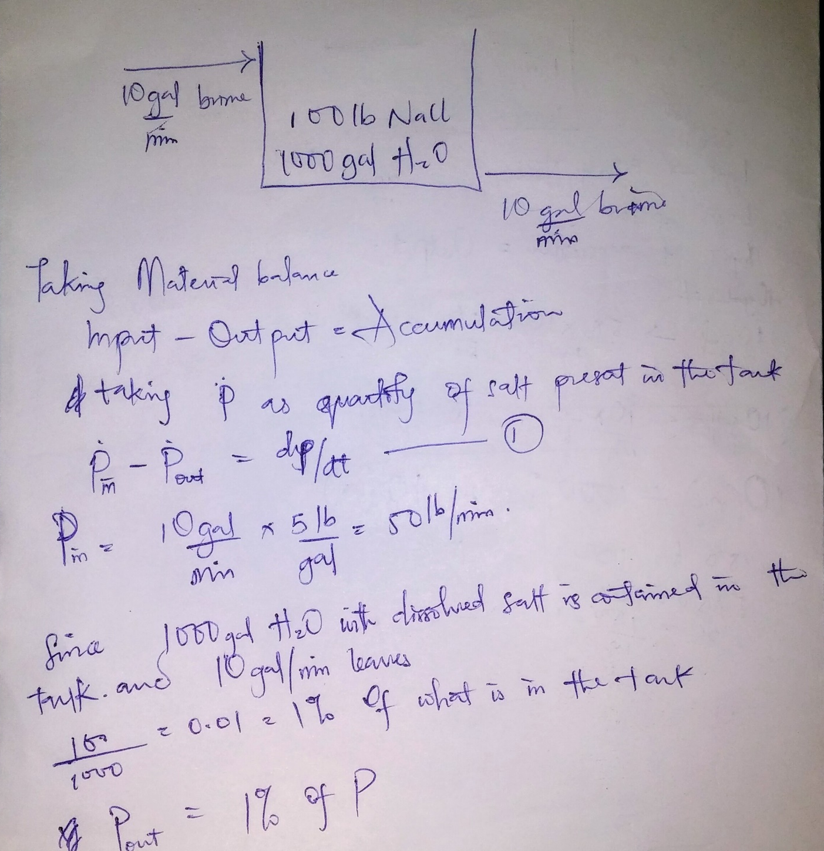

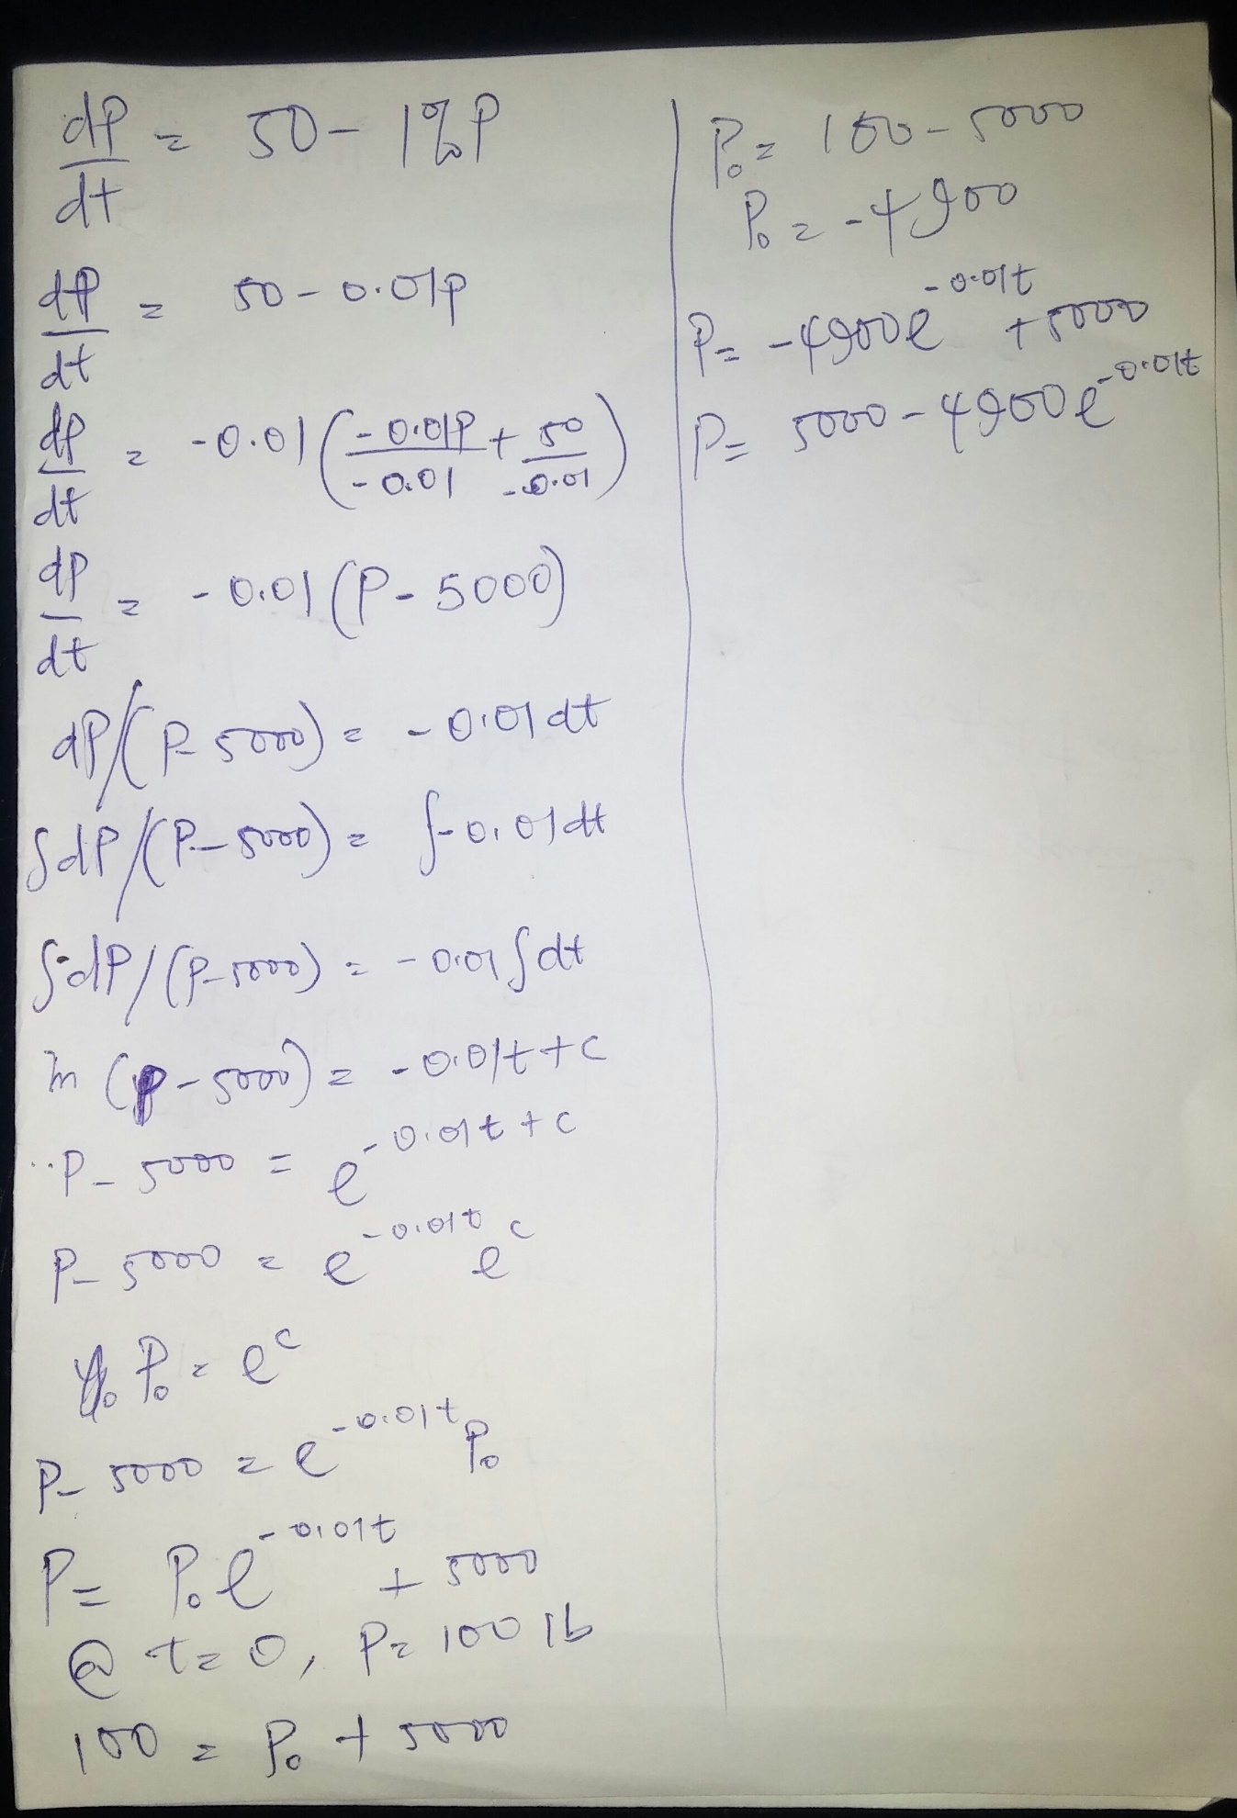
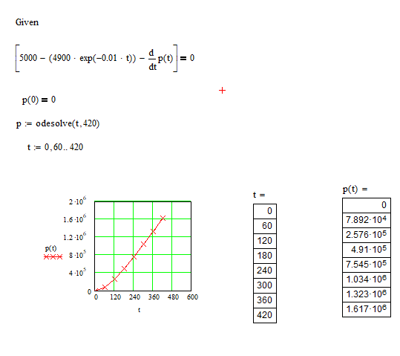
Ode45 function
commandwindow
clear
clc
f =@ (t, p)[5000+(-4900*exp(-0.01*t))-p]
tstep=[0:60:420]
p=0
[t,p] = ode45(f,tstep,p)
figure(1)
plot(t,p)
tablo=[t p]
title('Graph of p against t')
xlabel('t')
ylabel('p')

tablo =
1.0e+03 *
0 0
0.0600 2.2839
0.1200 3.5079
0.1800 4.1828
0.2400 4.5521
0.3000 4.7529
0.3600 4.8629
0.4200 4.9246
Euler method
commandwindow
clear
clc
t0=0
tn=420
h=60
t = t0:h:tn
n=length(t)
p(1)=0
for i=1:n-1
pprime(i+1) = (5000+(-4900*exp(-0.01*t(i))))
p(i+1)=p(i)+h
end
tablo=[p' pprime']
figure(2)
plot(t,p)
grid minor

