Biomedical Engineering

Physics of a Light Microscope
A light microscope is a type of microscope that uses visible light and a system of lenses to produce magnified images of small objects. It can also be referred to as an Optical microscope.
Light produced from either an internal or external light source passes through the iris diaphragm, a hole variable size which controls the amount of light reaching the specimen. The light passes through the condenser which focuses the light onto the specimen.
The slide is held on the stage at 90 degrees to the path of light which then travels through the specimen. The objective lens magnifies the image of the specimen before the light travels through the barrel of the microscope. The light then passes through the eyepiece lens and into the eyes of the viewer which send an impulse to the brain which interprets the image. Destructive and constructive interference results in bright and dark areas.

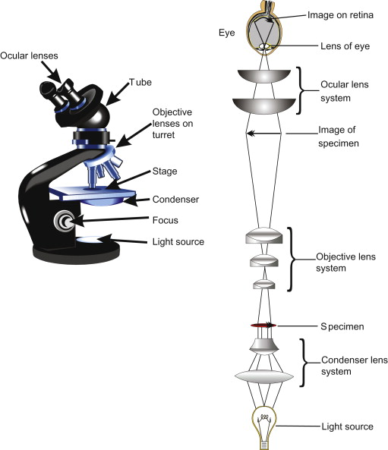

Biomedical Equipment

Centrifuge
A centrifuge is a laboratory device that is used for the separation of fluids, gas or liquid, based on density. Separation is achieved by spinning a vessel containing material at high speed.

Principle
Centrifugation is a technique used for the separation of particles using a centrifugal field. The centrifuge works using the sedimentation principle, where the centripetal acceleration causes denser substances and particles to move outward in the radial direction. At the same time, objects that are less dense are displaced and move to the center. The particles are suspended in liquid medium and placed in a centrifuge tube. The tube is then placed in a rotor and spun at a definitive speed. Rotation of the rotor about a central axis generates a centrifugal force upon the particles in the suspension. Particles move away from the axis of rotation in a centrifugal field only when the centrifugal force exceeds the counteracting buoyant and frictional forces resulting in sedimentation of the particles at a constant rate. Particles which differ in density, size or shape sediment at different rates. The rate of sedimentation depends upon:
1. The applied centrifugal field
2. Density and radius of the particle.
3. Density and viscosity of the suspending medium.

Brands
- Beckman Coulter
- Eppendorf 5424
- ELMI CM-7S Clinical PRP
- Scilogex
- Globe Scientific

Care and Maintenance
- Clean your centrifuge daily. This includes cleaning both the exterior and the interior of the centrifuge. A sponge, warm water, and a mild detergent can be used to clean the centrifuge.
- Do not use caustic detergents or a product that contains chlorine ions. A plastic scrub brush should be used to avoid damaging the coatings.
- When you are finished cleaning the centrifuge you should use a centrifuge lubricant to lubricate the bucket grooves and rubber seals.
- Use approved disinfectants and/or “spill” kits to disinfect the centrifuge on a regular basis.
- Check for residue and corrosion on the rotors on a weekly or monthly basis.
- Scheduling regular preventive maintenance with a trained technician.

Price
Price range for a centrifuge is $500-$5000

Automatic Tissues processor
This processor is used to process animal and human tissues automatically.

Principle
The tissue basket oscillates up and down in each station at three-second intervals to ensure thorough and even mixing of the reagents and optimum tissue infiltration. Infiltration time is separately programmable for each station. Up to nine programs may be run with immediate or delayed starting times. When it’s time for tissue to be transferred to the next beaker or jar, the cover of the machine is raised up, and the lifting mechanism carefully removes the tissue basket and gently transfers it to the next beaker.
When the infiltration time for any particular station is exceeded, a warning message will display, indicating the station number and excess time. Controls are arranged by functionality with an LCD to indicate operational parameters. Reagent container lids have seals to minimize operator exposure to hazardous fumes.
Tissue basket immediately immerses in a station in the event of power loss to protect samples from drying out. When power is restored, program will resume. In the event of long-term power failure, wax is liquefied. Capacity of tissue basket is 80 cassettes.

Brands
- Radical scientific equipments
- Qiagen
- Sakura
- Leica Biosystems
- Thermo Scientific

Care and Maintenance
- Wipe the wax baths and lids clean.
- The lid can be removed for cleaning purposes.
- Remove the wax strainers from the wax baths. Clean, dry and reinsert them.
- Ensure that the air vent hole at the top rear right hand corner is unobstructed.
- Instrument exterior should be wiped with a damp cloth moistened with mild detergent and dry when dirty.
- Schedule regular maintenance with trained technician.
- Follow manufacturers instruction manual of product bought.

Price
$5000- $15000

Microtome
A microtome is a specialized precision cutting instrument, which accurately and repeatedly slices sections from a block of embedded tissue.

Principle
Microtome is a sectioning instrument that allows the cutting of extremely thin slices of a material known as section. Microtomes are used in microscopy, allowing for the preparation of sample for observation under transmitted light or electrons radiation.
The razor is placed in front of the microtome in a razor- holder which is movable. The material, embedded in a paraffin block, is fixed on the block-holder which can be fixed to an adjustable socket. There is a scale indicating the thickness of the section in microns. The thickness is adjusted by moving a screw. The block-holding socket can be moved forward or backward by rotating a handle placed at the back of the microtome. Sections are cut by moving a horizontal handle forward and backward.

Brands
- Thermo Scientific
- ANA-MED
- Boeckeler Instruments Inc.
- Leica Biosystems
- Sigma Scientific Instruments

Care and Maintenance
- Microtome knife has been coated with an oil mixture to prevent rust and corrosion when not in use.
- Removing of sectioning debris from the working area, brushing debris from the knife and cleaning as appropriate.
- Carefully remove the microtome knife/blade holder and clean it after use.
- Remove the debris trays and clean.
- Wipe covers and remove excess debris as required.
- Wipe visor if required.
- Knives/blades must be stored in their boxes when not in use.
- In the event of a breakdown, a qualified person should be called.

Price
$5000 - $12000

