NAME: OKAM EDNA ACHI CHINMA
MATRIC NUMBER: 19/MHS03/015
DEPARTMENT: HUMAN ANATOMY

LACTATION AND GESTATION PERIOD IN A NORMAL FEMALE
Lactation is the secretion and yielding of milk by females after giving birth. The milk is produced by the mammary glands, which are contained within the breasts.
The breasts, unlike most of the other organs, continue to increase in size after childbirth. Although mammary growth begins during pregnancy under the influence of ovarian and placental hormones, and some milk is formed, copious milk secretion sets in only after delivery. Since lactation ensues after a premature birth, milk production is held back during pregnancy. The mechanism by which this inhibitory effect is brought about, or by which lactation is initiated at delivery, has long been the subject of an argument that revolves around the opposing actions of estrogen, progesterone, and prolactin, as studied in laboratory animals, goats, and cattle. During pregnancy the combination of estrogen and progesterone circulating in the blood appears to inhibit milk secretion by blocking the release of prolactin from the pituitary gland and by making the mammary gland cells unresponsive to this pituitary hormone. The blockade is removed at the end of pregnancy by the expulsion of the placenta and the loss of its supply of hormones, as well as by the decline in hormone production by the ovaries, while sufficient estrogen remains in circulation to promote the secretion of prolactin by the pituitary gland and so favour lactation.
For lactation to continue, necessary patterns of hormone secretion must be maintained; disturbances of the equilibrium by the experimental removal of the pituitary gland in animals or by comparable diseased conditions in humans quickly arrest milk production. Several pituitary hormones seem to be involved in the formation of milk, so that it is customary to speak of a lactogenic (“milk-producing”) complex of hormones. To some degree, the role of the pituitary hormones adrenocorticotropin, thyrotropin, and growth hormone in supporting lactation in women is inferred from the results of studies done on animals and from clinical observations that agree with the results of animal studies. Adrenal corticoids also appear to play an essential role in maintaining lactation.
The stimulus of nursing or suckling supports continued lactation. It acts in two ways: it promotes the secretion of prolactin (and possibly other pituitary hormones of value in milk formation), and it triggers the release of yet another hormone from the pituitary gland—oxytocin, which causes the contraction of special muscle cells around the alveoli in the breast and ensures the expulsion of milk. It is in this way that a baby’s sucking at one breast may cause an increase in milk flow from both, so that milk may drip from the unsuckled nipple. About 30 seconds elapse between the beginning of active suckling and the initiation of milk flow.

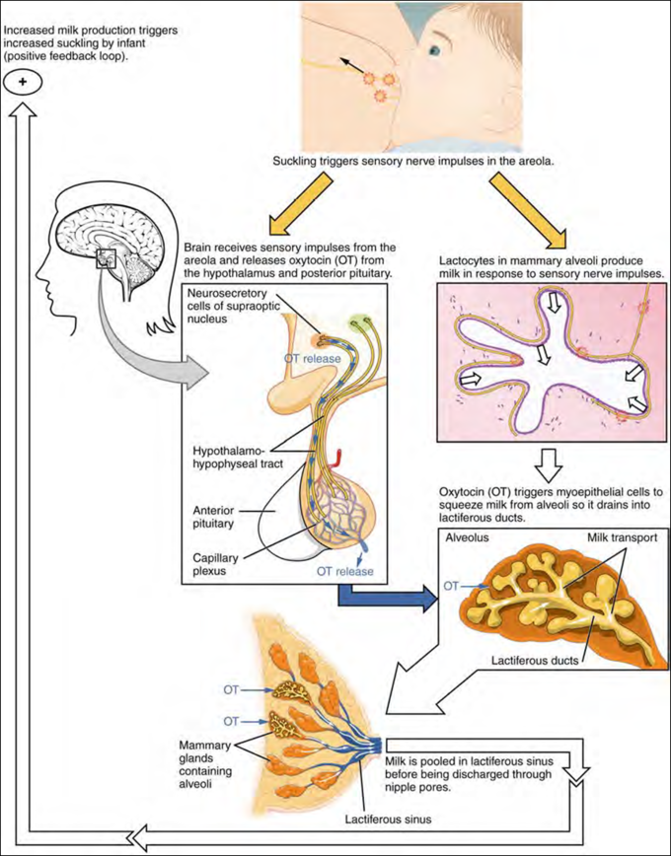

Physiology of Pregnancy
Hormonal
Pregnant women experience numerous adjustments in their endocrine system that help support the developing fetus. The fetal-placental unit secretes steroid hormones and proteins that alter the function of various maternal endocrine glands. Sometimes, the changes in certain hormone levels and their effects on their target organs can lead to gestational diabetes and gestational hypertension.

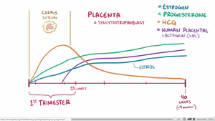

Estrogen, progesterone, and human chorionic gonadotropin (hCG) levels throughout pregnancy.

Fetal-placental unit
Levels of progesterone and estrogen rise continually throughout pregnancy, suppressing the hypothalamic axis and subsequently the menstrual cycle. The progesterone is first produced by the corpus luteum and then by the placenta in the second trimester. Women also experience increased human chorionic gonadotropin (β-hCG), which is produced by the placenta.

Pancreatic Insulin
The placenta also produces human placental lactogen (hPL), which stimulates maternal lipolysis and fatty acid metabolism. As a result, this conserves blood glucose for use by the fetus. It can also decrease maternal tissue sensitivity to insulin, resulting in gestational diabetes.

Pituitary gland
The pituitary gland grows by about one-third as a result of hyperplasia of the lactrotrophs in response to the high plasma estrogen. Prolactin, which is produced by the lactrotrophs increases progressively throughout pregnancy. Prolactin mediates a change in the structure of the breast mammary glands from ductal to lobular-alveolar and stimulates milk production.

Parathyroid
Fetal skeletal formation and then later lactation challenges the maternal body to maintain their calcium levels. The fetal skeleton requires approximately 30 grams of calcium by the end of pregnancy. The mother's body adapts by increasing parathyroid hormone, leading to an increase in calcium uptake within the gut as well as increased calcium reabsorption by the kidneys. Maternal total serum calcium decreases due to maternal hypoalbuminemia, but the ionized calcium levels are maintained.

Adrenal glands
Total cortisol increases to three times of non-pregnant levels by the third trimester. The increased estrogen in pregnancy leads to increase corticosteroid-binding globulin production and in response the adrenal gland produces more cortisol. The net effect is an increase of free cortisol. This contributes to insulin resistance of pregnancy and possibly striae. Despite the increase in cortisol, the pregnant mom does not exhibit Cushing syndrome or symptoms of high cortisol. One theory is that high progesterone levels act as an antagonist to the cortisol.
The adrenal gland also produces more aldosterone, leading to an eight-fold increase in aldosterone. Women do not show signs of hyperaldosterone, such as hypokalemia, hypernatremia, or high blood pressure.
The adrenal gland also produces more androgens, such as testosterone, but this is buffered by estrogen's increase in sex-hormone binding globulin (SHBG). SHBG binds avidly to testosterone and to a lesser degree DHEA.

Thyroid
The thyroid enlarges and may be more easily felt during the first trimester. The increase in kidney clearance during pregnancy causes more iodide to be excreted and causes relative iodine deficiency and as a result an increase in thyroid size. Estrogen-stimulated increase in thyroid-binding globulin (TBG) leads to an increase in total thyroxine (T4), but free thyroxine (T4) and triiodothyronine (T3) remain normal.

