NAME : CHUKWUMA JENNIFER C.
MATRIC NO: 15/MHS06/022
COURSE CODE: MLS 410
Assignment

- Discuss the physics of the light microscope diagrams and illustrations needed.

All to frequently, sophisticated and well-equipped microscopes fail to yield excellent images due to incorrect use of the light source, which usually leads to inadequate sample illumination. When optimized, illumination of the specimen should be bright, glare-free, and evenly dispersed in the field of view.
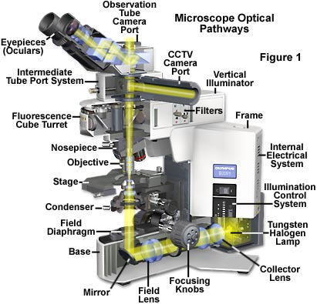

There are numerous light sources available to illuminate microscopes, both for routine observation and critical photomicrography. A most common light source, because of its low cost and long life, is the 50 or 100 watt tungsten halogen lamp as illustrated at the base of the microscope diagram in Figure 1, which also details the optical pathways in a typical modern transmitted light microscope. In this figure, the tungsten-halogen lamp emits a continuous spectrum of light centered at 3200 K (when set at a lamp voltage of +9 volts), which is then passed through a collector and field lens before being reflected into the substage condenser and onto the specimen. Image forming light rays are captured by the microscope objective and passed either into the eyepieces or directed by a beamsplitter into one of several camera ports. Throughout the optical pathway of the microscope, illumination is directed and focused through a series of diaphragms and lenses as it travels from the source to illuminate the specimen and then into the eyepieces or camera attachment. Alignment of the optical components of a microscope to optimize illumination in modern microscopes is carried out following the rules of Köhler illumination. More details of how both transmitted and reflected light microscopes are aligned for proper Köhler illumination are discussed in our sections on setting up a microscope for transmitted light and reflected light. The optical pathways shown above in Figure 1 are typical for a transmitted light microscope and involve a number of lenses, diaphragms, mirrors, and beamsplitters to direct light through the microscope.

- Write notes on the biomedical equipment. Add notes on principle, brand, care and maintenance and cost;
A. Centrifuge
B. Automatic Tissues processor
C. Microtome

CENTRIFUGE .

Centrifuges are used to increase the sedimentation rate of particles by using centrifugal forces, which are forces that are greater than gravity. Centrifuges consist of several parts including a rotor, motor, imbalance detector, tachometer, safety lid, and braking system. Some centrifuges also include a refrigeration system. They are classified into three categories: low-speed, high-speed, and ultra-speed. Low-speed centrifuges are used to separate serum or plasma from red blood cells, and to harvest and purify various precipitates and cell fragments. High-speed centrifuges are used to separate cell constituents. They are also used to isolate and purify viruses. Ultracentrifuges are mainly used to isolate and purify membrane components.

There are several important cleaning and safety procedures that should be used to ensure a centrifuge works properly. First, you should clean your centrifuge daily. This includes cleaning both the exterior and the interior of the centrifuge. A sponge, warm water, and a mild detergent can be used to clean the centrifuge. Do not use caustic detergents or a product that contains chlorine ions. A plastic scrub brush should be used to avoid damaging the coatings. When you are finished cleaning the centrifuge you should use a centrifuge lubricant to lubricate the bucket grooves and rubber seals. You should also use approved disinfectants and/or “spill” kits to disinfect the centrifuge on a regular basis. In addition to cleaning the centrifuge, you should also check for residue and corrosion on the rotors on a weekly or monthly basis.

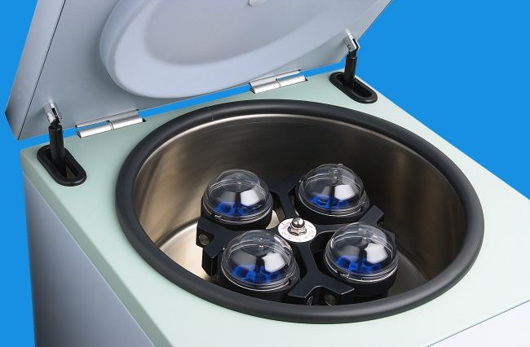

Scheduling regular preventive maintenance with a trained technician for your centrifuge is vital because it increases the durability and functionality of the centrifuge. Regular preventive maintenance also ensures accurate results and reliable performance, which will benefit your research. Regular preventive maintenance includes the inspection of the physical condition, inspection of the electrical condition, cleaning, and testing of the centrifuge. Regular preventive maintenance will not only prevent damage, but can also identify damage that has already occurred and repair it before the centrifuge is no longer usable. In order for your centrifuge to be in the best possible condition and to ensure the reliability of your research you should regularly schedule preventive maintenance with a trained technician.

AUTOMATIC TISSUE PROCESSOR.

WHAT IS THE AUTOMATIC TISSUE PROCESSOR MACHINE (ATPM)?
A tissue processor is a device that prepares tissue samples for sectioning and microscopic examination in the diagnostic laboratory.

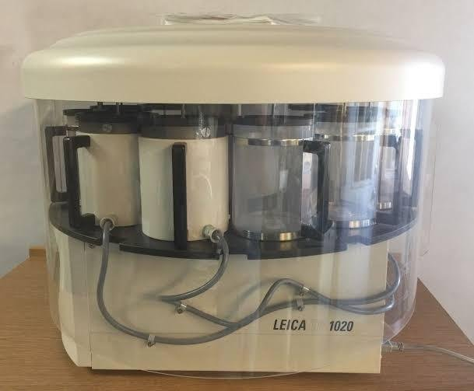

Microscopic analysis of cells and tissues requires the preparation of very thin, high quality sections (slices) mounted on glass slides and appropriately stained to demonstrate normal and abnormal structures.

The ATP machine plays a big role in the preparation of the tissue by passing them through various chemicals; a major process called TISSUE PROCESSING

Most ATPMs are easy-to-program interface. The Leica processor model has ten 1.8L (60.9oz.) reagent beakers and two 1.8L (60.9oz.) wax baths.

The tissue basket oscillates up and down in each station at three-second intervals to ensure thorough and even mixing of the reagents and optimum tissue infiltration.

Infiltration time is separately programmable for each station. Up to nine programs may be run with immediate or delayed starting times.

When it’s time for tissue to be transferred to the next beaker or jar, the cover of the machine is raised up, and the lifting mechanism carefully removes the tissue basket and gently transfers it to the next beaker.

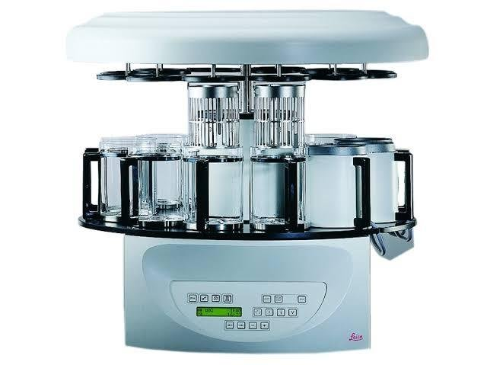

When the infiltration time for any particular station is exceeded, a warning message will display, indicating the station number and excess time. Controls are arranged by functionality with an LCD to indicate operational parameters. Reagent container lids have seals to minimize operator exposure to hazardous fumes.

Tissue basket immediately immerses in a station in the event of power loss to protect samples from drying out. When power is restored, program will resume. In the event of long-term power failure, wax is liquified. Capacity of tissue basket is 80 cassettes.

Vacuum configurations hasten infiltration, allowing pressure to be applied to any station in either manual or automatic operation. Fume control configurations extract fumes with a fan and pass them through an internal carbon filter.

For added efficiency, these models feature a two-part containment shield surrounding the reagent container platform.

ATPM – processing time schedule
Processing schedule varies and it depends oh the following:

(i) Nature and size of tissue
(ii) Urgency

Beaker I – fixative (formalin) 1-2 hours
Beaker II – fixative 1 hour
Beaker III – fixative. 30- 45 minutes
Beaker IV – 70% alcohol. 30 minutes
Beaker V – 90% alcohol. 30 minutes
Beaker VI – Absolute alcohol. 1 hour
Beaker VII – Absolute alcohol. 1 hour
Beaker VIII – Methanol 30 minutes
Beaker IX – Xylene. 1-2 hours
Beaker X – Xylene 45 minutes – 1 hour
Wax bath I (done at 45°c) 2 hours
Wax bath II. 2 hours

Remember that the nature of tissue, size and urgency determines the processing time schedule.
All the processes are performed by the ATPM from start to finish except embedding which is best done manually. This wasn’t possible in the 18th and 19th century.

MICROTOME
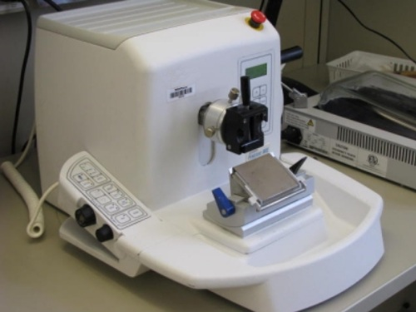

The rotary microtome is the most common instrument found in a histology laboratory. Although most microtomes are manual, some are automatic or semi-automatic, where the advancement of the block and speed of cutting are controlled by a foot pedal or a digital keypad at one's fingertips. Automatic and semi-automatic microtomes greatly improve ergonomics by reducing repetitive stress on joints. Microtomes have become more precise and easier to use since the first versions. Although a good microtome can last decades, most laboratories are equipped with modern microtomes with current design innovations.
Microtomes are very heavy, weighing 40 to 60 pounds. This is to reduce vibration during microtome, in which stability is critical during sectioning to prevent undulations (washboarding) in the paraffin sections. Daily cleaning from paraffin debris and yearly preventive maintenance will keep a microtome cutting optimally for many years.
The main components of a rotatory microtome are described below. Although some microtomes have more bells and whistles, the standard microtome remains relatively simple to operate.
Microtome base plate or stage: A platform which has rails that secure the knife holder base.
Knife holder base: A part that anchors the knife holder to the microtome stage. The knife holder base can be moved toward or away from the block, but MUST be stationary and locked during microtomy.
Knife holder: This part is comprised of several components including the blade clamp that holds the blade, the knife tilt for adjusting the knife angle, and the face plate that guides that ribbons away from the blade and towards the operator.
Cassette clamp or block holder: Holds the paraffin block in place. Typically, the block moves up and down with each revolution while the blade is stationary. The block holder may have knobs that allow the user to manipulate the block face in various directions to bring the tissue in alignment with the blade.
Coarse hand-wheel: Moves the block holder either toward the knife or away from the knife.
Advancement hand-wheel: Turns in one direction and advances the block toward the knife at the specified microns. Most hand-wheels are equipped with a safety lock to prevent the wheel from releasing and having the block holder come down towards the blade while a block is inserted or removed. The safety lock should be used anytime the microtomist is not actively sectioning paraffin blocks.
Micron adjustment: Micron settings for section thickness can range from 1 to 60 microns on most microtomes.

