Matric number:16/mhs06/025
The microscope is a multiple-element system having more than a single lens or mirror.
- Many optical devices contain more than a single lens or mirror. These are analysed by considering each element sequentially. The image formed by the first is the object for the second, and so on. The same ray tracing and thin lens techniques apply to each lens element.
- The overall magnification of a multiple-element system is the product of the magnifications of its individual elements. For a two-element system with an objective and an eyepiece, this is m = m_{o}m_{e}, where m_{o} is the magnification of the objective and m_{e} is the magnification of the eyepiece, such as for a microscope.
- Microscopes are instruments for allowing us to see detail we would not be able to see with the unaided eye and consist of a range of components.
- The eyepiece and objective contribute to the magnification. The numerical aperture NA of an objective is given by
NA = n sin α where n is the refractive index and α the angle of acceptance.
- Immersion techniques are often used to improve the light gathering ability of microscopes. The specimen is illuminated by transmitted, scattered or reflected light though a condenser.
- The f/# describes the light gathering ability of a lens. It is given by f/#=fD≈12NAf/#=fD≈12NA.
- light microscope is a biology laboratory instrument or tool, that uses visible light to detect and magnify very small objects, and enlarging them.
- They use lenses to focus light on the specimen, magnifying it thus producing an image. The specimen is normally placed close to the microscopic lens.
- Microscopic magnification varies greatly depending on the types and number of lenses that make up the microscope. Depending on the number of lenses, there are two types of microscopes i. e Simple light microscope (it has low magnification because it uses a single lens) and the Compound light microscope (it has a higher magnification compared to the simple microscope because it uses at least two sets of lenses, an objective lens, and an eyepiece). The lenses are aligned in that, they can be able to bend light for efficient magnification of the image.
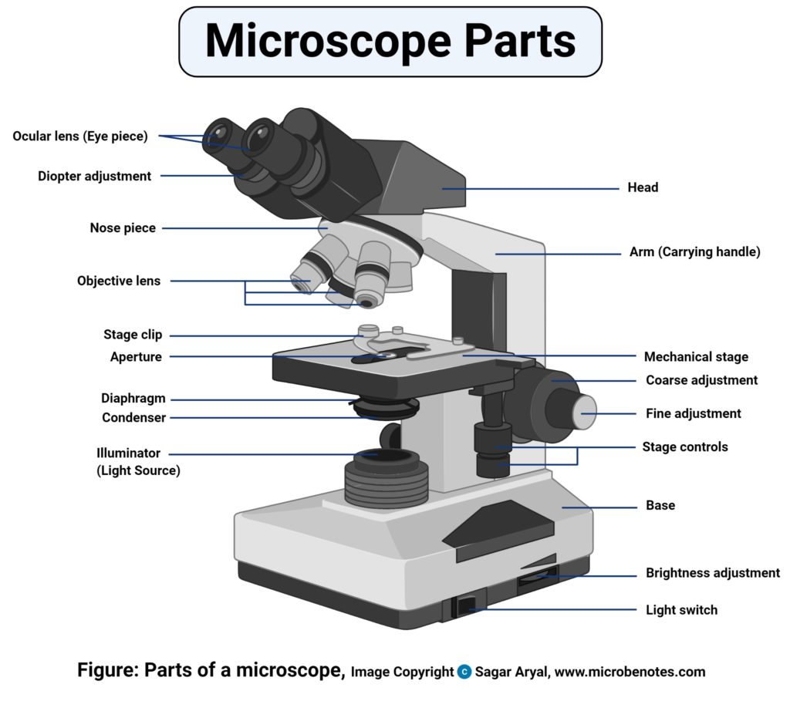
- The functioning of the light microscope is based on its ability to focus a beam of light through a specimen, which is very small and transparent, to produce an image. The image is then passed through one or two lenses for magnification for viewing. The transparency of the specimen allows easy and quick penetration of light. Specimens can vary from bacterial to cells and other microbial particles.
2. Centrifuge
centrifuge is a laboratory device that is used for the separation of fluids, gas or liquid, based on density. Separation is achieved by spinning a vessel containing material at high speed; the centrifugal force pushes heavier materials to the outside of the vessel.
Principle:
centrifuge works using the sedimentationprinciple, where the centrifugal acceleration causes denser substances and particles to move outward in the radial direction. At the same time, objects that are less dense are displaced and move to the center.
Care and maintenance:
Clean the centrifuge daily, or at least weekly. Remove the rotor and any sample or container holders. Interiorcleaning includes the interior bucket, specimen holder, rotor and supports. Use a sponge, warm water and a mild detergent such as dishwashing liquid.
Brand and cost:

Automatic tissue processor
KD-TS6A, Automatic Tissue Processor Price: $12,800
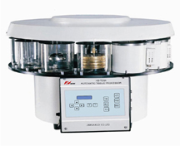
This processor is used to process animal and human tissues automatically. It is accurate and easy to use and maintain. It is an excellent choice for histology and pathology labs of hospitals and research institutions.
TISSUE PROCESSOR MACHINE – TP 1050 Leica processor model. ... Thetissue basket oscillates up and down in each station at three-second intervals to ensure thorough and even mixing of the reagents and optimumtissue infiltration. Infiltration time is separately programmable for each station.
microtome is a specialized precision cutting instrument, which accurately and repeatedly slices sections from a block of embedded tissue. Different kinds of microtomes are used to section paraffin and plastic embedded tissues .
care and maintenance:
Dust accumulation must be avoided by covering after use.
Wipe the moving parts regularly with neutral oil.

