NAME : BELLO MOYONINUOLUWA ESTHER

MAT.NO : 19/MHS02/035

DEPT : NURSING

COURSE : CHM102 [GENERAL CHEMISTRY II]

ASSIGNMENT TITLE : STEREOCHEMISTRY AND FUNCTIONAL GROUP

- Name the functional groups present in each of the following molecules
- CH₂=C(OH)HCHO – ( Aldehyde)

- C₆H₅CH(NH₂)COCH₃ - ( Methoxy)

- CH₃C=CHCH(OH)CHO – (Aldehyde)

- A 0.856 g sample of pure (2R, 3R)-tatrtaric acid was diluted to 10cm3 with water and placed in a 1.0 dm polarimeter tube. the observed rotation at 20⁰ C was +1.0⁰. Calculate the specific rotation of (2R, 3R)-tatrtaric acid.
Solution
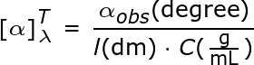
WHERE [α]= specific rotation
λ = wavelength
α= observed rotation [20$°]$
c= concentration[$\frac{0.856g}{10ml}=0.0856g/ml$]
conversion of 10${cm}^{3 }$to ml=10ml
T=temperature
[α]=$\frac{20}{0.0856 ×10 }=\frac{20}{0.856}=23.4°$
Therefore specific rotation is 23.4$°$
- Draw the possible geometric isomers (where possible) for each of the following compounds
- Hexa-2,4-diene

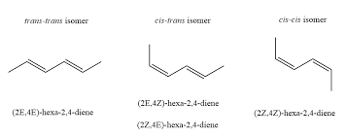
- 2,3-Dimethylbut-2-ene
