NAME: MADUOGWU KAMBILI EMMANUELLA
COLLEGE: MEDICINE AND HEALTH SCIENCES
DEPARTMENT: MEDICINE AND SURGERY
MATRIC NO.: 19MHS01/240
DATE: 12-05-2020
CHM 102 NEW ASSIGNMENTS
CLASSIFICATION OF ALCOHOLS
Classification based on the number of hydrogen atoms attached to the carbon atom containing the hydroxyl group. If the numbers of hydrogen atoms attached to the carbon atom bearing the hydroxyl group are three or two, it is a primary alcohol (10). If it is one hydrogen atom, it is called a secondary alcohol (20) and if no hydrogen atom is attached to the carbon atom bearing the hydroxyl group, it is called a tertiary alcohol (30). Example: CH3CH2OH ethanol(10)

Classification based on the number of hydroxyl groups they possess. Monohydric alcohols have one hydroxyl group present in the alcohol structure. Dihydric alcohol or Glycols have two hydroxyl groups present in the alcohol structure while trihydric alcohols or triols have three hydroxyl groups present in the alcohol structure. Polyhydric alcohols or polyols have more than three hydroxyl groups. Example: CH3CH2CH2OH propanol (monohydric alcohol).

SOLUBILITY OF ALCOHOLS IN WATER AND ORGANIC SOLVENTS
In water, lower alcohols with up to three carbon atoms in their molecules are soluble in water because these lower alcohols can form hydrogen bond with water molecules. The water solubility of alcohols decreases with increasing relative molecular mass.
In organic solvents, all monohydric alcohols are soluble in organic solvents. The solubility of simple alcohols and polyhydric alcohols is largely due to their ability to form hydrogen bonds with water molecules.

INDUSTRIAL PREPARATION OF ETHANOL

Carbohydrate such as starch is broken down by diastase contained in malt at a temperature of 600c to give maltose. Equation: 2(C6H10O5)n + n H2O –––––––––> n C12H22O11 carbohydrate 600c/diastase maltose
Maltose is broken down into glucose by maltase found in yeast at a temperature of 150c to give glucose.
Equation: C12H22O11 + H2O –––––––––––> 2C6H12O6
Maltose 150c/maltase glucose

Glucose is converted to ethanol at constant temperature of 150c by enzyme zymase also contained in yeast.
Equation: C6H12O6 –––––––––––> 2CH3CH2OH + 2CO2
Glucose 150c/zymase Ethanol

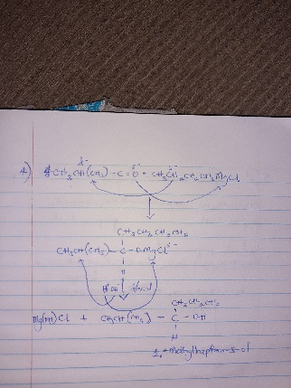
4.

7.

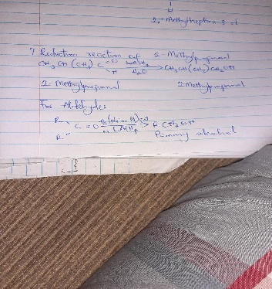

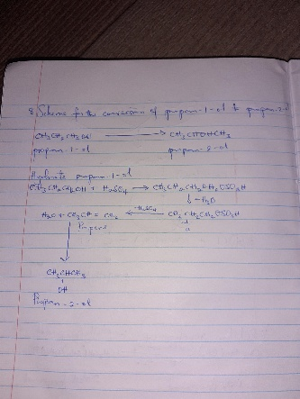
8.

