KWAME-OKPU E.A OGHENEOVU
17/MHS01/174
ANATOMY
ANA 314
Question
- comment on the relevance of comparative anatomy to evolution
Comparative anatomy is the study of similarities and differences in the anatomy of different species. It is closely related to evolutionary biology and phylogeny (the evolution of species).
The science began in the classical era, continuing in Early Modern times with work by Pierre Belon who noted the similarities of the skeletons of birds and humans.
Evolution is change in the heritable characteristics of biological populations over successive generations. These characteristics are the expressions of genes that are passed on from parent to offspring during reproduction
RELEVANCE OF COMPARATIVE ANATOMY TO EVOLUTION
Comparative anatomy has long served as evidence for evolution The study of comparative anatomy predates the modern study of evolution. Early evolutionary scientists like Buffon and Lamarck used comparative anatomy to determine relationships between species. Organisms with similar structures, they argued, must have acquired these traits from a common ancestor. Today, comparative anatomy can serve as the first line of reasoning in determining the relatedness of species
The Two major concepts of comparative anatomy: homologous and analogous structure shows seek to show proof evolution
Evidence for evolution is provided by homologous structures. These are structures shared by related organisms that were inherited from a common ancestor.
Other evidence for evolution is provided by analogous structures. These are structures that unrelated organisms share because they evolved to do the same job.

- discuss the types of comparative anatomy with relevant examples
They are two major types of comparative anatomy namely
- Homologous structures - structures (body parts/anatomy) which are similar in different species because the species have common descent and have evolved, usually divergently, from a shared ancestor. They may or may not perform the same function. An example is the forelimb structure shared by cats and whales.
At first glance, you wouldn't think many animals are very closely related, but millions of years ago, there was one ancestor whom many animals are related to. That ancestor had offspring that were all a little different, and different traits were selected for it through evolution. New species were created, and even newer species evolved from those species. However, the arm bone structure was advantageous to all the species, and so it remained in all the descendant species. Now, although we all look different, birds, bats, whales and humans all retain the arm bone structure from our ancestors.

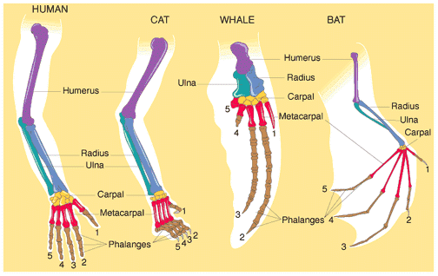
The structure above shows The forelimbs of all mammals have the same basic bone structure.
Source: https://www.quora.com/
- Analogous structures - structures similar in different organisms because, in convergent evolution, they evolved in a similar environment, rather than were inherited from a recent common ancestor. They usually serve the same or similar purposes. An example is the streamlined torpedo body shape of porpoises and sharks. So even though they evolved from different ancestors, porpoises and sharks developed analogous structures as a result of their evolution in the same aquatic environment. This is known as a homoplasy

Wings of bats and birds serve the same function. Look closely at the bones inside the wings. The differences show they developed from different ancestors.
Source: https://www.ck12.org/

Other types/concepts of comparative anatomy includes:
- Comparative Embryology
Comparative embryology is the study of the similarities and differences in the embryos of different species. Similarities in embryos are evidence of common ancestry. All vertebrate embryos, for example, have gill slits and tails. Most vertebrates, except for fish, lose their gill slits by adulthood. Some of them also lose their tail. In humans, the tail is reduced to the tail bone. Thus, similarities organisms share as embryos may be gone by adulthood. This is why it is valuable to compare organisms in the embryonic stage.

- Vestigial Structures
Structures like the human tail bone and whale pelvis are called vestigial structures. Evolution has reduced their size because the structures are no longer used. The human appendix is another example of a vestigial structure. It is a tiny remnant of a once-larger organ. In a distant ancestor, it was needed to digest food. It serves no purpose in humans today.
Vestigial structures are anatomical features that are still present in an organism (although often reduced in size) even though they no longer serve a function. When comparing anatomy of two organisms, presence of a structure in one and a related, although vestigial structure in the other is evidence that the organisms share a common evolutionary ancestor and that, in an evolutionary sense, they are relatively closely related. Whales, which evolved from land mammals, have vestigial hind leg bones in their bodies. While they no longer use these bones in their marine habitat, they do indicate that whales share an evolutionary relationship with land mammals. Humans have more than 100 vestigial structures in their bodies.

- Comparing DNA
Darwin could compare only the anatomy and embryos of living things. Today, scientists can compare their DNA. Similar DNA sequences are the strongest evidence for evolution from a common ancestor. More similarities in the DNA sequence is evidence for a closer evolutionary relationship. Look at the cladogram in the Figure below. It shows how humans and apes are related based on their DNA sequences.
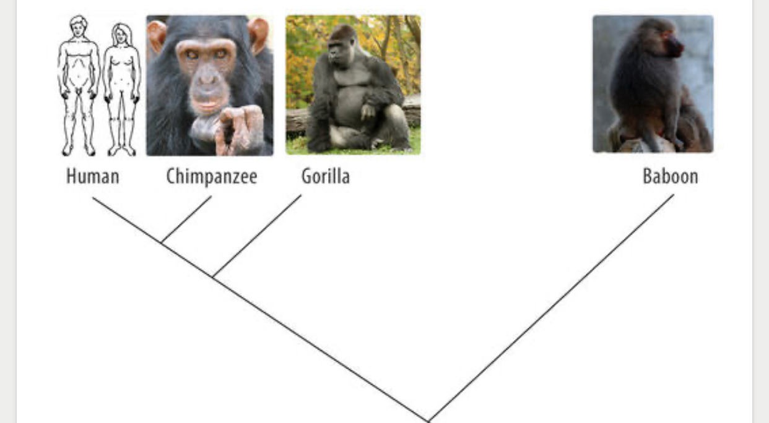
Cladogram of Humans and Apes. This cladogram is based on DNA comparisons. It shows how humans are related to apes by descent from common ancestors.
SOURCE: https://www.ck12.org/

