Name: Saliu Halima
Matric number: 17/mhs01/294
Department: Anatomy
Date: 13th May 2020.
ANA314 - Animal Handling and Comparative Mammalian Gross Anatomy Assignment
Question 1
Comment on the relevance of comparative anatomy to evolution
Answer
Comparative anatomy is an important tool that helps determine evolutionary relationships between organisms and whether or not they share common ancestors. However, it is also important evidence for evolution. Anatomical similarities between organisms support the ideas that these organisms evolved from a common ancestor.
Comparative anatomy explores and establishes the correspondences between body parts of organisms from different species. It builds the concepts of the living structures and thus should not be confused with morphology or evo-devo. Without comparative anatomy, naming and understanding what can be seen in organisms would be impossible. The neither descriptive embryology, causal embryology, phylogeny, paleontology nor systematics could be conducted and the understanding of both biology and evolution of species would be dead-end streets.
The study of comparative anatomy predates the modern study of evolution. Early evolutionary scientists like Buffon and Lamarck used comparative anatomy to determine relationships between species. Organisms with similar structures, they argued, must have acquired these traits from a common ancestor. Today, comparative anatomy can serve as the first line of reasoning in determining the relatedness of species. However, there are many hidden dangers that make it necessary to support evidence from comparative anatomy with evidence from other fields of study.
Question 2
Discuss the types of comparative anatomy with relevant examples
Answer
The two major types/concepts of comparative anatomy are:
- Homologous structures
- Analogous structures
Homologous Structures
Some organisms have anatomical structures that are very similar in embryological development and form, but may be very different in function. These structures are called Homologous Structures. Since these structures are so similar, they indicate an evolutionary relationship and a common ancestor of the species that possess them.
A clear example of homologous structures is the forelimb of mammals. When examined closely, the forelimbs of humans, whales, dogs and bats are very similar in structure. Each possess the same number of bones, arranged in almost the same way. While they have different external features and they function in different ways, the embryological development and anatomical similarities are striking.
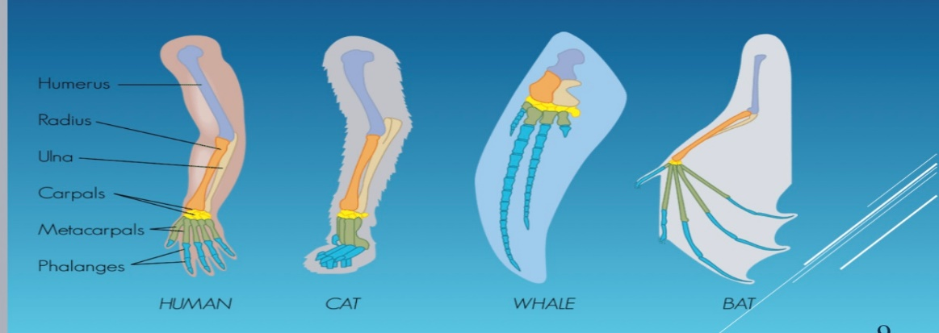
Analogous Structures
Other organisms have anatomical structures that function in very similar ways, however, morphologically and developmentally these structures are very different. These are called Analogous Structures. Since these structures are so different, even though they do not have the same function, they do not indicate an evolutionary relationship nor that two species share a common ancestor.
For example, the wings of a bird and a dragonfly both serve the same function; they help the organism to fly. However, when comparing the anatomy of these wings, they are very different showing that they evolved independently in the two groups of animals. Analogous structures are evidence that these organisms evolved along separate lines.
Asides from homologous and analogous structures which are the two main concepts of comparative anatomy we also have vestigial structures.
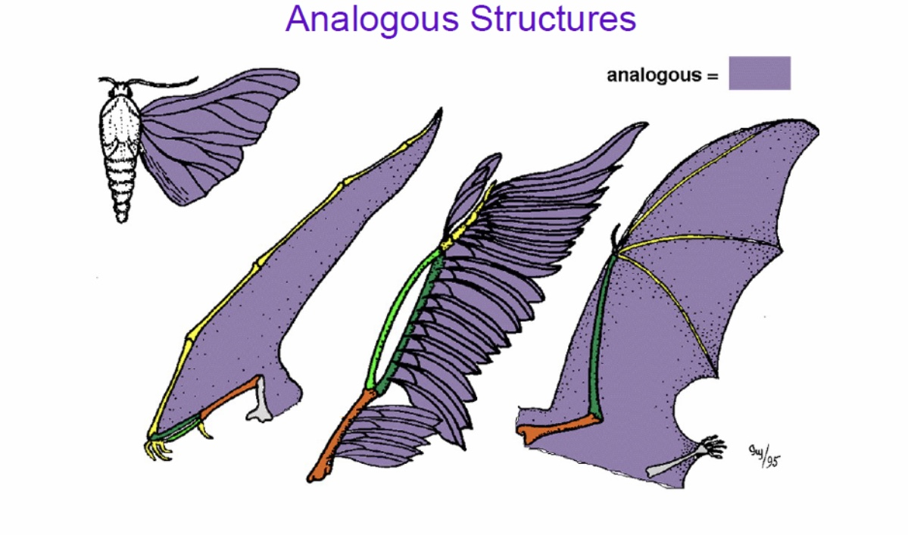
Vestigial Structures
Vestigial Structures are anatomical features that are still present in an organism (although often reduced in size) even though they no longer serve a function.
Examples of vestigial structures include;
- Whales which evolved from land animals, have vestigial hind leg bones in their bodies. While they no longer use these bones in their marine habitat, they do indicate that whales share an evolutionary relationship with land mammals.
Human have more than hundred vestigial structures in their bodies. Some of them include;
- The Human Appendix: it is a tiny remainant of a once larger organ. In a distant ancestor, it was needed to digest food, but it serves no purpose in the human body today. Any secondary function that the appendix might perform is certainly not missed in those who had it removed before it might have ruptured.
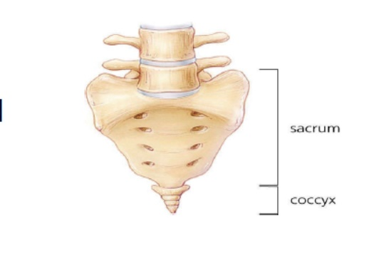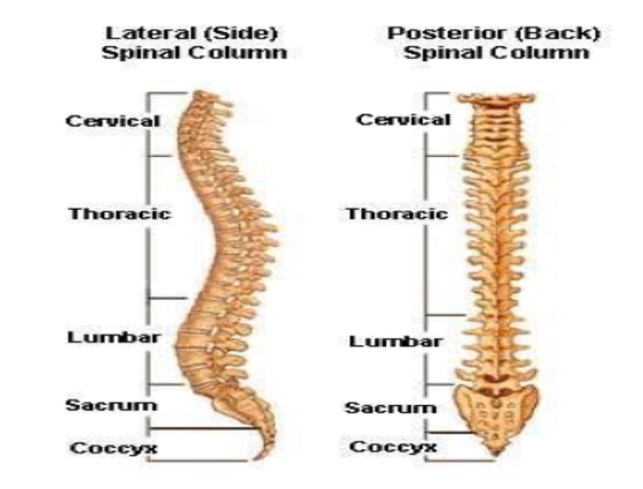

- Male Breast Tissue and Nipples: Male nipples are considered vestigial structures because while the y may perform a small role in sexual stimulation and a small number of men have been able to lactate, they are no fully functional.

- The Human Tailbone (Coccyx): These fused vertebrae are the only vestiges that are left of the tail that other mammals still use for balance, communication, and in some primates as a prehensile limb.
