KWAME-OKPU E.A OGHENEOVU
17/MHS01/174
ANATOMY
Systemic Embryology (Organogenesis) - ANA 206
Question
- Discuss the rotation of the intestine
INTRODUCTION:
During normal abdominal development, the 3 divisions of the GI tract (ie, foregut, midgut, hindgut) herniate out from the abdominal cavity, where they then undergo a 270º counterclockwise rotation around the superior mesenteric vessels. Following this rotation, the bowels return to the abdominal cavity, with fixation of the duodenojejunal loop to the left of the midline and the cecum in the right lower quadrant.
The midgut extends from the apex of the duodenal loop, which is fixed to the large liver anlage via the bile duct, to the last third of the transverse colon.Its parts are:
- Inferior part of the duodenum with the duodeno-jejunal bend
- Jejunum
- Ileum with the iliocaecal valve
- Cecum with vermiform appendix
- Ascending colon
- Transverse colon (2/3)
The midgut is supplied with blood by the superior mesenteric artery and innervated by the vagus nerve (CN X). Within the whole midgut and rectum unit there exists only one dorsal mesenterium, the ventral being readsorbed. Differentiation occurs in a cranio caudal sequence within a time window of roughly one week.

INTESTINAL ROTATION
- Normal embryologic development of the alimentary tract:
The alimentary tract develops from the embryologic foregut, midgut, and hindgut. Normal rotation takes place around the superior mesenteric artery (SMA) as the axis. It is described by referring to 2 ends of the alimentary canal, the proximal duodenojejunal loop and the distal cecocolic loop, and is usually divided into 3 stages. Both loops make a total of 270° in rotation during normal development. Both loops start in a vertical plane parallel to the SMA and end in a horizontal plane.

At day 32 , the midgut begins to extend into the umbilical coelom and forms the umbilical loop, whereby initially from the apex only a wide connection to the umbilical vesicle exists. In the further development this junction becomes constricted to become the omphalomesenteric duct. Mostly it is later obliterated, but can also partially remain as a Meckel's diverticulum. In the beginning the umbilical loop is positioned sagittally.

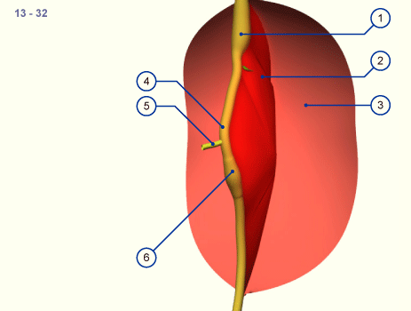

1 2 3 Stomach Mesenterium Parietal peritoneum |  | 4 5 6 Intestinal loop Omphalomesenteric duct Cecum

Only when the umbilical loop lengthens and grows into the umbilical coelom does it experience a rotation of 90 degrees in a clockwise direction as seen from the embryo. The cranial pedicle comes to lie to the right and the caudal to the left .The umbilical loop now has a horizontal position. Through the cranio-caudal growth gradient, the cranial pedicle forms first through lengthening of several loops in the umbilical coelom.
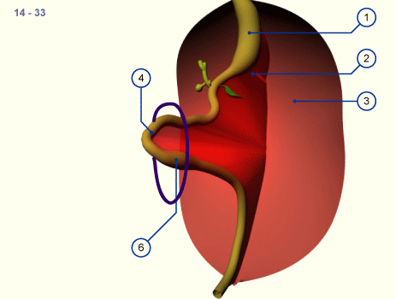
1 2 3 Stomach Mesenterium Parietal peritoneum |  | 4 6 Intestinal loop Cecum

(In the structure )above The navel opening is schematically indicated by the blue ring. The developing intestines invade the abdominal space, gliding into it.

The developing umbilical loop extends further into the umbilical coelom because there is no more room for it within the embryo's abdominal cavity. It is the time of the strongest flexion of the embryo. Very soon a thickening in the region of the caudal pedicle of the intestinal tube is also to be seen: the cecum. Visually, it becomes an important fixed point for purposes of orientation.
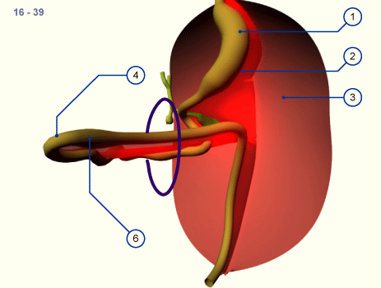
1 2 3 Stomach Mesenterium Parietal peritoneum |  | 4 6 Intestinal loop Cecum
(In the figure above) The entire intestinal loop has relocated in the umbilical coelom due to the limited space conditions in the abdominal cavity. The intestinal loop now has a horizontal orientation and the lengthening tube has formed several loops in the cranial pedicle. The caudal part is still straight.

As development proceeds the intestinal loop turns further around its own axis. In stage 18 (ca. 44 days, 18) the extension of the intestinal loop into the umbilical coelom has reached its maximum. This physiologic navel hernia remains in existence up to the 9th week of pregnancy. (Omphalocele / umbilical hernia)
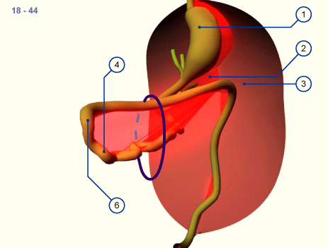
1 2 3 Stomach Mesenterium Parietal peritoneum |  | 4 6 Intestinal loop Cecum
(in the figure above) The largest part of the intestinal loop lies in the umbilical coelom and several loops have formed through the lengthening in the cranial, small intestine region.

At first, the loops of the small intestine return into the abdominal cavity and come to lie in the left half surrounded by the horizontal and descending part of the colon that never left the abdominal cavity. The rotation now amounts to more than 180 degrees and the colon is also shifted more and more into the abdominal space. The repositioning of the physiologic umbilical hernia is facilitated by the righting of the embryo's body..
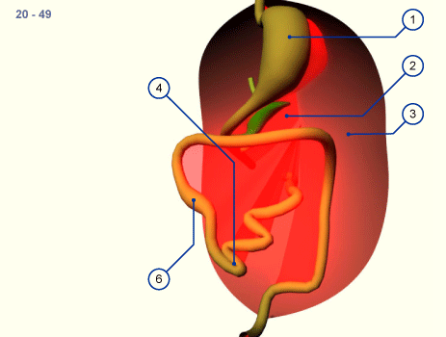
1 2 3 Stomach Mesenterium Parietal peritoneum |  | 4 6 Intestinal loop Cecum
(in the figure above) With the return of the intestines into the abdominal cavity the small intestine is moved to the left side and the cecum and the ascending part of the large intestine to the right. Initially the cecum may possibly be found in the upper right quadrant (elevated cecum).

Thus, after the reintegration of the intestinal loops into the abdominal cavity from the physiologic umbilical hernia, the derivatives of the originally caudal pedicle occupies the upper and ventral part of the abdominal cavity. At the end of the embryonic period this part migrates downwards into the iliac fossa, whereby an additional rotation occurs. The whole rotation of the intestines thus amounts to approximately 270 degrees. As a consequence, the mesenterium also turns with it and in its insertion it crosses over the inferior part of the duodenum. (Malrotation and congenital high cecum)
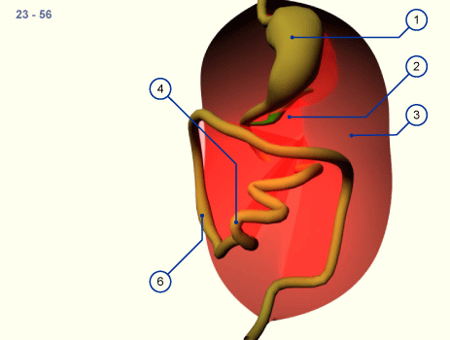
1 2 3 Stomach Mesenterium Parietal peritoneum |  | 4 6 Intestinal loop Cecum
(in the figure above) As a rule the cecum grows caudally and comes to lie in the right iliac fossa. Through rotation of the whole small intestine of more than 270 degrees the mesenterium also rotates thereby and moves off from the posterior wall over the inferior part of the duodenum to the small intestine.

SUMMARY
- Stage I occurs between 5-10 weeks' gestation. It is the period of physiologic herniation of the bowel into the base of the umbilical cord. The duodenojejunal loop begins superior to the SMA at a 90° position and rotates 180° in a counterclockwise direction. At 180°, the loop is to the anatomical right of the SMA, and by 270°, it is beneath the SMA. The cecocolic loop begins beneath the SMA at 270°. It rotates 90° in a counterclockwise manner and ends at the anatomical left of the SMA at a 0° position. Both loops maintain these positions until the bowel returns to the abdominal cavity. Also during this period, the midgut lengthens along the SMA, and, as rotation continues, a broad pedicle is formed at the base of the mesentery. This broad base protects against midgut volvulus.
- Stage II occurs at 10 weeks' gestation, the period when the bowel returns to the abdominal cavity. As it return s, the duodenojejunal loop rotates an additional 90° to end at the anatomical left of the SMA, the 0° position. The cecocolic loop turns 180° more as it reenters the abdominal cavity. This turn places it to the anatomical right of the SMA, a 180° position.
- Stage III lasts from 11 weeks' gestation until term. It involves the descent of the cecum to the right lower quadrant and fixation of the mesenteries.

COMPLICATIONS THAT OCCUR DURING ROTATION OF THE STOMACH
Nonrotation:
- Arrest in development at stage I results in nonrotation. Subsequently, the duodenojejunal junction does not lie inferior and to the left of the SMA, and the cecum does not lie in the right lower quadrant. The mesentery in turn forms a narrow base as the gut lengthens on the SMA without rotation, and this narrow base is prone to clockwise twisting leading to midgut volvulus. The width of the base of the mesentery is different in each patient, and not every patient with nonrotation develops midgut volvulus.
Incomplete rotation:
- Stage II arrest results in incomplete rotation and is most likely to result in duodenal obstruction. Typically, peritoneal bands running from the misplaced cecum to the mesentery compress the third portion of the duodenum. Depending on how much rotation was completed prior to arrest, the mesenteric base may be narrow and, again, midgut volvulus can occur. Internal herniations may also occur with incomplete rotation if the duodenojejunal loop does not rotate but the cecocolic loop does rotate. This may trap most of the small bowel in the mesentery of the large bowel, creating a right mesocolic (paraduodenal) hernia.
Incomplete fixation:
- Potential hernia pouches form when the mesentery of the right and left colon and the duodenum do not become fixed to the retroperitoneum. If the descending mesocolon between the inferior mesenteric vein and the posterior parietal attachment remains unfixed, the small intestine may push out through the unsupported area as it migrates to the left upper quadrant. This creates a left mesocolic hernia with possible entrapment and strangulation of the bowel. If the cecum remains unfixed, volvulus of the terminal ileum, cecum, and proximal ascending colon may occur.

