ABSTRACT

The permanent-magnet synchronous machine (PMSM) drive is one of best choices for a full range of motion control applications. For example, the PMSM is widely used in robotics, machine tools, actuators, and it is being considered in high- power applications such as industrial drives and vehicular propulsion. It is also used for residential/commercial applications. The PMSM is known for having low torque ripple, superior dynamic performance, high efficiency and high power density.

Introduction

The electrical motors are electromechanical machines used to convert electrical energy into mechanical power. Asynchronous and synchronous engines are the main types of AC motors. The asynchronous motors are called single excited machines, i.e. the stator windings are connected to the AC supply whereas the rotor does not have any connection from the stator or any other supply source. The power is transferred only by mutual induction from the stator to the rotor, owing to which the asynchronous motors are called as induction machines. The synchronous motors require the stator windings with AC supply, and the rotor windings with DC supply. The speed of the motor is determined by the frequency of supply of the AC and the number of poles of the synchronous motor, the rotor rotates at the rate of the stator rotating field at constant speed. Mechanical load variations within the rating of the system do not affect the synchronous speed of the motor. Another of the synchronous motor types is that of PMSM. The PMSM is composed of traditional three-phase windings in the stator and permanent rotor magnets. The field windings in the modern synchronous system are performed in PMSM with permanent magnets. The traditional synchronous machine needs supply of AC and DC, while the PMSM needs only supply of AC for its operation. One of PMSM's biggest advantages over its counterpart is the absence of dc supply for field excitation. Thanks to the discovery of new mag-netic materials and rare earth materials, the development of PMSM has happened. PMSM provides various advantages in the design of modern motion control systems. Energy-efficient PMSM is designed because of the availability of high magnetic flux density permanent magnet materials. The rotor rotates in synchronous motors at stator revolving field speed. The velocity of the field of rotating stator is called synchronous speed. The number of stator pole pairs (p) and the number of stator pole pairs can be determined by the frequency of the stator input supply (fs). The stator of a synchronous three-phase motor consists of distributed three-phase sine winding, while the rotor consists of the same number of p-pole pairs as stator, excited by permanent magnets or a separate DC supply source. When the synchronous machine is excited with a three phase AC supply, a magnetic field rotates at synchronous speed develops in the stator. The synchronous speed of this rotating magnetic field is shown by the Equation below

N 1⁄4 􏰀120 f s􏰂=P rpm (1)

where N, synchronous speed, fs, frequency of AC supply in Hz; P, number of

poles; p, pole pairs and it is given by (P/2).

Types of PMSM

The PMSM are classified based on the direction of field flux are as follows,

1.Radial field  
2.Axial field

In radial field, the flux direction is along the radius of the machine. The radial field permanent magnet motors are the most commonly used. In axial field, the flux direction is parallel to the rotor shaft. The axial field permanent magnet motors are presently used in a variety of numerous applications because of their higher power density and quick acceleration.

The permanent magnets can be placed in many different ways on the rotor of PMSM as discussed in diagrams below show the permanent magnets mounted on the surface of the outer periphery of rotor laminations. This type of arrangement provides the highest air gap flux density, but it has the drawback of lower structural integrity and mechanical robustness. Machines with this arrange- ment of magnets are known as Surface mount PMSMs.

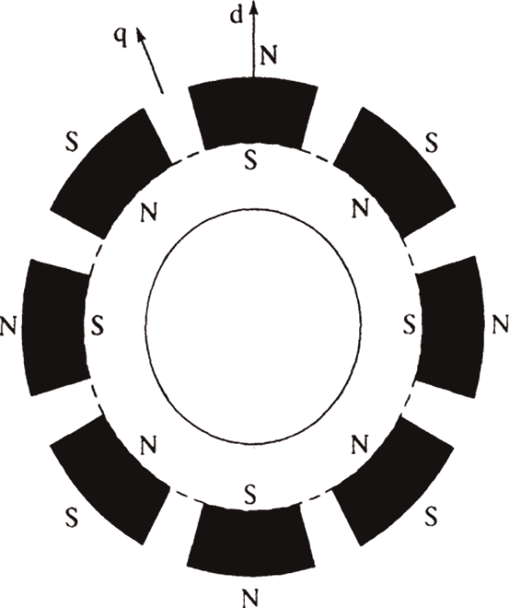

*Surface permanent magnet.*

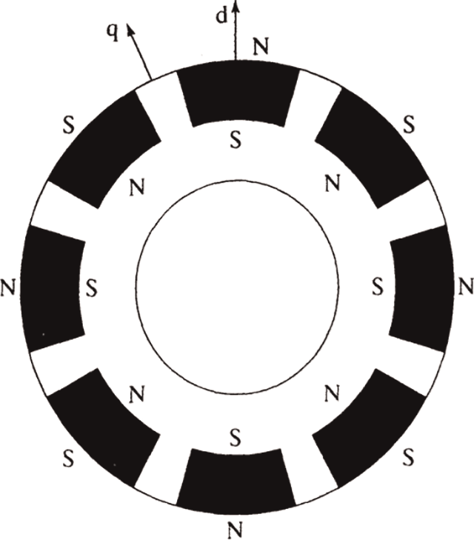

*Surface inset permanent magnet.*

rotor arrangements by easier construction and mechanical robustness, with a high ratio between the quadrature and direct-axis inductances, respectively.

The surface PMSM with radial flux are generally applied for applications which require low speed operations. These machines have the advantage of high power density than the other types of PMSM. The interior PMSM are used for applications which require high speed.

The principle of operation is identical for all the types of PMSM, in spite of the types of mounting the permanent magnets in the rotor.

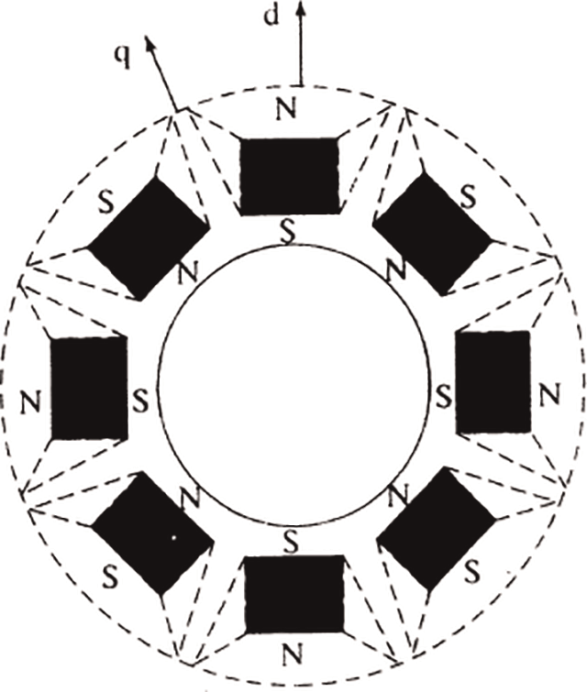

*Interior permanent magnet.*

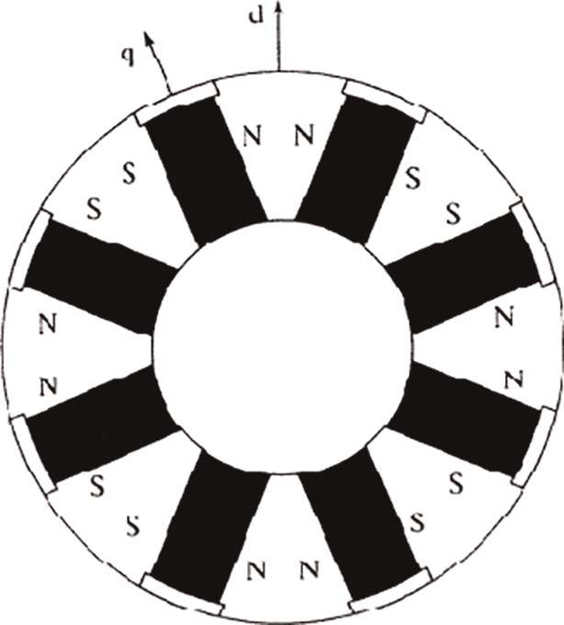

*Interior permanent magnet with circumferential orientation.*

The important significance of the type of mounting on the rotor of the permanent magnets is the variation of the inductance values in direct axes and quadrature axes, which is explained below. The flux 'principal path through the permanent magnet rotor is the direct axis. The stator inductance is called direct axis inductance, when measured in the position of permanent magnets aligned with stator winding. The inductance of the quadrature axis is measured by rotating the magnets from the already aligned position (direct axis) by 90 °, in that position the stator flux is seen by the iron (inter polar area of the rotor). The permanent magnet materials are currently high in flux density

Modeling of PMSM

A complete modeling of the drive mechanism is necessary for proper simulation and analysis of the device. The motor axis was developed using the theory of d-q rotor refer- ence frame, as shown in Figure below. The rotor reference axis makes an angle αr with the fixed stator axis at any particular time t and the rotating stator mmf with the rotor d axis creates an angle α. It is shown that the stator mmf rotates at the same speed as the rotor axis at any given time t.

The required assumptions are obtained for the modelling of the PMSM without damper windings.

1.Saturation is neglected.  
2.Induced EMF is sinusoidal in nature.  
3.Hysteresis losses and Eddy current losses are negligible.

4.No field current dynamics.

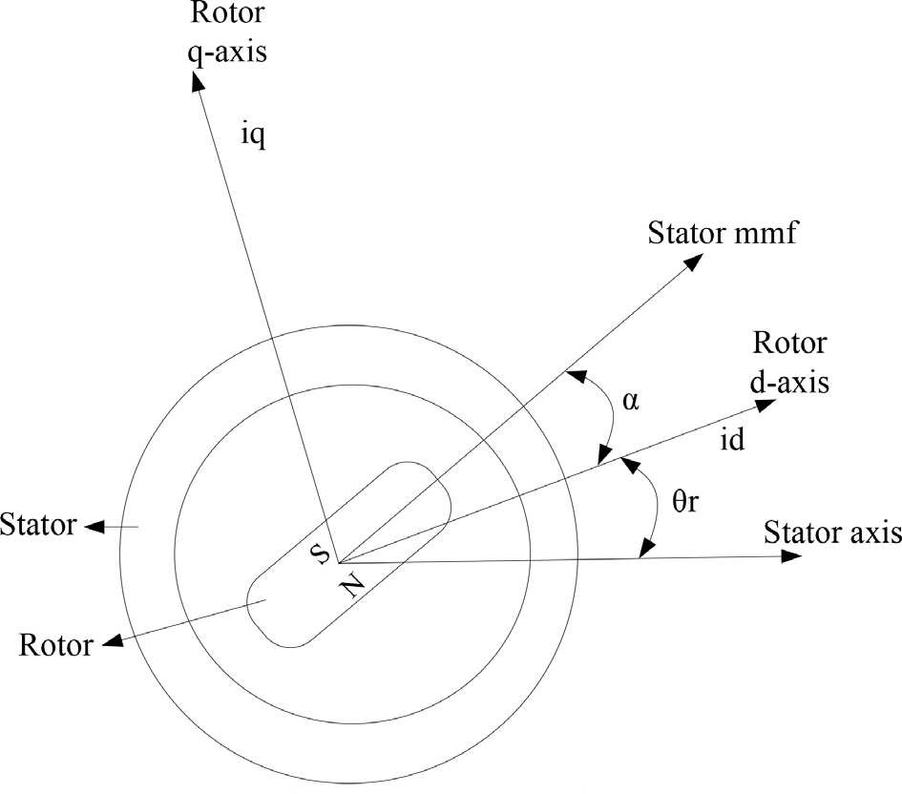

Motor axis diagram

Applied Electromechanical Devices and Machines for Electric Mobility Solutions

Voltage equations from the model are given by,

Vq ¼ Rsiq þ ωrλd þ ρλq (3)

Vd ¼ Rsid — ωrλq þ ρλd (4)

Flux linkages are given by,

λq ¼ Lqiq (5)

λq ¼ Lqiq þ λf (6)

Substituting Eq. (5) and Eq. (6) into Eq. (3) and Eq. (4)

Vq ¼ Rsiq þ ωrðLdid þ λf Þ þ ρLdid (7)

Vd ¼ Rsid — ωrLqiq þ ρðLdid þ λf Þ (8)

Arranging Eq. (7) and Eq. (8) in matrix form,

  
The developed torque motor is being given by,

. Σ

T ¼ 3

e 2

P . Σ

2 λdiq — λqid

(10)

The mechanical torque equation is,

Te ¼ TL

þ Bωm

þ J dωm

dt

(11)

Solving for the rotor mechanical speed form Eq. (11)

ð. Σ

ωm ¼

Te — TL — Bωm

J

dt (12)

and

. Σ

2

ωm ¼ ωr P

(13)

In the above equations ωr is the rotor electrical speed, ωm is the rotor mechanical speed.

**Parks transformation and dynamic d-q modeling**

The dynamic d-q modelling of the system is used for the study of motor during transient state and as well as in the steady state conditions. It is achieved by converting the three phase voltages and currents to dqo axis variables by using the Parks transformation .

Converting the phase voltages variables Vabc to Vdqo variables in rotor reference frame axis are illustrated in the equations,

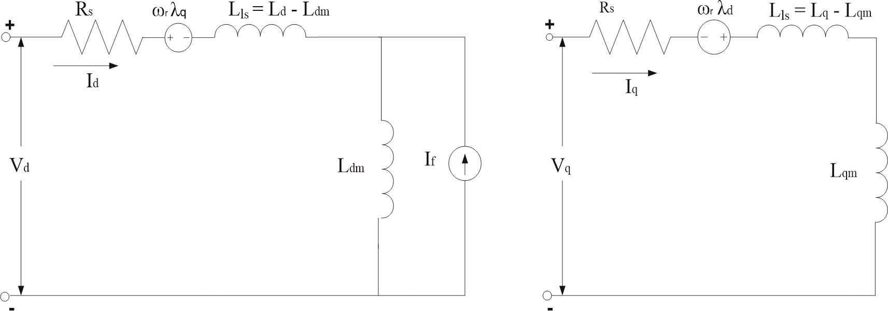

*Equivalent circuit of PMSM without damper windings.*

**Equivalent circuit of PMSM**

Equivalent circuit is essential for the proper simulation and designing of the motor. It is achieved and derived from the d-q modelling of the motor using the voltage equations of the stator. From the assumption, rotor d axis flux is represented by a constant current source which is described through the following equation,

λf ¼ Ldm if (16)

where λf, field flux linkage; Ldm, d-axis magnetizing inductance; if, equivalent permanent magnet field current.

# **Permanent magnet synchronous motor drive system**

The motor drive essentially consists of four main components such as the PMSM, the inverter, the main control unit and the position sensor.

**Inverter**

For variable frequency and magnitude, voltage source inverters are devices which convert the constant DC voltage level to variable AC voltage. As specified in the function, these inverters are commonly used in adjustable speed drives.

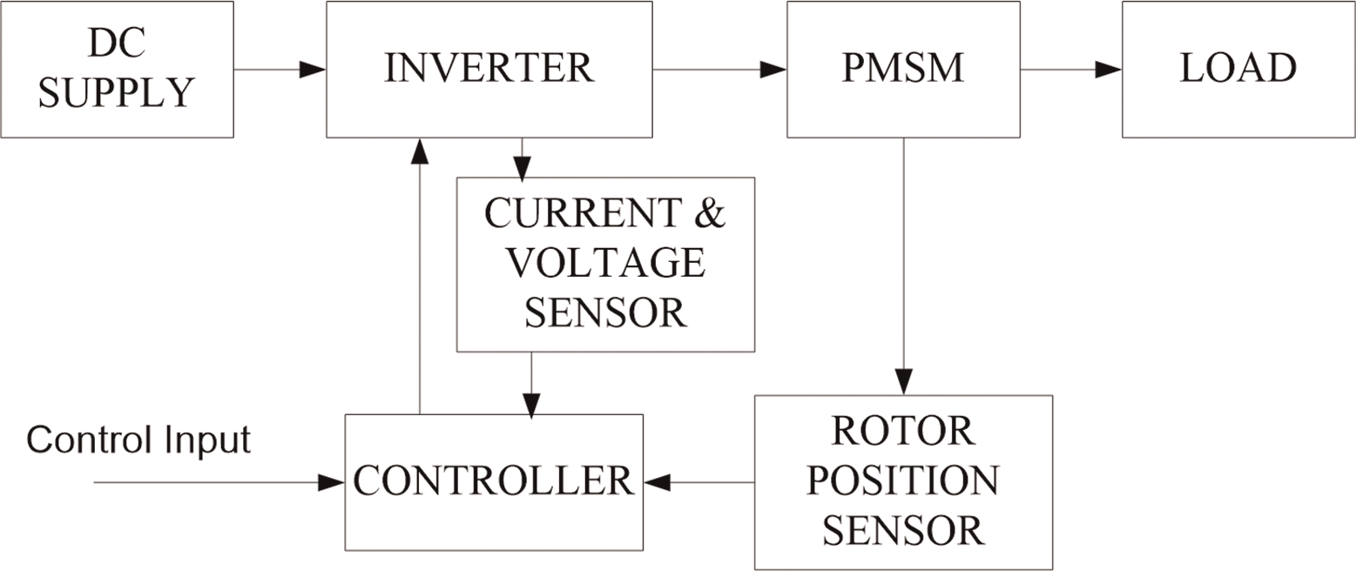

*Components permanent magnet synchronous motor drive.*

# Control techniques of PMSM

# Many techniques based on both motor designs and control techniques that have been proposed in literature to diminish the torque ripples in the PMSM

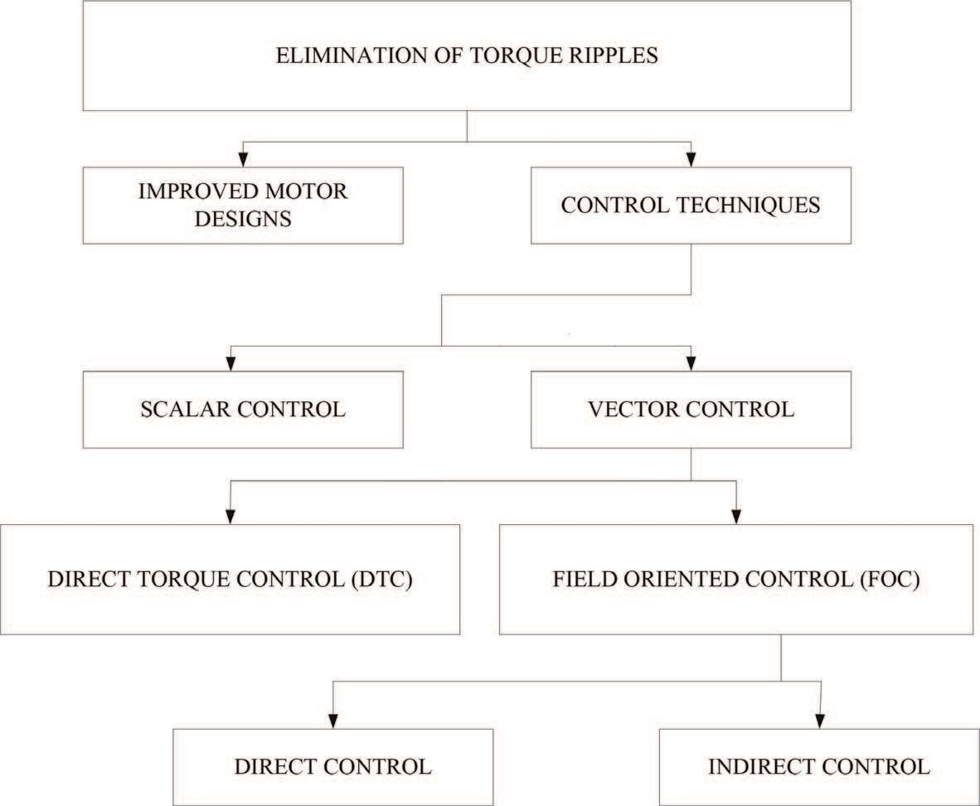

*Classification of the various control techniques.*

**Field oriented control (FOC) of PMSM**

For the control of PM motors, FOC technique is used for synchronous motor to

evaluate as a DC motor. The stator windings of the motor are fed by an inverter that generates a variable frequency variable voltage scheme. Instead of controlling the inverter frequency independently, the frequency and phase of the output wave are controlled using a position sensor.

FOC was invented in the beginning of 1970s and it demonstrates that an induction motor or synchronous motor could be controlled like a separately excited DC motor by the orientation of the stator mmf or current vector in relation to the rotor flux to achieve a desired objective. For the motor to behave like a DC motor, the control needs knowledge of the position of the instantaneous rotor flux or rotor position of permanent magnet motor. This needs a resolver or an absolute optical encoder.

One of the major disadvantages of the PMSM drive is the torque ripple produced which can be attributed to the following sources:

* + - 1. mutual torque, due to the interaction of the rotor field and stator currents;
      2. reluctance torque, due to rotor saliency;
      3. cogging torque, due to the existence of stator slots.