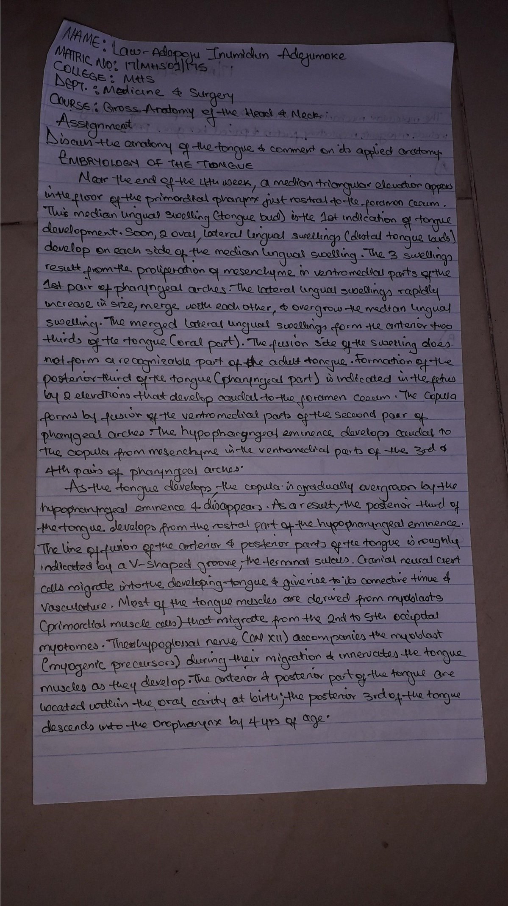
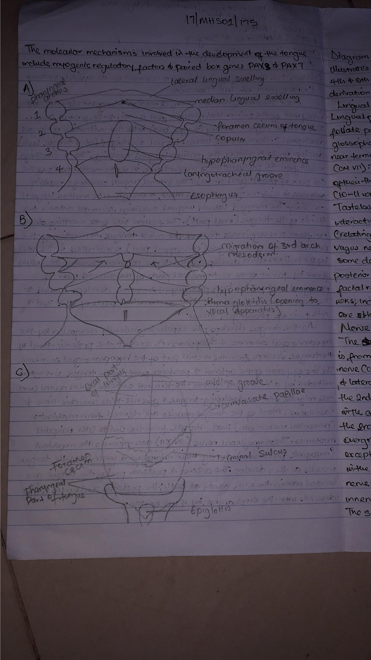
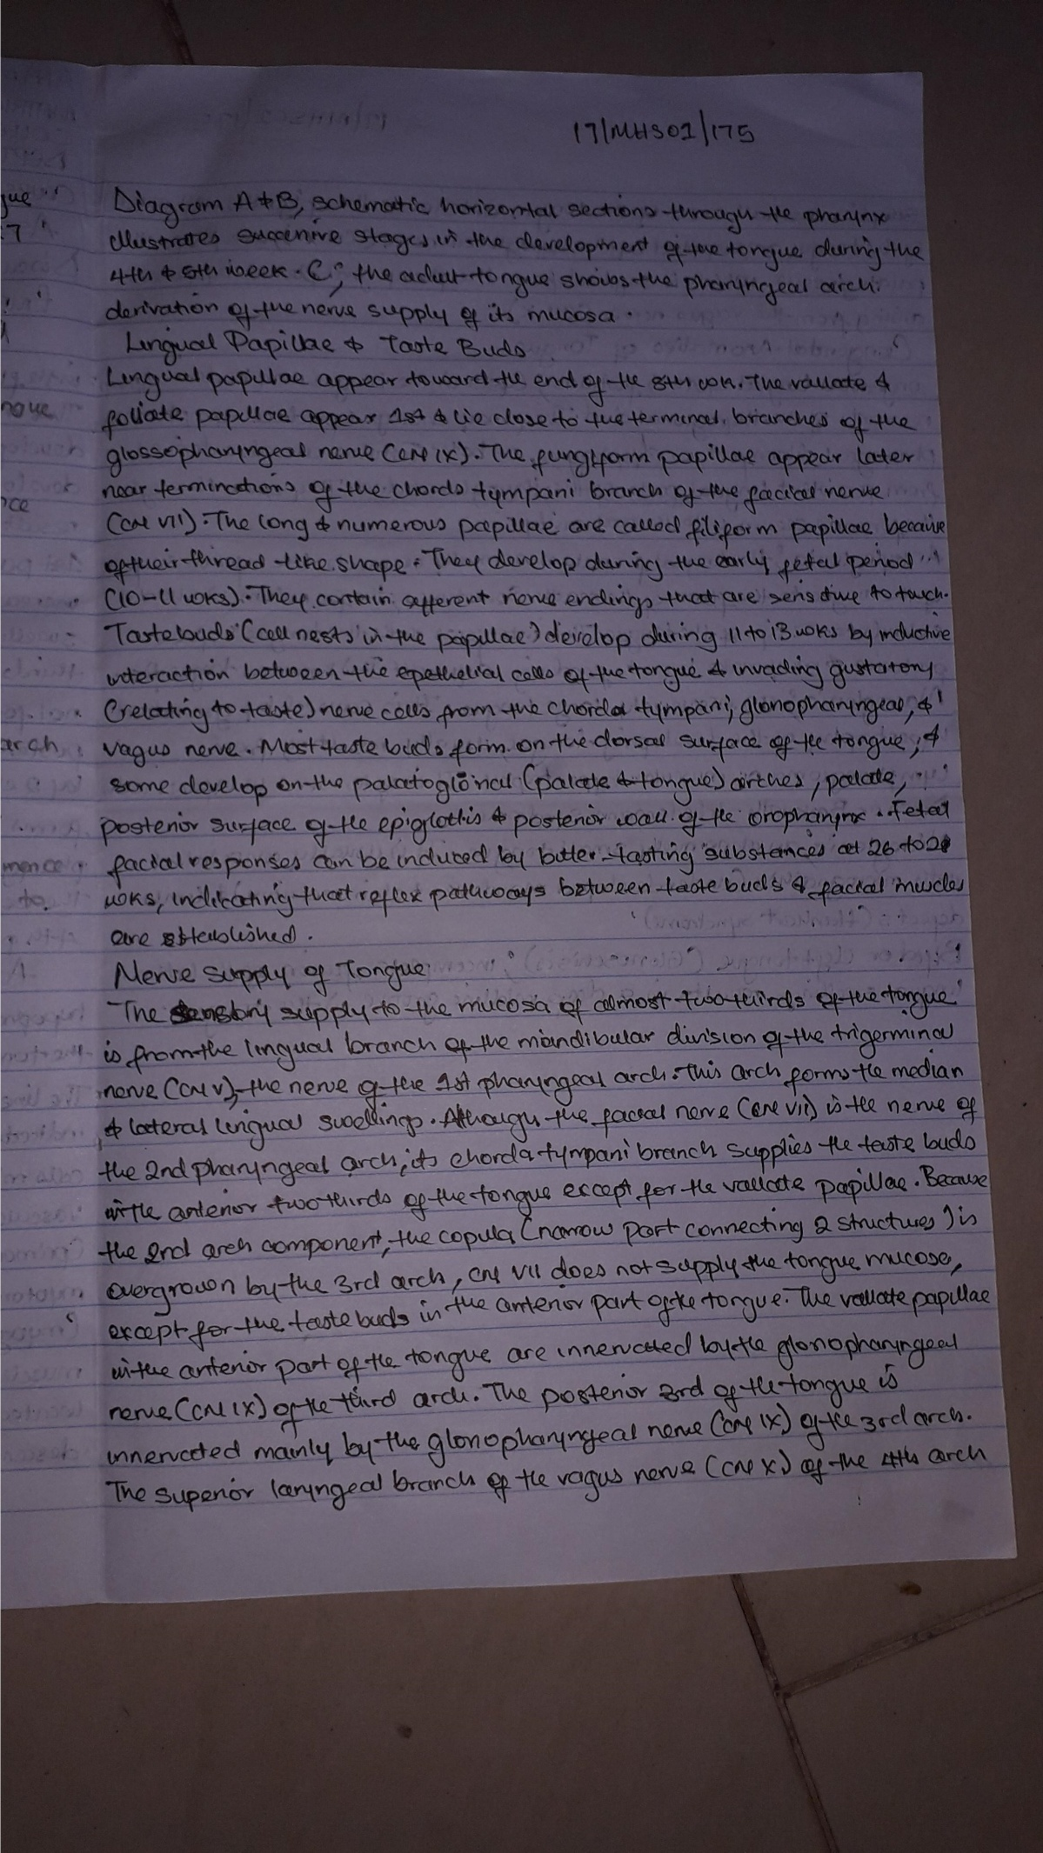
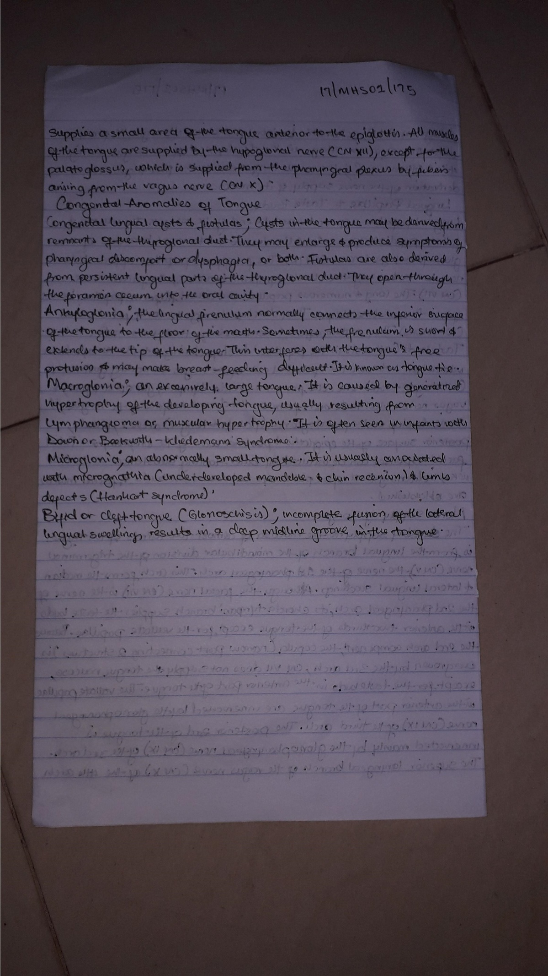
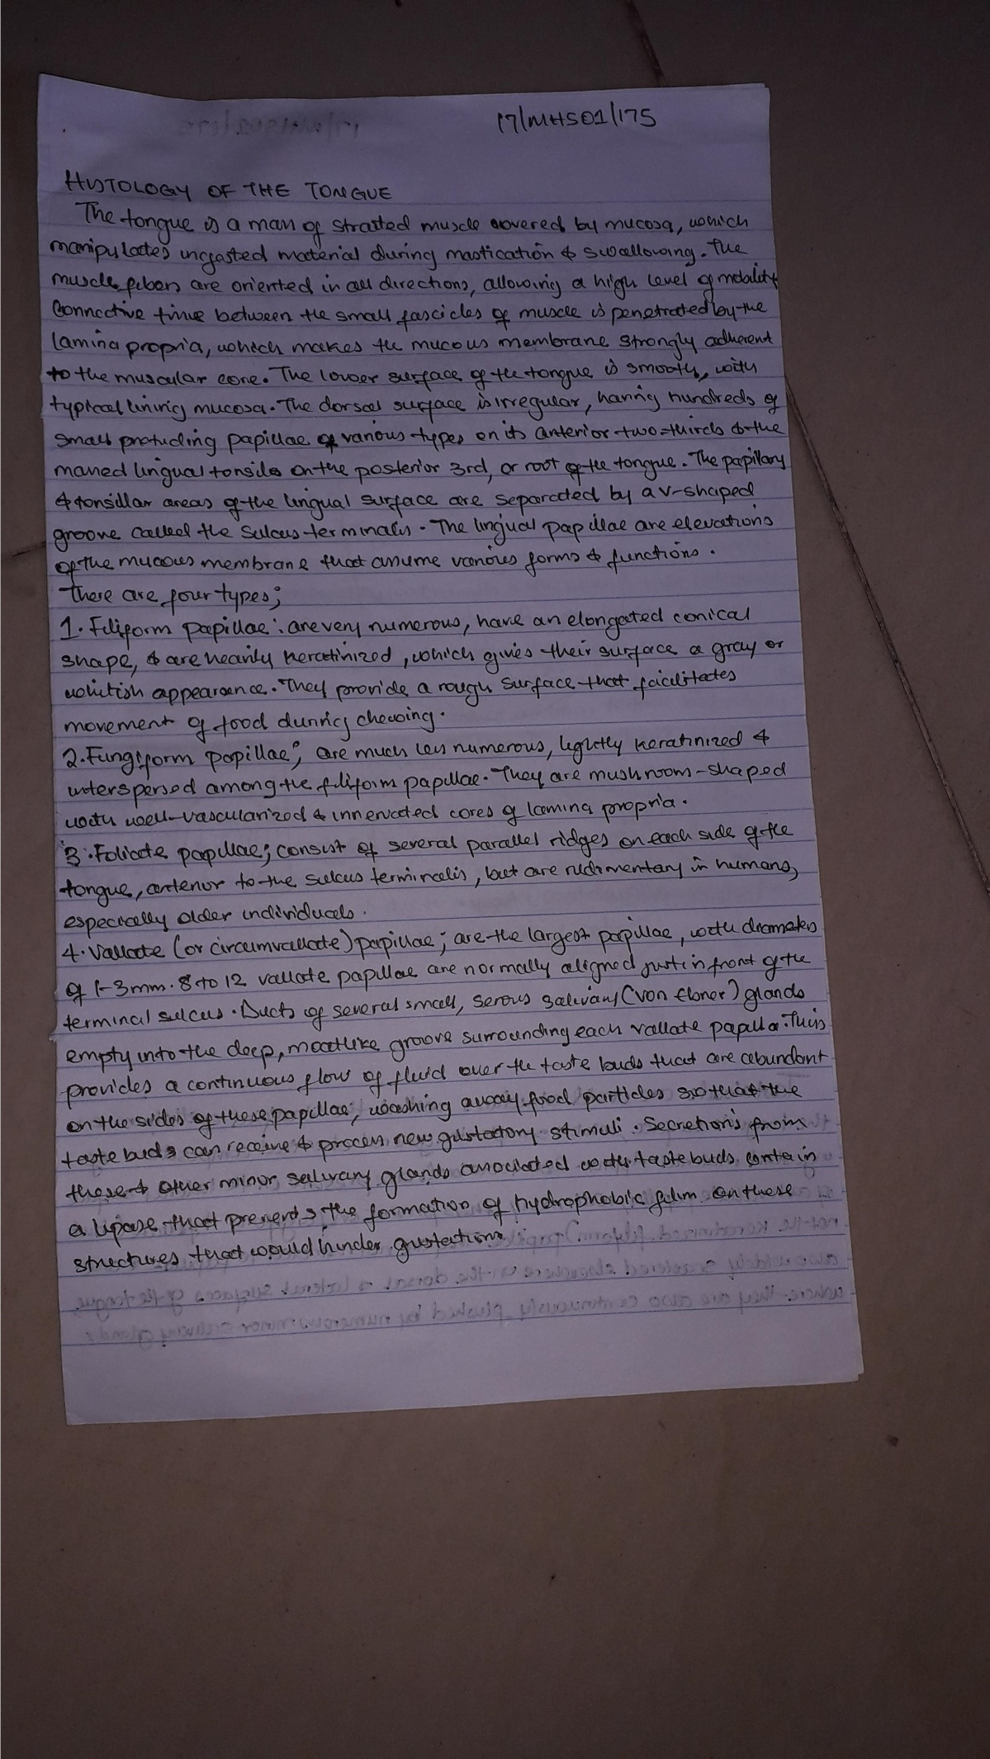
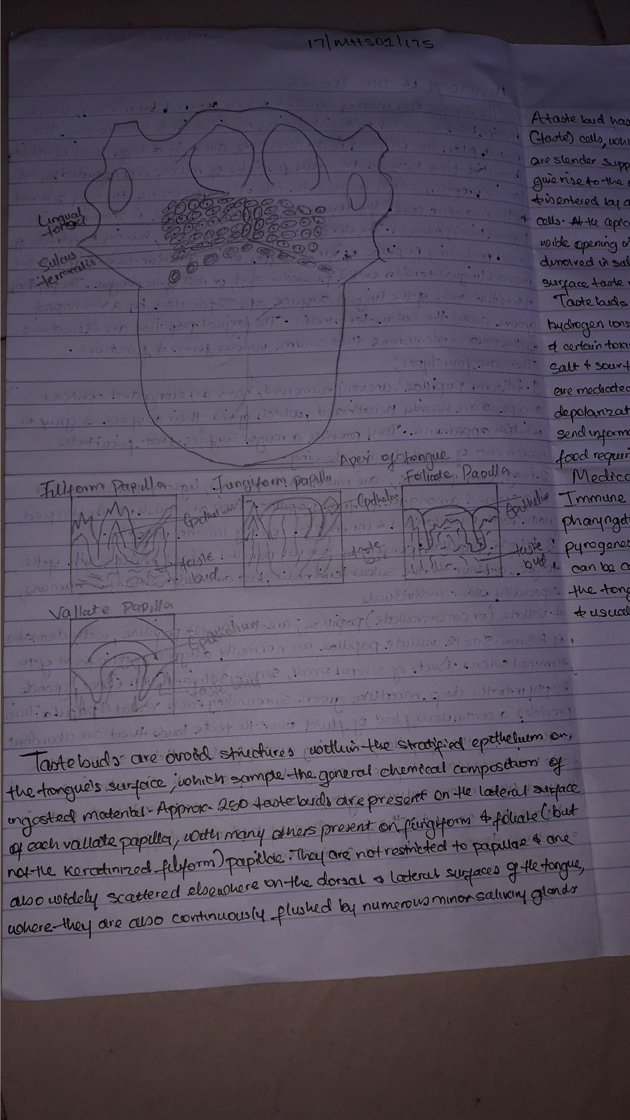
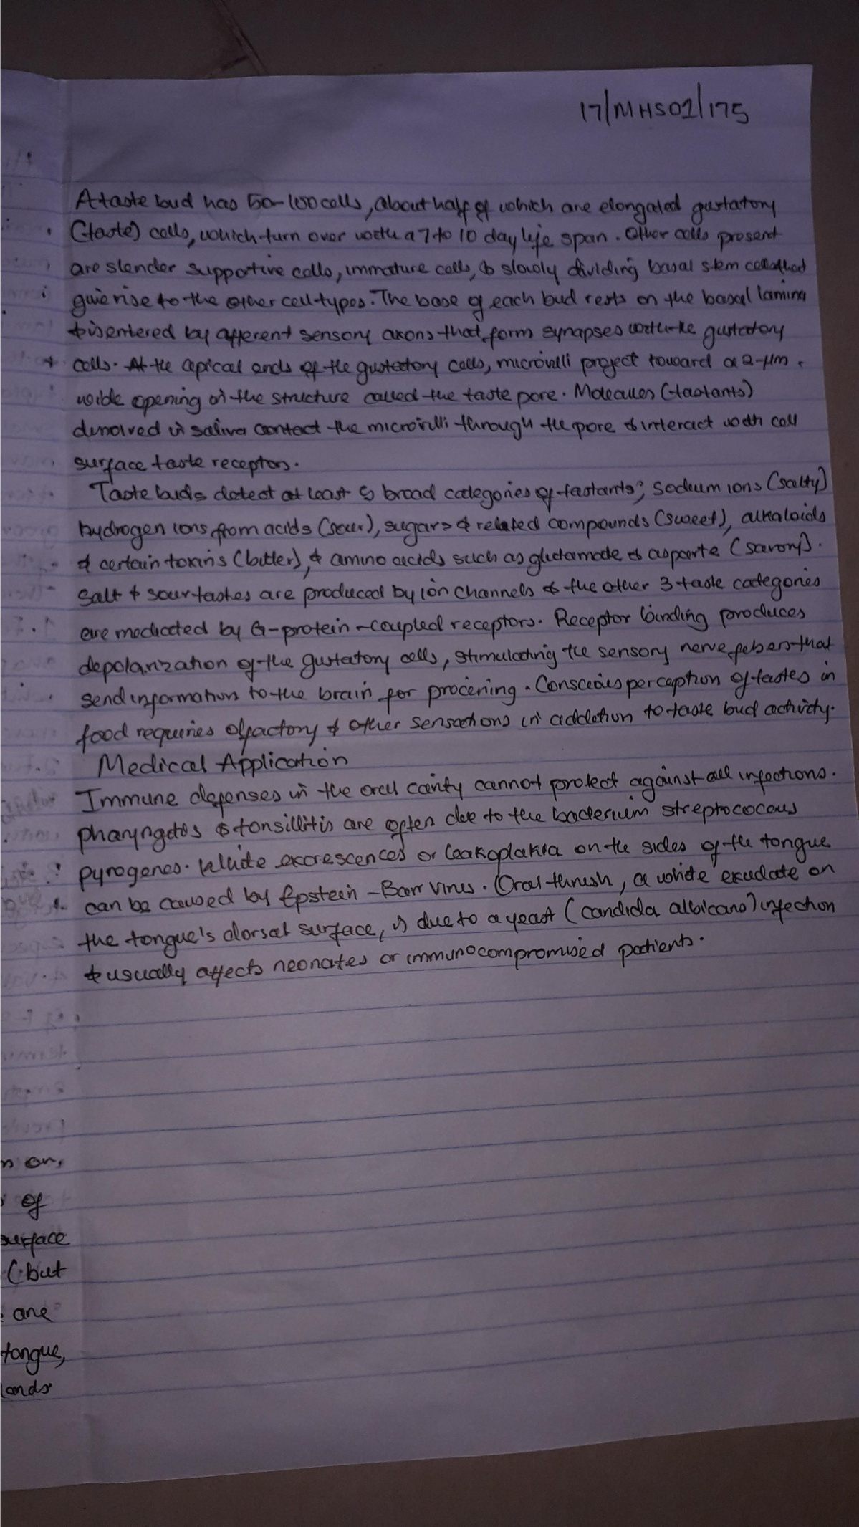

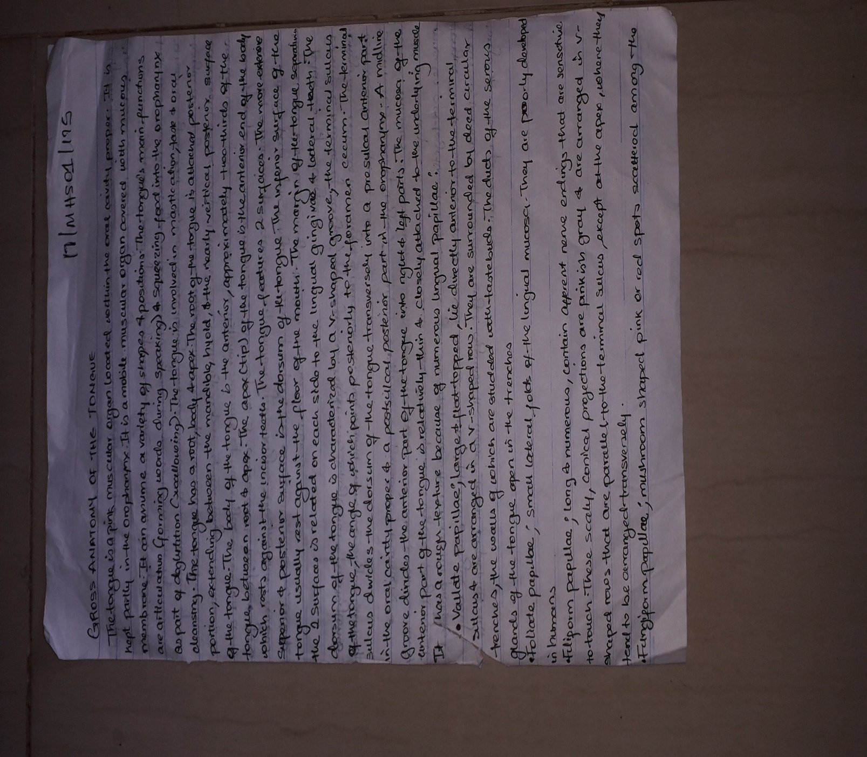
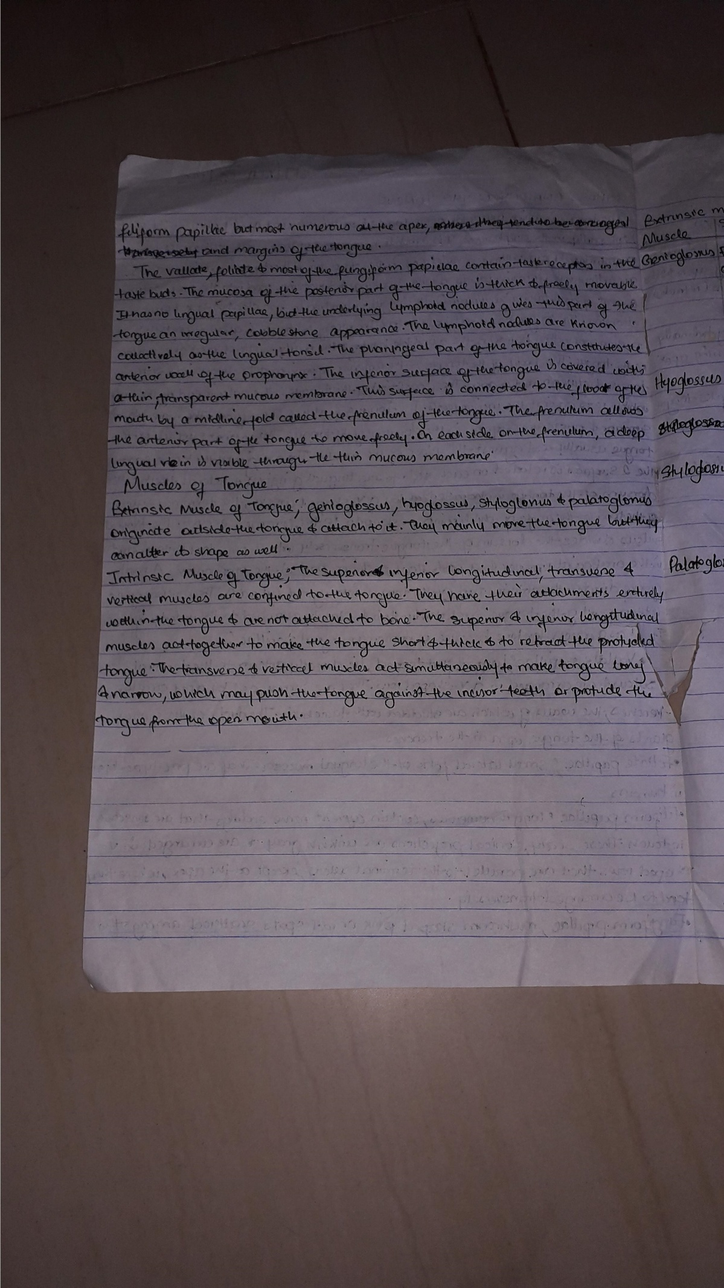
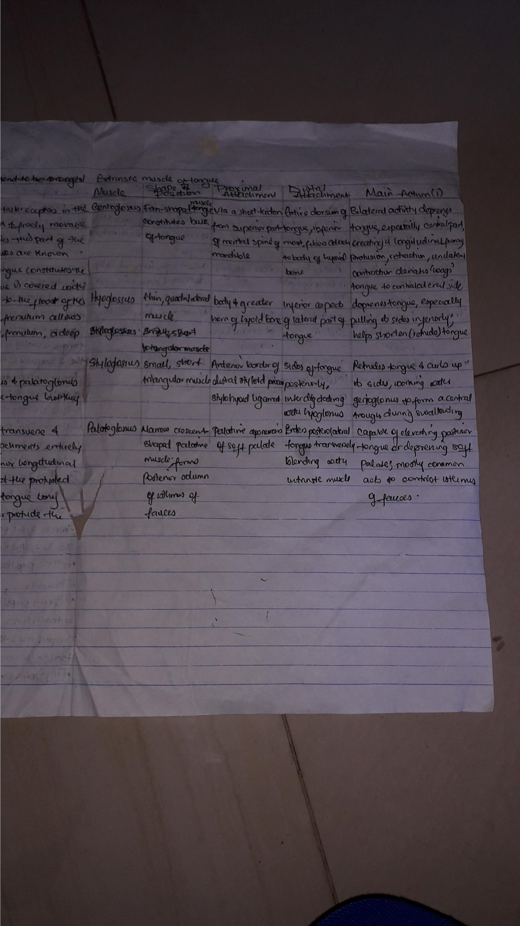

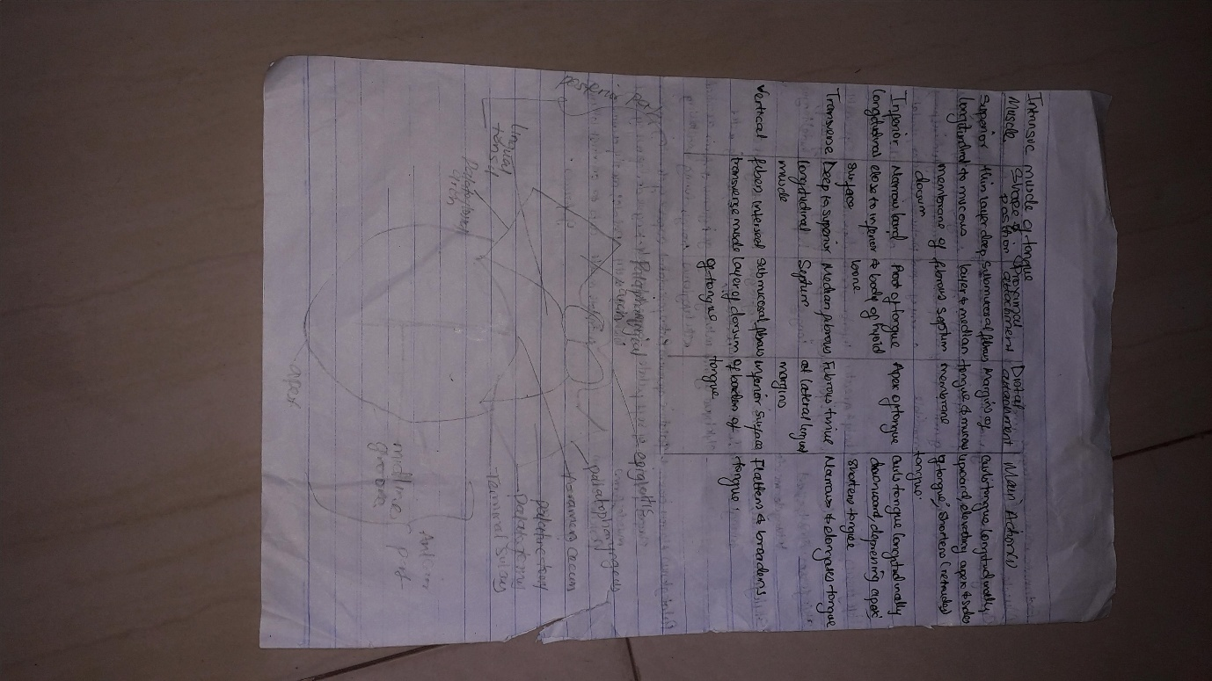
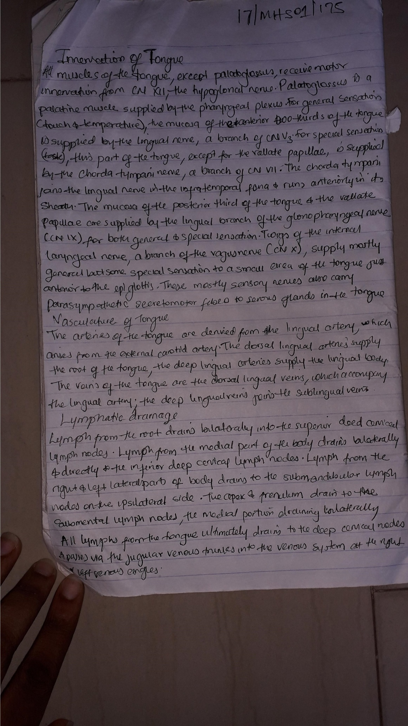
2. Air sinuses
The paranasal sinuses are air cavities that help circulate the air that is breathed in and out of the respiratory system. They are situated around the nasal cavity and they are all paired and sometimes symmetrical, while always being bilateral. There are four different pairs of sinuses and they are called the:
- maxillary sinuses
- frontal sinuses
- sphenoidal sinuses
- ethmoidal sinuses

Maxillary sinuses
The maxillary sinuses are the largest of the all the paranasal sinuses. They have thin walls which are often penetrated by the long roots of the posterior maxillary teeth. The superior border of this sinus is the bony orbit, the inferior is the maxillary alveolar bone and corresponding tooth roots, the medial border is made up of the nasal cavity and the lateral and anterior border are limited by the cheekbones.
Posteriorly, two anatomical spaces known as the pterygopalatine fossa and the infratemporal fossa exist.
The submandibular lymph nodes are the main destination during lymphatic drainage. The blood supply includes a contribution from the:
- anterior superior alveolar artery
- middle superior artery
- posterior superior alveolar artery
Innervation occurs through nerves of the same names as the arteries.

Frontal sinuses
Anteriorly, the frontal sinuses are contained by the forehead and the superciliary arches, superiorly and posteriorly by the anterior cranial fossa and inferiorly by the bony orbit, the anterior ethmoidal sinuses and the nasal cavity. Medially the sinuses face one another, separated by the midline.
This pair of sinuses are irregular in shape when compared to one another and is underdeveloped at birth. They reach their full size and shape around seven to eight years of age.
They drain primarily into the ethmoidal infundibulum and the corresponding lymph drainage occurs via the submandibular lymph nodes. It is innervated by the ophthalmic nerve, including the supraorbital and supratrochlear branches.
The frontal sinuses are supplied by the:
- anterior ethmoidal artery
- Supraorbital artery
- supratrochlear artery
Spheniodal sinuses
- The most posterior of all the sinuses in the head, the sphenoidal sinuses are large and irregular, just like their septum, which is made by the sphenoid bone. Laterally, a cavernous sinus exists which is part of the middle cranial fossa and also the carotid artery and cranial nerves III, IV, V/I,V/II and VI can be found.
- The anterior wall separates this pair of sinuses from the nasal cavity, as does the hypophyseal fossa, the pituitary gland and the optic chiasm superiorly and the nasopharynx and pterygoid canal inferiorly.
The lymphatic drainage occurs in the same way as the posterior ethmoid sinus. The posterior ethmoidal artery and the posterior lateral nasal branches supply the sphenoidal sinuses. The posterior ethmoidal nerve and the orbital branch of the pterygopalatine ganglion innervate them.
Ethmoidal sinuses
Superior to the ethmoidal sinus is the anterior cranial fossa and the frontal bone, laterally the orbit can be found, while the nasal cavity is situated medially. The ethmoid sinuses are unique because they are the only paranasal sinuses that are more complex than just a single cavity.
On each side of the midline, anywhere from three to eighteen ethmoidal air cells may be grouped together. These air cells are smaller individual sinuses grouped together to form one large one which encompass the anterior, middle and posterior nasal meatuses.
The anterior and middle ethmoid sinuses send their lymphatic drainage to the submandibular lymph nodes while the posterior ethmoid sinus sends its own to the retropharyngeal lymph nodes.
The anterior and posterior ethmoidal arteries, as well as the posterior lateral nasal branches provide an ample blood supply to this region. Meanwhile the anterior and posterior ethmoidal nerves and the posterior lateral superior and inferior nasal nerves help innervate it.
Paranasal sinuses form developmentally through excavation of bone by air-filled sacs (pneumatic diverticula) from the nasal cavity. This process begins prenatally (intrauterine life), and it continues through the course of an organism's lifetime.
The results of experimental studies suggest that the natural ventilation rate of a sinus with a single sinus ostium (opening) is extremely slow. Such limited ventilation may be protective for the sinus, as it would help prevent drying of its mucosal surface and maintain a near-sterile environment with high carbondioxide concentrations and minimal pathogen access. Thus composition of gas content in the maxillary sinus is similar to venous blood, with high carbon dioxide and lower oxygen levels compared to breathing air.
At birth only the maxillary sinus and the ethmoid sinus are developed but not yet pneumatized; only by the age of seven they are fully aerated. The sphenoid sinus appears at the age of three, and the frontal sinuses first appear at the age of six, and fully develop during adulthood.

Clinical significance

Inflammation
The paranasal sinuses are joined to the nasal cavity via small orifices called ostia. These become blocked easily by allergic inflammation, or by swelling in the nasal lining that occurs with a cold. If this happens, normal drainage of mucus within the sinuses is disrupted, and sinusitis may occur. Because the maxillary posterior teeth are close to the maxillary sinus, this can also cause clinical problems if any disease processes are present, such as an infection in any of these teeth. These clinical problems can include secondary sinusitis, the inflammation of the sinuses from another source such as an infection of the adjacent teeth.
These conditions may be treated with drugs such as decongestant, which cause vasoconstriction in the sinuses; reducing inflammation; by traditional techniques of nasal irrigation; or by corticoseriod.

Cancer
Malignancies of the paranasal sinuses comprise approximately 0.2% of all malignancies. About 80% of these malignancies arise in the maxillary sinus. Men are much more often affected than women. They most often occur in the age group between 40 and 70 years. Carcinomas are more frequent than sarcomas. Metastases are rare. Tumors of the sphenoid and frontal sinuses are extremely rare.

