NAME: YAKUBU ZAINAB IZEE COURSE: CHEM 102
DEPARTMENT: PHARMACY MATRIC NO: 19/MHS11/149.

- CLASSIFICATION OF ALCOHOLS
Alcohols can be classified based on the following;
- Based on the number of hydrogen atom attached to the carbon atom containing the hydroxyl group. We have;
- PRIMARY ALCOHOL: this is an alcohol in which the number of hydrogen atom attached to the carbon carrying the –OH group are three or two. Examples are; CH₃OH (Methanol)
- SECONDARY ALCOHOL: This are alcohol which the number of hydrogen atom attached to the carbon atom carrying the –OH group is one. Examples are; CH₃CH(OH)CH₃ – Prapan-2-ol
- TERTIARY ALCOHOL: These are alcohols with no hydrogen atom attached to the carbon atom carrying the –OH group. Examples are;
(CH₃)₃C-OH 2-Methylpropan-2-ol

Ii Based on the number on hydroxyl group they possess;
- MONOHYDRIC ALCOHOL: this are alcohols that have one hydroxyl group present in the alcohol structure. E.g CH₃CH₂CH₂OH Propanol
- DIHYDRIC ALCOHOL: this are alcohols containing two hydroxyl group presents in their alcohol structure. E.g. OHCH₂CH₂OH Ethane -1,2 diol
C. TRIHYDRIC ALCOHOL: These are alcohol with three hydroxyl group present in their alcohol structure. E.g OHCH₂CH (OH) CH (OH) CH₃ Butan-1, 2, 3-triol
d. POLYHYDRIC ALCOHOL: These are alcohol with more than three hydroxyl group present in the structure. E.g. CH₃CH(OH)CH(OH)CH(OH)CH(OH)CH(OH)CH₃ Heptane-2,3,4,5,6-pentaol.

- Solubility of alcohols:
IN WATER; Alcohol is soluble in water due to the hydroxyl group present in the alcohol which is able to form hydrogen bonds with water molecules. Alcohols with a smaller hydrocarbon chain are very soluble. As the length of the hydrocarbon chain increases, the solubility in water decreases. With four carbon in the hydrocarbon chain and higher, the decrease in the solubility becomes visible as the mixture forms two immiscible layers of liquid.

IN ORGANIC SOLVENT:
All monohydric alcohols are soluble in organic solvents. Alcohols above 4 carbon are more soluble in organic solvent.

- INDUSTRIAL PREPARATION OF ETHANOL:
- The starch containing materials include molasses, potatoes, cereals, rice etc. warming with malt to 60⁰C for a specific period of time and converted into maltose by the enzyme diastase contained in malt.
2(C₆H₁₀O₅) n + nH₂0 nC₁₂H₂₂O₁₁
Carbohydrate 60ºC/ diastase Maltose

- The maltose is broken down into glucose on the addition of yeast which contains the enzyme maltase and a temperature of 15ºC.
C₁₂H₂₂O₁₁ + H₂O 2C₆H₁₂O₆
Maltose 15⁰C/maltase glucose

- The glucose at constant temperature of 15⁰C is then converted into ethanol by an enzyme zymase contained in yeast.

C₆H₁₂O₆ 2CH₃CH₂OH + 2CO₂
Glucose 15⁰C/ zymase Ethanol carbon (IV) oxide

- The reaction between 2-methylpropanal and butylmagnesiumchloride.
d- d+ d+ d-
CH3CH2CH2CH2MgCl + (CH3)2 CH-C=O (2methylpropanal)
(Butylmagnesiumchloride) |
H
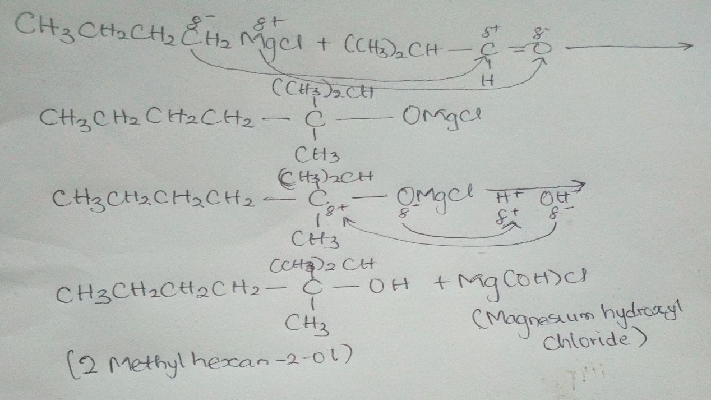
- The reduction reaction of 2-methylpropanal
CH₃ O CH₃ OH
| || NaBH₄ | |
H₃C − CH ── C ──H H₃O⁺ H₃C −CH− C−H
2-Methylpropanal 2-Methylpropanol

- Conversion of Propan-1-ol to propan-2-ol
CH₃CH₂CH₂OH CH₃CHOHCH₃
Propan-1-ol propan-2-ol
CH₃CH₂CH₂OH + H₂SO₄ CH₃CH₂CH₂OH₂OSO₃H
-H₂O
CH₃CH₂CH₂OSO₃H

-H -H2SO₄

CH₃CHOHCH₃ H⁺ OH⁻ CH₃CH=CH₂
Propan-2-ol propene

