MODELING THE OPERATION OF A PERMANENT MAGNET SYNCHRONOUS MACHINE

BY
EDOKPOLOR NOSARIEMEN DAVID

15/ENG04/018

EEE566

INTRODUCTION
Permanent magnet synchronous motors (PMSM) are well known in industrial drives. They have better efficiency and better power/mass ration than more robust induction motors. The PMSMs become even more interesting due to decreasing prices of permanent magnet material. PMSMs used in industrial drives are normally closed- or open-loop controlled. The three-phase models of PMSMs have dependent state variables. Therefore, they cannot be used for the closed-loop control design, where independent state variables are needed. For the control design purposes, the two-axis SMPM dynamic models oriented with the magnetic axis of permanent magnets are normally used. Magnetic saturation and even cross-saturation are accounted for in two-axis dynamic models of PMSMs , while the effects of slotting are neglected. However, in the dynamic two-axis PMSM model presented in this work the saturation, cross-saturation and effects of slotting are accounted for by position- and current-dependent characteristics of flux linkages. Actually, this work focuses on experimental methods applied for determining aforementioned characteristics of flux linkages. The complete characteristics of flux linkages are composed of two parts and determined by two independent sets of tests. During the first set of tests shaft of the tested PMSM is rotated by speed controlled load at constant angular speed, while the induced voltages (back emfs) are measured on open motor terminals. Considering angular speed and measured terminal voltages, the part of flux linkage characteristics due to the permanent magnets at no armature excitation is determined. The second set of tests is performed at locked rotor, while the PMSM is supplied by the controlled voltage source inverter (VSI) . At chosen position, the current in one axis is closed-loop controlled in order to keep constant value, while the voltage in the orthogonal axis is step-wise changing. The characteristic of flux linkage at given position and given value of closed-loop controlled current is determined by numerical integration using applied voltage and responding current. If the described test is performed at different positions and different values of controlled current the complete part of flux linkage characteristics due to the armature excitation is determined. The complete characteristics of flux linkages are composed of two parts, one due to the permanent magnets at no armature excitation and the other part due to the armature excitation.
MODEL OF A PMSM
PMSMs used in industrial drives are normally closed-loop controlled. The wye-connected three-phase PMSM has linearly dependent currents which cannot be used as independent state variables in the control design. Therefore, the three-phase PMSM model is transformed into a d-q-0 reference frame. The magnetically nonlinear characteristics of flux linkages are in such a way expressed as nonlinear functions of rotor position and the d-q reference frame currents. The complete voltage-balance equations in d-q reference frame, ud for direct-axis and uq for quadrature-axis can be written as (electrical subsytem):
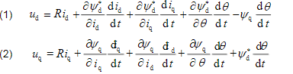
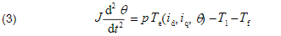
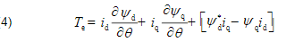

STRUCTURE OF THE PERMANENT MAGNET MACHINE
The cross-sectional layout of a surface mounted permanent magnet motor
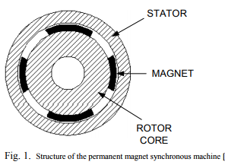
The stator carries a three-phase winding, which produces a near sinusoidal distribution of magneto motive force based on the value of the stator current. The magnets are mounted on the surface of the motor core. They have the same role as the I field winding in a synchronous machine except their magnetic field is constant and there is no control on it
EQUIVALENT DQ0 MODEL OF THE PM MACHINE
The dq0 equivalent circuit of the PM machine shown in Fig.2 is similar to the one for the synchronous machine; it has the armature resistance Rs , d and q axis leakage and mutual inductances sl , Lmd and Lmq
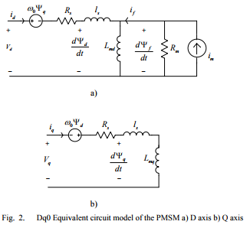
The equations for the dq0 model of the Permanent Magnet Synchronous Machine are:
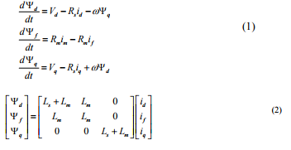

CONCLUSION
The dq0 and embedded model of the permanent magnet machine has been implemented and verified in RTDS. The models have identical results. The embedded model of the machine is more stable with large time-steps than the conventional model of the machine. The problem of the embedded model of the machine is the calculation load of the model which is higher than the conventional model, because the inductance matrix of the machine has to be inverted in every time step. With the new RPC cards in RTDS, this task is not a significant problem anymore. Coupling the FEM based programs and transient simulation programs can be a very successful step in modeling the power system network with more accuracy.

