NAME: AFOLABI AJIBOLA ADUKE
MATRIC NO : 17/MHS03/003
DEPARTMENT : ANATOMY
LEVEL : 300
COLLEGE : MEDICINE AND HEALTH SCIENCES
COURSE TITLE :
COURSE CODE : ANA 314
QUESTION
1. Comment on the relevance of comparative anatomy to evolution
2. Discuss the types of comparative anatomy with relevant examples
ANSWERS
- Relevance of comparative anatomy to evolution
-Comparative anatomy has long served as evidence for evolution, now joined in that role by comparative genomics it indicates that organisms share a common ancestor.
-It also assists scientists in classifying organisms based on similar characteristics of their anatomical structures.

- There are many forms of evidence for evolution. One of the strongest forms of evidence is comparative anatomy; comparing structural similarities of organisms to determine their evolutionary relationships. Organisms with similar anatomical features are assumed to be relatively closely related volutionarily, and they are assumed to share a common ancestor.
The types
Homologous structures
are those that are similar in multiple species and show that the organisms descended from a common ancestor. However, having the same ancestry does not mean that a bodily structure will always have the same function. Homologous structures can be anything from a specific skeletal structure to the nervous system to a body plan.
are structures that are similar in two organisms because they have a common ancestor. These structures may or may not have the same function in the descendants. Figure below shows the hands of several different mammals. They all have the same basic pattern of bones. They inherited this pattern from a common ancestor. However, their forelimbs now have different functions.
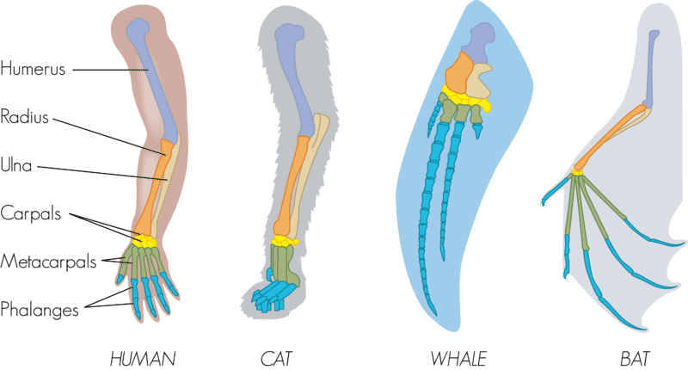

Analogous structures
They are those that are the same among different species that are not related. These organisms do not have a common ancestor, but their anatomical structures serve the same or similar purpose. A different ancestry can still lead to body parts with the same function. They are the structures that are similar in unrelated organisms. The structures are similar because they evolved to do the same job, not because they were inherited from a common ancestor. For example, the wings of bats and birds, shown in Figure below, look similar on the outside. They also have the same function. However, wings evolved independently in the two groups of animals. This is apparent when you compare the pattern of bones inside the wings.
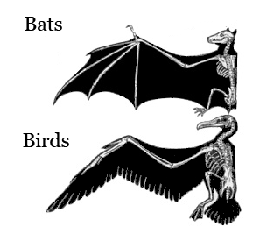

Comparative embryology is the study of the similarities and differences in the embryos of different species. Similarities in embryos are evidence of common ancestry. All vertebrate embryos, for example, have gill slits and tails. Most vertebrates, except for fish , lose their gill slits by adulthood. Some of them also lose their tail. In humans, the tail is reduced to the tail bone. Thus, similarities organisms share as embryos may be gone by adulthood. This is why it is valuable to compare organisms in the embryonic stage.
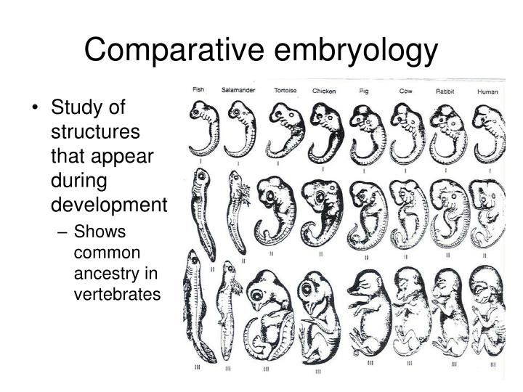

Vestigial structures
Evolution has reduced their size because the structures are no longer used. Vestigial structures are evolutionary leftovers. They are structures that have no function in an organism, but they come from a common ancestor that did need that structure. Over time, evolution and adaptation eliminated the need for these structures, yet they remain.
Examples of vestigial structures are the limb bones in snakes that cannot walk and whale sharks that have teeth but are filter feeders. There are flightless birds, like the emu, that have wings but cannot fly. There are also cave-dwelling fish and reptiles that live in the dark but still have eye structures.
Comparing DNA
Darwin could compare only the anatomy and embryos of living things. Today, scientists can compare their DNA. Similar DNA sequences are the strongest evidence for evolution from a common ancestor. More similarities in the DNA sequence is evidence for a closer evolutionary relationship. in the figure below . It shows how humans and apes are related based on their DNA sequences.

