ABSTRACT

The permanent-magnet synchronous machine (PMSM) drive is one of best choices for a full range of motion control applications. For example, the PMSM is widely used in robotics, machine tools, actuators, and it is being considered in high- power applications such as industrial drives and vehicular propulsion. It is also used for residential/commercial applications. The PMSM is known for having low torque ripple, superior dynamic performance, high efficiency and high power density.

Introduction

The electric motors are electromechanical machines, which are used for the conversion of electrical energy into mechanical energy. The foremost categories of AC motors are asynchronous and synchronous motors. The asynchronous motors are called singly excited machines, that is, the stator windings are connected to AC supply whereas the rotor has no connection from the stator or to any other source of supply. The power is transferred from the stator to the rotor only by mutual induction, owing to which the asynchronous motors are called as induction machines.

The synchronous motors require AC supply for the stator windings and DC supply for the rotor windings. The motor speed is determined by the AC supply frequency and the number of poles of the synchronous motor, the rotor rotates at the speed of the stator revolving field at synchronous speed, which is constant. The variations in mechanical load within the machine’s rating will not affect the motor’s synchronous speed

One of the types of synchronous motor is the PMSM. The PMSM consists of conventional three phase windings in the stator and permanent magnets in the rotor. The purpose of the field windings in the conventional synchronous machine is done by permanent magnets in PMSM. The conventional synchronous machine requires AC and DC supply, whereas the PMSM requires only AC supply for its operation. One of the greatest advantages of PMSM over its counterpart is the removal of dc supply for field excitation

The development of PMSM has happened due to the invention of novel mag- netic materials and rare earth materials. PMSM give numerous advantages in scheming recent motion management systems. Energy efficient PMSM are designed due to the availability of permanent magnet materials of high magnetic flux density.

In synchronous motors the rotor rotates at the speed of stator revolving field. The speed of the revolving stator field is called as synchronous speed. The synchro- nous speed (ωs) can be found by the frequency of the stator input supply (fs), and the number of stator pole pairs (p). The stator of a three phase synchronous motor consists of distributed sine three phase winding, whereas the rotor consists of the same number of p-pole pairs as stator, excited by permanent magnets or a separate DC supply source.

When the synchronous machine is excited with a three phase AC supply, a magnetic field rotates at synchronous speed develops in the stator. The synchronous speed of this rotating magnetic field is shown by the Equation below

N 1⁄4 􏰀120 f s􏰂=P rpm (1)

where N, synchronous speed, fs, frequency of AC supply in Hz; P, number of

poles; p, pole pairs and it is given by (P/2).

Types of PMSM

The PMSM are classified based on the direction of field flux are as follows,

1.Radial field  
2.Axial field

In radial field, the flux direction is along the radius of the machine. The radial field permanent magnet motors are the most commonly used. In axial field, the flux direction is parallel to the rotor shaft. The axial field permanent magnet motors are presently used in a variety of numerous applications because of their higher power density and quick acceleration.

The permanent magnets can be placed in many different ways on the rotor of PMSM as discussed in diagrams below show the permanent magnets mounted on the surface of the outer periphery of rotor laminations. This type of arrangement provides the highest air gap flux density, but it has the drawback of lower structural integrity and mechanical robustness. Machines with this arrange- ment of magnets are known as Surface mount PMSMs.

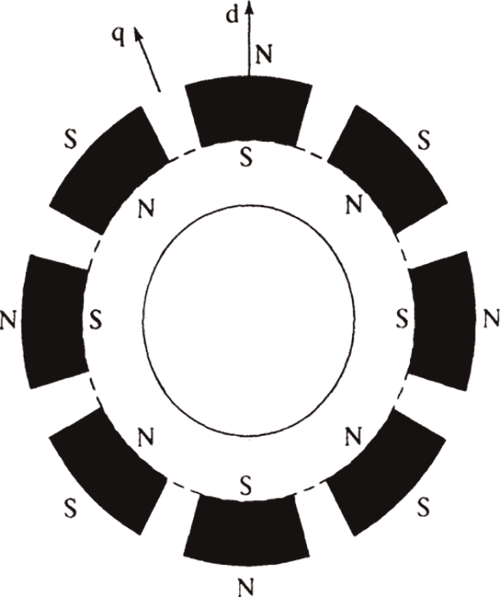

*Surface permanent magnet.*

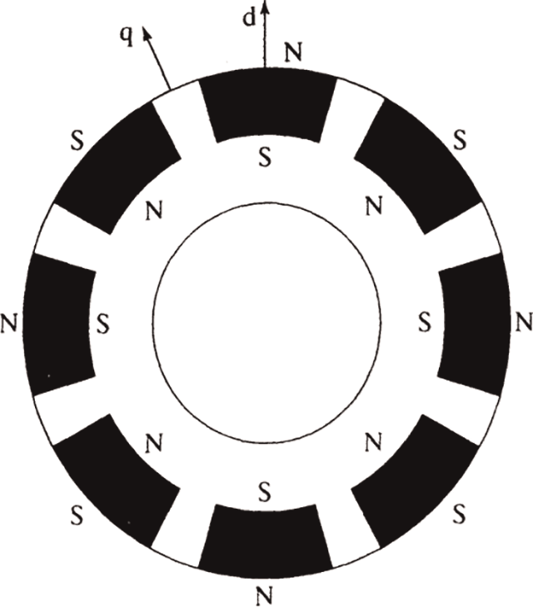

*Surface inset permanent magnet.*

rotor arrangements by easier construction and mechanical robustness, with a high ratio between the quadrature and direct-axis inductances, respectively.

The surface PMSM with radial flux are generally applied for applications which require low speed operations. These machines have the advantage of high power density than the other types of PMSM. The interior PMSM are used for applications which require high speed.

The principle of operation is identical for all the types of PMSM, in spite of the types of mounting the permanent magnets in the rotor.

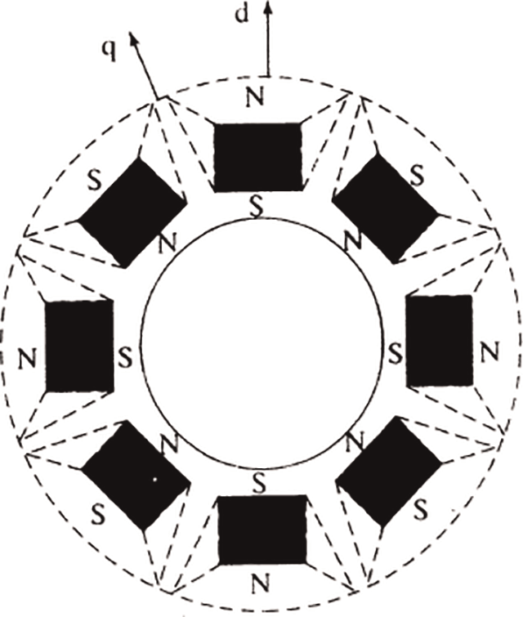

*Interior permanent magnet.*

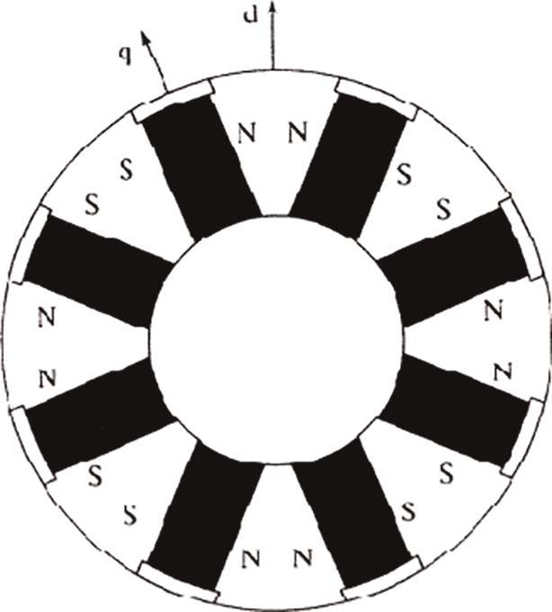

*Interior permanent magnet with circumferential orientation.*

The important significance of the type of mounting the permanent magnets on the rotor is the variation in direct axes and quadrature axes inductance values, which is explained below. The primary path of the flux through the permanent magnets rotor is the direct axis. The stator inductance when measured in the position of permanent magnets aligned with stator winding is called as direct axis inductance. The quadrature axis inductance is measured by rotating the magnets from the already aligned position (direct axis) by 90°, in this position the iron (inter polar area of the rotor) sees the stator flux. The flux density of the permanent magnet materials is presently high

Modeling of PMSM

For proper simulation and analysis of the system, a complete modelling of the drive model is essential. The motor axis has been developed using d-q rotor refer- ence frame theory as shown in Figure below. At any particular time t, the rotor reference axis makes an angle θr with the fixed stator axis and the rotating stator mmf creates an angle α with the rotor d axis. It is viewed that at any time t, the stator mmf rotates at the same speed as that of the rotor axis.

The required assumptions are obtained for the modelling of the PMSM without damper windings.

1.Saturation is neglected.  
2.Induced EMF is sinusoidal in nature.  
3.Hysteresis losses and Eddy current losses are negligible.

4.No field current dynamics.

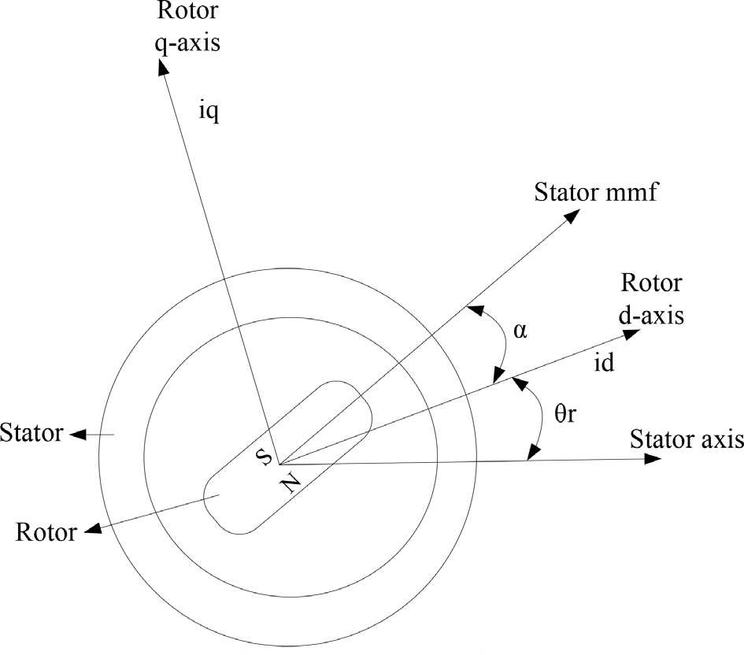

Motor axis diagram

Applied Electromechanical Devices and Machines for Electric Mobility Solutions

Voltage equations from the model are given by,

Vq ¼ Rsiq þ ωrλd þ ρλq (3)

Vd ¼ Rsid — ωrλq þ ρλd (4)

Flux linkages are given by,

λq ¼ Lqiq (5)

λq ¼ Lqiq þ λf (6)

Substituting Eq. (5) and Eq. (6) into Eq. (3) and Eq. (4)

Vq ¼ Rsiq þ ωrðLdid þ λf Þ þ ρLdid (7)

Vd ¼ Rsid — ωrLqiq þ ρðLdid þ λf Þ (8)

Arranging Eq. (7) and Eq. (8) in matrix form,

  
The developed torque motor is being given by,

. Σ

T ¼ 3

e 2

P . Σ

2 λdiq — λqid

(10)

The mechanical torque equation is,

Te ¼ TL

þ Bωm

þ J dωm

dt

(11)

Solving for the rotor mechanical speed form Eq. (11)

ð. Σ

ωm ¼

Te — TL — Bωm

J

dt (12)

and

. Σ

2

ωm ¼ ωr P

(13)

In the above equations ωr is the rotor electrical speed, ωm is the rotor mechanical speed.

**Parks transformation and dynamic d-q modeling**

The dynamic d-q modelling of the system is used for the study of motor during transient state and as well as in the steady state conditions. It is achieved by converting the three phase voltages and currents to dqo axis variables by using the Parks transformation [4].

Converting the phase voltages variables Vabc to Vdqo variables in rotor reference frame axis are illustrated in the equations,

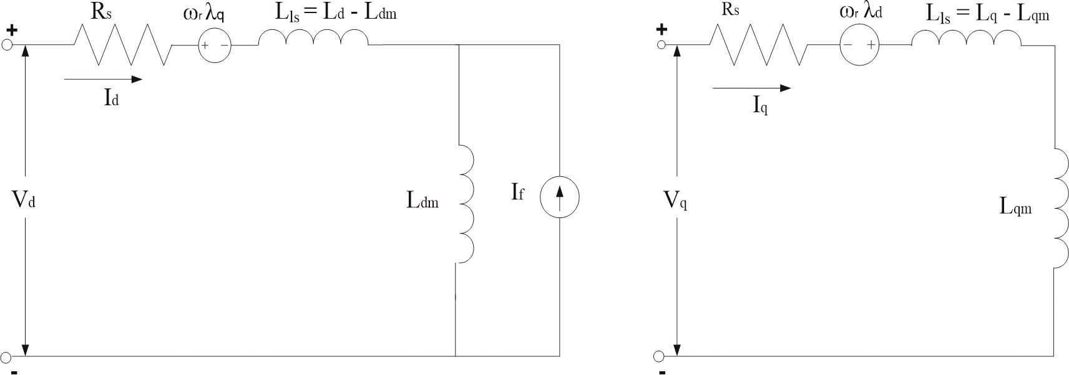

*Equivalent circuit of PMSM without damper windings.*

**Equivalent circuit of PMSM**

Equivalent circuit is essential for the proper simulation and designing of the motor. It is achieved and derived from the d-q modelling of the motor using the voltage equations of the stator. From the assumption, rotor d axis flux is represented by a constant current source which is described through the following equation,

λf ¼ Ldm if (16)

where λf, field flux linkage; Ldm, d-axis magnetizing inductance; if, equivalent permanent magnet field current.

# Permanent magnet synchronous motor drive system

The motor drive essentially consists of four main components such as the PMSM, the inverter, the main control unit and the position sensor.

Inverter

For variable frequency and magnitude, voltage source inverters are devices which convert the constant DC voltage level to variable AC voltage. As specified in the function, these inverters are commonly used in adjustable speed drives.

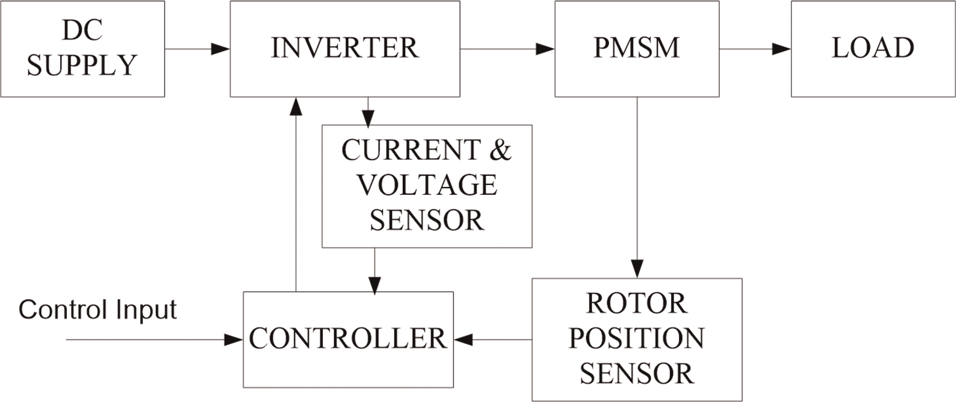

*Components permanent magnet synchronous motor drive.*

# Control techniques of PMSM

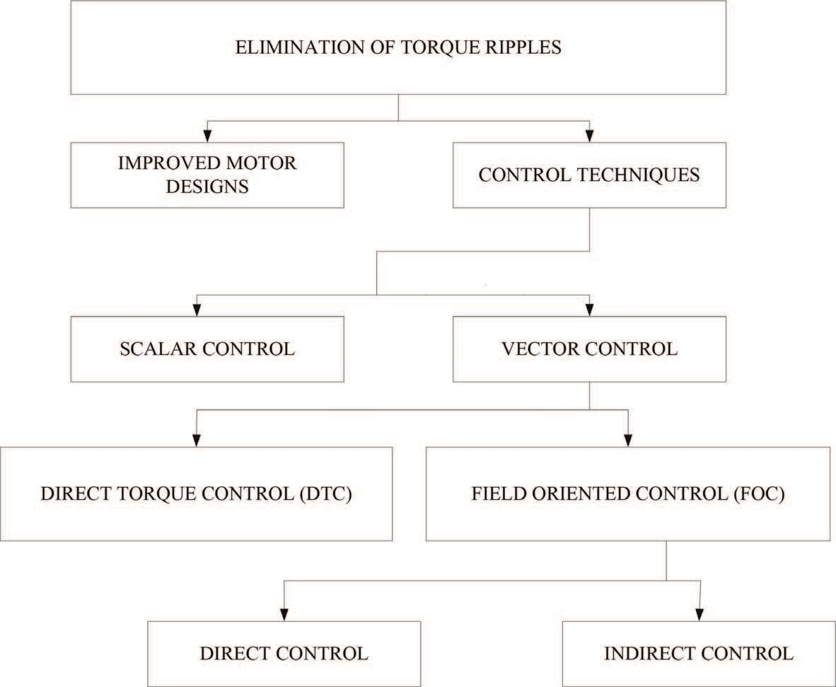

*Classification of the various control techniques.*

Field oriented control (FOC) of PMSM

For the control of PM motors, FOC technique is used for synchronous motor to

evaluate as a DC motor. The stator windings of the motor are fed by an inverter that generates a variable frequency variable voltage scheme. Instead of controlling the inverter frequency independently, the frequency and phase of the output wave are controlled using a position sensor.

FOC was invented in the beginning of 1970s and it demonstrates that an induction motor or synchronous motor could be controlled like a separately excited DC motor by the orientation of the stator mmf or current vector in relation to the rotor flux to achieve a desired objective. For the motor to behave like a DC motor, the control needs knowledge of the position of the instantaneous rotor flux or rotor position of permanent magnet motor. This needs a resolver or an absolute optical encoder.

One of the major disadvantages of the PMSM drive is the torque ripple produced which can be attributed to the following sources:

* + - 1. mutual torque, due to the interaction of the rotor field and stator currents;
      2. reluctance torque, due to rotor saliency;
      3. cogging torque, due to the existence of stator slots.