ONODJOHWO AVWEROSUOGHENE SAMUEL.
15|ENG04|046.
EEE 566 ASSIGNMENT

Question
Model the operation of a permanent-magnet synchronous machine

Answer
Permanent magnet synchronous machines generally have same operating and performance characteristics as synchronous machines. A permanent magnet machine can have a configuration almost identical to that of the conventional synchronous machines with absence of slip rings and a field winding.

Modeling of PMSM
For proper simulation and analysis of the system, a complete modelling of the drive model is essential. The motor axis has been developed using d-q rotor reference frame theory as shown in the figure below. At any particular time t, the rotor reference axis makes an angle θ_{r} with the fixed stator axis and the rotating stator mmf creates an angle α with the rotor d axis. It is viewed that at any time t, the stator mmf rotates at the same speed as that of the rotor axis.

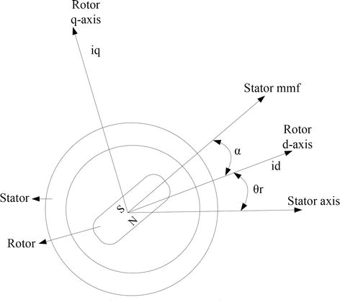

The required assumptions are obtained for the modelling of the PMSM without damper windings.
- Saturation is neglected.
- Induced EMF is sinusoidal in nature.
- Hysteresis losses and Eddy current losses are negligible.
- No field current dynamics.

Voltage equations from the model are given by,

V_{q} = R_{s}i_{q} + ω_{r}λ_{d} + ρλ_{q}.......................E1

V_{d} = R_{s}i_{d} – ω_{r}λ_{q} + ρλ_{d}…………………E2
Flux linkages are given by,

Λ_{q} = L_{q}i_{q}…………………E3
Λ_{q} = L_{q}i_{q} + λ_{f}…………………E4
Substituting Eq. (3) and Eq. (4) into Eq. (1) and Eq. (2)

V_{q} = R_{s}i_{q} + ω_{r} (L_{d}i_{d} +λ_{f}) + ρL_{d}i_{d}…………E5
V_{d} = R_{s}i_{d} – ω_{r}L_{q}i_{q} + ρ (L_{d}i_{d} + λ_{f})……….E6
Arranging Eq. (5) and Eq. (6) in matrix form,
($\begin{matrix}Vq \\ Vd\end{matrix}$ ) = ( $\begin{matrix}Rs+ρLq & ωrLd \\ -ωrLq & Rs+ρLd\end{matrix}$ ) ( $\begin{matrix}iq \\ id\end{matrix}$ ) + ($\begin{matrix}ωrλf \\ ρλf\end{matrix}$)………..E7
The developed torque motor is being given by,

T_{e} = 32 ($\frac{P}{2}$) (λ_{d}i_{q} − λ_{q}i_{d})……………E8
The mechanical torque equation is,

T_{e} = T_{L} + Bω_{m} + J$\frac{dωm}{dt}$…….……E9
Solving for the rotor mechanical speed form Eq. (9)

ωm=∫($\frac{Te – TL - Bωm }{J}$) dt ……..E10
and

ω_{m} = ω_{r} ( $\frac{2}{P}$)………………E11
In the above equations ω_{r} is the rotor electrical speed, ω_{m} is the rotor mechanical speed.

Parks transformation and dynamic d-q modeling
The dynamic d-q modelling of the system is used for the study of motor during transient state and as well as in the steady state conditions. It is achieved by converting the three phase voltages and currents to dqo axis variables by using the Parks transformation [4].
Converting the phase voltages variables V_{abc} to V_{dqo} variables in rotor reference frame axis are illustrated in the equations,

[ $\begin{matrix}Vq \\ Vd \\ Vo\end{matrix}$ ] = $\frac{2}{3}$ [ $\begin{matrix}cos θr & cos (θr-120) & cos (θr+120) \\ sin θr & sin (θr-120) & sin (θr+120) \\ 1/2 & 1/2 & 1/2\end{matrix}$] [$\begin{matrix}Va \\ Vb \\ Vc\end{matrix}$]……………E12
Convert V_{dqo} to V_{abc}

[$\begin{matrix}Va \\ Vb \\ Vc\end{matrix}$] = $\frac{2}{3}$ [$\begin{matrix}cos θr & sin θr & 1 \\ cos (θr-120) & sin (θr-120) & 1 \\ cos (θr+120) & sin (θr+120) & 1\end{matrix}$] [$\begin{matrix}Vq \\ Vd \\ Vo\end{matrix}$]……….E13

Equivalent circuit of PMSM
Equivalent circuit is essential for the proper simulation and designing of the motor. It is achieved and derived from the d-q modelling of the motor using the voltage equations of the stator. From the assumption, rotor d axis flux is represented by a constant current source which is described through the following equation,

Λ_{f} = L_{dm} i_{f} ……..E14
Where λ_{f}, field flux linkage; L_{dm}, d-axis magnetizing inductance; if, equivalent permanent magnet field current.
The figure below shows the equivalent circuit of PMSM without damper windings.

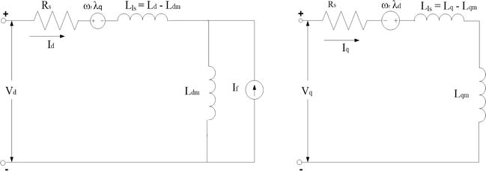

Equivalent circuit of PMSM without damper windings.

REFERENCE
- Modeling and simulation of permanent magnet synchronous motor drive system by Enrique L. Carrillo Arroyo (2006)

