NAME: Nwedozie Ujunwa
MATRIC NO: 15/mhs01/096
COURSE CODE: CSC 410

1.) The concepts of operational laws as applied to computer and network system performance evaluation.
A number of laws are derived which establish relationships between throughput, response time, device utilization, space-time products and various other factors related to computer system performance. These laws are obtained through the operational method of computer system analysis. The operational method, which is formally introduced in this paper, differs significantly from the conventional stochastic modeling approach and is based on a set of concepts that correspond naturally and directly to observed properties of real computer systems. The operational laws presented in this paper apply with complete precision to all collections of observational data.

2.) Eight operational laws that are widely employed in computer system
i.) Response Time:
A functioning computer environment comprises millions of data transmission cycles consisting of user requests and system responses. The response time is defined as the total time lapse between the completion of an inquiry or demand made on a system resource and the receipt of a response. In real life, it can be compared to the time between placing an order to receiving a delivery.

ii) Latency:
Latency is the term used to describe the state of existence of something in transition. Every transmitted piece of information on a computer system travels over some sort of medium. Computer latency is defined as the time it takes to communicate a message, or the time the message spends traveling the geographical distance ('on the wire') before it gets to its desired destination. This can be compared to the time one spends on an aircraft, traveling from one geographical location to another.

iii) Speed:
The term speed is usually in reference to the clock speed of the processor. The clock speed is defined as the clock cycles per second, which determines the rate at which instruction processing takes place. It is usually measured in megahertz (MHz) or gigahertz (GHz). Computer speed is one of the leading parameters in assessing a computer's performance. It can be compared to the horsepower of an engine. The higher the horsepower, the faster the car can move.

iv) Throughput:
Computer function consists of millions of data transmissions between devices and components. The computer's throughput is defined as the number of units of information that can be successfully processed at any given time. The throughput is commonly measured using bits per second (bps)—more specifically, megabits per second (Mbps) and gigabits per second (Gbps). For example, if the post office can receive and process a maximum of 1000 items per day, then that’s its throughput.

v) Channel capacity:
Channel capacity is the tightest upper bound on the rate of information that can be reliably transmitted over a communications channel. By the noisy-channel coding theorem, the channel capacity of a given channel is the limiting information rate (in units of information per unit time) that can be achieved with arbitrarily small error probability.

vi) Scalability: Scalability is the ability of a system, network, or process to handle a growing amount of work in a capable manner or its ability to be enlarged to accommodate that growth.

vii) Power consumption:
The amount of electricity used by the computer. This becomes especially important for systems with limited power sources such as solar, batteries, human power.

viii) Environmental impact:
The effect of a computer or computers on the environment, during manufacturing and recycling as well as during use. Measurements are taken with the objectives of reducing waste, reducing hazardous materials, and minimizing a computer's ecological footprint.

3.) The differences between the Forced Flow Law and the Residence Time Law from a systems perspective
Forced Flow Law
- Relates the system throughput to individual device throughputs.
- In an open model, System throughput = # of jobs leaving the system per unit time
- In a closed model, System throughput = # of jobs traversing OUT to IN link per unit time.
- If observation period T is such that Ai = Ci⇒ Device satisfies the assumption of job flow balance.
- Each job makes Vi requests for ith device in the system
- Ci = C0 Vi or Vi =Ci/C0 Vi is called visit ratio

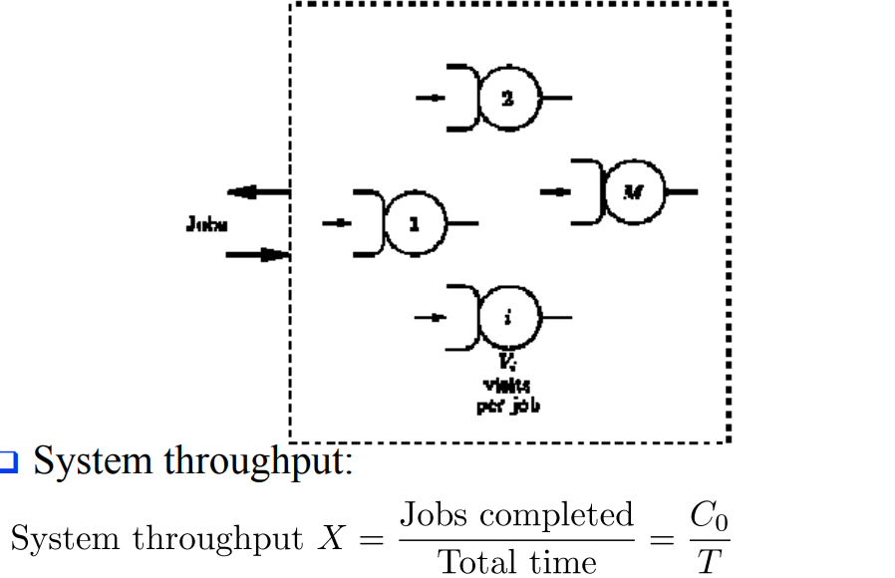

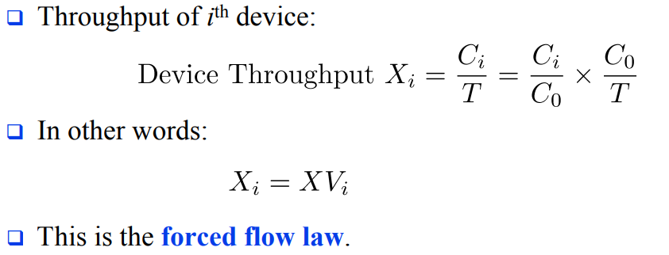

WHILE

Residence Time Law

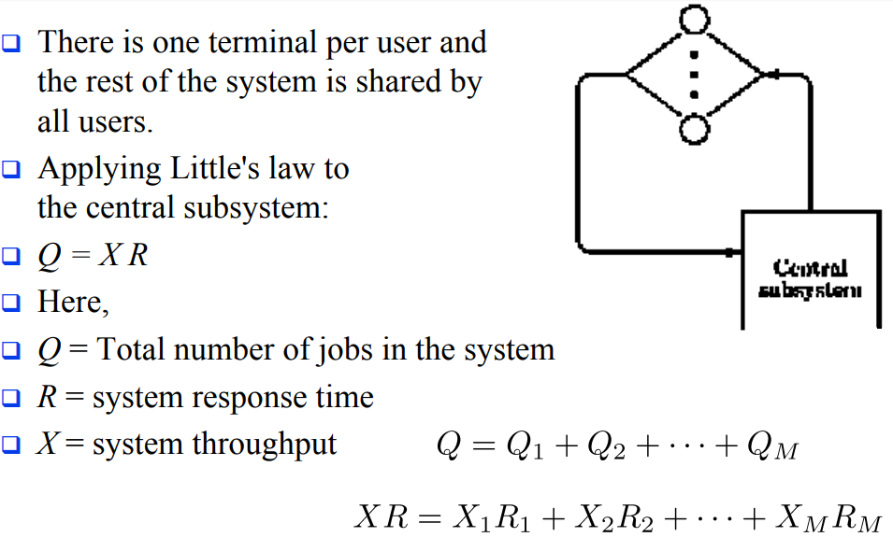

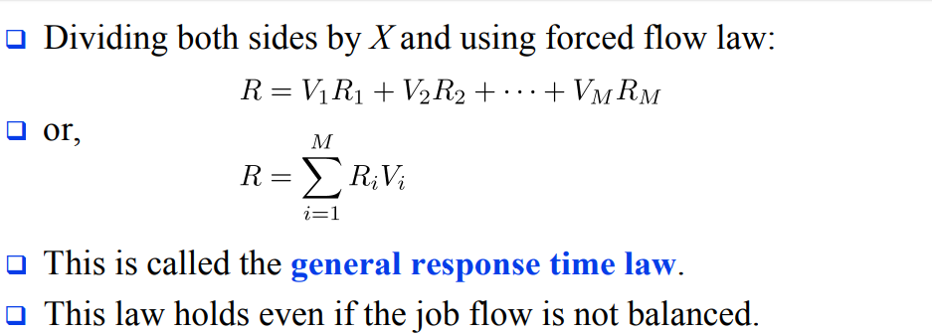

4. . Discuss some basic queuing models and basic queuing disciplines.
Some basic queuing models:
Arrival process: The arrival process is simply how customers arrive. They may come into a queue alone or in groups, and they may arrive at certain intervals or randomly.
Behavior: How do customers behave when they are in line? Some might be willing to wait for their place in the queue; others may become impatient and leave. Yet others might decide to rejoin the queue later, such as when they are put on hold with customer service and decide to call back in hopes of receiving faster service.
How customers are serviced: This includes the length of time a customer is serviced, the number of servers available to help the customers, whether customers are served one by one or in batches, and the order in which customers are serviced, also called service discipline.
Service discipline: refers to the rule by which the next customer is selected. Although many retail scenarios employ the “first come, first served” rule, other situations may call for other types of service. For example, customers may be served in order of priority, or based on the number of items they need serviced (such as in an express lane in a grocery store). Sometimes, the last customer to arrive will be served first (such s in the case in a stack of dirty dishes, where the one on top will be the first to be washed).

Waiting room: The number of customers allowed to wait in the queue may be limited based on the space available.

Basic queuing discipline:

First In First Out (FIFO): First In, First Out, commonly known as FIFO, is an asset-management and valuation method in which assets produced or acquired first are sold, used, or disposed of first. For tax purposes, FIFO assumes that assets with the oldest costs are included in the income statement's cost of goods sold (COGS). The remaining inventory assets are matched to the assets that are most recently purchased or produced.

Last In First Out (LIFO): Last in, first out (LIFO) is a method used to account for inventory that records the most recently produced items as sold first. Under LIFO, the cost of the most recent products purchased (or produced) are the first to be expensed as cost of goods sold (COGS)—which means the lower cost of older products will be reported as inventory.

Shortest Remaining Time(SRT): Shortest remaining time, also known as shortest remaining time first, is a scheduling method that is a preemptive version of shortest job next scheduling. In this scheduling algorithm, the process with the smallest amount of time remaining until completion is selected to execute.

5. How to resolve basic queuing problems
This could be by evaluating the system’s performance by either the measurement, simulation or analytical technique;
• Measurement; measurement of the real system can be undertaken if the real system is accessible and the process of measurement will not disrupt the system or services. The impact of these disturbances or instructions are very serious.

• Simulation; this technique drops from discreet event simulation philosophies a simplified model of the system and its nodes are implemented in a software and the performance of interest is measured as of a real system. But measurement side effects are usually not present.

• Analytical; a mathematical model of the system is analyzed numerically. This technique is viewed as a special form of simulation, it is often much quicker than simulation, but most times wide assumption needs to be made for numerical processes to be applicable. Analytical methods are usually used to gain insight during development phases and also to learn fundamental facts about a system.
These are some of the algorithms that can be used to solve queuing problem;

6. I. Don’t trust the result of a simulation model until they have been validated by other performance evaluation techniques
II. It’s important so as to know if the system is correctly defined and if the goals are clearly stated.
iii. Such report is invalid
iv. Go through the report to check if there are any mistakes
V. The forth report (measurement and simulation) because measurement technique requires more effort and it is the most accurate; simulation method requires relatively lesser effort and it is averagely accurate while analytical method is very quick and often very less accurate.

