NAME: Imoyin-Omene Emuobonuvie
MATRIC NUMBER: 17/MHS01/159
DEPARTMENT: ANATOMY
COURSE CODE: ANA 314
COURSE TITLE: ANIMAL HANDLING AND COMPARATIVE MAMMALIAN GROSS ANATOMY
LEVEL: 300L

ASSIGNMENT

QUESTION 1
COMMENT ON THE RELEVANCE OF COMPARATIVE ANATOMY TO EVOLUTION
Comparative anatomy is the study of the body structures of different species of animals; it compares and contrasts the similarities and differences of these structures.It is an mportant tool that helps determine evolutionary relationships between organisms and whether or not they share common ancestors.It is closely related to evolutionary biology and phylogeny (the evolution of species).It has provided evidence of common descent,and has assisted in the classification of animals. Anatomical similarities between organisms support the idea that these organisms evolved from a common ancestor. Thus, the fact that all vertebrates have four limbs and gill pouches at some part of their development indicates that evolutionary changes have occurred over time resulting in the diversity we have today.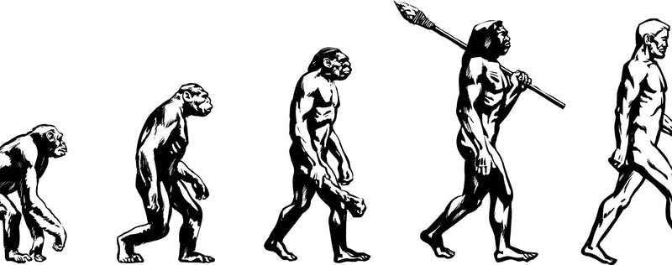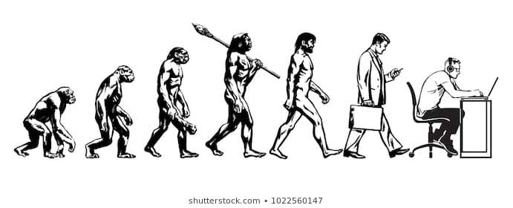
Evolution is the change in the heritable characteristics of biological populations over successive generations.In it's contemporary meaning refers to the changes in the proportions of biological types of various plants,animals and other living things on Earth.Factors such as environment and predation pressures can have different effects on the 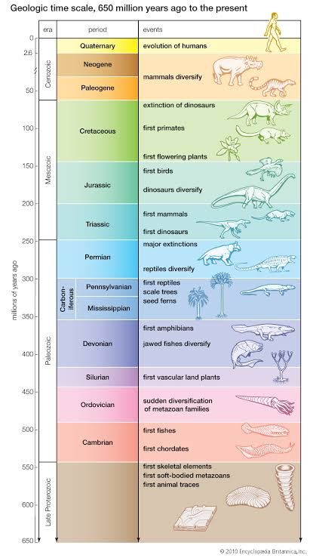ways in which species exposed to them evolve.
It has long served as one of the main evidences for evolution, due to the fact that it is very concrete, and does not require extensive technology.There are many forms of evidence for evolution. One of the strongest forms of evidence is comparative anatomy; comparing structural similarities of organisms to determine their evolutionary relationships. Organisms with similar anatomical features are assumed to be relatively closely related evolutionarily, and they are assumed to share a common ancestor. As a result of the study of evolutionary relationships, anatomical similarities and differences are important factors in determining and establishing classification of organisms.

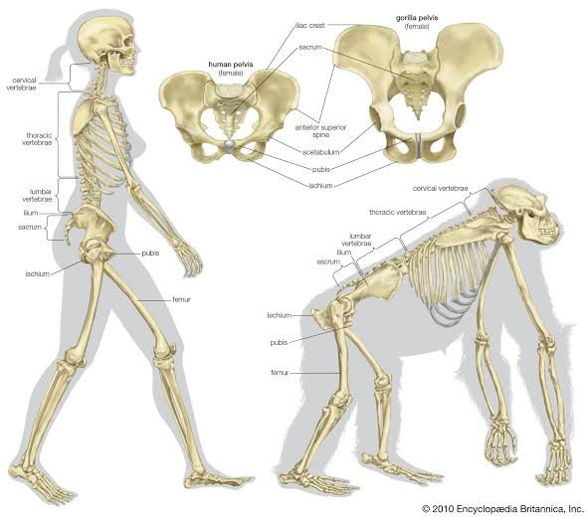
QUESTION 2
DISCUSS THE TYPES OF COMPARATIVE ANATOMY WITH RELEVANT EXAMPLES
The study of comparative anatomy predates the modern study of evolution. Early evolutionary scientists like Buffon and Lamarck used comparative anatomy to determine relationships between species. Organisms with similar structures, they argued, must have acquired these traits from a common ancestor. . As a result of the study of evolutionary relationships, anatomical similarities and differences are important factors in determining and establishing classification of organisms.
The two major concepts of comparative Anatomy are: Homologous structures (body parts/Anatomy) which are similar in different species because the species have common descent and have evolved, usually divergently,from a shared ancestor and may or may not perform the same function. And the analogous structures that are similar in different organisms because,in convergent evolution,they evolved in a similar environment,rather than weeeey inherited from a recent common ancestor.They usually serve the same or similar purposes.
EMBRYOLOGY: Some organisms have anatomical structures that are very similar in embryological development and form, but very different in function. These are called homologous structures. Since these structures are so similar, they indicate an evolutionary relationship and a common ancestor of the species that possess them. A clear example of homologous structures is the forelimb of mammals. When examined closely, the forelimbs of humans, whales, dogs, and bats all are very similar in structure. Each possesses the same number of bones, arranged in almost the same way. While they have different external features and they function in different ways, the embryological development and anatomical similarities in form are striking. By comparing the anatomy of these organisms, scientists have determined that they share a common evolutionary ancestor and in an evolutionary sense, they are relatively closely related.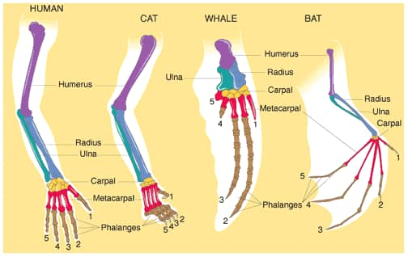
ANALOGOUS TRAITS: Other organisms have anatomical structures that function in very similar ways, however, morphologically and developmentally these structures are very different. These are called analogous structures. For example, the wings of a bird and dragonfly both serve the same function; they help the organism to fly. However, when comparing the anatomy of these wings, they are very different. The bird wing has bones inside and is covered with feathers, while the dragonfly wing is missing both of these structures. They are analogous structures. Another example, is the wings of bats and birds, shown in Figure below, look similar on the outside. They also have the same function. However, wings evolved independently in the two groups of animals. This is apparent when you compare the pattern of bones inside the wings.Thus, by comparing the anatomy of these organisms, scientists have determined that birds and dragonflies do not share a common evolutionary ancestor, nor that, in an evolutionary sense, they are closely related. Analogous structures are evidence that these organisms evolved along separate lines.

HOMOLOGOUS STRUCTURES:
These structures may or may not have the same function in the descendants. Figure below shows the hands of several different mammals. They all have the same basic pattern of bones. They inherited this pattern from a common ancestor. However, their forelimbs now have different functions.
The wings of bats and birds are both derived from the forelimb of a common, probably wingless, ancestor. Both have wings with bone structures similar to the forelimbs of ancestral and current tetrapod, or four-legged, animals. Such traits that are derived from a trait found in a common ancestor are called homologous traits.

VESTIGIAL STRUCTURES: Vestigial structures are anatomical features that are still present in an organism (although often reduced in size) even though they no longer serve a function. When comparing anatomy of two organisms, presence of a structure in one and a related, although vestigial structure in the other is evidence that the organisms share a common evolutionary ancestor and that, in an evolutionary sense, they are relatively closely related. . For example, the wings of bats and birds look similar on the outside. They also have the same function. However, wings evolved independently in the two groups of animals. This is apparent when you compare the pattern of bones inside the wings.Whales, which evolved from land mammals, have vestigial hind leg bones in their bodies. While they no longer use these bones in their marine habitat, they do indicate that whales share an evolutionary relationship with land mammals. Humans have more than 100 vestigial structures in their bodies.

