NAME: OLAYIWOLA FATIMA BISOLA
MATRIC NUMBER: 18/SMS04/039
DATE: 7/ May/ 2020

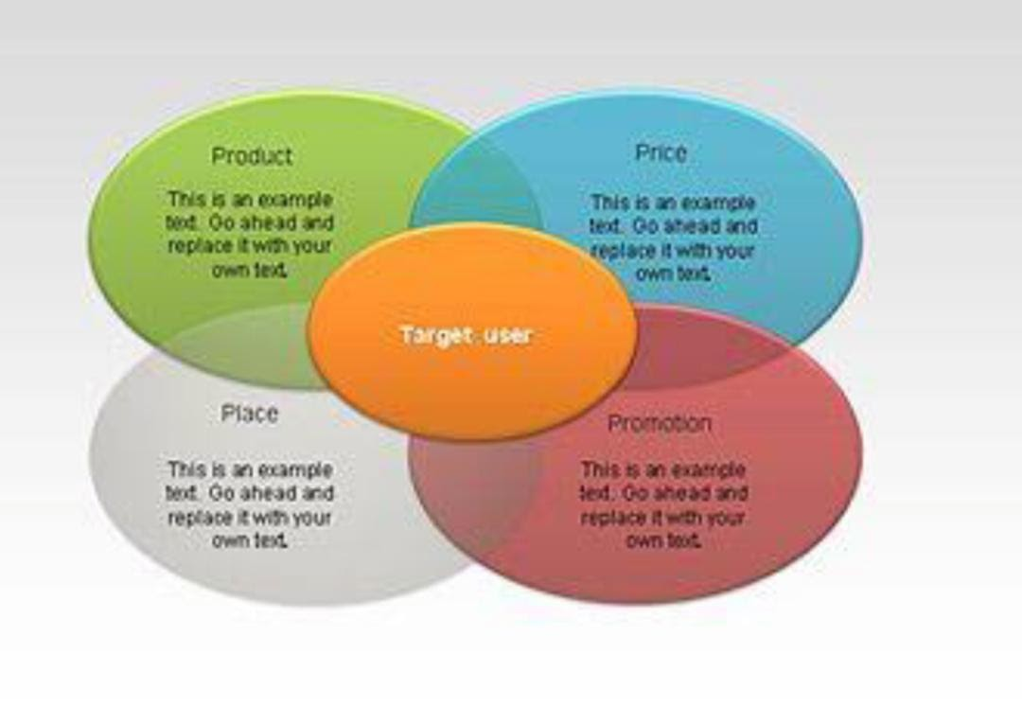
1a. Strategic marketing is a statement in very general terms of how the marketing is to be achieved like price reduction, acquiring a competitive company and intensive advertising. It can also be seen as a way an organization differentiates itself from its competition by focusing more on its strengths to provide better service and value to its customers. The role of strategic marketing is to lead the organization towards attracting economic opportunity by targeting people and convert them into customers of the organization products and services.
A strategic marketing plan integrates selected, targeted marketing tactics all with common goals. Strategic marketing has to do with ensuring that every one of your marketing efforts goes with the overall plan to connect the information you have with the audience that needs to hear it.
We have four(4) basic types of marketing strategies as follow:
- Cause Marketing
Cause marketing, also known as cause related marketing, links a company and its products and services to a social cause or issue.
- Relationship Marketing
Relationship marketing focuses on customer retention and satisfaction in order to enhance your relationships with existing customers to increase loyalty.
- Scarcity Marketing
Scarcity marketing creates a perception of a shortage which aims to entice customers to purchase out of fear that they may not be able to get it in future.
- Undercover Marketing
Undercover marketing, also known as stealth marketing, involves marketing to consumers in a way that they do not realize they are being marketed to.
Cause Marketing and Relationship Marketing are positive marketing techniques that focus on the benefits of others. While Scarcity Marketing and Undrcover Marketing are more unconventional and potentially controversial techniques.
The main key to understanding and creating an effective strategic marketing campaign is developing a well comprehensive strategic marketing plan that allows everyone in the organization to understand what your marketing goals are and your plans for achieving them.
Some of the processes for creating this marketing plan are as follows:
- Set your goals and objectives: Before creating a marketing plan, ensure you have a purpose. The purpose should be based on the long-term goal that guides all your efforts, once those long-term goals are established break them down into specific objectives. And objectives should be measurable over a period of time. For example, your goals maybe to create a social media marketing strategy but then your objective related to this goal could be to gain 200 followers on social media during the first month on the platform.
- Executive summary/Situation analysis: This has to do with what you intend to do using the strengths, weakness, opportunities and threats (SWOT) analysis can give you a snapshot of the situations you face as you market your business. By analysing your situation this way you can improve your marketing strategies, while overcoming challenges that may or may not be in your control.
- Messages: this is also part of your marketing strategy and your brand. These messages can then be incorporated into your illusion statement, press release and other marketing materials.
- Target audience: you should be able to identify your target audience. These are the specific group of people which you will like to direct your marketing efforts.
- Media selection: you have to give adequate justification for the media selected.
- Implementation: you have to provide a practical means for accomplishing your plan by carrying into effect.
- Evaluation: you have to ascertain your plans.

1b. In a competitive world with innumerable marketing and adverting mediums and powerful marketing campaigns, you’ve got to communicate a consistent marketing message using a 360-degrees approach to strengthen your position in the market and have an impact on your perspective as well as existing customers.
Integrated marketing communications (IMC) is a concept which a company carefully integrates and coordinates its many communications channels to deliver a dear and consistent message. It aims at ensuring the consistency of the message and the complementary use of media. Integrated marketing communication is a simple concept. It ensures that all forms of communication and messages are carefully linked together.
It uses several innovative ways to ensure that the customer gets the right message at the right place and right time.
Integrated Marketing Communication (IMC) uses some tools such as:
- Advertising: This refers to any paid form off non-personal promotion of products or services by an identified sponsor. The various media used are print, broadcast, network, electronic and display
- Sale promotion: It is a variety of short-term in incentives to encourage trial or purchase of a product or services. Sales promotion helps to draw the attentions of the consumers and offers an invitation to engage in a transaction by giving various types of incentives.
- Personal selling: face –to-face interaction with one or more buyers for the purpose of making presentations, answering questions and taking orders. The advantage of this is that the message can be customized to the needs of the buyer and building a long-term relationship with the buyer.
- Events and Experiments: These are company sponsored activities and programs designed to create brand-related interactions with customers.
- Social Media Marketing: This has to do with the concept of social media marketing basically refer to as the process of promoting business through social media platforms.
- Mobile marketing: It involves communicating with the customer via a mobile device, either to send a simple marketing message, to introduce them to a new participation- based campaign or to allow them to visit a mobile website.

2. Marketing mix is considered the most famous phrase used in marketing. It is the term used to describe the combination of the 4 inputs that constitutes the cue of a company marketing system.
Some of the adverse effect of the COVID-19 pandemic on the element of the marketing mix of Unilever Company could be as follow:
- Production: This can be defined as a set of tangible and intangible attributes which includes packaging color, manufacturer’s prestige, and retailer’s prestige.
Unilever since the pandemic started has been experiencing a great reduction in out of home food, consumption of ice-cream and restaurant product because of the lockdown people are not allowed outside as before. But even with the great reduction of food consumption, Unilever soap brands have been seeing increased demand because people are defiantly washing their hands more as one of the preventive measures of the pandemic.
- Price: It is the amount that a consumer is paying for a product.
Unilever prices still remains the same although the company has been experiencing flat sales since the pandemic began.
- Place: It is a means which a producer uses to get his/her products to the consumers.
Unilever representative have not been able to reach out to their target audience because of the lockdown order and so their wholesalers have not been allowed to place orders. This has affected the growth of the company somehow.
- Promotion: This refers to how you let your consumers know about your product.
Unilever Company since the pandemic started has switched from offline to more of online mode. The company is stopping major advertising production and exploring cheaper media in a bit to make savings during the COVID-19 pandemic so the company doesn’t go bankrupt.

