NAME: KOLAPO OLAJUMOKE JANET
DEPARTMENT: PHYSIOLOGY
COURSE CODE: CHEM 102
MATRIC NO: 19/MHS05/001
- Alcohols are very important organic compounds. Discuss briefly their classification and give one example each.
- CLASSIFICATION BASED ON THE NUMBER OF HYDROGEN ATOMS ATTACHED TO THE CARBON ATOM CONTAINING THE HYDROXYL GROUP: If the number of hydrogen atom attached to the carbon atom bearing the hydroxyl group is three or two, it’s called a primary alcohol. If its one hydrogen atom it’s called a secondary alcohol. If there’s no carbon atom attached to the
Examples: CH3OH (METHANOL)-primary alcohol
CH3CH(OH)CH3 (PROPAN-2-OL)- secondary alcohol
- CLASSIFICATION BASED ON THE NUMBER OF HYDROXYL GROUP: Alcohols with one hydroxyl group are referred to as monohydric alcohols. Those with two hydroxyl groups in their alcoholic structure are called dihydric alcohols/ glycols while trihydric alcohols have three hydroxyl groups present in their alcoholic structure.
Polyhdric alcohols have more than three hydroxyl groups.
Examples: CH3CH2OH (ETHANOL)- monohydric alcohol
CH3CHOHCH2CH2OH (Butane-1,3-diol)
- Discuss the solubility of alcohols in water, Organic solvents.
Lower alcohols with up to three carbon atoms are soluble in water because they can form hydrogen bonds with water molecules. All monohydric alcohols are soluble in organic solvents. The solubility of simple and polyhydric alcohols is largely due to their inability to form hydrogen bonds with water molecules.
- Show three steps in the industrial manufacture of ethanol. Equations of reactions are mandatory.
INDUSTRIAL PRODUCTION OF ETHANOL: Carbohydrates such as starch are a major group of natural compounds that can be made to yield ethanol by the biological process of fermentation. The starch containing materials include potatoes, cereals, rice and on warming with malt to 60 degree Celsius for a specific period of time are converted into maltose by the enzyme diastase contained in the malt.
2(C6H10O5)n + nH2O n(C12H22O11)
Carbohydrate 60c/diastase maltose
The maltose is then broken into glucose on addition of yeast which contains the enzyme maltase and at a temperature of 15 degree Celsius.
C12H22O11 + H2O 2C6H12O6
Maltose 15C/maltase glucose
The glucose at constant temperature of 15C is then converted into alcohol by the enzyme Zymase contained also in yeast.
C6H12O6 2CH3CH2OH + 2CO2
Glucose 15C/Zymase ethanol
- Show the reaction between 2-methyl propanal and butyl magnesium chloride.
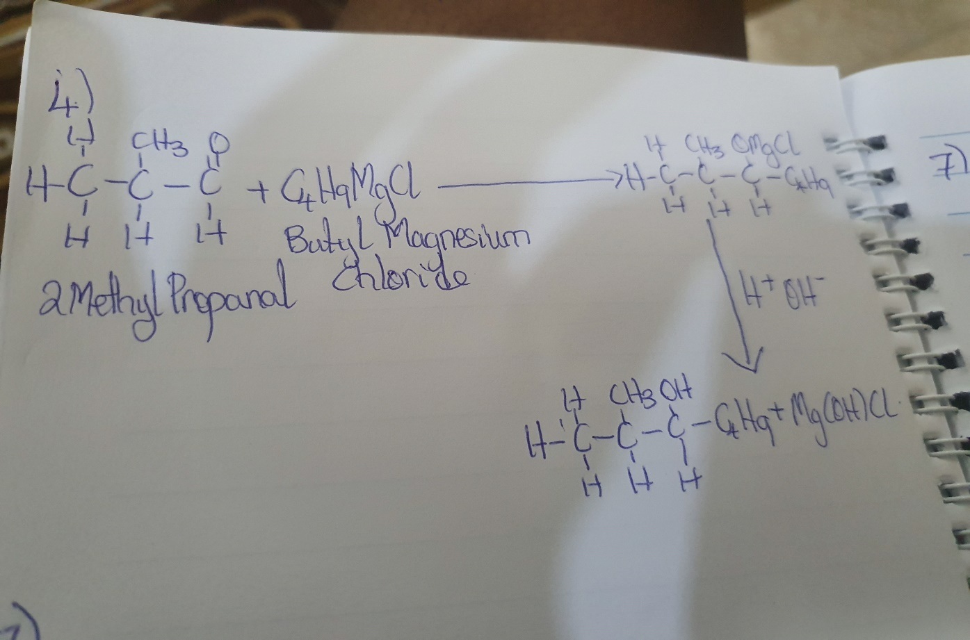

7. Show the reduction of 2-methyl propanal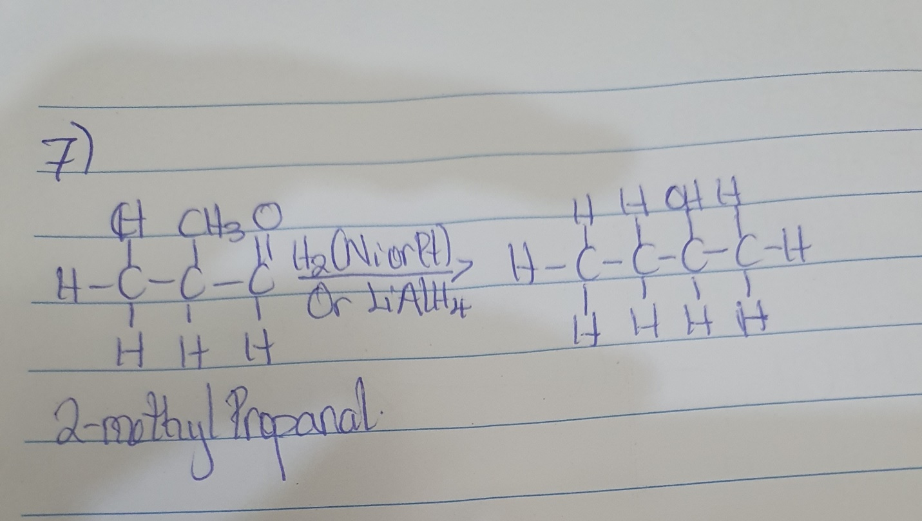
8. Propose a scheme for the conversion of propan-1-ol to propan-2-ol.