Model the operation of a permanent-magnet synchronous machine
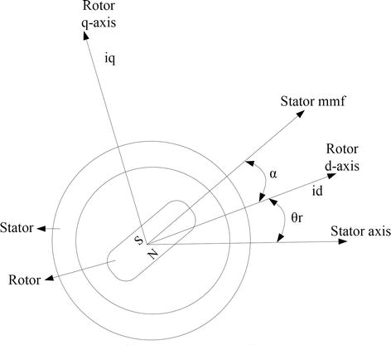
The required assumptions are obtained for the modelling of the PMSM without damper windings.
Saturation is neglected.
Induced EMF is sinusoidal in nature.
Hysteresis losses and Eddy current losses are negligible.
No field current dynamics.
Voltage equations from the model are given by,
$V q = R s i q + ω r λ d + ρλ q$equation 3
$V d = R s i d - ω r λ q + ρλ d$equation 4
Flux linkages are given by,
λ q = L q i q equation 5
λ q = L q i q + λ f equation 6
Substituting equation 5 and equation 6 into equation 3 and equation 4
V q = R s i q + ω r L d i d + λ f + ρ L d i d equation 7
V d = R s i d − ω r L q i q + ρ L d i d + λ f equation 8
Arranging equation 7 and equation 8 in matrix form,
V q V d = R s + ρ L q ω r L d − ω r L q R s + ρ L d i q i d + ω r λ f ρλ f equation 9
The developed torque motor is being given by,
T e = 3 2 P 2 λ d i q − λ q i d equation 10
The mechanical torque equation is,
T e = T L + B ω m + J d ω m dt equation 11
Solving for the rotor mechanical speed form equation 11
ω m = ∫ T e − T L − B ω m J dt equation 12
and
ω m = ω r 2 P equation 13
In the above equations ωr is the rotor electrical speed, ωm is the rotor mechanical speed.

