NAME: ADEBIYI ITUNUNOLUWA ISAAC
MATRIC NO: 18/MHS01/013
DEPARTMENT: ANATOMY
COURSE: PHS 204

QUESTION: Discuss lactation and gestation period in a normal female
Lactation is the process by which milk is synthesized and secreted from the mammary glands of the postpartum female breast in response to an infant sucking at the nipple. Breast milk provides ideal nutrition and passive immunity for the infant, encourages mild uterine contractions to return the uterus to its pre-pregnancy size (i.e., involution), and induces a substantial metabolic increase in the mother, consuming the fat reserves stored during pregnancy.

STRUCTURE OF THE LACTATING BREAST
Mammary glands are modified sweat glands. The non-pregnant and non-lactating female breast is composed primarily of adipose and collagenous tissue, with mammary glands making up a very minor proportion of breast volume. The mammary gland is composed of milk-transporting lactiferous ducts, which expand and branch extensively during pregnancy in response to estrogen, growth hormone, cortisol, and prolactin. Moreover, in response to progesterone, clusters of breast alveoli bud from the ducts and expand outward toward the chest wall. Breast alveoli are balloon-like structures lined with milk-secreting cuboidal cells, or lactocytes, that are surrounded by a net of contractile myoepithelial cells. Milk is secreted from the lactocytes, fills the alveoli, and is squeezed into the ducts. Clusters of alveoli that drain to a common duct are called lobules; the lactating female has 12–20 lobules organized radially around the nipple. Milk drains from lactiferous ducts into lactiferous sinuses that meet at 4 to 18 perforations in the nipple, called nipple pores. The small bumps of the areola (the darkened skin around the nipple) are called Montgomery glands. They secrete oil to cleanse the nipple opening and prevent chapping and cracking of the nipple during breastfeeding.

THE PROCESS OF LACTATION
The pituitary hormone prolactin is instrumental in the establishment and maintenance of breast milk supply. It also is important for the mobilization of maternal micronutrients for breast milk.
Near the fifth week of pregnancy, the level of circulating prolactin begins to increase, eventually rising to approximately 10–20 times the pre-pregnancy concentration. We noted earlier that, during pregnancy, prolactin and other hormones prepare the breasts anatomically for the secretion of milk. The level of prolactin plateaus in late pregnancy, at a level high enough to initiate milk production. However, estrogen, progesterone, and other placental hormones inhibit prolactin-mediated milk synthesis during pregnancy. It is not until the placenta is expelled that this inhibition is lifted and milk production commences.
After childbirth, the baseline prolactin level drops sharply, but it is restored for a 1-hour spike during each feeding to stimulate the production of milk for the next feeding. With each prolactin spike, estrogen and progesterone also increase slightly.
When the infant suckles, sensory nerve fibers in the areola trigger a neuroendocrine reflex that results in milk secretion from lactocytes into the alveoli. The posterior pituitary releases oxytocin, which stimulates myoepithelial cells to squeeze milk from the alveoli so it can drain into the lactiferous ducts, collect in the lactiferous sinuses, and discharge through the nipple pores. It takes less than 1 minute from the time when an infant begins suckling (the latent period) until milk is secreted (the let-down). Figure 1 summarizes the positive feedback loop of the let-down reflex.
GESTATION PERIOD IN A NORMAL FEMALE
Human Gestation
Twenty-four hours before fertilization, the egg has finished meiosis and becomes a mature oocyte. When fertilized (at conception) the egg becomes known as a zygote. The zygote travels through the oviduct to the uterus (Figure 1). The developing embryo must implant into the wall of the uterus within seven days, or it will deteriorate and die. The outer layers of the zygote (blastocyst) grow into the endometrium by digesting the endometrial cells, and wound healing of the endometrium closes up the blastocyst into the tissue. Another layer of the blastocyst, the chorion, begins releasing a hormone called human beta chorionic gonadotropin (β-HCG) which makes its way to the corpus luteum and keeps that structure active. This ensures adequate levels of progesterone that will maintain the endometrium of the uterus for the support of the developing embryo. Pregnancy tests determine the level of β-HCG in urine or serum. If the hormone is present, the test is positive.
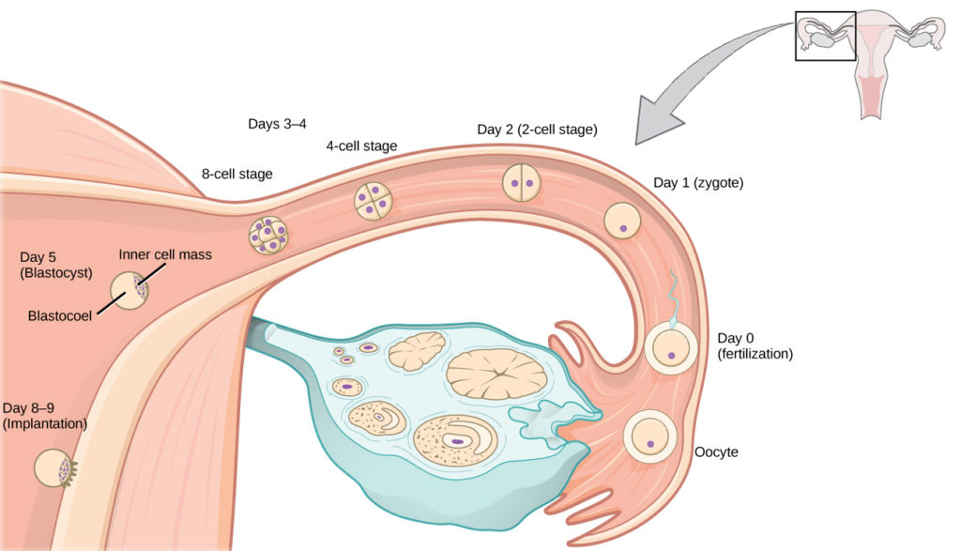
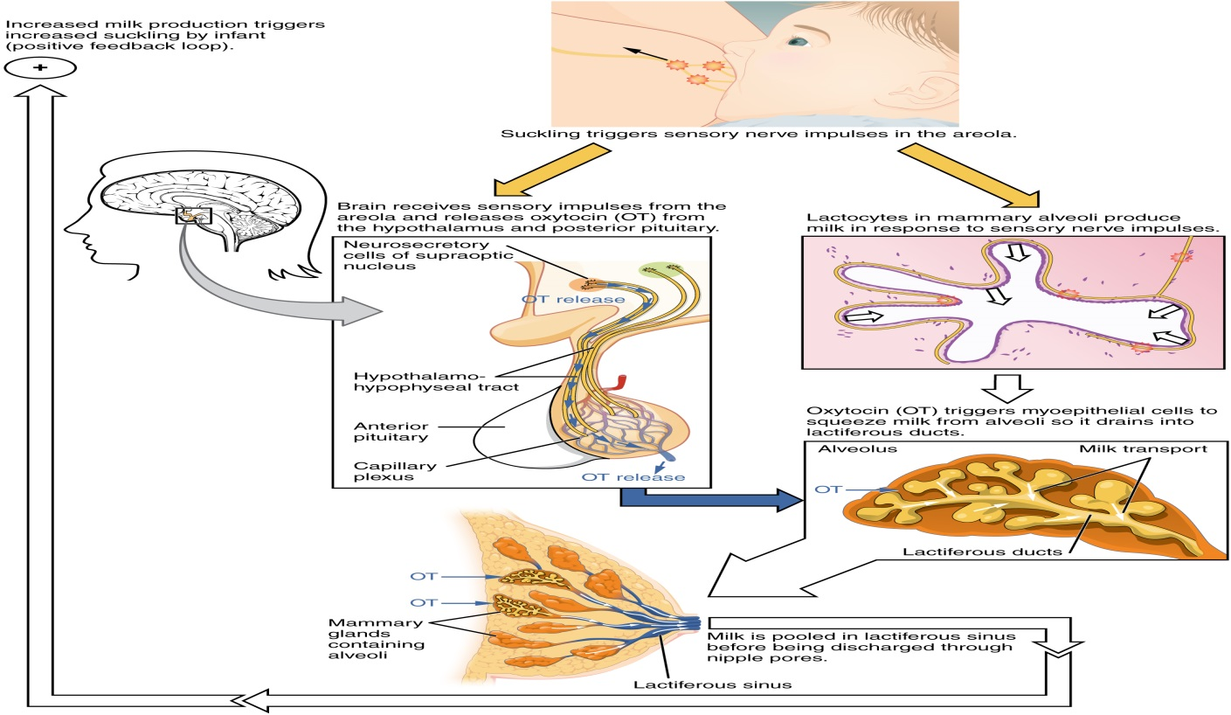Figure 1. Let-Down Reflex. A positive feedback loop ensures continued milk production as long as the infant continues to breastfeed.
The prolactin-mediated synthesis of milk changes with time. Frequent milk removal by breastfeeding (or pumping) will maintain high circulating prolactin levels for several months. However, even with continued breastfeeding, baseline prolactin will decrease over time to its pre-pregnancy level. In addition to prolactin and oxytocin, growth hormone, cortisol, parathyroid hormone, and insulin contribute to lactation, in part by facilitating the transport of maternal amino acids, fatty acids, glucose, and calcium to breast milk.
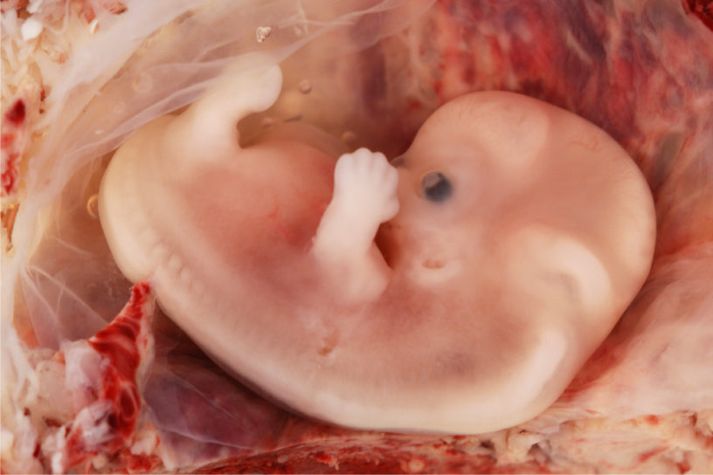 FIG FIG 2. Fetal development is shown at nine weeks gestation.
The gestation period is divided into three equal periods or trimesters. During the first two to four weeks of the first trimester, nutrition and waste are handled by the endometrial lining through diffusion. As the trimester progresses, the outer layer of the embryo begins to merge with the endometrium, and the placenta forms. This organ takes over the nutrient and waste requirements of the embryo and fetus, with the mother’s blood passing nutrients to the placenta and removing waste from it.
Chemicals from the fetus, such as bilirubin, are processed by the mother’s liver for elimination. Some of the mother’s immunoglobulins will pass through the placenta, providing passive immunity against some potential infections.
Internal organs and body structures begin to develop during the first trimester. By five weeks, limb buds, eyes, the heart, and liver have been basically formed. By eight weeks, the term fetus applies, and the body is essentially formed, as shown in Figure 2.
The individual is about five centimeters (two inches) in length and many of the organs, such as the lungs and liver, are not yet functioning. Exposure to any toxins is especially dangerous during the first trimester, as all of the body’s organs and structures are going through initial development. Anything that affects that development can have a severe effect on the fetus’ survival.
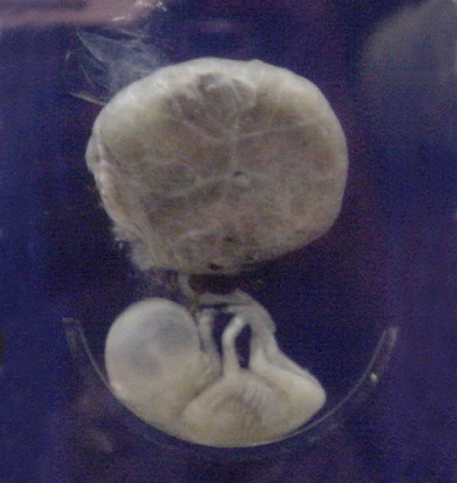 Figure 3. This fetus is just entering the second trimester, when the placenta takes over more of the functions performed as the baby develops. (credit: National Museum of Health and Medicine)
During the second trimester, the fetus grows to about 30 cm (12 inches), as shown in Figure 3. It becomes active and the mother usually feels the first movements. All organs and structures continue to develop.
The placenta has taken over the functions of nutrition and waste and the production of estrogen and progesterone from the corpus luteum, which has degenerated. The placenta will continue functioning up through the delivery of the baby.
During the third trimester, the fetus grows to 3 to 4 kg (6 ½–8 ½ lbs.) and about 50 cm (19–20 inches) long, as illustrated in Figure 4. This is the period of the most rapid growth during the pregnancy. Organ development continues to birth (and some systems, such as the nervous system and liver, continue to develop after birth).
REFRENCES:
https://courses.lumenlearning.com/wm-biology2/chapter/human-gestation/
https://www.betterhealth.vic.gov.au/health/healthyliving/baby-due-date

