Name: AGBOOLA AMOS .A.
Matric No: 15/ENG04/005
EEE 566 Assignment
Modelling of a Permanent Magnet Synchronous Machine
Abstract
The permanent-magnet synchronous machine (PMSM) drive is one of best options for a full range of motion control applications. For example, the PMSM is widely used in robotics, machine tools, actuators, and it is being considered in high-power applications such as industrial drives and vehicular propulsion. It is also used for residential/commercial applications. The PMSM is known for having low torque ripple, superior dynamic performance, high efficiency and high power density. This paper sheds lights on the types of PMSM, the modelling of PMSM, the operation of the PMSM and the various control techniques used for the operation of a PMSM.
1. Introduction
The electric motors are electromechanical machines, which are used for the conversion of electrical energy into mechanical energy. The two main categories of AC motors are asynchronous and synchronous motors. The asynchronous motors are called singly excited machines, that is, the stator windings are connected to AC supply whereas the rotor has no connection from the stator or to any other source of supply. The power is transferred from the stator to the rotor only by mutual induction, owing to which the asynchronous motors are called as induction machines.
The synchronous motors require AC supply for the stator windings and DC supply for the rotor windings. The motor speed is determined by the AC supply frequency and the number of poles of the synchronous motor, the rotor rotates at the speed of the stator revolving field at synchronous speed, which is constant. The variations in mechanical load within the machine’s rating will not affect the motor’s synchronous speed.
One of the types of synchronous motor is the PMSM. The PMSM consists of conventional three phase windings in the stator and permanent magnets in the rotor. The purpose of the field windings in the conventional synchronous machine is done by permanent magnets in PMSM. The conventional synchronous machine requires AC and DC supply, whereas the PMSM requires only AC supply for its operation. One of the greatest advantages of PMSM over its counterpart is the removal of dc supply for field excitation.
The development of PMSM has happened due to the invention of novel magnetic materials and rare earth materials. PMSM give numerous advantages in scheming recent motion management systems. Energy efficient PMSM are designed due to the availability of permanent magnet materials of high magnetic flux density.
In synchronous motors the rotor rotates at the speed of stator revolving field. The speed of the revolving stator field is called as synchronous speed. The synchronous speed (ωs ) can be found by the frequency of the stator input supply (fs ), and the number of stator pole pairs (p). The stator of a three phase synchronous motor consists of distributed sine three phase winding, whereas the rotor consists of the same number of p-pole pairs as stator, excited by permanent magnets or a separate DC supply source.

When the synchronous machine is excited with a three phase AC supply, a magnetic field rotates at synchronous speed develops in the stator. The synchronous speed of this rotating magnetic field is shown by the equation below.
N=(120fs)/P rpm
where N is the synchronous speed, fs is frequency of AC supply in Hz and P is number of poles.
2. Types of PSPM
The PMSM are classified based on the direction of field flux are as follows,
- Radial
- Axial
In radial field, the flux direction is along the radius of the machine. The radial field permanent magnet motors are the most commonly used. In axial field, the flux direction is parallel to the rotor shaft. The axial field permanent magnet motors are presently used in a variety of numerous applications because of their higher power density and quick acceleration.

3. Modeling of a PMSM
For proper simulation and analysis of the system, a complete modelling of the drive model is essential. The motor axis has been developed using d-q rotor reference frame theory as shown in Figure 1. At any particular time t, the rotor reference axis makes an angle θr with the fixed stator axis and the rotating stator mmf creates an angle α with the rotor d axis. It is viewed that at any time t, the stator mmf rotates at the same speed as that of the rotor axis.
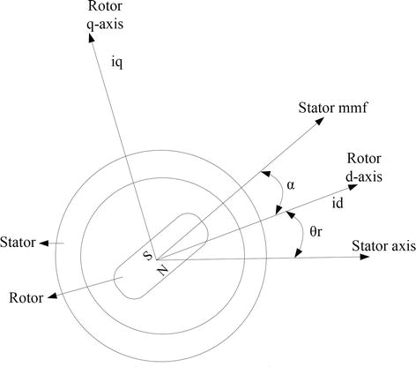
Fig 1: Diagram illustrating motor axis.

The required assumptions are obtained for the modelling of the PMSM without damper windings.
- Saturation is neglected.
- Induced EMF is sinusoidal in nature.
- Hysteresis losses and Eddy current losses are negligible.
- No field current dynamics.

Solving for the mechanical and electrical speed of the rotor, we get the equation:
Wm = Wr(2/P)

Where Wm is the mechanical speed of the rotor and Wr is the rotor electrical speed.

3.1 Parks transformation and dynamic d-q modeling
The dynamic d-q modelling of the system is used for the study of motor during transient state and as well as in the steady state conditions. It is achieved by converting the three phase voltages and currents to dqo axis variables by using the Parks transformation

3.2 Equivalent circuit of PMSM
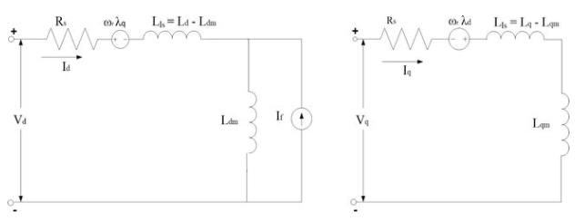
Fig 2: Equivalent circuit of PMSM without damper windings.

Equivalent circuit is essential for the proper simulation and designing of the motor. It is achieved and derived from the d-q modelling of the motor using the voltage equations of the stator. From the assumption, rotor d axis flux is represented by a constant current source which is described through the following equation,
λf=Ldmif

Where λ_{f} is field flux linkage, L_{dm} is the d-axis magnetizing inductance and i_{f} is equivalent permanent magnet field current.

3.3 Permanent magnet synchronous motor drive system

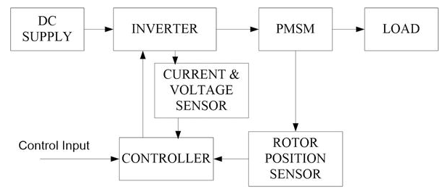

Fig 3: Overview of the PMSM model with inverter.

The motor drive essentially consists of four main components such as the PMSM, the inverter, the main control unit and the position sensor. Interconnections of the components are shown in Figure 3.

For variable frequency and magnitude, voltage source inverters are devices which convert the constant DC voltage level to variable AC voltage. As specified in the function, these inverters are commonly used in adjustable speed drives.

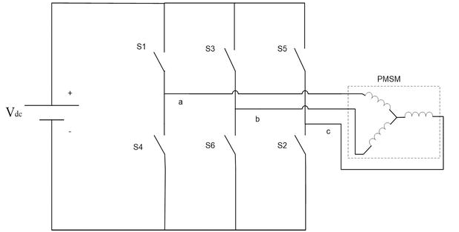

Fig 4: Diagram Voltage source inverter with DC supply and load (PMSM).

The above diagram shows a voltage source inverter with a supply voltage Vdc and with six switches. The frequency of the AC voltage can be variable or constant based on the application.
Three phase inverters consist of a DC voltage source and six power ON/OFF switches connected to the PMSM as shown in Fig 4 . Selection of the inverter switches must be carefully done based on the necessities of operation, ratings and the application. There are several devices available in the market and these are thyristors, bipolar junction transistors (BJTs), MOS field effect transistors (MOSFETs), insulated gate bipolar transistors (IGBTs) and gate turn off thyristors (GTOs). It has been inferred that MOSFETs and IGBTs are preferred in the industry because of its advantages that the MOS gating permits high power gain and control advantages. MOSFET is considered to be universal power ON/OFF device for low power and low voltage applications, whereas IGBT has wide acceptance in the motor drive applications and other application in the low and medium power range. The power devices when used in motor drives applications require an inductive motor current path provided by antiparallel diodes when the switch is turned off.

3.4 Control techniques of PMSM

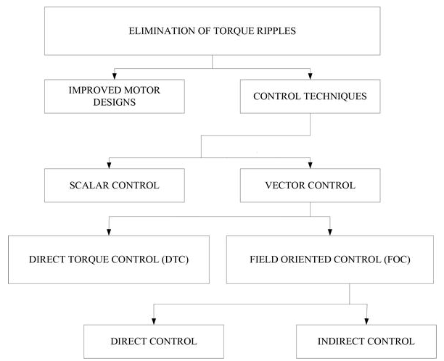
Fig 5: Diagram of classification of the various control techniques.
Many techniques based on both motor designs and control techniques are applied to diminish the torque ripples in the PMSM as shown in fig 5.

Scalar control
One way of controlling AC motors for variable speed applications is through the open loop scalar control, which represents the most popular control strategy of squirrel cage AC motors. It is presently used in applications where information about the angular speed need not be known. It is suitable for a wide range of drives as it ensures robustness at the cost of reduced dynamic performance. Typical applications are pump and fan drives and low-cost drives. The main idea of this method is the variation of the supply voltage frequency inattentively from the shaft response (position, angular speed). The magnitude of the supply voltage is changed according to the frequency in a constant ratio. The motor is then in the condition where the magnetic flux represents the nominal value and the motor is neither over excited nor under excited. The major advantage of this simple method is running in a sensorless mode because the control algorithm does not need information about the angular speed or actual rotor position. On the contrary, the significant disadvantages are the speed dependence on the external load torque, mainly for PMSM, and the reduced dynamic performances.
Vector control
The vector control of PMSM allows separate closed loop control of both the flux and torque, thereby achieving a similar control structure to that of a separately excited DC machine.
Direct torque control (DTC)
The DTC is one of the high performance control strategies for the control of AC machine. In a DTC drive applications, flux linkage and electromagnetic torque are controlled directly and independently by the selection of optimum inverter switching modes of operation. To acquire a faster torque output, low inverter switching frequency and low harmonic losses in the model, the selection is made to restrict the flux linkages and electromagnetic torque errors within the respective flux and torque hysteresis bands. The required optimal switching vectors can be selected by using the optimum switching voltage vector look-up table. This can be obtained by simple physical considerations involving the position of the stator-flux linkage space vector, the available switching vectors, and the required torque flux linkage.
4. Conclusion
A Permanent magnet synchronous motor drive is modelled. The PMSM was modelled in dq reference system with an inverter model.

