NAME: Rotimi Oluwatomini Godsfavour
MATRIC NO: 19/MHS01/387
DEPT: MBBS/MHS
COURSE CODE: CHM102
ASSIGNMENT SOLUTIONS
1. A. Based on the number of hydrogen attached to the carbon carrying the functional group.
a. Primary alcohols: if the number of hydrogen attached to the carbon carrying the -OH is 2 or 3. Eg. CH3CH2OH- ETHANOL
b. Secondary alcohols: if the number of hydrogen attached to the carbon carrying the –OH is just 1. Eg. CH3CHOHCH3- PROPAN-2-OL
c. Tertiary alcohols: if there is no hydrogen atom attached to the carbon carrying the hydroxyl group.Eg. (CH3)3OH- 2METHYL-PROPAN-2OL
B. Based on the number of hydroxyl groups present in the compound.
a. Monohydric alcohols: they are alcohols with just one hydroxyl group. Eg. CH3CH2CH2OH- PROPANOL
b. Dihydric alcohols: they have 2 hydroxyl groups. Eg. CH2(OH)CH2(OH)- ETHAN-1,2-DIOL
c. Trihydric alcohols: they have 3 hydroxyl groups. Eg:PROPAN1,2,3-TRIOL---- CH2(OH)CH(OH)CH2(OH)

2. Alcohols especially those with 3 and less number of carbon atoms in their molecules are soluble in water because they can form hydrogen with water molecules. Also, all monohydric alcohols are soluble in organic solvents.

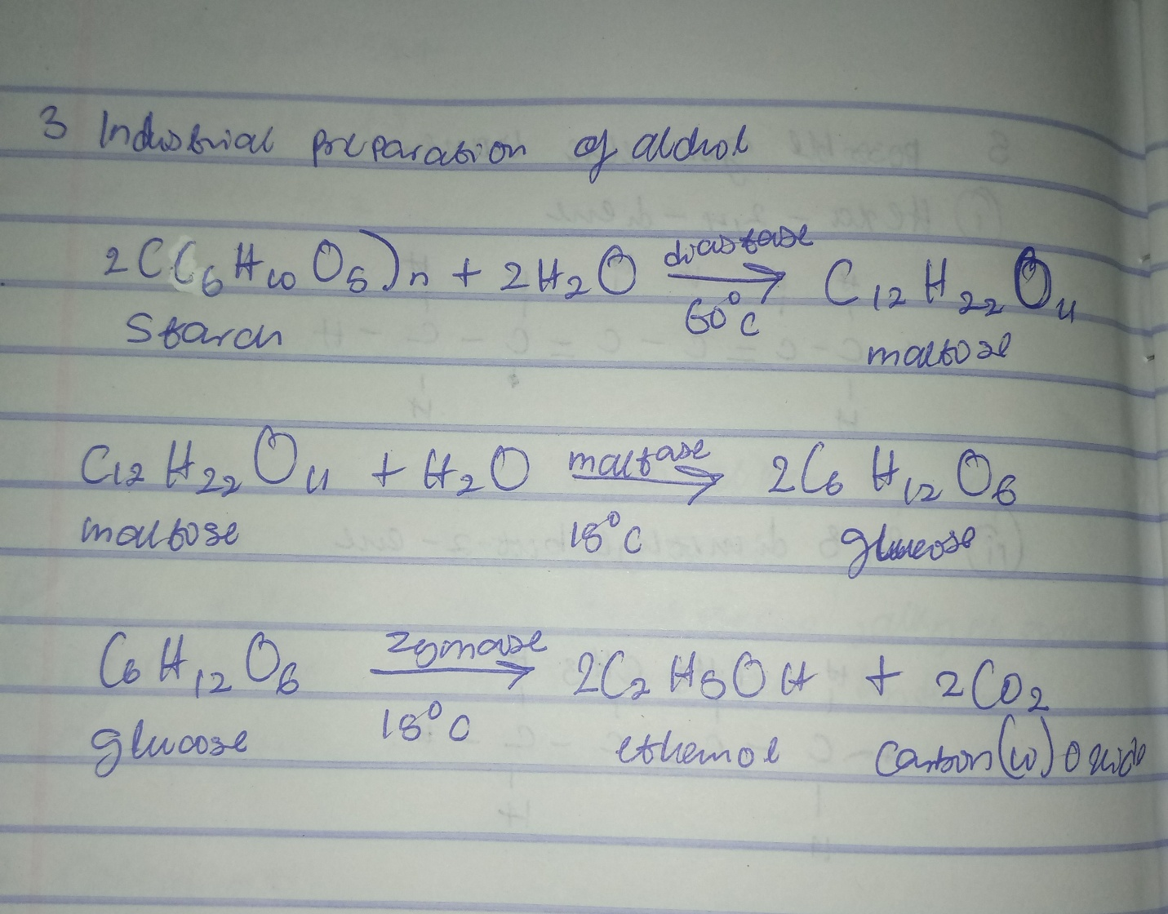
3. INDUSTRIAL PREPARATION OF ETHANOL

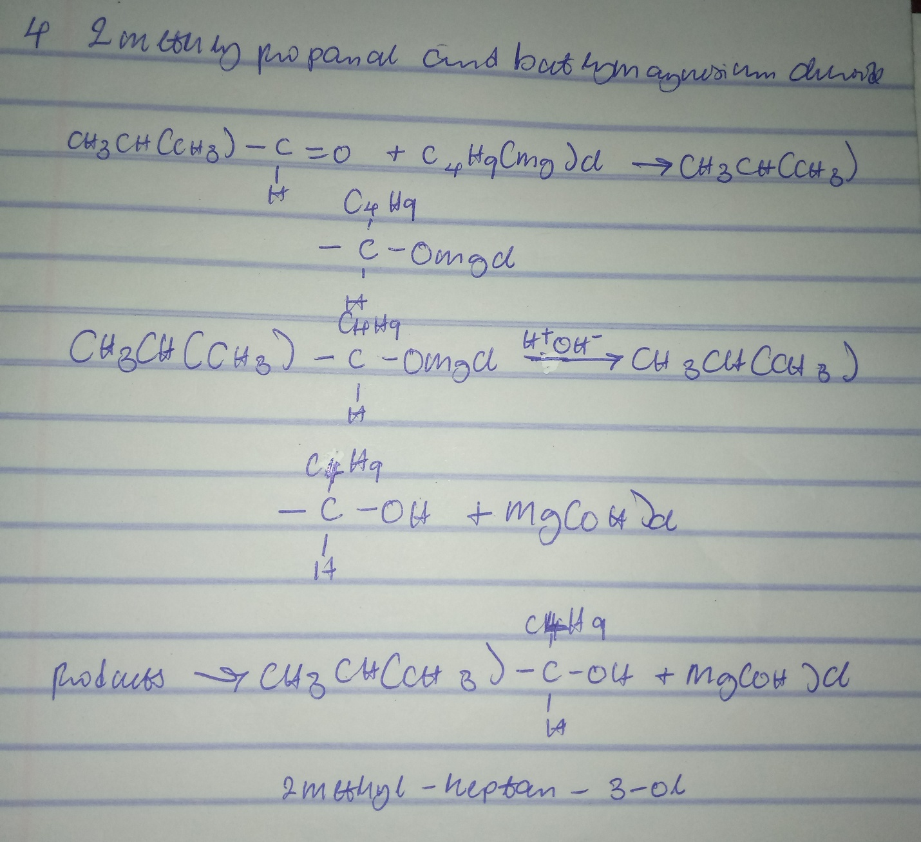
4. 2- Methyl propanal and butylmagnesiumchloride

Questions 5 and 6 are not correct.

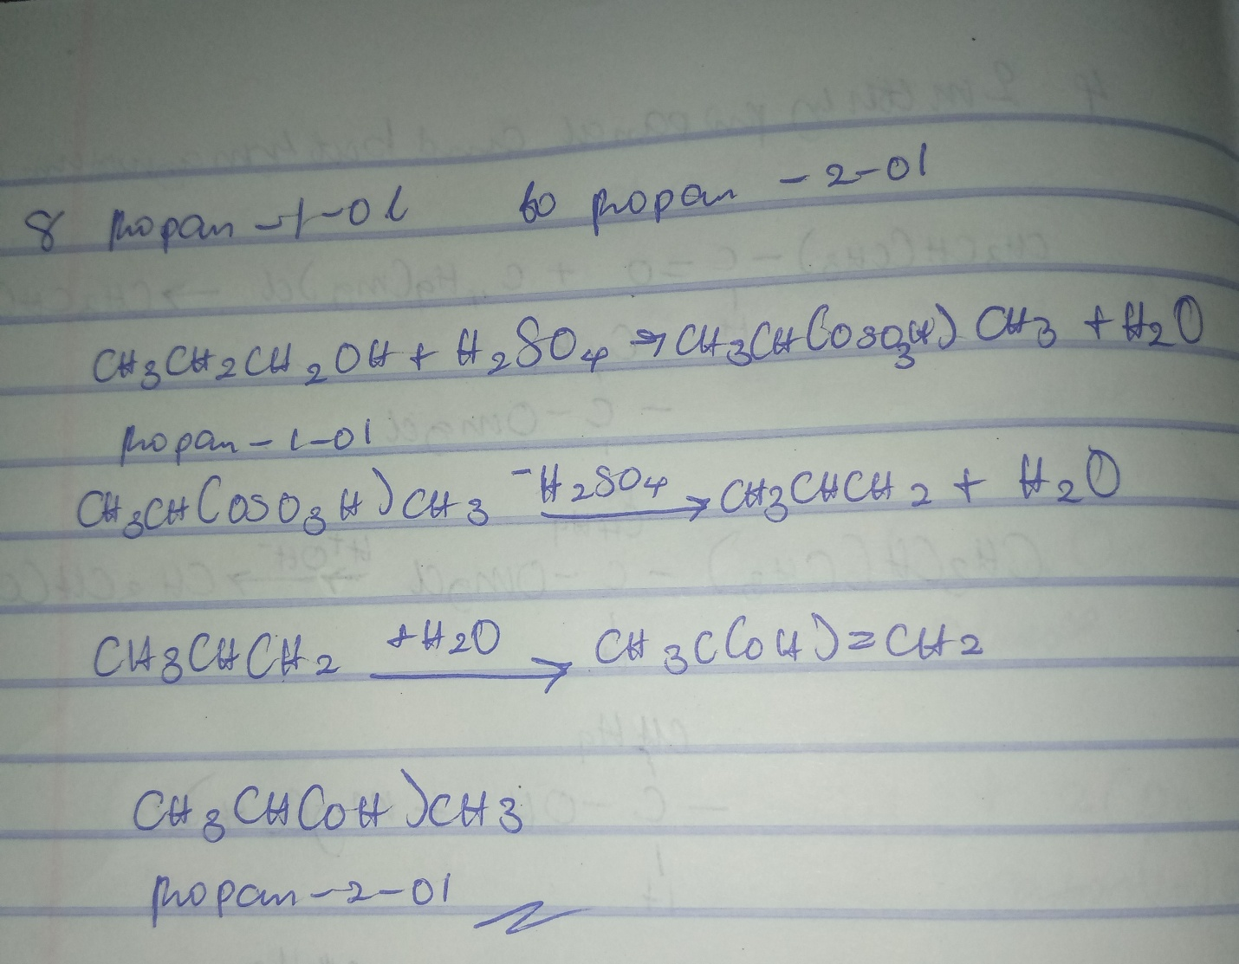
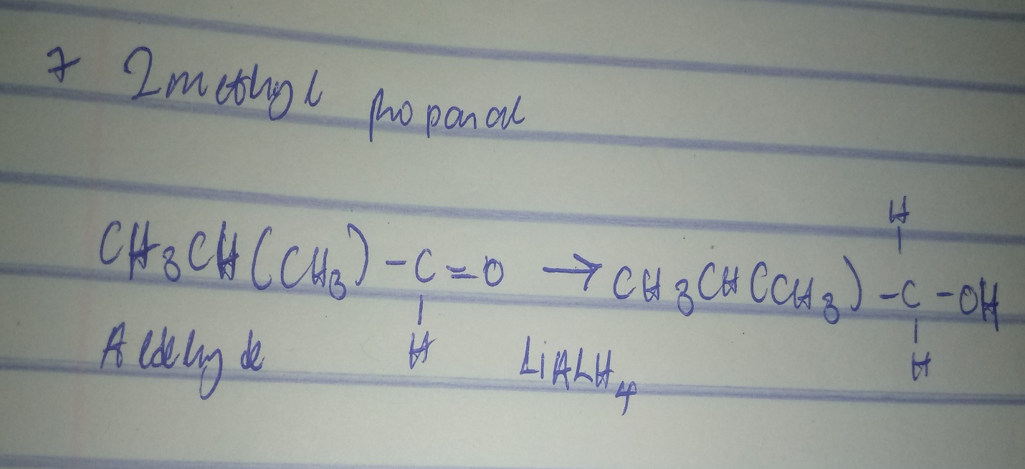
7. reduction of 2 methyl propanal.
8.conversion of propan-1-ol to propan-2-ol.

