NAME: OSIBANJO IYANUOLUWA A.
MATRIC NO: 17/MHS03/029
COURSE CODE: ANA 314

- Comment on the relevance of comparative anatomy to evolution
Comparative anatomy is the study of similarities and differences in the anatomy of different species.
Its relevance to evolution
Comparative anatomy is an important tool that helps determine evolutionary relationships between organisms and whether or not they share common ancestors. However, it is also important evidence for evolution.
Anatomical similarities between organisms support the idea that these organisms evolved from a common ancestor. Organisms that are closely related to one another share many anatomical similarities.
Sometimes the similarities are obvious, as between crocodiles and alligators, but in other cases considerable study is needed for a full appreciation of relationships. An example is on whales and hummingbirds have skeletons inherited from a common ancestor. Their bodies have been modified and parts have been lost through natural selection, resulting in adaptation to their respective lifestyles over millions of years.
On the surface, these animals look very different, but the relationship between them is easy to demonstrate. Except for those bones that have been lost over time, nearly every bone in each corresponds to an equivalent bone in the other.
It is closely related to evolutionary biology and phylogeny (the evolution of species). The study of comparative anatomy predates the modern study of evolution. Early evolutionary scientists like Buffon and Lamarck used comparative anatomy to determine relationships between species.
Organisms with similar structures, they argued, must have acquired these traits from a common ancestor.
An example is with humans and the great apes (large apes) chimpanzees, bonobos, orangutans and gorillas -- share a common ancestor that lived between 6 to 8 million years ago

2. Discuss the types of comparative anatomy with relevant examples
They are classified based on:
- Homologous structures
- Analogous structures
- Vestigial structures

Homologous structures:
These are organs with similar structure, but different functions
An example is with the bones in the forelimb of the human, whale, cat, bat, bird, alligator are used for vastly different movement, they all have remarkably similar structure and organization (bones, nerves, blood vessels)
This indicated common ancestry (DNA)
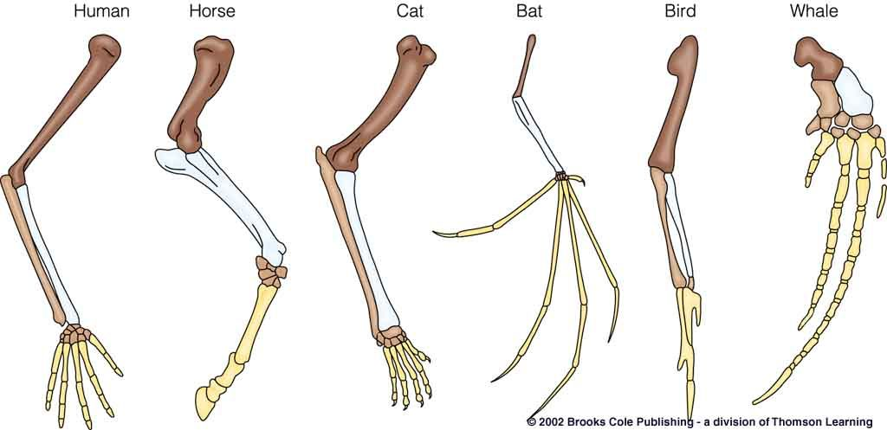

Analogous Structures
These are features of different species that are similar in function but are structurally different or have different anatomies but similar function.
These are seen on organisms that are not necessarily closely related, but live in similar environments and have similar adaptations. They do not have a common ancestry. They evolved due to a similar environmental challenge.
An example is birds & insects have wings to fly although their wing structure is different.
Another example is Fat insulated, streamlined shapes of seals & penguins
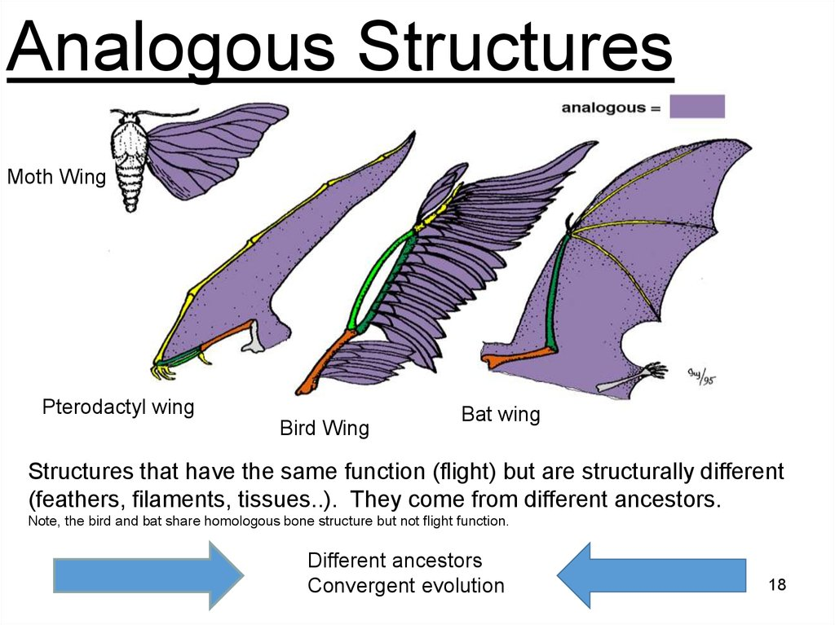

Vestigial Structures
They are structures in the body of animals which seem to be of no use to them
In other species, the same structures exist and they have a definite function
An example is in Dogs & humans, they have a similar set of muscles attached to their ears
The dog can use these to “point” its ears in the direction of a sound, humans cannot
In humans the appendix, coccyx and hair are all vestigial structures.
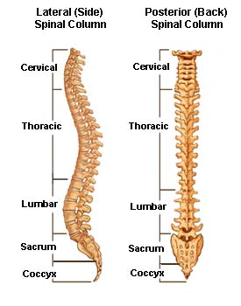
Diagram of the spinal cord
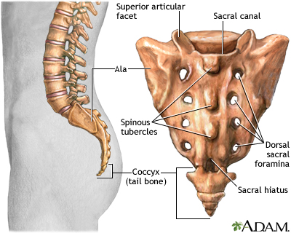
Diagram showing the coccyx

