NAME: OLANIYAN TAWAKKALT MOROTIOLUWA
MATRIC NO: 18/MHS01/281
DEPARTMENT: MEDICINE AND SURGERY
LEVEL: 200L
COURSE: ANATOMY (EMBRYOLOGY)

SECOND WEEK OF DEVELOPMENT
Day 8
At the eighth day of development the blastocyst is partially embedded in the endometrium. The syncytiotrophoblast continues it invasion of the endometrium, eroding endometrial blood vessels and endometrial glands. More cells in the cytotrophoblast divide and migrate into the syncytiotrophoblast where they fuse and lose their individual cell membranes. The cells of the embryoblast also differentiate into:
- The hypoblast layer which is made up of small cuboidal cells nearer to the blastocystic cavity
- The epiblast layer which is made of columnar cells and is nearer to the amniotic cavity
These two layers form a flat ovoid shaped disc called the bilaminar embryonic disc. Epiblasts near cytotrophoblast are called amnioblasts
Day 9
The blastocyst is more deeply embedded in the endometrium and the penetration defect in the surface surface epithelium is closed by a fibrin coagulum. Vacuoles appear at the region of the trophoblast and they fuse to form larger lacunae. This phase is called the lacunar stage. The cells of the hypoblast near the cytotrophoblast form a thin membrane called the exocoelomic (heuser) membrane which lines the inner cytotrophoblast. This membrane, together with the hypoblast forms the lining of the exoceolomic cavity or primitive yolk sac.
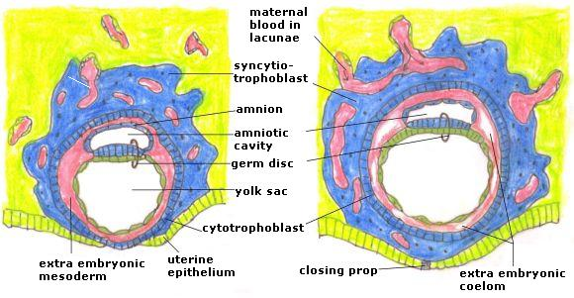
Day 11-12
The blastocyst is completely embedded in the endometrium and the surface epithelium almostentirely covers the original defect in the uterine wall. The blastocyst now produces a slight protusion in the lumen of the uterus. The syncytiotrophoblast penetrate deeper into the stroma and erode the endothelial lining of the endometrial capillaries. The ruptured capillaries are called sinusoids. The maternal blood then begins to enter the lacunar system. This establishes a primordial uteroplacental circulation which supplies the embryo with oxygen and nutrients. A new population of cells appear between the inner cell surface of the cytotrophoblast and the outer surface of the extracoelomic cavity. These cells form a fine loose connective tissue called the extraembryonic mesoderm. Soon large cavities form in the extraembryonic mesoderm called the chorionic cavity.

Day 13
The surface defect is completely covered by the surface epithelium. Occasional bleeding occurs at the implantation site as a result of increased blood flow into the lacunar. The cells of the cytotrophoblast proliferate locally and penetrate into the syncytiotrophoblast, forming cellular columns known as primary villi. The primary yolk sac becomes reduced in size and is known as the secondary yolk sac. During its formation, large portions of the exocoelomic cavity are pinched off to form exocoelomic cysts. The extraembryonic coelom expands and forms a large cavity called the chorionic cavity. The extraembryonic mesoderm lining the inside of the cytotrophoblast is then known as chorionic plate. The only place the extraembryonic mesoderm traverses the chorionic cavity is in the connecting stalk. With the development of blood vessels, the connecting stalk becomes the umbilical cord
