NATASHA GIMBIYA DANIEL
17/MHS01/094
ANATOMY

THE IMPORTANCE OF COMPARATIVE ANATOMY TO EVOLUTION
- Comparative anatomy explores and establishes the correspondences between body parts of organisms from different species.
- Without comparative anatomy, naming and understanding what can be seen in organisms would be impossible
- It builds the concepts of the living structures
- Comparative anatomy helps to propose homology hypotheses between different organs.
- It also assists scientists in classifying organisms based on similar characteristics of their anatomical structures
THE TYPES OF COMPARATIVE ANATOMY AND EXAMPLES
There are two types of comparative anatomy and they are
- Analogous structures
- Homologous structures
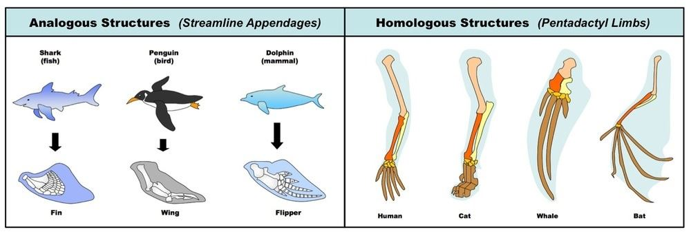

Analogous Structures

What is an analogous structure?

It is defined as biological structures having similar or corresponding functions but not from the same evolutionary origin. In other words, species use these biological structures for the same purpose and yet these species are from unrelated evolutionary lines.

EXAMPLES
- The bird’s wings are similar to human hands in the structure in comparison to insect wings. Analogous structure emerges from convergent evolution.
- The complex eyes of vertebrates, cephalopods (squid and octopus), cubozoan jellyfish, and arthropods (insects, spiders, crustaceans) evolved separately. Nevertheless, their eyes are, essentially, for the function of vision.
- The very similar shells of brachiopods and bivalve mollusks
- The organs for smell are an example of analogous organs. An analogous organ pertains to an organ that functions similarly to the organ from another yet evolutionary disparate species. The smelling organs of the terrestrial coconut crab are similar to the sensilla of insects. Both of them developed similar organs that can detect smells in the air and flick antennae for improved reception.
Homologous Structures
What is a homologous structure?
It is an example of an organ or bone with similar underlying anatomical features found in different animals. These structures support the idea that the different animals descend from a common ancestor and serve as evidence of evolution.
In other words, these examples of homology occur when very different animals have bones or other structures that appear very similar in form but not in function. Meaning that, despite their outward differences, animals with homologous structures are somehow related.

Examples
- A dolphin's flipper, a bird's wing, a cat's leg, and a human arm are considered homologous structures. Whereas human beings have bones such as the humerus (upper arm), ulna and radius (forearm), carpals (wrist bones), metacarpals (hand bones), and phalanges (fingers), these features appear as similar bones in form in the other animals. Bats, whales, and many other animals have very similar homologous structures, demonstrating that these creatures all had a common ancestor.
- The tailbone in human beings is so-named because it is a homologous structure to the beginning of many animals' tails, such as monkeys. It is known as a "vestigial structure" because it is the last vestige of what was once a tail. This structure serves as evidence of having a common ancestor, one that would have had a tail.
- All mammals share the homologous structure of the vertebrae in common. For instance, in spite of its height, the giraffe has the very same number of neck bones (seven) as a giant whale and a tiny human being.
- Human beings, dogs, and cats all have similar pelvises, which are homologous structures to a vestigial pair of bones in snakes. These bones in snakes are the last remains of a pelvis, with no legs to attach.
- Human eyes are homologous to the eye bulbs which blind creatures that live in caves -- like cave fish -- have on their heads.

For instance whales, birds and humans all possess the same arm bone structure.

Another example of the homologous structure is forelimb structure that is similar to whales and cats. At first glance, we may not think that humans and whales are closely related but several million years ago there existed an ancestor that was similar to both humans and whales. The offspring that evolved was a new species. Furthermore, even newer species were evolved from those species.

