NAME: OKEDARE ADESEWA JULIET
MATRIC NUMBER: 19/MHS02/091
DEPARTMENT: NURSING
COURSE CODE: CHM102
COURSE TITLE: GENERAL CHEMISTRY 102
LEVEL: 100 Level

- Alcohols are very important organic compounds. Discuss briefly their classification and give one example each.
- Alcohol can be classified based on the number of hydrogen atoms attached to the carbon atom containing the hydroxyl group. If the numbers of hydrogen atoms attached to the carbon atom bearing the hydroxyl group are three or two, it is called a primary alcohol$(1^{o})$. If it is one hydrogen atom, it is called a secondary alcohol$(2^{o})$ and if no hydrogen atom is attached the carbon atom bearing the hydroxyl group, it is called a tertiary alcohol$(3^{o})$.

Examples are: $({CH}_{3}{CH}_{2}OH)$-----Ethanol
$({CH}_{3}CH(OH){CH}_{3})$--------Propan-2-ol$(2^{o})$.
- Alcohol can also be classified based on the number of hydroxyl groups they possess. Monohydric alcohols have one hydroxyl group present in the alcohol structure. Dihydric alcohols are also called Glycols have two hydroxyl groups present while trihydric alcohols or triols have three hydroxyl group.

Examples are: ${CH}_{3}{CH}_{2}{CH}_{2}OH$----Propanol (Monohydric alcohol)
$HO{CH}_{2}{CH}_{2}OH$------Ethane-1, 2-diol (Dihydric alcohol)

- Discuss the solubility of alcohols in water, organic solvents.
In water, alcohols with up to three carbon atoms that are lower in their molecules are soluble in water because the lower alcohols can form hydrogen bond with water molecules. The water solubility of alcohols decreases with increasing relative molecular mass.
In organic solvent, all monohydric alcohols are soluble in organic solvents but the solubility of simple alcohols and polyhydric alcohols is largely due to their ability to form hydrogen bonds with water molecules.

- Show the three steps in the industrial manufacture of ethanol. Equations of reaction are mandatory.
Production of ethanol
Carbohydrate such as starch are major group of natural compound that can be made to yield ethanol by the biological process of fermentation. The biological catalysts enzymes found in yeast break down the carbohydrate molecules.
$${2(C}_{6}H_{10}O_{5})_{n}+{nH}_{2}O-------→{nC}_{12}H_{22}O_{11}$$
Carbohydrate ${60}^{o}$/diastase maltose
The maltose is broken down into glucose on addition of yeast which contains the enzymes maltase and at a temperature of${15}^{o}$.
$$C_{12}H_{22}O_{11}+H_{2}O-------→{2C}_{6}H_{12}O_{6}$$
Maltose ${15}^{o}$/maltase glucose

The glucose at constant temperature of${15}^{o}$ is then converted into alcohols by the enzymes Zymase contained also in yeast.
$$C_{6}H_{12}O_{6}-------→{2CH}_{3}{CH}_{2}{OH+2CO}_{2}$$
Glucose ${15}^{o}$/Zymase Ethanol

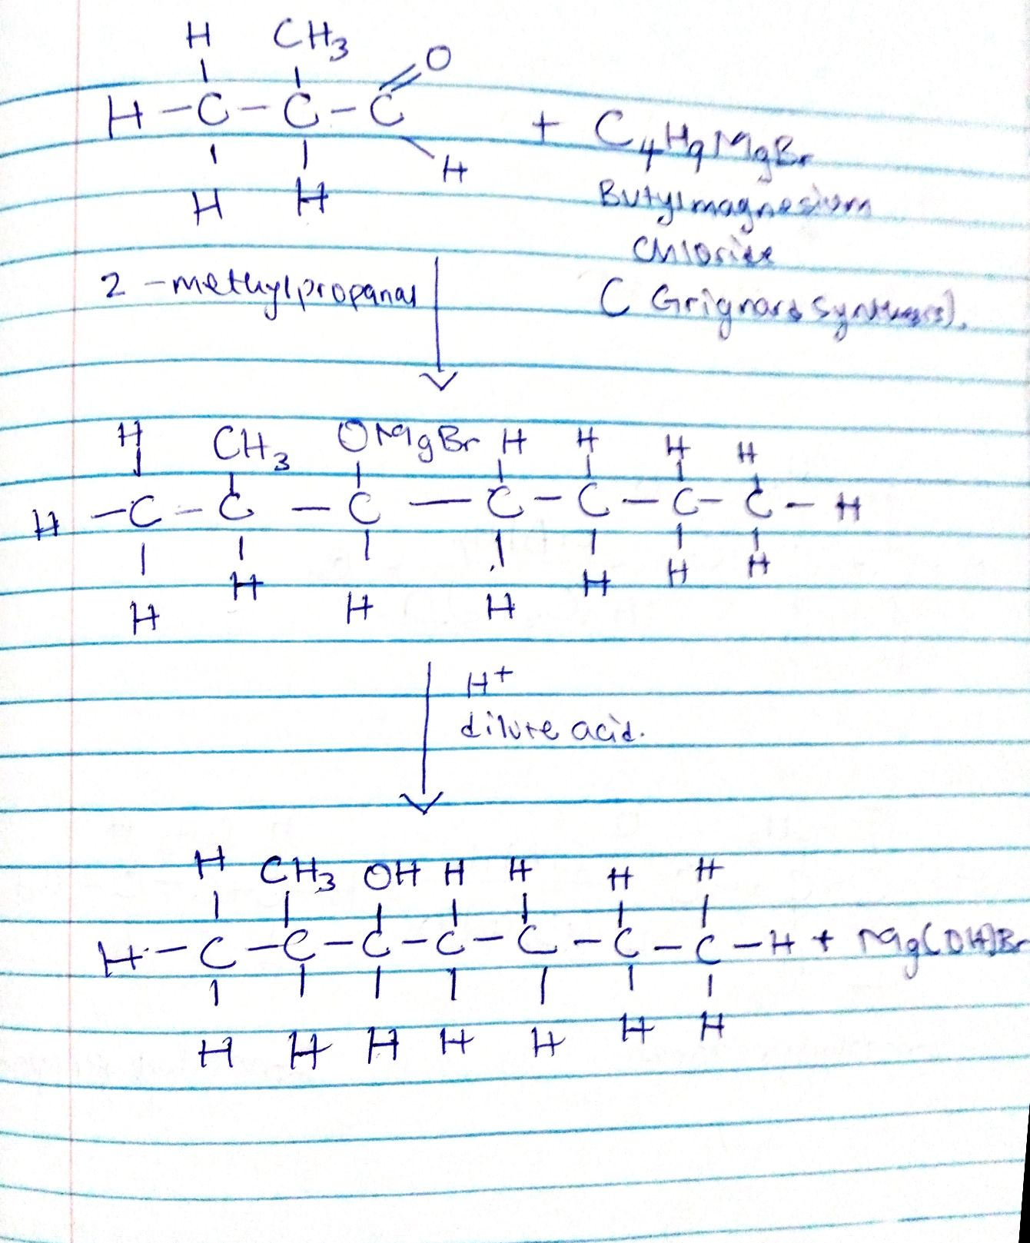
- Show the reaction between 2-methylpropanal and butylmagnesiumchloride Hint: Grignard synthesis. Note: show all structures.

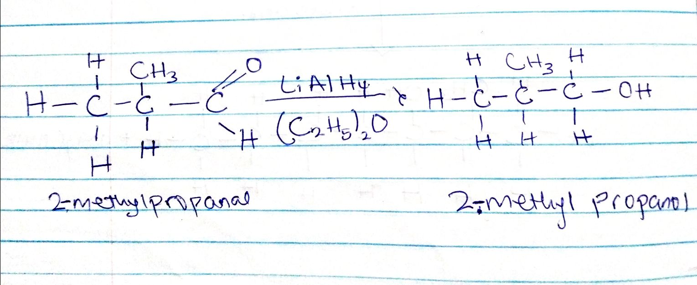
- show the reduction reaction of 2-methylpropanal

- Propose a scheme for the conversion of propan-1-ol to propan-2-ol.

${ CH}_{3}{CH}_{2}{CH}_{2}OH+ H_{2}SO_{4}----→{CH}_{3}{CH}_{2}{CH}_{2}OH_{2}OSO_{3}H$
Propan-1-ol
$-H_{2}O$
${CH}_{3}{CH}_{2}{CH}_{2}OH_{2}OSO_{3}H----→$ ${CH}_{3}{CH}_{2}{CH}_{2}OSO_{3}H$

${ -H}_{2}SO_{4}$
${CH}_{3}{CH}_{2}{CH}_{2}OSO_{3}H----→{CH}_{3}CH{CH}_{2}$
Propene
$H^{+}{OH}^{-}$
${CH}_{3}CH{CH}_{2}-----→ { CH}_{3}CHOH{CH}_{3}$
Propene Propan-2-ol

