OVBUDE IRENOISE DEBORAH

16/MHS03/026

ELECTRON MICROSCOPIC TECHNIQUE AND ULTRASTRUCTURE
ANA 402

DR OGEDENGBE OLUWATOSIN OLALEKAN
ASSIGNMENT
- DISCUSS THE PROCEDURE INVOLVED IN MAKING GLASS KNIFE FOR CUTTING IN ULTRATTHIN SECTIONS.
- DRAW A KNIFE MAKER AND LEBEL IT.

WHAT IS A GLASS KNIFE?
Glass knives are used in an ultramicrotome to cut ultrathin slices of samples for electron and light microscope applications. A glass knife is a knife with a blade composed of glass. The cutting edge of a glass knife is formed from a fracture line, and is extremely sharp (Griffiths et.al., 1983).
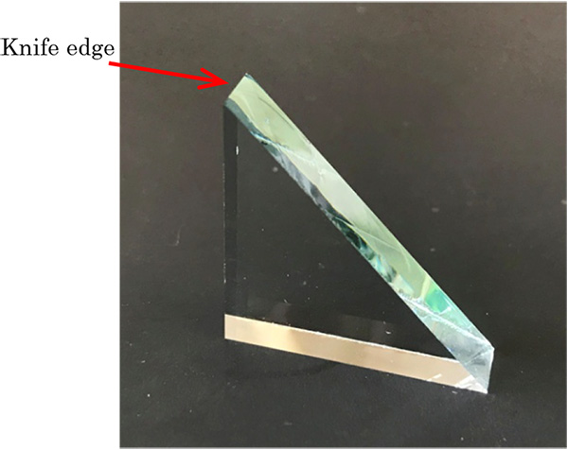
Fig.1. Image of a glass knife
GLASS KNIFE DISCRIPTION
For resin and for cryosections the knife edge must be extremely sharp, strong and stable. An important requirement for breaking glass knives of superior quality is the quality of the glass strips. Glass strips are produced from specially selected glass, the thickness and quality of which is precisely controlled. Only strict tolerances ensured by careful quality control allow breaking of two high quality knives from one square (Tokuyasu, 1986).
PROCEDURE INVOLVED IN MAKING GLASS KNIVES FOR CUTTING IN ULTRATHIN SECTIONS
The right side of a glass knife is the optimal cutting edge for microtomy if the counterpiece (heel opposite the edge) is controlled within 1 mm. The right cutting edge has been considered the "saw toothed" side and has not been used for ultrathin sectioning The right cutting edge is sharper and more durable than the left (Cai, 1997). Light and scanning electron microscopy were used to observe the cutting edge, and transmission electron microscopy was used to examine semithin and ultrathin sections of animal and plant tissues cut by the right and left sides of the cutting edge. The results indicate that the cutting edge becomes sharper and more durable from left to right. Both the quality and efficiency of ultrathin sectioning is improved by using the right cutting edge (Wang et.al., 1997). For the procedure some concepts are best followed.
Balanced Break Concept
This method is aimed at producing a break controlled straight strip of good scientific quality. It is formed by applying equal weight and pressure to each sides of the glass strip. The support equipment placed underneath the strip must avoid uncontrolled stress applied to the glass to prevent breakage by using minimum surface contact. The glass strip is then broken into two equal halves. Each broken side is then freshly planned and divided into equal halves, this is done repeatedly until certain amount of squares are produced with straight sides.
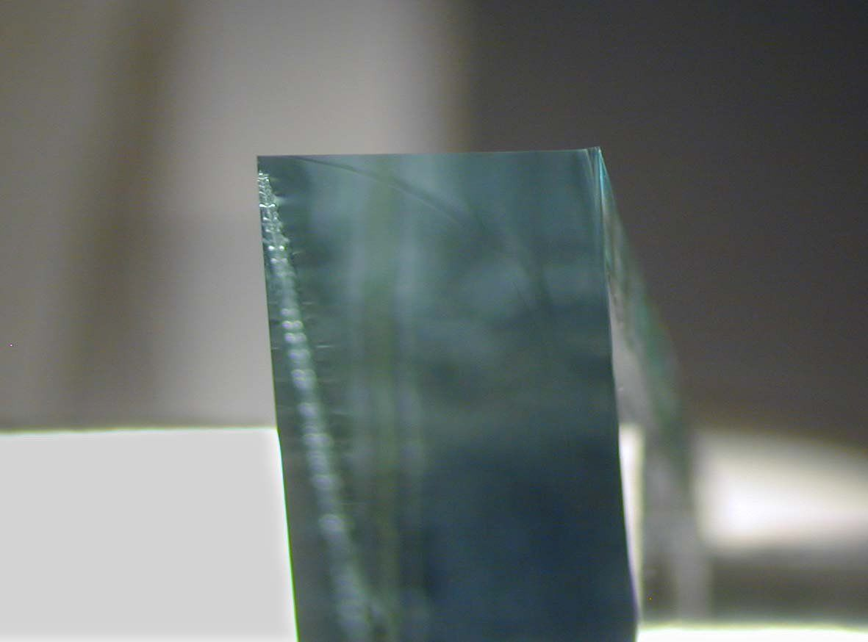
Fig.2. Showing the Edge of a Glass Knife
Scoring and Breaking Concepts
Each score is preset and equidistant from the corners of the square. During the break the glass sits on two steel hemispheres and is held from above by two pins. The break follows the score line as far as it goes and then a free break occurs. The direction of this free break is determined by the mass of the glass on either side of the break and the breaking forces.

The real knife angle
When scoring the square all scores stop some distance from the corner. When pressure is applied under the score, the fracture is initiated and is seen first as a deepening of the score. The fracture extends towards the corners of the square following the line of the score. Where the score ends and the break is free, the fracture deviates from the line of the score to curve away from the corner, towards one of the edges of the square. This results in the real angle of the knife being somewhat greater than the angle of scoring. The real angle of the knife increases as the score is moved further from the diagonal. This is when the knife shoulder becomes larger.

Length of useful edge
When a glass knife edge is examined under darkfield illumination using a stereo microscope (or using back light on an Ultramicrotomes using), it can be seen that the central part is most useful for ultrathin sectioning. The right side of the edge has visible marks which reduce the quality of the knife, and the left corner is also unsuitable for sectioning because of the stress line. The useful knife edge starts where the stress line moves away from the knife edge until the part where the stress marks can be seen.

Evaluation of the knife edge
After making a pair of knives, evaluation of the quality can be carried out in an ultramicrotome.Using the backlight illumination and setting the clearance angle to maximum a fine white line can be seen. The image of the line indicates the quality of the knife edge, which must be straight, free of any dirt such as dust, grease and finger prints and free of glass splinters.

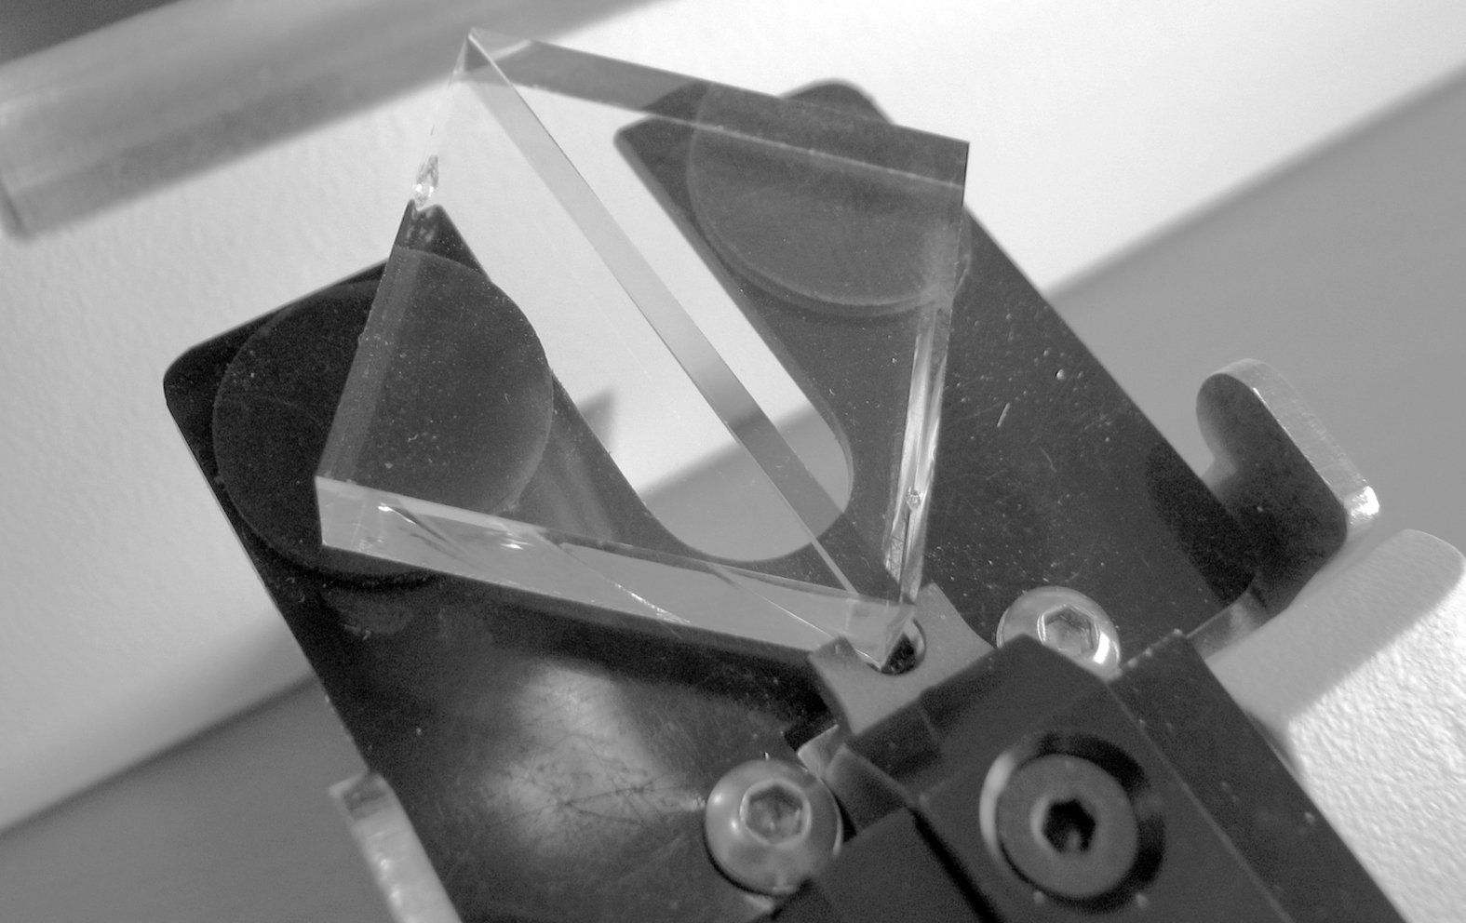
Fig.3. Image showing the final picture of the made glass knives

DRAW A KNIFE MAKER AND LEBEL IT.
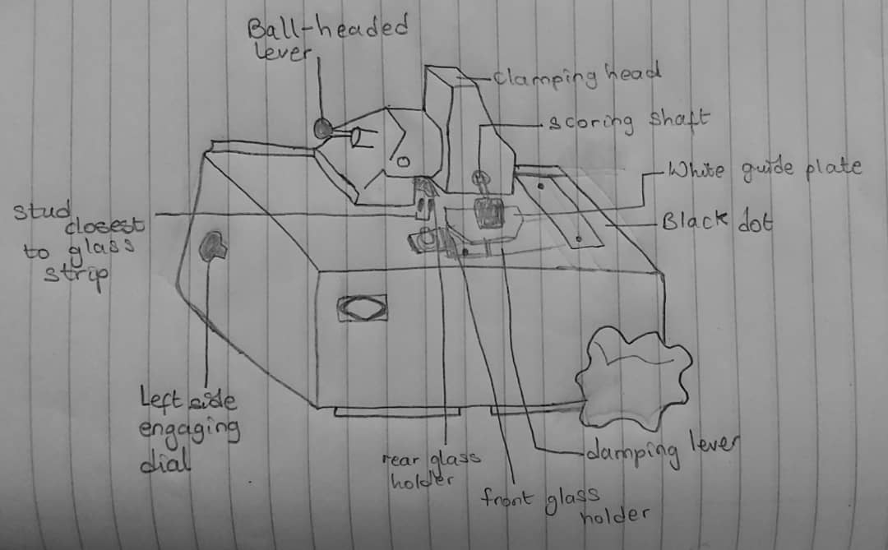

REFERENCE
Wang W, Cai Z, Du K. (1997). Improved methods for making and using glass knives. PubMed. Pg.72(3):129-34. https://www.ncbi.nlm.nih.gov/pubmed/9187734.
Griffiths G, Simons K, Warren G and Tokuyasu KT: Immunoelectron microscopy using thin, frozen sections: Application to studies of the intracellular transport of Semliki Forest virus spike glycoproteins. In: Methods in Enzymology 466–485 (1983).
Tokuyasu KT: Application of cryoultramicrotomy to immunocytochemistry. Journal of Microscopy 143 (2): 139–149 (1986).

