NAME: ADEKUNLE USMAN.O
MATRIC NO.: 18/MHS01/017

SECOND WEEK OF DEVELOPMENT

DAY 8;
;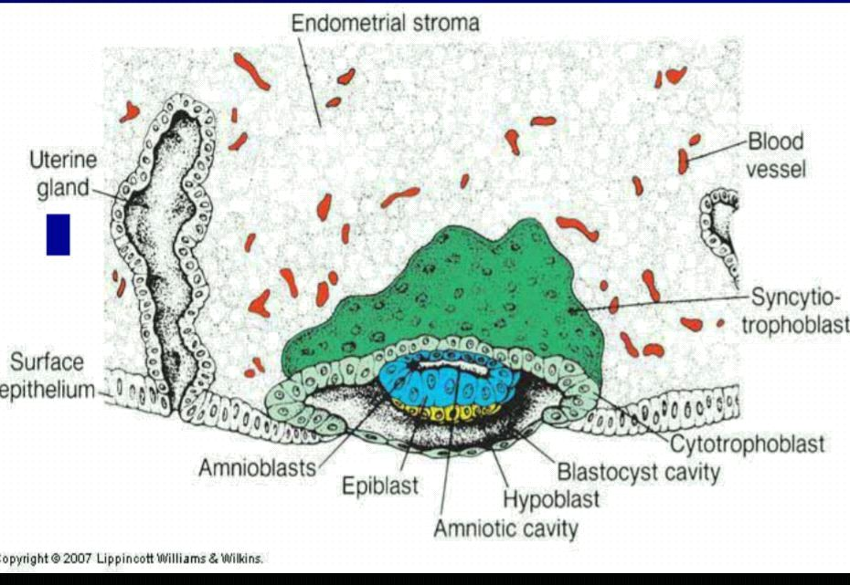
At day 8 of development, the blastocyst is partially embedded in the endometrial stroma. In the area over the embryoblast, the trophoblast has differentiated into two layers:
- Cytotrophoblast:an inner layer of mononucleated cells
- Syncytiotrophoblast:an outer multinucleated zone without distinct cell boundaries.
Mitotic figures are found in the cytotrophoblast but not in the syncytiotrophoblast. Thus cells in the cytotrophoblast divide and migrate into the syncytiotrophoblast where they fuse and lose their individual cell membranes.
Cells of embroyoblast also differentiate into two layers;
(i)Hypoblast: a layer of small cuboidal cells adjacent to the blastocyst cavity.
(ii)Epiblast: a layer of high columnar cells adjacent to the amniotic cavity.
Together the layers form a flat disc. At the same time a small cavity appears within the epiblast which enlarge to fom amniotic cavity and the epiblast cells adjacent to the cytotrophoblast are called amnioblast and line the amniotic cavity together with the rest of epiblast.
DAY 9;
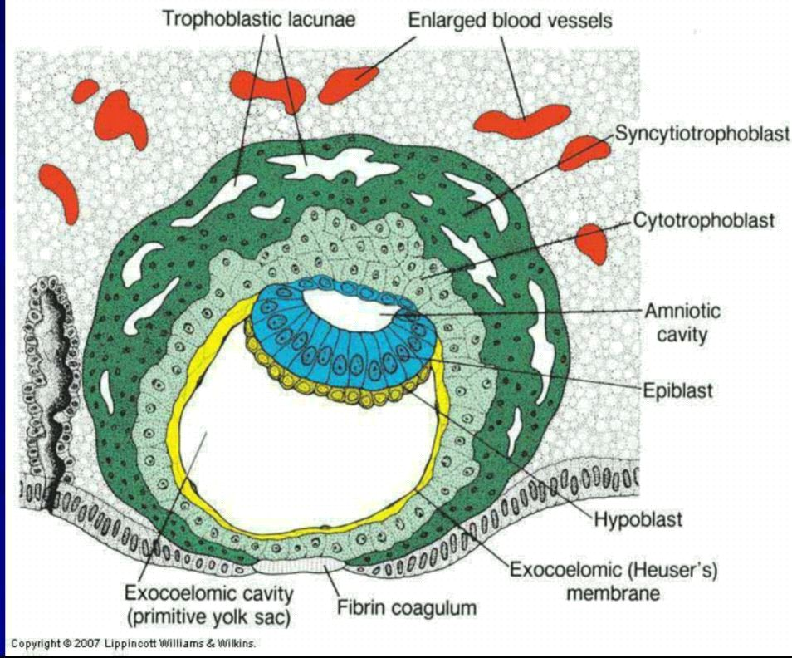
The blastocyst is more deeply embedded in the endometrium and the penetration defect in the surface epithelium is closed a fibrin coagulum. Vacuoles lacunae, and this phase of trophoblast development is known as lacunae stage. At the embryonic pole, flattened cells probably originating from the hypoblast form a thin membrane called excoelomic(Heuser) membrane that lines the inner surface of the cytotrophoblast. This membrane together with the hypoblast forms the lining of the excoelomic cavity/primitive yolk sac,
DAY 11&12;
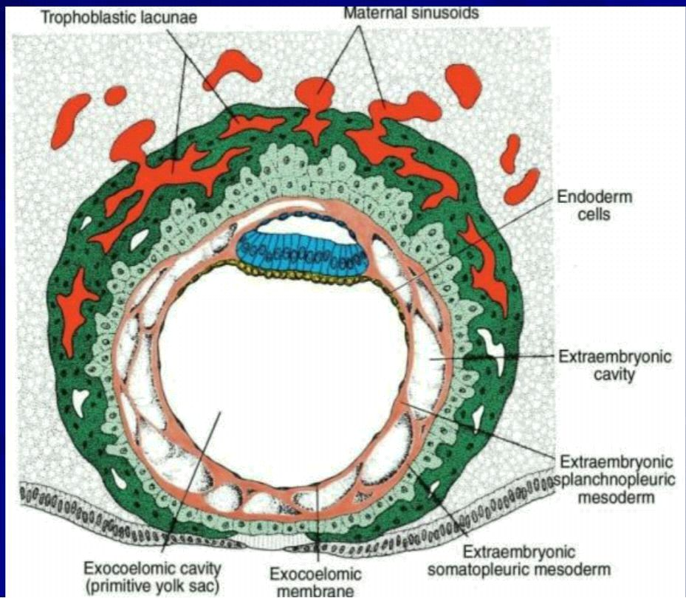
At this stage the blastocyst is completely embedded in the endometrial stroma and the surface epithelium almost entirely covers the original defect in the uterine wall. The trophoblast is characterised by lacunae spaces in the syncytium that form an intercommunicating network.
The cells of the syncytiotrophoblast penetrate deeper into the stroma and erode the endothelial lining of the maternal capillaries, these capillaries which are congested and dilated are known as sinusoids and maternal blood enters the lacunar system. As the trophoblast continues to erode more and more sinusoids, maternal blood begins to flow through the trophoblastic system establishing the uteroplacental circulation. Cells come together to form extraembryonic mesoderm between inner surface of the cytotrophoblast and the outer surface of the excoelomic cavity, which eventually fills all of the space between the trophoblast externally and the amnion and exocoelomic membrane internally.
Soon large cavities develop in the extraembryonic mesoderm and when these become confluent, they form a new space known as the extraembryonic cavity/chorionic cavity. This space surrounds the primitive yolk sac and amniotic cavity except where the germ disc is connected to the trophoblast by the connecting stalk. The extraembryonic mesoderm lining the cytotrophoblast and amnion is called the extraembryonic somatic mesoderm and the one lining covering the yolk sac is known as the extraembryonic splanchnic mesoderm.
DAY 13;
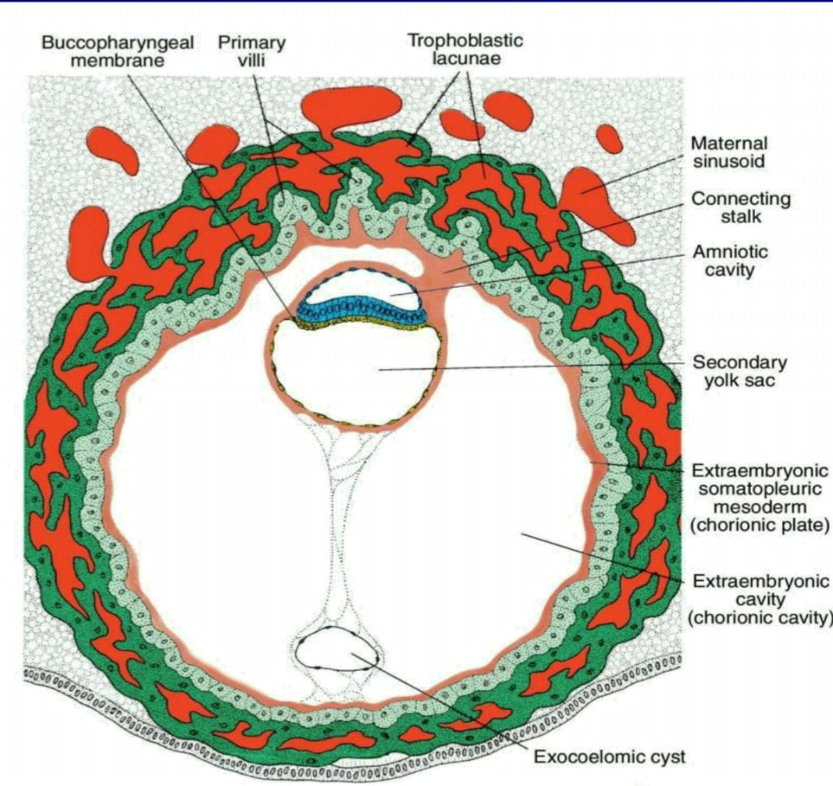
At this stage, the surface defect in the endometrium has usually healed. Occasionally, bleeding occurs at the implantation site as a result of increased blood flow into the lacunar space.
The trophoblast is characterised by villous structures. Cells of the cytotrophoblast proliferate locally and penetrate into the syncytiotrophoblast, forming cellular columns surrounded by syncytium. Cellular columns with the syncytial covering are known as primary villi.
In the meantime, the hypoblast produces additional cells that migrate along the inside of the excoelomic membrane. These cells proliferate and gradually form a new cavity within the exocoelomic membrane cavity.This new cavity is known as the secondary yolk sac/definitive yolk sac which is much smaller than the original exocoelomic cavity or primitive yolk sac. During its formation, large portions of the excoelomic cavity are pinched off and these portions are represented by exocoelomic cysts, which are often found in the extraembryonic coelom or chorionic cavity.
The extraembryonic colom expands and forms a large cavity, the chorionic cavity. The embryonic mesoderm lining the inside of the cytotrophoblast is then known as the chorionic plate. The only place where extraembryonic mesoderm traverses the chorionic cavity is in the connecting stalk. With development of blood vessels, the stalk becomes the umblical cord.
CLINICAL CORRELATES
The syncytiotrophoblast is responsible for hormone production including the human chorionic gonadotrophin (hCG), which enters the maternal blood via lacunae keeps the corpus luteum secreting estrogens and progesterone. hCG maintains the hormonal activity of the corpus luteum in the ovary during pregnancy hCG can be detected in maternal blood or urine as early as day 10 of pregnancy and is the basis for pregnancy tests. Enough hCG is produced by the syncytiotrophoblast at the end of the second week to give a positive pregnancy test, even though the woman is probably unaware that she is pregnant.
●Extrauterine Implantation
Blastocysts may implant outside the uterus. These implantations result in ectopic pregnancies 95% to 98% of ectopic implantations occur in the uterine tubes, most often in the ampulla and isthmus.

