NAME: OYEMIKE OGORCHUKWU CLARA
MATRIC NUMBER: 19/MHS01/376
DEPARTMENT: MBBS
COLLEGE OF MEDICINE AND HEALTH SCIENCES
COURSE CODE: CHM 102
ASSIGNMENT 4- STEREOCHEMISTRY AND FUNCTIONAL GROUP
- Name the functional groups present in each of the following molecules
- CH₂=C(OH)HCHO: Double chain(alkene), OH (hydroxyl group), O (Alkanol)
//
C
\
H
- C₆H₅CH(NH₂)COCH₃: Amine, phenol group(C₆H₅)with double bonds, Kentone.
- CH₃C=CHCH(OH)CHO: Alkene(C=C), OH (hydroxyl group), Alkanol.
- A 0.856g sample of pure (2R, 3R)-tartaric acid was diluted to 10cm³ with water and placed in a 1.0dm polarimeter tube. The observed rotation of 20ºC was +1.0º. Calculate the specific rotation of (2R, 3R)-tartaric acid.
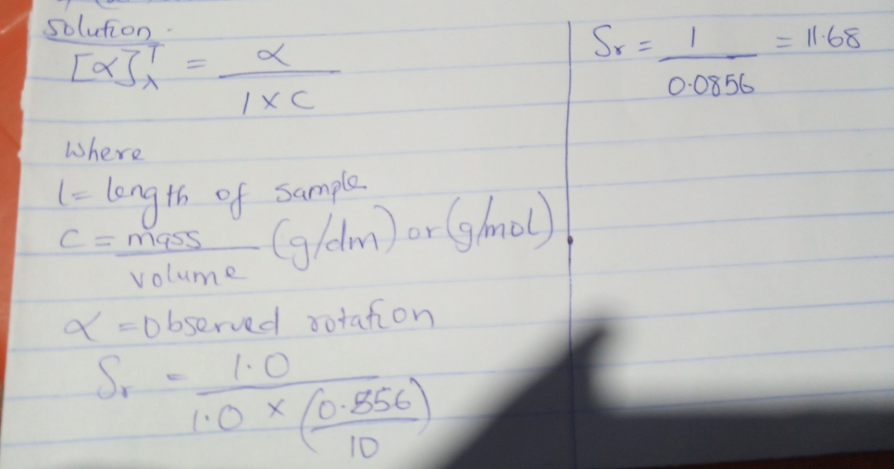
- Draw the possible geometric isomers (where possible) for each of the following compounds: [i] Hexa-2,4-diene [ii] 2,3-dimethylbut-2-ene.
- H H H H H
- H C C C C C C H
H H H
ii. 