NAME: BABATUNDE ANUOLUWAPO ORIYOMI
MATRIC NO: 19/MHS02/030
DEPT: NURSING SCIENCE
COURSE: CHEM102
LEVEL: 100L
NEW ASSIGNMENT
- CLASSSIFICATION OF ALCOHOL
*This is based on the number of hydrogen atoms atom attached to the carbon atom containing the hydroxyl group. If the numbers of hydrogen atoms attached to the carbon atom bearing the hydroxyl group are three or two, it is called a primary alcohol (1) . If it is one hydrogen atom, it is called secondary alcohol (2). If no hydrogen atom is attached to the carbon atom bearing the hydroxyl group, it is called tertiary alcohol (3). E.g CH3OH Methanol (1), CH3CH2OH Ethanol (1).

*This is based on the number of hydroxyl groups they possess. Monohydric alcohols have one hydroxyl group present in alcohol structure. Dihydric alcohols are also called Glycols have two hydroxyl groups present in the alcohol structure while trihydric alcohols or triols have three hydroxyl groups present the structure of the alcohol. Polyhydric alcohols or polyols have more than three hydroxyl groups. E.g CH3CH2CH2OH Propanol (Monohydric alcohol). HOCH2CH2OH Ethane-1,2-diol (Dihydric alcohol).

- Solubility of alcohol in water, organic solvent;
Lower alcohols with up to three carbon atoms in their molecules are soluble in water because this lower alcohol can form hydrogen bonds with water molecules. The water solubility of alcohols decreases with increasing relative molecular mass. All monohydric alcohol are soluble in organic solvents. The solubility of simple alcohols and polyhydric alcohols is largely due to their ability to form hydrogen bods with water molecules.

- Three steps in the industrial manufacture of ethanol with equation reaction.

*Production of Ethanol

Carbohydrates such as starch are major natural compounds that can be made to yield ethanol by the biological process of fermentation. The biologist catalysts, enzymes found in yeast break down the carbohydrates molecules into ethanol to give a yield of 95%. The starch containing materials include molasses, potatoes, cereals, rice and on warming with malt to 60c for specific period of time are converted into maltose bythe enzyme diastase contained in the malt.

2(C6H10O5)n + nH2O ------- ------------> nC12H22O11
Carbohydrate 60C/diastase maltose

The maltose is broken down into glucose on addition of yeast which contains the enzyme maltase and at a temperature of 15C.

C12H22O11 + H20 -------------------------> 2C6H12O6
maltose 15C/maltose glucose

The glucose at constant temperature of 15C is then converted into alcohol by the enzyme Zymase contained also in yeast.

C6H12O6 ----------------------------> 2CH3CH2OH + 2CO2
Glucose 15C/Zymase Ethanol

- Show the reaction between 2-methylpropanal and buthylmagnesiumchloride. Hints: Grinard synthesis.

ANSWERS;

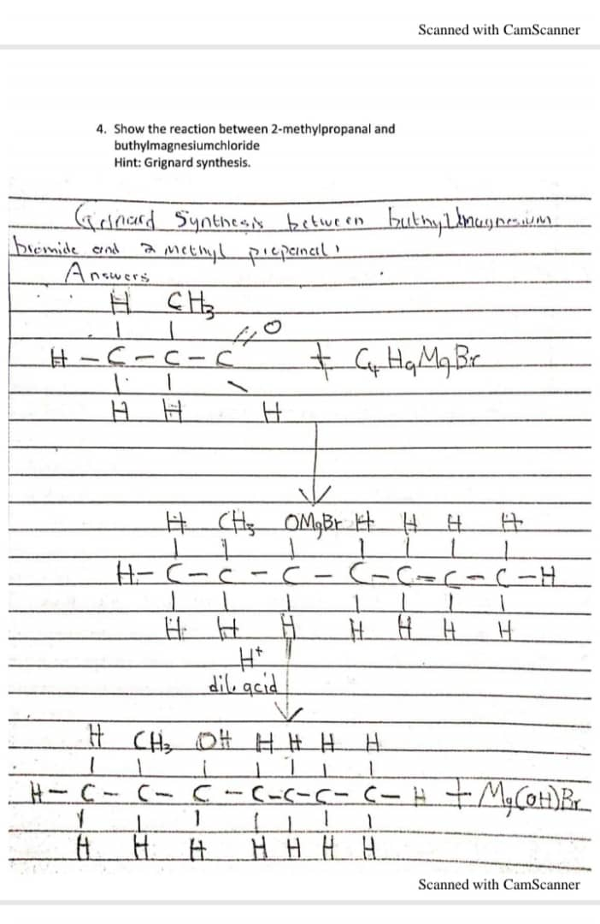
Show the reduction reaction of 2-methylpropanal.

ANSWERS;

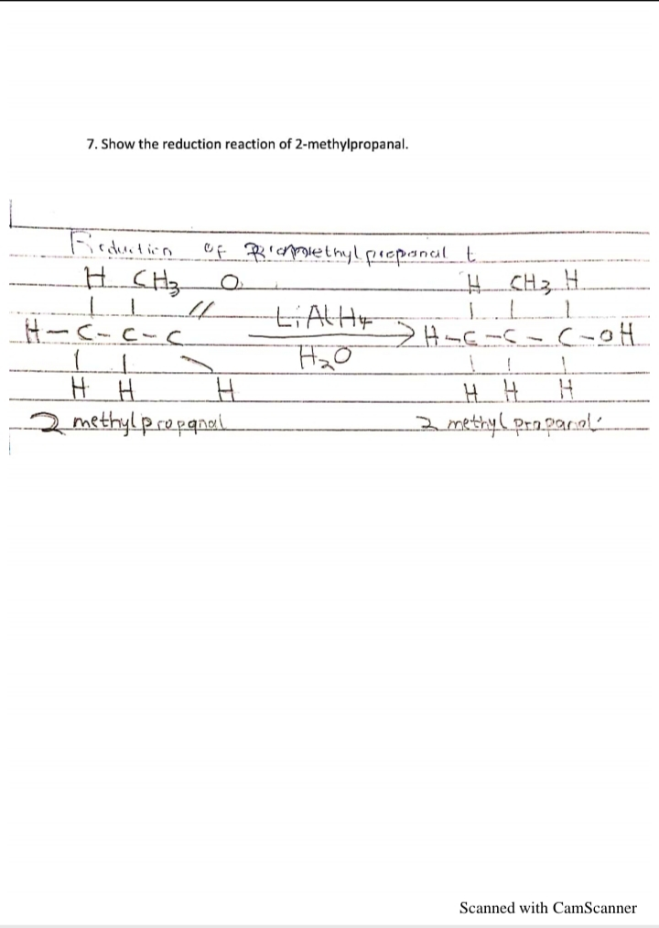

8. Propose a scheme for the conversation of Propam-1-ol to Propam-2-ol.

ANSWERS.

