ANA 402
Electron Microscopic Technique & Ultrastructure
ASSIGNMENT SUBMITED
BY
OLUDELE DOYINSOLA ESOSA
16/MHS01/196
DEPARTMENT OF HUMAN ANATOMY
A glass knife is a knife with a blade composed of glass. The cutting edge of a glass knife is formed from a fracture line, and is extremely sharp.
Glass knives were used in antiquity due to their natural sharpness and the ease with which they could be manufactured. In modern electron microscopy, glass knives are used to make the ultrathin sections needed for imaging.
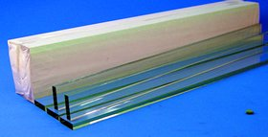
Glass knives are used in an ultramicrotome to cut ultrathin slices of samples for electron and light microscope applications.
For resin and for cryosections (Tokuyasu samples) the knife edge must be extremely sharp, strong and stable. An important requirement for breaking glass knives of superior quality is the quality of the glass strips. Glass strips are produced from specially selected glass, the thickness and quality of which is precisely controlled. Only strict tolerances ensured by careful quality control allow breaking of two high quality knives from one square.
invention refers to medical and biological instrument engineering and aims at preparing histological sections in the tissue ultra-structure analysis. A method for making two forms of glass knives involving cutting the first square of a glass bar, turning it counter clock wise at 45° in a horizontal plane, fixing in adjusted fasteners of a knife-maker, incising and breaking the square in two knives; then the first knife having an acute angle of a cutting edge from the left is taken, and the second knife is made of the second square. Thereafter, the square is turned clock wise at 45° in a horizontal plane; additionally, the second square is turned at 180° along the axis aligned with the long axis of the knife-maker; the second knife is fixed in the fasteners of the knife-maker; the second knife is incised and broken in two knives; the second knife having an acute angle of the cutting edge from the right is taken. A pair of the first and second knives enabling forming two straight parallel side flat sides of a pyramid on the tissue sample surface without the position variation in the sample holder of an ultratome is formed.

Materials
1. Glass knife production: glass strips 6- or 10-mm thick, 25-mm wide by 400-mm long, detergent for cleaning the glass strips, fingernail polish, aluminum tape, truf-style plastic boats, small boxes suitable for storage of glass knives.
2. Sectioning: distilled water, compressed air, hot plate, toluidine blue stain (2), dilute nitric acid (i.e., two drops concentrated nitric acid in 10 mL of distilled water), source of eye lashes or Dalmatian dog hairs, soft drinking straws, fingernail polish, microscopic slides for thick sections, EM grids, grid boxes, double action forceps, a good light microscope for evaluation of thick sections and a basic TEM.
3. Methods
3.1. Glass Knife Production: The Balanced Break Method
1. The use of the balanced break for producing excellent glass knives is quite simple in principle, i.e., to use an equal weight of glass plus breaking force on each side of the score (a scratch that is made in the glass surface using a diamond or tungsten-carbide wheel or scribe) used to initiate a fracture in the glass strip. This method was used when glass knives were first routinely broken using a pair of glazier's pliers. All scores were made in the middle of the glass sheet to be broken and an equal force was applied symmetrically to each side of the score. With the availability of the very first LKB 7800 glass knife maker, this fundamental principle was discarded and the glass knives that have been made in most EM laboratories for the past 30 yr have been made using a nonsymmetrical fracture from one end of a strip of glass. The development and distribution of this instrument has practically guaranteed that everyone has been using very poor-quality glass knives for routine plastic and cryosectioning ever since. In early work by Tokuyasu and Okamura (3), they described the importance of using the balanced break in the production of glass knives for cryoultramictomy. The importance of this observation and additional details were also described by Griffiths et al. (4). It was only during a cryo course 10 yr ago that this principle came to our attention (5), and we began to perfect the method using existing commercial knife makers for the making of excellent glass knives. Heinz Schwarz was instrumental in helping determine the optimum time for the break in experiments performed at an EMBO course in Dundee (H. Schwarz, personal communication, 1994). Because most laboratories still have access to an "old" LKB 7800 glass knife maker and there is such strong resistance to switching over to a better technique (5), I will describe how to "fix" this knife maker to make it possible to put into practice the principle of the balanced break. These details are described in Note 1. It is still very difficult to get a good balanced break with all of the currently manufactured glass knife makers. They all seem to misunderstand the fundamentally simple principle of the balanced break and produce knife makers that make the balanced break difficult to achieve.
2. A diagram of the glass knife and the terms associated with it are shown in Fig. 1. This figure illustrates that the smaller (closer to 45°) the actual knife angle, the
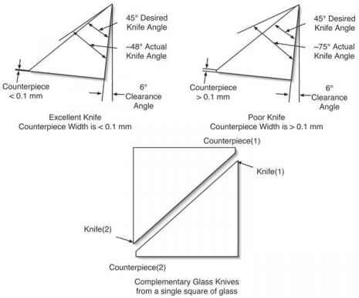
Counterpiece(2)
Complementary Glass Knives from a single square of glass
Fig. 1. The optimal 45° glass knife is shown in top left of the figure and has a counter-piece width of <0.1 mm. This knife has an actual knife angle of approx 48°. The 6° clearance angle is used most commonly with glass knives. The knife at the top right illustrates an unacceptable glass knife with an actual knife angle of approx 75° produced with a counterpiece width >0.1 mm, more on the order of 1 to 2 mm as was recommended in the instruction manual that came with the LKB 7800 glass knife maker. This glass knife will not be sharp, and the actual knife angle will vary along the knife edge. Shown at the bottom is a diagram of a glass square after the diagonal break is made. Illustrated are the two knives and their associated complementary counterpieces. The respective counterpiece that is associated with each knife is used for evaluation of the knife and is explained more fully in following figures and text.
sharper the knife. The making of excellent glass knives requires patience in the production process, and they must be prepared well before the day of intended use. Because ultramicrotomy demands the use of excellent glass knives, this production process cannot be left until the last minute when the specimen is mounted in the ultramicrotome demanding to be sectioned right now! The use of excellent glass knives is absolutely essential to the successful production of ultra-thin sections for electron microscopy. Fully 95% of the failures to obtain good sections on the ultramicrotome can be directly attributed to the use of an unsuitable glass knife or dull diamond knife.
It is important to remember that our goal is to produce very high-quality glass knives that can be reused many times, so that the time involved is not wasted by throwing away the knives after a single use. The old mythical tale that glass knives must be made fresh just is not true. If care is taken in the making of high-quality glass knives described here, they may be stored for months to years and used repeatedly until they become unusable after 5 to 15 or more uses for thin sectioning. We do get more uses when the knives are used for cryosectioning (4); however, we routinely use a good glass knife 5 to 15 times when cutting thin sections, for example, of Spurr's plastic-embedded specimens. The glass knives do not last as long when they are used for the cutting of thick sections because of the increased stress that is placed on the knife edge, which also is true if diamond knives are used routinely for thick sections, that there is a greater danger of damage to the diamond knife.
3. The process begins with the acquisition of glass strips typically measuring 6 or 10 mm thick x 25 mm wide x 400 mm long. The manufacturer's edges are inspected carefully to insure that they are flat surfaces. Many times the manufacturing equipment used to produce these strips is not correctly calibrated and thus produces strips that have a slightly concave edge on one side of the strip and a convex edge on the other side. These poor-quality strips are not suitable for the reproducible production of high-quality glass knives because they will result in distinctly curved edges in the final glass knife edges if the fracture is allowed to propagate into the curved manufacturer's edge.
4. The first step is to clean the glass strip with soap and water, rinse under hot running tap water, and dry the glass with a clean cloth or paper towel.
5. Figure 2 illustrates the next part of the process. The long strip is first balanced on the balance pins of a "fixed" LBK 7800 (see Note 1 [5]), gently clamped to hold the glass strip perpendicular to the desired fracture line (see Fig. 3, left side), a breaking force applied (see Fig. 4, items 6, 7, and 8), and then the glass is scored. When the glass is preloaded with a breaking force before scoring the glass, the fracture begins immediately and progresses very slowly through the glass strip. The force applied (see Fig. 4) with the glass knife maker is adjusted so that it takes about 3 min (H. Schwarz, personal communication, 1994) for the glass to separate under the score. The term separate is used to emphasis that we are not trying to achieve a violent break, but a gentle, controlled fracture perpendicular to the long axis of the glass strip.
6. It is critical for the person breaking the glass to understand that, for this process to be reproducible, the process must be followed as depicted in Fig. 2, completely finishing all of the same-sized glass strips from each row before progressing to the next row. This step insures that the balanced break of each strip of the same length is more reproducible. Because each length has half the weight of the previous row, the balance "feel" will change slightly and must be mastered by the practice of balancing all of the lengths that are the same weight at the same time. This
Breaking Pins F1 = F2
Balance Pins
Fig. 2. The first step is to clean the glass strip with soap and water, rinse under hot running tap water, and dry the glass with a clean cloth or paper towel. The long strip is then balanced on the balance pins of a "fixed" LBK 7800 (see Note 1), and broken into two equal pieces. These two pieces, shown in the second row, are then balanced and broken. The resulting four pieces are then balanced and broken, and finally the resulting eight pieces are then balanced and broken, which should result in 16 square pieces that are all have identical dimensions. The two original end pieces may not yield usable knives because they contain manufacturer-produced edges. The edges produced in this fashion should be perpendicular to the surface of the glass strip and very flat. It is important to note that the new surfaces created by this process will be the ones that will contain the knife edge. The preparation of these surfaces requires as much care and patience as the final 45° fracture for the production of the knives. Details of the clamping and breaking of the glass are shown in Fig. 3.
process of balancing, preloading with the breaking force, and scoring is repeated with each equal length of glass until we have as a final product 16 squares of glass that are the same shape and size. Experience has shown that most people have mastered this process by the time they have processed at least three complete glass strips.
7. The breaking of the complete strip of glass should take approx 45 to 60 min to complete (approx 3 min/fracture), resulting in the production of 16 equal-sized squares. It is important to note that the new surfaces that are created will be super clean and will ultimately contain the knife edge, which is produced in the next steps. These
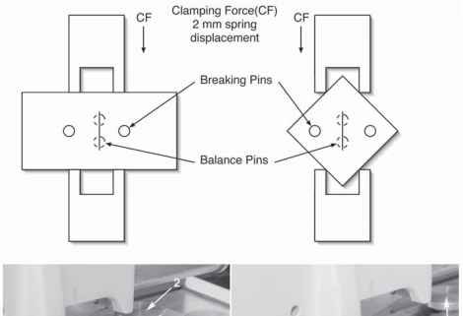
Fig. 3. This figure illustrates the light clamping force that is used to gently position the glass while making the balanced break to create the squares on the left and the final diagonal break shown on the right side. The millimeter scale is used to set the 2-mm force against the glass strip using clamp screw . The millimeter scale is also used to set the 2-mm force against the glass square using clamp screw . Typically, the force is set for the glass strip and then readjusted if necessary for fracturing the diagonal of the resulting squares.
fractures require as much care and patience as the final 45° fracture used for the production of the knives.
Fig. 5 illustrates the production of the glass knives from the final square pieces of glass. The squares at the top show clean (Fig. 5c, freshly broken) and dirty (Fig. 5d, manufacturer produced) edges of the final squares. The cleanest edges are the freshly made surfaces. The squares are rotated counterclockwise 90° and positioned between the holding forks of the glass knife maker as illustrated in the right side of Figs. 3 and 5. The squares are positioned under the score wheel (see Figs. 4 and 5, which show the score setting that is used for all scores) such that the
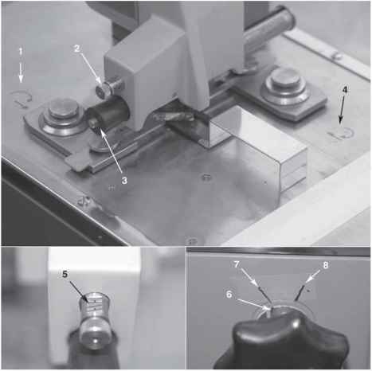
Fig. 4. Details of the LKB 7800 glass knife maker showing (1) and (4) the picto-grams detailing the direction to turn the upper fork and lower fork adjustment knobs to achieve the alignment of the score such that the fracture propagates into the corners of the glass square. Numbers (2) and (5) show the setting of the score wheel cam which is used to score the strips and the final diagonal break of the squares. The score knob (3) is used to pull the score wheel along the top surface of the glass. The lower right panel shows a mark that is made on the breaking force knob. Number (6), which is aligned with a mark (7), indicates the zero or reset position of the breaking knob. Using trial and error with a stopwatch a mark, number (8) is drawn at the clockwise position, which gives, on average, an approx 3-min time to fracture for each break made with the glass knife maker.
Fig. 4. Details of the LKB 7800 glass knife maker showing (1) and (4) the picto-grams detailing the direction to turn the upper fork and lower fork adjustment knobs to achieve the alignment of the score such that the fracture propagates into the corners of the glass square. Numbers (2) and (5) show the setting of the score wheel cam which is used to score the strips and the final diagonal break of the squares. The score knob (3) is used to pull the score wheel along the top surface of the glass. The lower right panel shows a mark that is made on the breaking force knob. Number (6), which is aligned with a mark (7), indicates the zero or reset position of the breaking knob. Using trial and error with a stopwatch a mark, number (8) is drawn at the clockwise position, which gives, on average, an approx 3-min time to fracture for each break made with the glass knife maker.
fracture propagates just into the clean glass at each of the top and bottom corners as illustrated in Fig. 5. The distance between the knife edge and the corner of the glass square should be <0.1 mm so that a knife with an actual knife angle of approx
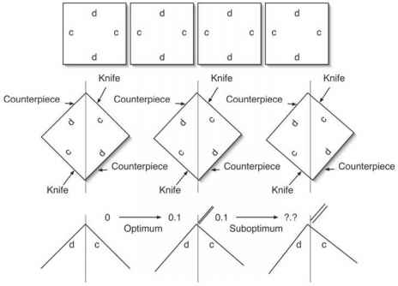
Fig. 5. Details of positioning the final glass squares is shown. In the top row the clean (c) and dirty (d) edges of the glass squares are shown. In the second row, the glass square has been rotated 90° counter-clockwise, which places the clean (c) glass surface in the upper right and lower left quadrant. There are three fractures depicted, left, directly into the apex, center, with a counterpiece width of <0.1 mm and, right, >0.1 mm. The optimum counterpiece width is shown on the left in the bottom row, whereas unacceptable knives are shown on the right in the bottom row. The direction of the fracture is controlled by moving the upper and lower apexes either left or right to place the fracture into the clean side of the apexes to produce the optimum thickness counterpiece.
Fig. 5. Details of positioning the final glass squares is shown. In the top row the clean (c) and dirty (d) edges of the glass squares are shown. In the second row, the glass square has been rotated 90° counter-clockwise, which places the clean (c) glass surface in the upper right and lower left quadrant. There are three fractures depicted, left, directly into the apex, center, with a counterpiece width of <0.1 mm and, right, >0.1 mm. The optimum counterpiece width is shown on the left in the bottom row, whereas unacceptable knives are shown on the right in the bottom row. The direction of the fracture is controlled by moving the upper and lower apexes either left or right to place the fracture into the clean side of the apexes to produce the optimum thickness counterpiece.
48° will be produced (Fig. 1). Because the squares have all been made by balancing and are all the same size, it is relatively easy to adjust the upper holding fork and the lower holding fork (shown in right side of Fig. 3) by moving each of them either left or right until the desired <0.1 mm distance is obtained at both corners of the glass square. The best way to understand the direction to move the upper (Fig. 4, number 4) and lower (Fig. 4, number 1) holding forks is to ask the following question. Which direction do the upper and lower apexes of the glass square have to be moved to position the fracture <0.1 mm from the apexes into the clean side? Several glass squares may have to be fractured before the optimal setting is achieved. Once this final adjustment is complete most of the remaining knives should be perfect, consistently producing counterpieces that have <0.1-mm widths. This adjustment is usually only required for the first set of glass squares. Subsequent glass strips will require little or no additional adjustments and this is usually
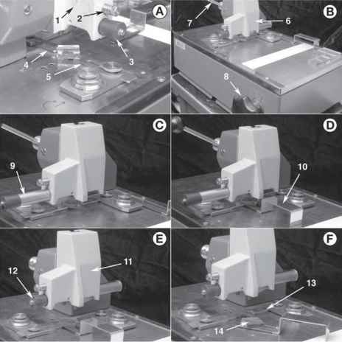
Fig. 6. Shown are the steps involved in breaking the glass squares. (A) the anvil (1), with score setting (2) and scoring knob (3), are lowered by gravity onto the diagonally aligned glass square. The upper fork (4) is released and holds the square against the lower fork (5). (B) the anvil (6) is locked into place using the locking lever (7), then the breaking force is applied using the breaking knob (8). (C) the scoring knob (9) is firmly pulled out. (D) the pickup tool (10) is placed under the glass square. (E) after the fracture, the anvil (11) is raised by releasing the locking lever (7) and the scoring knob (12) pushed in. (F) the upper fork (13) is retracted and the fractured glass square (14) removed using the pickup tool.
Fig. 6. Shown are the steps involved in breaking the glass squares. (A) the anvil (1), with score setting (2) and scoring knob (3), are lowered by gravity onto the diagonally aligned glass square. The upper fork (4) is released and holds the square against the lower fork (5). (B) the anvil (6) is locked into place using the locking lever (7), then the breaking force is applied using the breaking knob (8). (C) the scoring knob (9) is firmly pulled out. (D) the pickup tool (10) is placed under the glass square. (E) after the fracture, the anvil (11) is raised by releasing the locking lever (7) and the scoring knob (12) pushed in. (F) the upper fork (13) is retracted and the fractured glass square (14) removed using the pickup tool.
true for four to five complete strips of glass. By spending about a day making glass knives, there will be enough to last for several weeks to months.
9. The operational steps are always the same whether glass strips or final diagonal fractures are being produced. They are illustrated in Fig. 6: (a) balance the glass
Counterpiece(U) Knife(U)
Counterpiece(U) Knife(U)
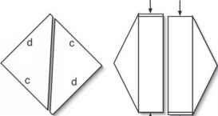
Counterpiece(L)
Fig. 7. The fractured glass square is removed from the knife maker, the left and right corners are then folded away from the microtomist, and the knives with their counter-pieces next to the knife that is complementary to it held as shown on the right. The upper (U) knife and counterpiece (U) are kept side by side as are the lower (L) knife and coun-terpiece (L). The counterpieces are then judged as described in the next figure.
strips or squares on the Balance Pins; (b) apply the 2-mm clamping force to hold the strips or square in position (Fig. 6, numbers 4 and 5); (c) lower the anvil (Fig. 6), from position (1) to position (6), bringing the breaking pins into contact with the top of the glass and then use the locking lever (Fig. 6, number 7), to hold the glass in position; (d) apply the predetermined breaking force using the breaking knob, (Fig. 6, step 8; also see Fig. 4), the mark on knob (6) is rotated clockwise to alignment with position (8), this applies the amount of force that results in a approx 3-min fracture; (d) score the top surface of the glass by pulling out the scoring knob, Fig. 6, (9); (f) after the score is made, the preloaded glass begins to fracture over the course of the next approx 3 min until the fracture is complete, then the pickup fork is inserted under the glass square (Fig. 6, number 10); (g) the anvil, (Fig. 6, number 11) is raised by releasing the locking lever; (h) the scoring knob is pushed back in, (Fig. 6, number 12); and (i) the glass carefully removed using the pickup tool for the glass squares, (Fig. 6, number 14).
10. Fig. 7 illustrates the handling of the glass knives for examination of each complementary knife and counterpiece from the two corners of the diagonal fracture. The broken square is removed gently from the knife maker, the left and right corners are folded away, and the two knives with their complementary counterpieces held together. This step allows the examination described in the next step and keeps the knife edge adjacent to the complementary counterpiece that produced it.
11. Each final glass square has the potential of yielding two perfect knives. Figure 8 illustrates the judgment criteria that are used to select which knives will be kept
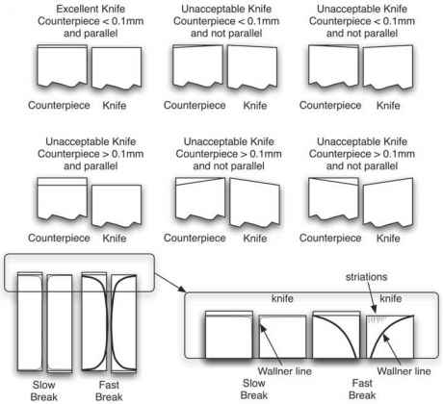
Fig. 8. Judging the quality of glass knife from observing the counterpiece. Six of the many possibilities are illustrated. Only one, the upper left illustrates a "perfect" glass knife that is suitable for use with ultramicrotomy. The other possibilities demonstrate imperfect knives and the reasons that they would not be chosen for cutting thin sections. In the case in which the counterpiece is not parallel, the knife will have an actual knife angle that changes all the way across the knife, which makes the sectioning characteristics difficult to reproduce from knife to knife. When the counterpiece is too thick, the resulting knife has a very large actual knife angle, thus making it difficult to impossible to cut thin sections. These other knives may be used to rough trim specimens but there is a risk of damaging the specimen because the knives are really dull. The importance of the slow break (>3 min) is illustrated in the bottom portion of the figure. With the slow break, the Wallner line (stress line) will be parallel and very close to the knife edge and the striations and variation in actual knife angle across the knife will be minimal. The illustrated striations associated with a fast break and the very strong Wallner line will be absent in the slow break condition. The two criteria, the counterpiece <0.1 mm and a slow (>3 min) break are required to produce the excellent knife. The excellent knives will cut more sections before they become damaged than will the poor quality knives.
for future ultramicrotomy. As illustrated in the Fig. 8, only knives that meet the criteria (produced using a slow break and a counterpiece <0.1 mm and parallel edges in the counterpiece) are chosen for ultramicrotomy. All of the other knives are tossed away. Some of the unacceptable knives may be used for rough trimming of specimen blocks, but the final block faces used for thin sectioning should never see a less than perfect glass knife.
A perfect glass knife produced with less than 0.1-mm counterprieces and using a slow break will result in the entire knife edge being suitable for thin sections. The slow break (approx 3 min or longer) will ensure that the striations normally associated with the classic method described in the literature will be absent from the knife edge.
The best knife, based on the aforementioned criteria, is chosen and the opposite knife with its counterpiece is placed against the bottom of a storage box. Only one of the knives from each pair is kept and stored with the counterpiece that produced it. It is bad luck if both are perfect, then one just has to choose one to place on the bottom of the box. Storing the knife with its counterpiece allows the later observation of the counterpiece to verify the quality of the knife that it produced. Thus, we have a way to look at a knife indirectly through observation of the counter-piece and judge its quality today, next week or next month. It is important to note that there is no reliable way to observe a knife edge without its complementary counterpiece to choose the best knife. There are methods described in the literature using a dissection microscope for this purpose, but the method of using the counterpiece is a more precise and reliable method in practice.
The literature on glass knife making describe vertical striations that run perpendicular to the knife edge and can extend more than 80% of the knife edge. These striations, which are caused by the fast breaking of the glass, will produce very bad knife marks in the final thin sections. If the conditions described here are followed, selecting counterpieces that are <0.1 mm in thickness and using a slow break, then the striations usually are absent from the knife edge. The use of these methods and criteria will ensure a much larger, defect-free knife edge for thin sectioning. Under these optimum conditions, the large Wallner line (stress line) normally observed with fast breaks will mostly disappear resulting in a constant actual knife angle across the width of the glass knife edge.
12. An additional process that can be performed after all of the knives have been made is the coating of the knife edges with a discontinuous film of tungsten metal in a vacuum evaporator (6). This process has been used by Griffiths et al. (4) and they have described marked improvement of the knife performance particularly with multiple uses of the same knife (1). When possible, we use this light coating of tungsten to improve the number of times a knife may be cleaned and reused. There is a note of caution when using this tungsten coating procedure; if the tungsten becomes a continuous film, i.e., electrically conductive, then the sections will stick irreversibly to a continuous film of tungsten. It is therefore very important to use a discontinuous film of tungsten produced as described in the reference.
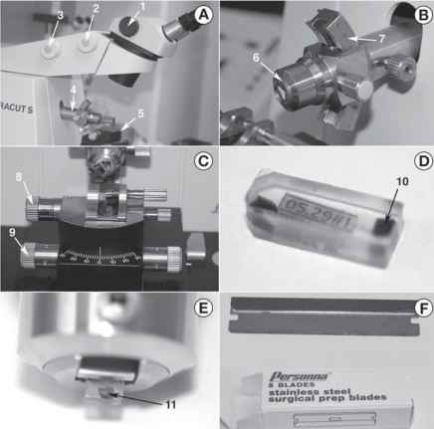
Fig. 9. (A) Overview of typical ultramicrotome, microscope eyepieces, magnification (1), focus (2), and positioning knobs (3), relationship between the microscope, specimen (4) and knife holders (5). (B) Specimen arc holder allowing the specimen holder (6) to rotate about the specimen arm axis and tilt about the knife edge axis (7).
(C) Knife stage showing clearance angle adjustment (8) and ± 30° knife rotation (9).
(D) Spurr's epoxy block with specimen (10) embedded in each end. (E) Specimen block (11) clamped in ultramicrotome specimen holder. (F) Surgical prep blades preferred for block trimming operations.
Fig. 9. (A) Overview of typical ultramicrotome, microscope eyepieces, magnification (1), focus (2), and positioning knobs (3), relationship between the microscope, specimen (4) and knife holders (5). (B) Specimen arc holder allowing the specimen holder (6) to rotate about the specimen arm axis and tilt about the knife edge axis (7).
(C) Knife stage showing clearance angle adjustment (8) and ± 30° knife rotation (9).
(D) Spurr's epoxy block with specimen (10) embedded in each end. (E) Specimen block (11) clamped in ultramicrotome specimen holder. (F) Surgical prep blades preferred for block trimming operations.
Question 2
Draw and label a glass knife
