AHIOME DANIELLA ADERONKE
19/MHS02/009
NURSING
CHM ASSIGNMENT
- Alcohols are very important organic compounds. Discuss briefly their classification and give one example each.
Alcohols are those organic compounds which are characterized by the presence of one, two or more hydroxyl groups (−OH) that are attached to the carbon atom in an alkyl group or hydrocarbon chain.
- Primary alcohols: are those alcohols where the carbon atom of the hydroxyl group(OH) is attached to only one single alkyl group. Some of the examples of these primary alcohols include Methanol (, propanol, ethanol, etc. The complexity of this alkyl chain is unrelated to the classification of any alcohol considered as primary. The existence of only one linkage among –OH group and an alkyl group and the thing that qualifies any alcohol as a primary.
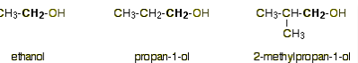
- Secondary alcohols: are those where the carbon atom of the hydroxyl group is attached to two alkyl groups on either side. The two alkyl groups present may be either structurally identical or even different. Some of the examples of secondary alcohols are given below-
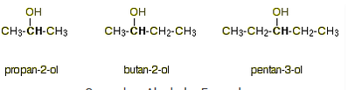
- Discuss the solubility of alcohols in water, organic solvents
Alcohols are soluble in water. This is due to the hydroxyl group in the alcohol which is able to form hydrogen bons with water molecules. Alcohols with a smaller hydrocarbon chain are very soluble. As the length of the hydrocarbon chain increases, the solubility in water decreases. Because of the strength of the attraction of the OH group, first three alcohols (methanol, ethanol and propanol) are completely miscible. They dissolve in water in any amount.
- Show the three steps in the industrial manufacture of ethanol. Equations of reaction are mandatory.
Carbohydrate is converted into maltose at temperature of 60 degree Celsius and by the enzyme diastase.
2(C₆ H₁₀ O₅)n + nH₂0 n C₁₂H₂₂0₁₁
60⁰C/diastase
Maltose is broken down into glucose or addition of yeast which contains the enzyme maltose at 15⁰C
C₁₂H₂₂O₁₁+ H₂O C₆H₁₂O₆
15⁰C/maltose
Glucose at constant temperature 15⁰C is converted into alcohol with enzyme zymase contained also in yeast.
C₆H₁₂O₆ 2CH₃OH + Co₂
15⁰C/zymase ethanol carbondioxide
- Show the reaction between 2-methylpropanal and butylmagnesiumchloride Hint: Grignard synthesis
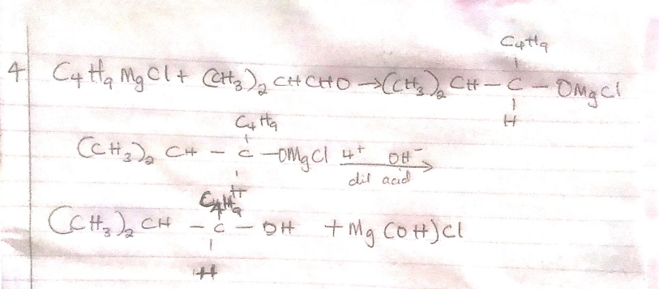
  - Show the reduction reaction of 2-methylpropanal

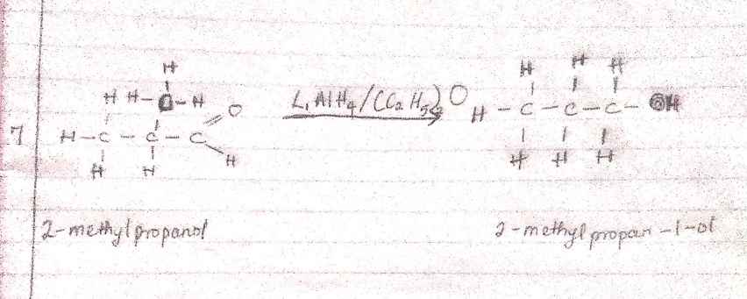

- Propose a scheme for the conversion of propan-1-ol to propan-2-ol
    - Heat propan-1-ol in the presence of sulphuric acid to dehydrate it to propene. Then add
Water to from propan-2-ol.
