19/MHS06/033
MLS
BCH 202

ANSWER Q1
(I) Cholesterol is essential for making a number of critical hormones, including the stress hormone cortisol.
(II)) Cholesterol is also used to make the sex hormones testosterone, progesterone, and estrogen.
(III) The liver also uses cholesterol to make bile, a fluid that plays a vital role in the processing and digestion of fats.
(IV) Cholesterol is essential for your body to produce vitamin D.

ANSWER Q2
A globoside is a type of glycosphingolipid with more than one sugar as the side chain (or R group) of ceramide. The sugars are usually a combination of N-acetylgalactosamine, D-glucose or D-galactose. A glycosphingolipid that has only one sugar as the side chain is called a cerebroside.
WHILE
A ganglioside is a molecule composed of a glycosphingolipid (ceramide and oligosaccharide) with one or more sialic acids (e.g. n-acetylneuraminic acid, NANA) linked on the sugar chain. NeuNAc, an acetylated derivative of the carbohydrate sialic acid, makes the head groups of gangliosides anionic at pH 7, which distinguishes them from globosides.

ANSWER Q3
Methyl transferase

ANSWERQ4
Lipid.

ANSWER Q5

(I) Phosphoglycerides are amphiphilic
(II) They are hydrophobic (fears water)
(III) They are also hydrophilic (loves water) parts and the head groups of phosphoglycerides are hydrophilic.

ANSWER Q6

Phosphoglycerides | Triaglycerol
Is a lipid composed of a phosphate group attached to a glycerol backbone | Is a lipid that is composed of a glycerol backbone attached to three fatty acids chains.
Composed of two fatty acid chains | Composed of three fatty acid chains
Composed of phosphate group attached to the glycerol backbone | Has no phosphate groups attached to the glycerol backbone
In the formation of a molecule, two water molecules are released as by products of each molecule | In the formation of a molecule, three water molecules are released as byproducts of each molecule
Make up the cell membrane of cells | Acts as the fat storage in our body

Examples of Phosphoglycerides
I Plasmalogens
Ii Phosphatidates
Iii Phosphatidylcholines

Examples of Triaglycerol
I saturated, fatty acids.
Ii monounsaturated fatty acids.
Iii polyunsaturated fatty acids.

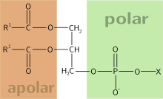

Structure of phophoglyceride

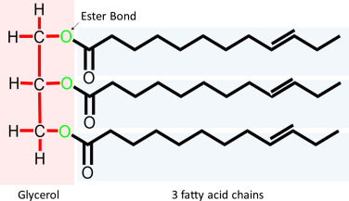
Structure of Triaglyceride

