NAME; DAVID ORITSUWA
ASSIGMENT; WRITE ON CORONA VIRUS

The World Health Organization (WHO) has declared the new coronavirus outbreak, which originated in Wuhan, China, a pandemic.
As of April 28, the global death toll surpassed 211,000 amid three million cases. More than 896,000 people have recovered from the disease worldwide, according to the data collected by the Johns Hopkins University in the United States.

What is a coronavirus?
The coronavirus family causes illnesses ranging from the common cold to more severe diseases such as severe acute respiratory syndrome (SARS) and Middle East respiratory syndrome (MERS), according to the WHO.
They circulate in animals and some can be transmitted between animals and humans. Several coronaviruses are circulating in animals that have not yet infected humans.
The new coronavirus, the seventh known to affect humans, has been named COVID-19.

What are the symptoms?
Common signs of infection include fever, coughing and breathing difficulties. In severe cases, it can cause pneumonia, multiple organ failure and death.
The incubation period of COVID-19 is thought to be between one and 14 days. It is contagious before symptoms appear, which is why so many people get infected.
Infected patients can be also asymptomatic, meaning they do not display any symptoms despite having the virus in their systems.

Where did it come from?
China alerted the WHO to cases of unusual pneumonia in Wuhan on December 31.
COVID-19 is thought to have originated in a seafood market where wildlife was sold illegally.
On February 7, Chinese researchers said the virus could have spread from an infected animal to humans through illegally trafficked pangolins, prized in Asia for food and medicine.
Scientists have pointed to either bats or snakes as possible sources.
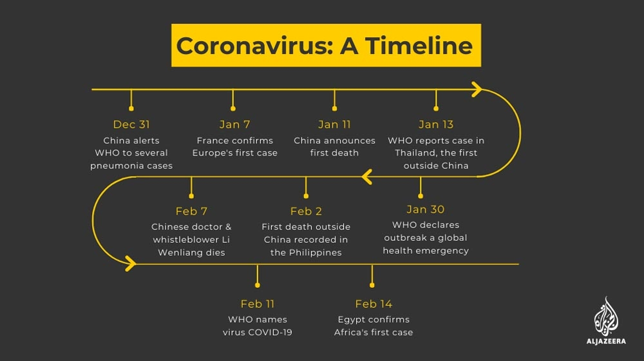

Should I worry? How can I protect myself?
The WHO declared the virus a pandemic on March 11 and said it was "deeply concerned by the alarming levels of spread and severity" of the outbreak.
The WHO recommends basic hygiene such as regularly washing hands with soap and water, and covering your mouth with your elbow when sneezing or coughing.
Maintain "social distancing" - keeping at least 1.8 metres (six feet) between yourself and others - particularly if they are coughing and sneezing, and avoid touching your face, eyes and mouth with unwashed hands.
Avoid unnecessary, unprotected contact with animals and be sure to thoroughly wash hands after contact.

Spain daily coronavirus deaths reach six-week low: Live updates
Spain records 164 more deaths from COVID-19, lowest daily rise since March 18, taking the total to 25,264.
03 May 2020 16:47 GMT
- Spain's death toll rose by 164 to 25,264 on Sunday, the health ministry said, the lowest one-day increase since March 18. Confirmed cases of the virus rose to 217,466 from 216,582, the ministry said.
- Afghanistan's health ministry raised the alarm over the spread of the new coronavirus after a small study with random tests in Kabul suggested that about a third of the capital's residents could be infected.
- Russia and India both recorded their highest daily rise of coronavirus infections.
- Worldwide, the number of confirmed infections stands above 3.44 million, with more than 244,000 deaths and approximately 1.1 million recoveries.

Sunday, May 3

16:45 GMT - Turkey death toll rises by 61
The number of people who have died from COVID-19 in Turkey has risen by 61 in the last 24 hours to 3,397, according to data from the country's health ministry.
The overall number of cases rose by 1,670 to 126,045, the data showed, the highest total outside Western Europe, the United States and Russia.
A total of 63,151 people have so far recovered from the new coronavirus, the ministry added.
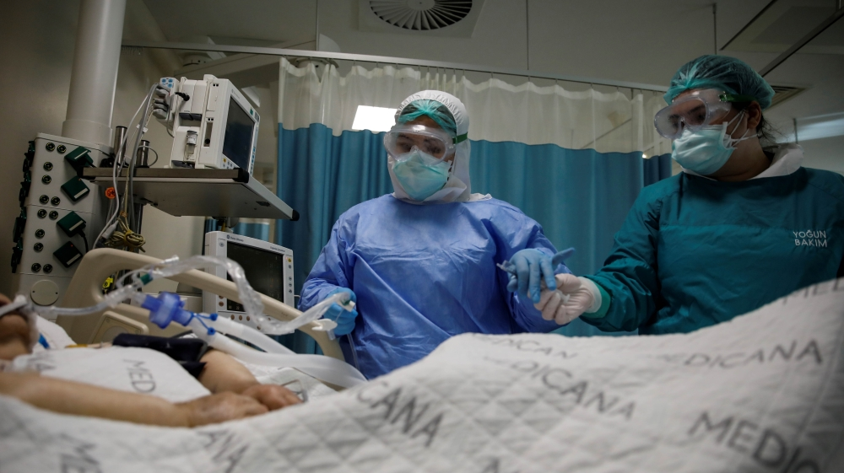
Turkey has the highest number of cases outside Western Europe, the United States and Russia [Umit Bektas/Reuters]

16:40 GMT - Latest COVID-19 figures from the UK
The United Kingdom's death toll from COVID-19 rose to 28,446, an increase of 315, according to figures announced on Sunday.
That figure includes coronavirus deaths in hospitals, care homes and the community.

16:30 GMT - Jordan lifts all restrictions on economic activity
Meanwhile in Jordan, all restrictions on economic activity have been lifted, the latest easing of coronavirus lockdown rules to help jump-start the cash-strapped economy.
Jordan has in the last two weeks been lifting restrictions to allow businesses back to work, but with lower levels of staff and strict social distancing and hygiene guidelines.

16:15 GMT - Italy reports lowest death toll since start of lockdown
Deaths from the COVID-19 in Italy climbed by 174 on Sunday, against 474 the day before, the Civil Protection Agency said, posting the smallest daily toll of fatalities since March 10.
The daily number of new cases also declined sharply to 1,389 from 1,900 on Saturday.
Italy's total death toll since the outbreak came to light on February 21 now stands at 28,884, the Civil Protection Agency said, the second highest in the world after the United States.
The number of confirmed cases amounts to 210,717, the third highest global tally behind the US and Spain.

16:00 GMT - UK to test new COVID-19 tracing system
Britain will trial a new coronavirus tracing programme next week on the Isle of Wight, just off the south coast of England, cabinet minister Michael Gove said on Sunday.
"This week we will be piloting new test, track and trace procedures on the Isle of Wight with a view to having that in place more widely later this month," he told a news conference.
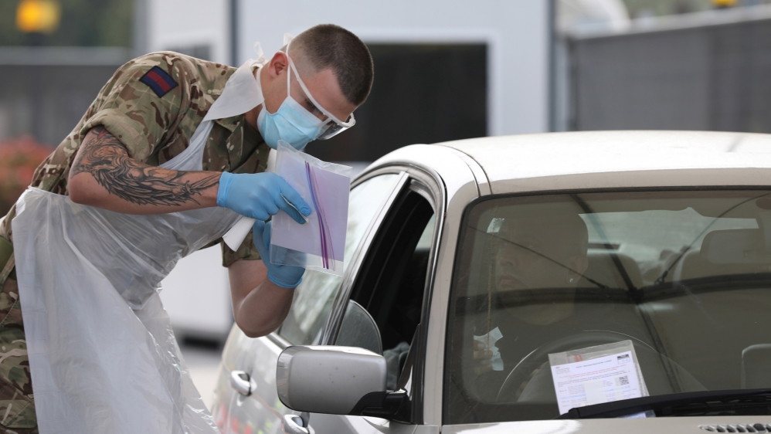
UK is one of the worst-hit countries in Europe [Reuters]

15:50 GMT - Canada death toll jumps by 4 percent
According to data from the public health agency, 160 people died in Canada from coronavirus in the last 24 hours, taking the total to 3,606.
The agency confirmed 1,576 news cases of the virus rising the total to 57,148.

15:00 GMT - Where are we with a coronavirus vaccine?
As government lockdowns focus on limiting the spread of the coronavirus, scientists around the world are working on treating and protecting us.
They have their work cut out. Vaccine and drug development is laborious, full of experimentation and repeated testing. Knowing how the virus works is key.
But what other challenges do they face? And how long will it take before we can defeat this virus with a pill or an injection?
Start Here explains.

14:51 GMT - Iran death toll rises by 47
Meanwhile in Iran, the death toll from the coronavirus outbreak rose by 47 over the past 24 hours to 6,203, Kianush Jahanpur, health ministry spokesman, said on state TV on Sunday.
Iran, one of the countries in the Middle East hardest hit by the outbreak, has a total of 97,424 cases, he said.

14:00 GMT - Pompeo says 'enormous evidence' COVID-19 came from Wuhan lab
US Secretary of State Mike Pompeo said on Sunday that there was "enormous evidence" that the coronavirus pandemic originated in a laboratory in Wuhan, China.
"There is enormous evidence that this is where it began," he said on ABC's "This Week."

12:55 GMT - Latest figures from the Netherlands
The number of confirmed coronavirus infections in the Netherlands increased by 335 to 40,471, according to health authorities.
The National Institute for Public Health reported 69 new deaths, taking the total COVID-19 fatalities to 5,056. Authorities believes the actual number of infections is likely higher because not all suspected COVID-19 patients are being tested.
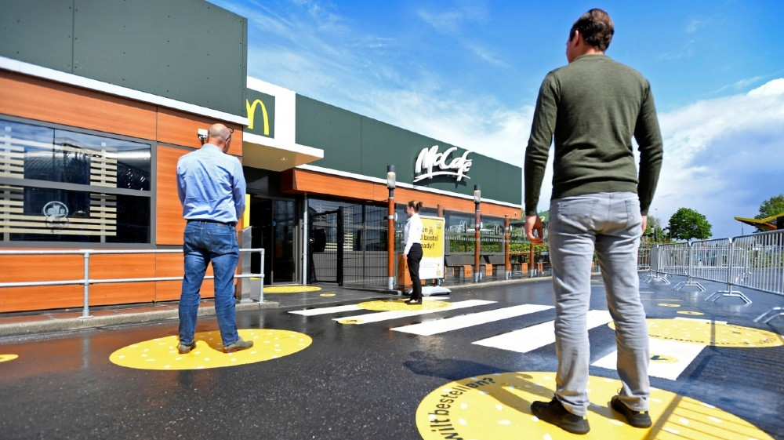
Customers wait outside on social distancing markings at a prototype location of fast food giant McDonald's for restaurants in Arnhem, Netherlands [Piroschka van de Wouw/Reuters]

12:43 GMT - Vienna Airport to offer tests to avoid quarantine
On-site coronavirus testing will become available on Monday at the airport in Austria’s capital, Vienna, in a move aimed at enabling inbound passengers to avoid having to be quarantined for 14 days.
European Commission: Members should coordinate on virus curbs
Passengers arriving at the airport have so far been required to present a health certificate showing a negative COVID-19 result which is no older than four days, or go into quarantine.
The test at the airport would cost 190 euros ($209) and results would be ready in two to three hours.

12:20 GMT - NY Governor Cuomo thanks Qatar for aid
New York Governor Andrew Cuomo thanked Qatar for helping send critical supplies and aid to the worst-hit state in the US.
"Thank you to the government and people of Qatar from the people of New York. We are grateful for your assistance in helping send critical supplies and for the donation of aid," he wrote on Twitter.

Andrew Cuomo
✔@NYGovCuomo

Thank you to the government and people of Qatar from the people of New York. We are grateful for your assistance in helping send critical supplies and for the donation of aid.

34.6K
3:17 AM - May 3, 2020
Twitter Ads info and privacy

4,806 people are talking about this

11:35 GMT - First case in Vietnam after 9 days
Vietnam reported its first new coronavirus infection in nine days, a British oil expert who was quarantined on arrival, the health ministry said.
The Southeast Asian country has registered a total of 271 coronavirus cases and has reported no deaths.
More than 30,500 people have been quarantined and 261,000 tests have been carried out.

10:56 GMT - Palestinian stock exchange resumes
Could the world be heading for another financial crisis? | Counting the Cost
After 40 days of inactivity, the Palestinian stock exchange resumed trading as authorities started easing restrictions from a full lockdown.
Ahmad Aweidah, chief executive of Palestine Exchange, said investors would be able to trade remotely, in line with health guidelines.
Forty-eight companies are listed on the exchange and the market has a total market capitalisation of about $3.8bn.

10:47 GMT - Despite rising cases, Armenia reopens bars and shops
Armenia's Deputy Prime Minister Tigran Avinyan said shops, restaurants and bars will resume activities, even as the number of confirmed infections keeps rising.
The move comes as the government is trying to cushion the impact of the pandemic on its economy which is expected to shrink by 2 percent this year.
To date, Armenia has reported 2,386 coronavirus cases and 35 deaths, with the number of infections rising from an average of 50 a day in mid-April to more than 100 in recent days, including 134 registered on Wednesday.
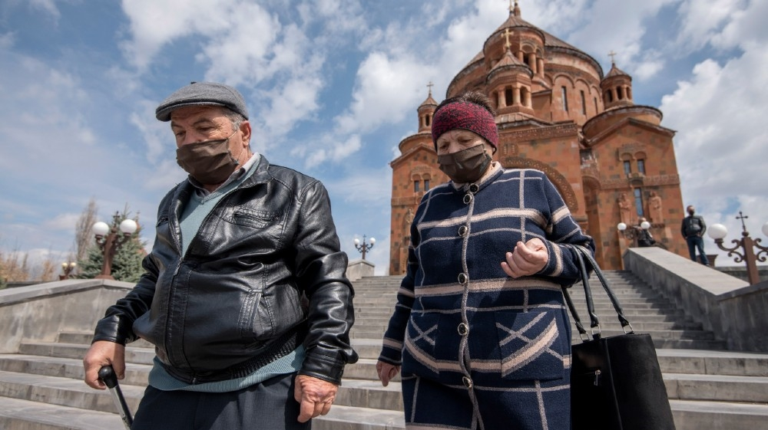
Armenia's shops, restaurants and bars will resume activities, even as the number of confirmed infections keeps rising. [Karen Minasyan/AFP]

10:35 GMT - Flights expected to resume this year: Wizz Air
Wizz Air's Abu Dhabi-based joint venture is expected to start flying again this year, the Hungarian low-cost airline said in a statement.
The airline will also start flights from European cities to Abu Dhabi from June, which it said would supplement the launch of the joint venture.

10:20 GMT - Virus may be spreading faster than expected in Afghanistan: Health ministry
Afghanistan's public health ministry said 500 random coronavirus tests in Kabul revealed more than 150 positive results, sparking concerns that COVID-19 may be spreading faster than originally thought.
Ministry spokesman Wahid Mayar called the results from the capital "concerning" and said people must remain in their homes to slow the spread.
Afghanistan has so far taken close to 12,000 samples, of which more than 2,700 have been positive, and 85 people have died.
Kabul and most other cities are in lockdown.
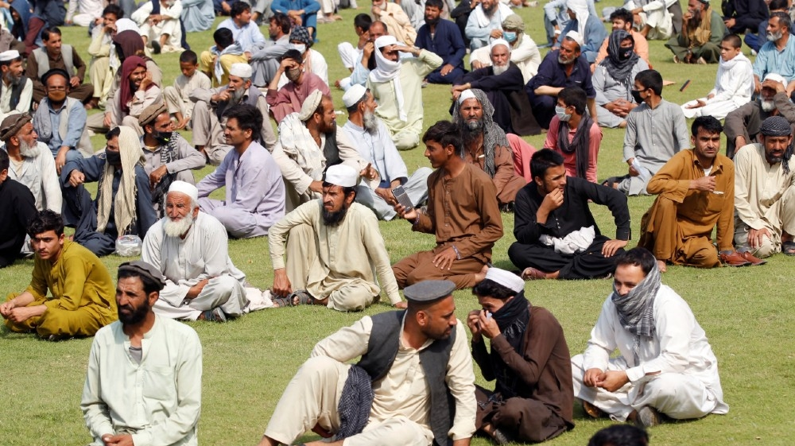
Men wait to receive free food donated by the Afghan government, amid the spread of the coronavirus disease (COVID-19), in Jalalabad, Afghanistan [Parwiz/Reuters]

09:24 GMT - Some Israeli pupils return to school after almost two months
First, second and third graders in Israel and illegal settlements built in occupied West Bank went back to schools for the first time since they were shuttered 50 days ago to curb the spread of the pandemic.
Pupils in the last two grades of high school also returned to classes, allowing them to prepare for final exams, a government statement said.
After introducing sweeping restrictions in mid-March, Israel has in recent days been gradually relaxing its lockdown.
As of Sunday, Israel has registered 16,194 infections and 230 deaths.
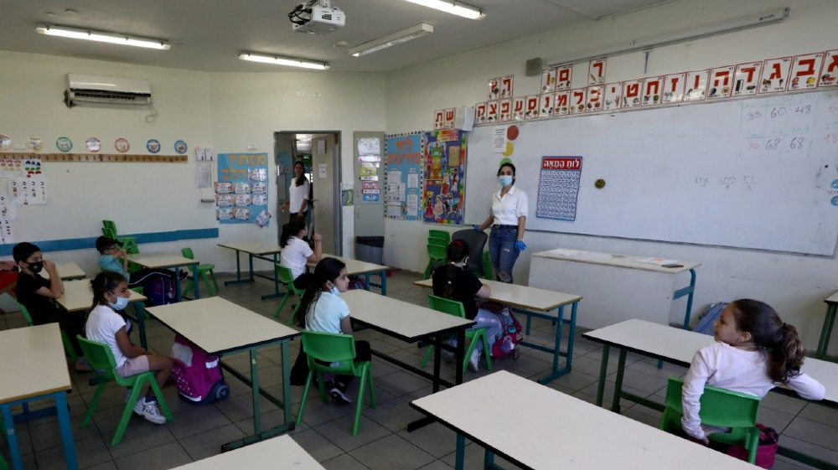
Students sit in a classroom as it reopens following the ease of restrictions preventing the spread of the coronavirus disease (COVID-19), in one of Israel's illigal settlements in the occupied West Bank [Ammar Awad/Reuters]

08:44 GMT - Malaysia, Indonesia report new cases
Health authorities in Malaysia reported an additional 122 coronavirus infections, bringing the country's total to 6,298 infections. The death toll rose to 105 due to two new fatalities in the last 24 hours.
Meanwhile in Indonesia, health ministry official Achmad Yurianto reported 349 new cases, taking the total number of infections to 11,192.
Yurianto said 14 new coronavirus-related deaths were confirmed, bringing the total to 845.

08:15 GMT - Iran to reopen some mosques as lockdown eases: Rouhani
Mosques across 132 Iranian counties will reopen on Monday after being shuttered since early March, President Hassan Rouhani said during a televised coronavirus task force meeting.
Maintaining "social distancing is more important than collective prayer", he added, arguing that Islam considers safety obligatory while praying in mosques is only recommended.
Iran, one of the Middle Eastern countries hardest hit by the pandemic with 6,156 deaths amid 96,448 cases, will be divided up into white, yellow and red regions based on the number of infections and deaths, Rouhani said last week.
Could reopening Iran's economy worsen its coronavirus crisis? | The Stream

07:40 GMT - Latest tally in Singapore, Russia
Singapore's health ministry on Sunday confirmed 657 new coronavirus infections, taking the city-state's total to 18,205. Most of the new cases are among migrant workers living in dormitories, the ministry said.
Meanwhile, Russia reported 10,633 cases in the past 24 hours, an increase compared with the 9,623 new cases reported the previous day.
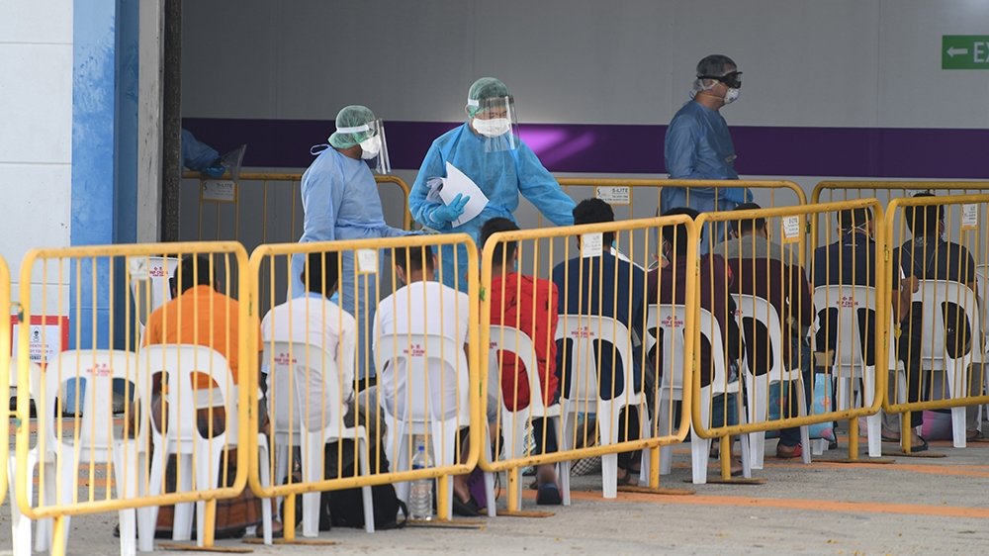
Medical personnel as they check COVID-19 patients upon arrival at a community isolation facility at the Changi Exhibition Centre in Singapore [EPA]

07:15 GMT - More UAE shopping centres, restaurants reopen
Three Abu Dhabi shopping centres reopened at 30 percent customer capacity after adopting safety measures, including installing thermal inspection devices, as the United Arab Emirates continued easing lockdown measures imposed more than a month ago.
Malls, dine-in restaurants and cafes in Dubai, the UAE's business and tourism hub, had earlier resumed operations with limited capacity. Shoppers must wear face masks and gloves and keep their distance from others.

06:50 GMT - India records highest daily increase
India has reported 2,644 new coronavirus cases in the last 24 hours, its highest daily number to date, bringing its total to more than 39,000 confirmed infections. The country also reported 83 additional deaths for a total of total 1,301.
Meanwhile, the Indian Air Force conducted flypasts and showered flower petals on hospitals across different cities including the national capital of New Delhi as part of the armed forces' efforts to thank doctors, nurses and police personnel who have been at the forefront of the country's battle against the pandemic.
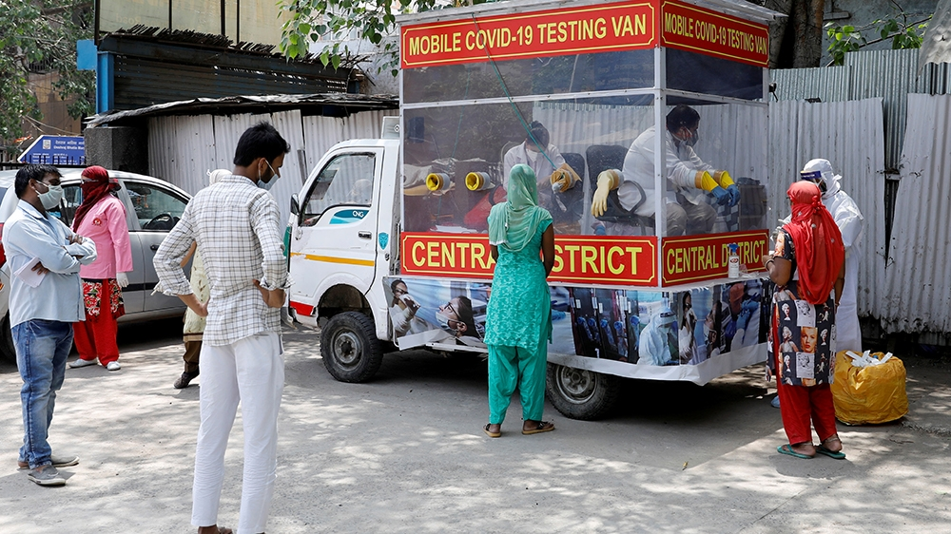
People wearing protective face masks wait to be tested at a mobile testing centre during an extended nationwide lockdown to slow the spread of the coronavirus disease in New Delhi, India [Adnan Abidi/Reuters]

06:35 GMT - S Korea to further ease physical distancing rules
South Korean Prime Minister Chung Sye-kyun said the country will further relax physical distancing rules starting on May 6.
The government "will allow businesses to resume at facilities in phases that had remained closed up until now, and also allow gatherings and events to take place assuming they follow disinfection guidelines", he told a televised meeting of government officials.

06:10 GMT - Philippines temporarily bars incoming flights
HRW: COVID-19 lockdown violators in Philippines abused
Incoming passenger flights are barred from entering the Philippines for one week to curb the spread of the coronavirus.
"This decision is meant to decongest our quarantine facilities to protect our people by preventing the further spread of COVID-19 and also ensure that our overseas Filipino workers are well taken care of when they arrive from abroad", officials said in a statement.
Some 20,000 repatriated Filipinos are undergoing mandatory quarantine in the capital, Manila, officials said. Entry to the country is closed to all except repatriated Filipinos.
As of Sunday, the country has reported 9,223 infections and 607 deaths.

05:30 GMT - Thailand reports lowest number of cases, as some restrictions ease
Marking its lowest number since early March, Thailand reported three new coronavirus cases and no new deaths as it started easing restrictions on some business and aspects of life.
The country allowed businesses such as restaurants, hair salons and outdoor markets to reopen as long as physical distancing was maintained and temperature checks carried out.
So far, there have been a total of 2,966 infections and 54 deaths.
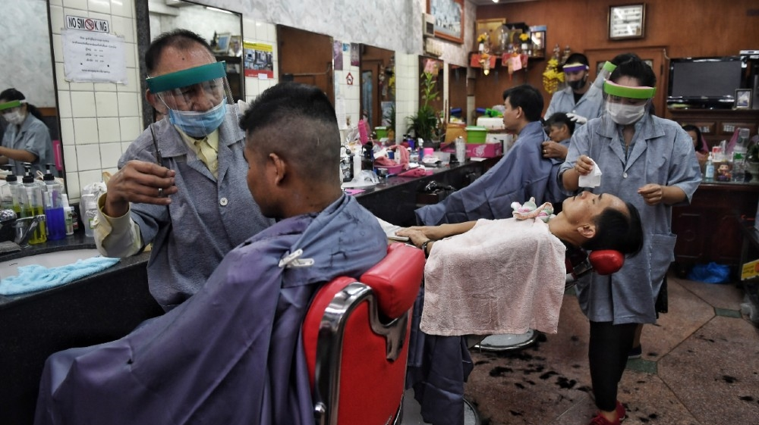
Hairdressers wear face shields and masks as they tend to customers at a barber shop in Bangkok after it reopened due to an easing of measures to combat the spread of COVID-19 [Lillian Suwanrumpha/AFP]

04:51 GMT - World 'needs a robust airline system for COVID-19 recovery'
Geoffrey Thomas, editor-in-chief of Airline Ratings, has said more needs to be done to assist airlines with their recovery.
"Across the globe, we've all got to make concessions. This is all costing us money. At the same time, whether we are supporting our local airline or our favourite local restaurant with takeaways - everybody needs help, and the airlines are no different. Because the airlines are losing half of their revenue for 2020, and some of the bailouts are absolutely massive," he told Al Jazeera.
"In certain jurisdictions, it has been enough. For instance in the Middle East - some of the countries there have stepped up significantly, like Qatar. In other jurisdictions, they haven't. In Australia, the federal government hasn't supported its two airlines. So coming out of COVID-19, you're going to get some airlines that are very well looked after and other ones that are not."
He added: "A lot more needs to be done because aviation is the fabric of the economy of the world and we need a robust airline system to help with this recovery … Certainly, we want to preserve as many of these airlines as we possibly can for the highly competitive market that we want post-COVID-19."

03:56 GMT - UK made contingency plan for Johnson's death as he battled COVID-19
Boris Johnson, the prime minister of the United Kingdom, has said the British government made contingency plans for his death as his condition deteriorated while he battled COVID-19 last month in intensive care.
In an interview with The Sun newspaper on Sunday, Johnson said he was given "litres and litres of oxygen" to keep him alive.
"They had a strategy to deal with a 'death of Stalin'-type scenario," Johnson told The Sun. "It was a tough old moment, I won't deny it."

03:05 GMT - Roche gets US FDA approval for antibody test
Roche Holding AG said received emergency use approval from the US Food and Drug Administration (FDA) for an antibody test to help determine if people have ever been infected with the coronavirus.
The Swiss drugmaker said its antibody test, Elecsys Anti-SARS-CoV-2, has a specificity greater than 99.8 percent and can help assess patients' immune response to the new coronavirus, officially known as SARS-Cov-2.

02:36 GMT - South Korea reports 13 new cases
Health authorities in South Korea reported 13 new coronavirus cases, of which 10 were imported.
The country reported fewer than 15 cases for more than two weeks, and authorities say they plan to loosen social distancing rules this week. Details of the so-called "everyday life quarantine" are expected later today, according to the official Yonhap news agency.

02:17 GMT - Rise in virus cases in crowded Indian jails prompts concerns
The spread of the coronavirus in India's notoriously crowded prisons prompted authorities to impose jail lockdowns and release thousands of pretrial detainees on parole, as health experts worry the cramped facilities are serving as breeding grounds for the disease.
"It is a terrifying situation. If measures aren't taken soon, then things can become extremely difficult," Madhurima Dhanuka, head of the Prison Reforms Program for the Commonwealth Human Rights Initiative, told the Associated Press news agency.
Although there are no official numbers on how many inmates have been infected by the virus, India's correction facilities are slowly recording more infections and have temporarily banned visitors.
On Thursday, authorities locked down Nagpur Central Jail in coastal Maharashtra, among the Indian states worst hit by the pandemic. It was the eighth prison in Maharashtra to be locked down. The move came after 19 inmates in Indore Central Jail in central Madhya Pradesh state tested positive for the virus on Tuesday.
Indian prisons are highly overcrowded. According to the latest data by the National Crimes Records Bureau in 2018, India has some 450,000 prisoners, exceeding the country's official prison capacity by about 17 percent.
Prisons in New Delhi and neighbouring Uttar Pradesh state have the highest occupancy rates, at more than 50 percent above capacity.
Making matters worse, "the health facilities in prisons are not up to the mark," said Dhanuka.

02:06 GMT - China reports two new coronavirus cases
China reported two new coronavirus cases for May 2, up from one the day before, according to data from the National Health Commission.
One case was imported and the other is local. This compared with one imported case and no domestic transmissions on May 1. The NHC also reported 12 asymptomatic cases for May 2, down from 20 the day before.
The number of confirmed cases in China has reached 82,877. With no new deaths reported, the death toll remains at 4,633.

01:46 GMT - Hundreds in US state of Oregon protest against stay-at-home order
Hundreds opposed to Oregon's stay-at-home order demonstrated in the city of Salem as health officials announced five additional deaths from COVID-19, the respiratory illness caused by the coronavirus.
Most of the protesters did not wear face masks, but they waved American flags and Trump campaign signs in the rain. Other signs read, "Reopen Oregon" and "Let me earn a living".
A group of healthcare workers demonstrated at the top of the Capitol steps, urging a phased plan to ease the state's social distancing requirements. Most of the other protesters ignored them.
A woman holds a sign saying Open Oregon on the steps of the state capitol at the Reopen Oregon Rally on May 2, 2020, in Salem, Oregon [Terray Sylvester/Getty Images/AFP]

01:04 GMT - Pelosi, McConnell decline coronavirus tests for US Congress
The top Republican and Democrat in Congress said they are respectfully declining an offer of quick COVID-19 tests offered by the Trump administration.
Democratic House Speaker Nancy Pelosi and Republican Senate Majority Leader Mitch McConnell, normally fierce political rivals, say Congress is "grateful" for the offer, but "wants to keep directing resources to the front-line facilities where they can do the most good the most quickly".
The US's 100 senators, many of whom are advanced in age, will return to Washington, DC on Monday following a recess that was prolonged due to the pandemic.

00:54 GMT - Yemen's Houthi rebels call for more test kits
Taha al-Mutawakel, the Houthi public health minister, urged the United Nations to increase the number of testing kits for COVID-19.
"We are sending this appeal given the global situation of coronavirus, the ongoing assault against our country, the embargo on our country, and because the amount of the PCR tests which the World Health Organization has sent to us is very little and is about to run out," he told reporters in Sanaa on Saturday.

00:26 GMT - UN calls for probe into Venezuela prison riot that left 46 dead
The UN's Office of the High Commissioner for Human Rights has called for an investigation into a prison riot in western Venezuela that left 46 people dead and 75 injured.
The OHCHR said on Twitter it is "gravely concerned" about the incident on Friday at the Los Llanos penitentiary in Portuguesa state. The South American country's prisons are infamous for extreme levels of violence and poor conditions.
"We urge the authorities to conduct a thorough investigation, tackle overcrowding, and guarantee basic rights," the office said.
The riot came shortly after prison officials barred inmates' family members from bringing them food, a measure to prevent the spread of the coronavirus within prisons.

00:12 GMT - Guards freed after prison riot at Brazil's Manaus
Prison authorities in Brazil said 10 guards and five inmates suffered non-critical injuries following an uprising at a prison in Manaus, a state capital in the Amazon rainforest.
The inmates held seven guards hostage for more than five hours, but the situation was brought under control, according to the state's public security secretariat.
Relatives of inmates said the prisoners at Puraquequara prison were protesting against the suspension of all family visits and poor conditions at the lockup amid the coronavirus pandemic.

Hello and welcome to Al Jazeera's continuing coverage of the coronavirus pandemic. I'm Zaheena Rasheed in Male, Maldives, with all the latest updates.
You can find all the key developments from yesterday, March 2.

w we use cookies or edit your cookie preferences.
X

