NAME: FASUYI OMOKOREDE OLUWATOYIN
DEPARTMENT: NURSING
MATRIC NUMBER: 19/MHS02/057
ASSIGNMENT
- Classification of alcohols are;
- This is based on the number of hydrogen atoms attached to the carbon atom containing the hydroxyl group. If the numbers of hydrogen atoms attached to the carbon atom bearing the hydroxyl group are three or two, it is called a primary alcohol (1˚). If it is one hydrogen atom, it is called a secondary alcohol (2˚) and if no hydrogen atom is attached the carbon atom bearing the hydroxyl group, it is called a tertiary alcohol (3˚).E.g. CH3OH Methanol (1˚)
- This is based on the number of hydroxyl groups they possess. Monohydric alcohols have one hydroxyl group present in the alcohol structure. Dihydric alcohols which are also called glycols have two hydroxyl groups present in the alcohol structure while trihydric alcohols or triols have three hydroxyl groups present in the structure of the alcohol. Polyhydric alcohols or polyols have more than three hydroxyl groups. E.g. CH3CH2CH2OHPropanol (Monohydric alcohol).
- Solubility of alcohol in water; Lower alcohols with up to three carbon atoms in their molecules are soluble in water because these lower alcohols can form hydrogen bond with water molecules. The water solubility of alcohols decreases with increasing relative molecular mass.
- Industrial manufacture of ethanol;
- The biological catalysts, enzymes found in yeast break down the carbohydrate molecules into ethanol to give a yield of 95%. The starch containing materials include molasses, potatoes, cereals, rice and on warming with malt to 60˚C for a specific period of time are converted into maltose by the enzyme diastase contained in the malt.
2(C6H10O5) n + nH2O nC12H22O11
Carbohydrate 60˚C/diastase maltose
- The maltose is broken down into glucose on addition of yeast which contains the enzyme maltase and at a temperature of 15˚C
C12H22O11 + H2O 2C6H12O6
Maltose 15˚C/maltose glucose
- The glucose at constant temperature of 15˚C is then converted into alcohol by the enzyme zymase contained also in yeast.
C6H12O6 2CH3CH2OH + 2CO2
Glucose 15˚C/Zymase Ethanol
- Show the reaction between 2-methylpropanal and butylmagnesiumchloride Hint: Grignard synthesis

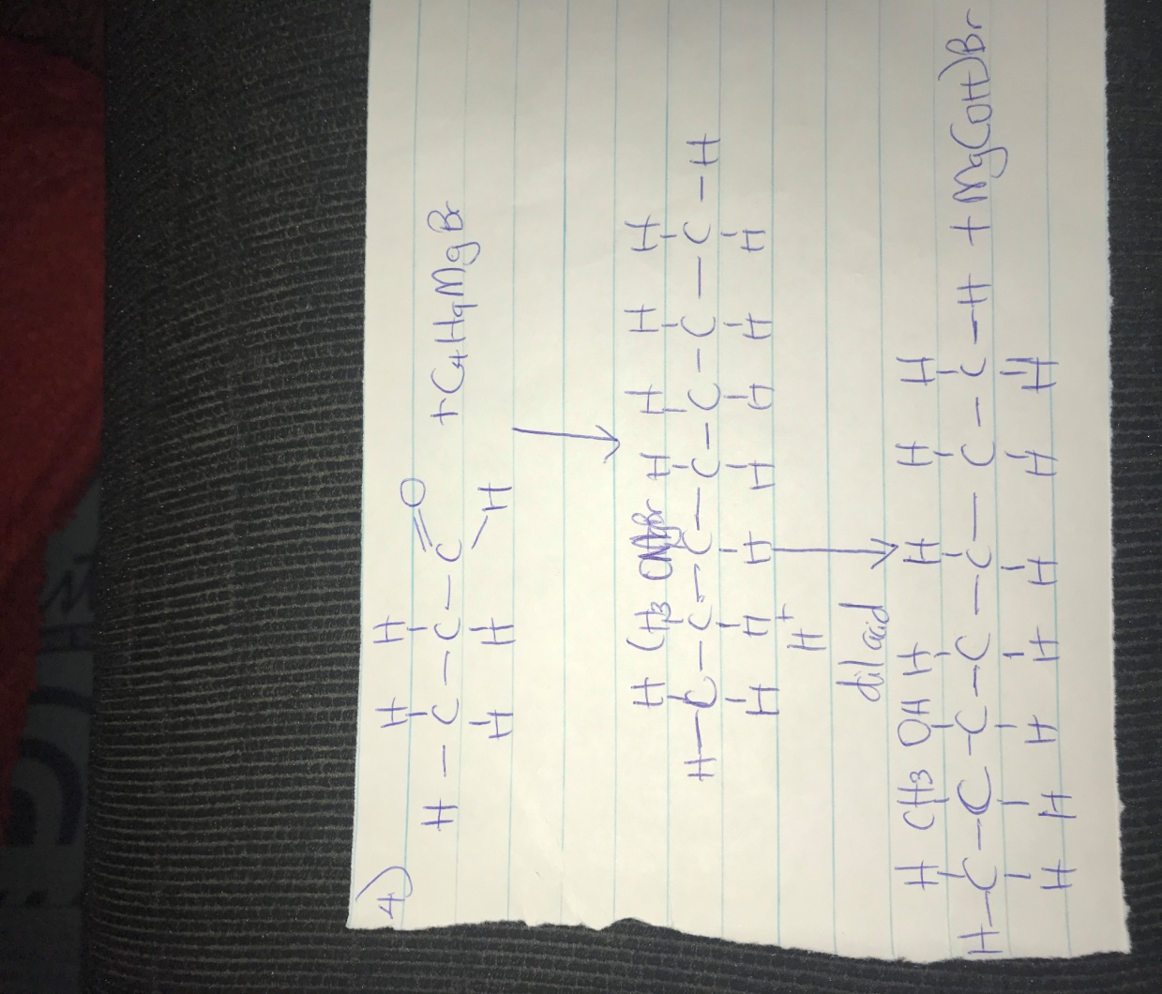
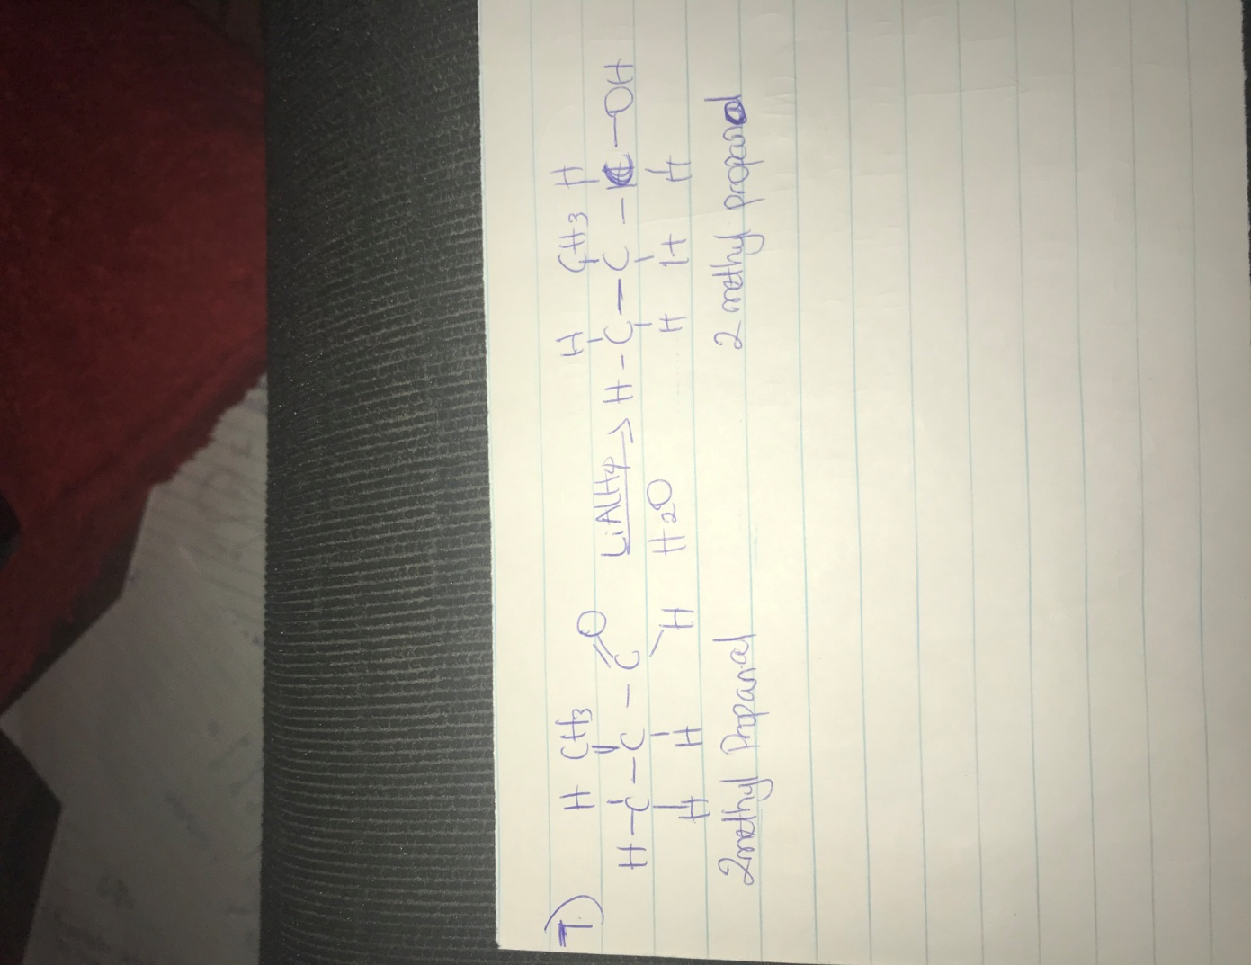
8.) Propose a scheme for the conversion of propan-1-ol to propan-2-ol.

