SOPEJU OLUWABUSUYI FEYIKEMI
COMPUTER ENGINEERING
15/ENG02/046
MAY, 2020

Permanent Magnet Synchronous Machines (PMSM)
The Permanent Magnet Synchronous Machine block operates in either generator or motor mode. The mode of operation is dictated by the sign of the mechanical torque (positive for motor mode, negative for generator mode). The electrical and mechanical parts of the machine are each represented by a second-order state-space model.
Permanent magnet synchronous machines generally have same operating and performance characteristics as synchronous machines. A permanent magnet machine can have a configuration almost identical to that of the conventional synchronous machines with absence of slip rings and a field winding.

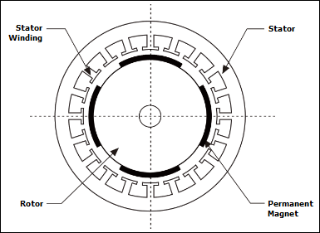
Figure 1: Figure showing stator and rotor of PMSM

PMSM are usually three-phase machines, though many new designs have other phase numbers.
Alternating-current synchronous motors and generators are normally constructed with the armature winding on the stator and the field winding on the rotor. There is no clear distinction between the armature and field windings of ac induction motors or generators. AC windings are generally short pitched to reduce harmonic voltage generated in the windings.
Many permanent magnet synchronous machines may be cylindrical or ―smooth rotor physically but electrically the magnet is still equivalent to a salient pole structure.
The rotating and stationary parts of an electrical machine can be called as rotor and stator respectively. The rotor or stator of electrical machines acts as a power-producing component and is called as an armature. In PMSM, permanent magnet is used instead of coil to provide excitation field. The permanent magnets mounted on the rotor are used to provide magnetic field of an electrical machine.
Permanent magnets located on the rotor of the PMSM create a constant magnetic field.
The working principle of permanent magnet synchronous motor is same as that of synchronous motor. It is due to the interaction of the rotating magnetic field of the stator and the constant magnetic field of the rotor. When three phase winding of stator is energized from 3 phase supply, rotating magnetic field (3 phase rotating magnetic flux) is set up in the air gap. Longer air gaps reduce machines windage losses.
At synchronous speed, the rotor field poles locks with the rotating magnetic field to produce torque and hence rotor continues to rotate. The torque is usually controlled by controlling the phase current since the electromagnetic torque is proportional to the motor current. In this regard, the PMSM cannot start itself when it is connected directly to the three-phase current network.
A single-phase (or two-phase derived from single phase) stator winding is possible, but if the direction of rotation is not defined, the machine may start in either direction unless prevented from doing so by the starting arrangements.
A PMSM requires a control system, for example, a variable frequency drive or a servo drive. There are many control techniques implemented control systems. Control techniques are critical to exploit the power capability of PMSMs over the entire speed range. The choice of the optimal control method mainly depends on the task that is put in front of the electric drive. The main methods for controlling a PMSM are sinusoidal and trapezoidal. The sinusoidal model assumes that the flux established by the permanent magnets in the stator is sinusoidal, which implies that the electromotive forces are sinusoidal. The trapezoidal model assumes that the winding distribution and flux established by the permanent magnets produce three trapezoidal back EMF waveforms.
PMSM have certain features that permit the machine to be operated not only in the constant torque region but also in the constant power region up to a high speed by ﬂux-weakening. PMSM can be used as an alternative for servo drives. It is widely used in various industrial application viz. robotics, traction, aerospace etc.

