NAME: Mbama Crystabel Zinachidi.
DEPARTMENT: Nursing.
MATRIC NUMBER: 19/MHS02/075.
COURSE: Chemistry 102
- Alcohols are very important organic compounds. Discuss briefly their classifications and give one example each.
- Based on the number of hydrogen atoms attached to the carbon atoms containing the hydroxyl group. If the numbers of hydrogen atoms attached to the carbon atom bbearing hydroxyl group are three or two, it is called a primary alcohol ( 1 ͦ). If it is one hydrogen atom it is called secondary alcohol (2 ͦ) and if no hydrogen atom attached the carbon atom bearing the hydroxyl group, it is called a tertiary alcohol (3 ͦ).
Examples are:
CH₃OHMenthanol (1 ͦ)
CH₃CH(OH)CH₃Propan-2-ol(2 ͦ)
(CH₃)₃COH-2-Methylpropan-2-ol(3 ͦ)

b)Based on the number of hydroxyl groups they possess. Monohydric alcohol has one hydroxyl group present in the alcohol structure. Dihydric alcohols are also called glycols have two hydrosyl groups present in the alcohol structure while trihydric alcohols or triols have t here hydroxyl groups present in the alcohol structure, polyhydric alcohols have more than three hydroxyl groups.
Examples are:
CH₃CH₂CH₂OHPropanol ( monohydric alcohol)
HOCH₂CH₂OHEthane-1,2-diol( dihydric alcohol)
OHCH₂CH(OH)CH₂OHPropane- 1,2,3-triol(trihydric alcohol)
CH₃CH(OH)CH(OH)CH(OH)CH(OH)CH(OH)CH₃Pentol(polyhydric alcohol)
- Discuss the solubility of alcohols in water, organic solvents
Lowers alcohols with up to three carbon atoms in their molecules are soluble in water because these lower alcohols can form hydrogen bond with water molecules. The water solubility of alcohols decreases with increasing molecular mass then alcohols which are monohydric are soluble in organic solvents, the solubility of simple alcohols and polyhydric alcohols is largely due to heir ability to form hydrogen bonds with water molecules.

- Show three steps in the industrial manufacture of ethanol. Equations of reaction are mandatory.
The starch containing material which is either potatoes, rice etc and on warming with malt to 60 ͦc for a specific period of time are converted into maltose the enzyme diastase contained in malt.
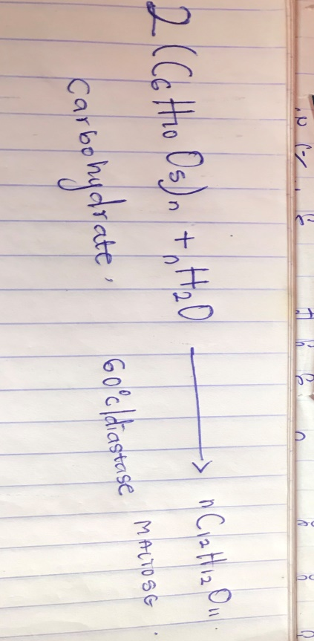
The maltose is broken down into glucose on addition of yeast which contains the enzyme maltase and at a temperature of 15 ͦc
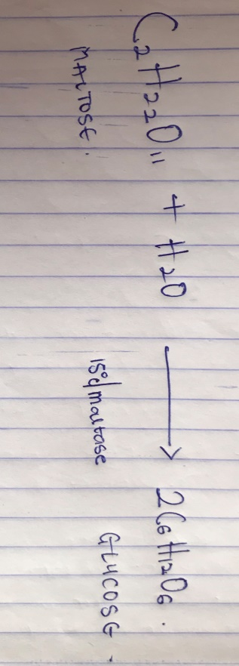
The glucose at constant temperature of 15 ͦc is then converted into alcohol by the enzyme zymase contained also in yeast
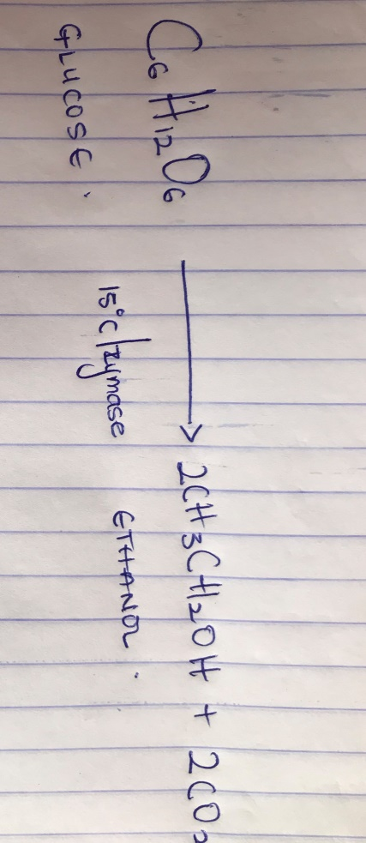

- Show the reaction between 2-methylpropanol and butylmagnesiumchloride.
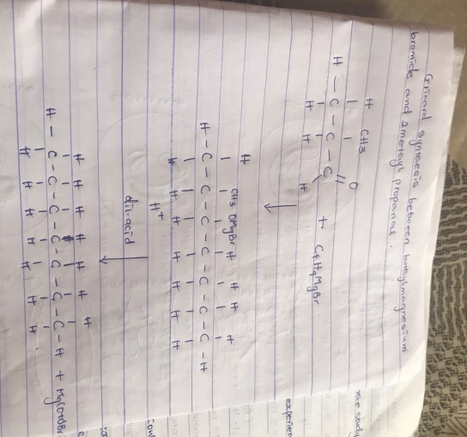
7) Show the reduction reaction of 2methylpropanal
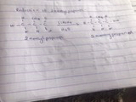

8) Propose a scheme for the conversion of propan-1-ol to propan-2-ol
a) dehydration of propanol to propene.
When propanol is treated with concentrated sulphuric acid(H₂SO₄) the phenomenon calles dehydration occurs due to which a water molecule from propanol gets eliminated.
Then propanol gets converted to propene.
CH₃CH₂CH₂OH conc.H₂SO₄ CH₃CH=CH₂

- Hydrolysis of propene to propane-2-ol
Propene can be hydrolysed to propane-2-ol in accordance with mechanism called markownikoffs reaction which states that when an unsymmentrical reacts the negative part of the reagent gets attached to the carbon atom of the alkene which has less number of hydrogen atoms.
In this case, the unsymmetrical reagent used in H₂O which is compossed of H+ OH- part. Due to hydrolysis of water, the negative parts attaches to propene and thus converts it as propan-2-ol.
CH₃-CH=CH₂ H₂O CH₃-CH₂-OH-CH₃

