NAME: RAJI OYINDAMOLA MARIAM
DEPARTMENT: NURSING (100 LEVEL)
COLLEGE: MEDICINE AND HEALTH SCIENCES
COURSE: CHM102
MATRIC NO: 19/MHS02/110
ASSIGNMENT
1. Alcohols are very important organic compounds. Discuss briefly their classification and give one example each
a. This is based on the number of hydrogen atoms attached to the carbon atoms containing the hydroxyl group. If the numbers of hydrogen atom attached to the carbon atom bearing the hydroxyl group are three or two, it is called a primary alcohol ( 1 ͦ), if it is one hydrogen atom, it is called secondary alcohol ( 2 ͦ) and if no hydrogen atom is attached to the carbon atom bearing the hydroxyl group, it is called a tertiary alcohol ( 3 ͦ).
Examples, CH₃CH₂OH Ethanol (1 ͦ)
b. This is based on the number of hydroxyl groups they possess. Monohydric alcohols have one hydroxyl group present in the alcohol structure. Dihydric alcohols is also called glycols have two hydroxyl groups present in the alcohol structure while Trihydric alcohols or triols have three hydroxyl groups present in the structure of the alcohols. Polyhydric alcohol or polyols have more than three hydroxyl groups.
Examples, CH₃CH₂CH₂OH Propanol (monohydric alcohol)
2. Discuss the solubility of alcohols in water, organic solvents
Alcohols are soluble in water: This is due to the hydroxyl group in the alcohol which is able to form hydrogen bonds with water molecules. Alcohols with smaller hydrocarbon chain are very soluble. As the length of the hydrocarbon chain increases, the solubility in the water decreases.
Alcohols are soluble in organic solvents: As the size of the alkyl group gets larger, alcohols become less soluble in water. Alcohols with 2(ethanol) or 3(n-propanol and iso-propanol) carbon atoms are miscible with water and are great solvents for non-polar organic compounds.
3. Show the three steps in the industrial manufacture of ethanol. Equations of reaction are mandatory
PRODUCTION OF ETHANOL:
Carbohydrates such as starch are major group of natural compounds that can be made to yield ethanol by the biological process of fermentation. The biological catalysts, enzymes found in yeast break down the carbohydrates molecules into ethanol to give a yield of 95%. The starch containing materials include molasses, potatoes, cereals, rice and on warming with malt to 60 ͦC for a specific period of time are converted into maltose by the enzymes diastase contained in the malt.
2(C₆H₁₀O₅)_{n} + nH₂O nC₁₂H₂₂O₁₁
Carbohydrates 60 ͦC/diastase Maltose
The maltose is broken down into glucose on addition of yeast which contains the enzyme maltase and at a temperature of 15 ͦC
C₁₂H₂₂O₁₁ + H₂O 2C₂H₁₂O₆
Maltose 15 ͦC/Zymase glucose
The glucose at constant temperature of 15 ͦC is then converted into alcohol by the enzyme zymase contained also in yeast.
C₆H₁₂O₆ 2CH₃CH₂OH + 2C0₂
Glucose 15 ͦC/Zymase Ethanol
4. Show the reaction between 2-methyl propanal and butylmagnesiumchloride. Hint: Grignard synthesis
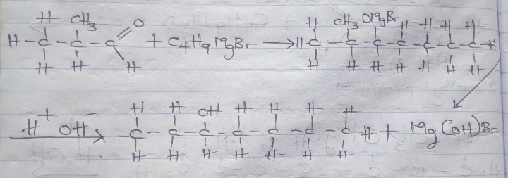

5. Not correct
6. Not correct

7. Show the reduction reaction of 2-methylpropanal.
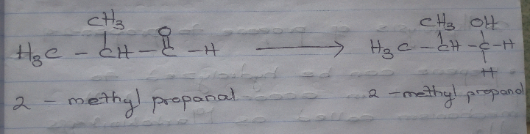

8. Propose a scheme for the conversion of propan-1-ol to propan-2-ol
I. Dehydration of propan-1-ol to propene:
⦁ when propan-1-ol is treated with concentrated sulfuric acid (H₂SO₄) the phenomenon called dehydration occurs due to which a water molecule from propan-1-ol gets eliminated.
⦁ Due to thus propan-1-ol get converted into propene, the reaction involved is as follows:
CH₃CH₂CH₂OH Conc.H₂SO₄ CH₃CH=CH₂
II. Hydrolysis of propene to propan-2-ol
⦁ Propene can be hydrolyzed to propan-2-ol in accordance with mechanism called as Markownikoffs addition.
⦁ it states that when an unsymmetrical reagent the negative parts of the reagent get attached itself to the carbon atom of the alkene which has less number of hydrogen atoms.
⦁ In this case, the unsymmetrical reagent used in H₂O which is composed of H⁺ and OH⁻ part.
⦁ Due to hydrolysis of water, the negative part attaches itself to the propene and thus convert it as propan-2-ol.
CH₃-CH=CH₂ H₂O CH₃-CH₂-OH-CH₃

