Name: Raji Fatimah Jimoh
Matric No: 19/MHS01/386
College: Medicine and Health Sciences
Department: MBBS
Course: CHM102

- Primary alcohols
In a primary (1°) alcohol, the carbon atom that carries the -OH group is only attached to one alkyl group. Some examples of primary alcohols are shown below:
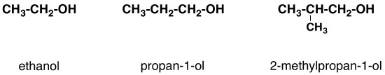
Notice that the complexity of the attached alkyl group is irrelevant. In each case there is only one linkage to an alkyl group from the CH₂ group holding the -OH group. There is an exception to this. Methanol, CH₃OH, is counted as a primary alcohol even though there are no alkyl groups attached to the the -OH carbon atom.

Secondary alcohols
In a secondary (2°) alcohol, the carbon atom with the -OH group attached is joined directly to two alkyl groups, which may be the same or different. Examples include the following:
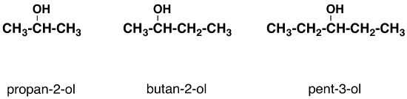

Tertiary alcohols

In a tertiary (3°) alcohol, the carbon atom holding the -OH group is attached directly to three alkyl groups, which may be any combination of the same or different groups. Examples of tertiary alcohols are given below:
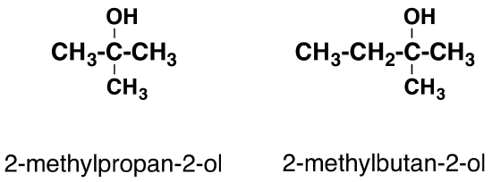

- Solubility of alcohols in water:
As the size of the alkyl group gets larger, alcohols become less soluble in water. Because of the strength of the attraction of the OH group, first three alcohols (methanol, ethanol and propanol) are completely miscible. They dissolve in water of any amount.

- Industrial manufacture of alcohol:
Carbohydrates such as starch are a major group of natural compounds that can bee made to yield ethanol by the biological process of fermentation.
2(C₆H₁₀O₅)_{n}+ _{N}H₂O------------------------ _{n}C₁₂H₂₂O₁₁
Carbohydrate 60ºC/diastase Maltose

The maltose is broken down into glucose on adding yeast which contains the enzyme maltase.
C₁₂H₂₂O₁₁ + H₂O------------------------------------2C₆H₁₂O₆
Maltose 15ºC/maltase glucose

The glucose at constant temperature of 15ºC is then converted into alcohol by the enzyme zymase contained alson in yeast
C₆H₁₂O₆------------------------------------- 2CH₃CH₂OH + 2CO₂
Glucose 15ºC/Zymase Ethanol

