NAME: UMIOM FAVPOR VICTOR
MATRIC NUMBER: 18/MHS06/053
DEPARTMENT: MEDICAL LABORATORY SCIENCE
LEVEL: 200
COURSE: BCH 202

- State 4 importance of cholesterol
ANSWER
The importance of cholesterol are;
- Helps to build the structure of cell membranes
- Helps metabolism work efficiently
- Essential for the body to produce vitamin D
- Produces hormones like estrogen, testosterone and adrenal hormones
- Differences between globosides and gangliosides.
ANSWER
- Globosides have multiple sugars while ganglosides have multiple sugars including at least one sialic acid.
- Globoside head groups are neutal while gangloside head group are charged.
- Globosides are the determinants of the A, B, O blood group system while ganggliosides are complex glycolipids derived from glucocerebrosides.
- Globosides are important constituents of the RBC-membrane while the simplest gangloside found in tissues is GM₃.
- Methylated form of phosphatidyl ethanol amin is known as LIPID METHYL TRANSFERASE.
- Which ring of cholesterol molecule contains a double bond?
ANSWER
The ring A contains a double bond in the cholesterol molecule.
- State 3 properties of phosphoglycerides.
ANSWER
The properties of phosphoglycerides are;
- The head group of phosphoglyceride are hydrophilic
- In phosphoglycerides, phosphate group of phosphatidic acid becomes esterified with the hydroxyl group of one of the several nitrogen base or other groups.
- In phosphoglycerides, the hydroxyl groups at C₁ and C₂ of glycerol are esterified with two fatty acids.
- In a tabular form, differentiate between triacylglycerol and phosphosglyceride. State examples and with schematic structures.
ANSWER
TRIACYLGLYCEROL | PHOSPHOGLYCERIDE
Has glycerol and three fatty acid | Has glycerol, two fatty acids and phosphorus
Fats cells store triacylglycerides | Helps break down fats in the body
Provides thermal insulation | Does not provide thermal insulation
Helps to give food its flavour | Does not help to give food its flavor
Stores energy | Does not store energy
Examples are palmitic acid, oleic acid | Examples are lecithin, cephalin

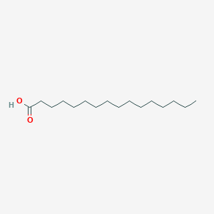
STRUCTURE OF PALMITIC ACID

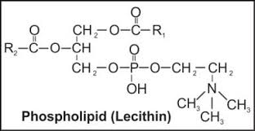
STRUCTURE OF LECITHIN

