NAME: OGUNSEMOWO AYOOLA ENIOLUWADUROTI.
COURSE: ANA 212- GROSS ANATOMY OF PELVIS AND PERINEUM.
COLLEGE: MEDICINE AND HEALTH SCIENCES.
DEPERTMENT: ANATOMY.
MATRIC NUMBER: 18/MHS01/254.
ASSIGNMENT.
Discuss the Anal canal.
ANSWER.
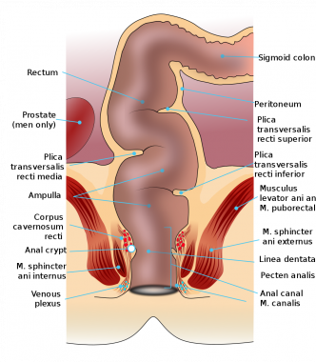
The anal canal is the final segment of the gastrointestinal tract. It has an important role in defecation and maintaining faecal continence.
The anal canal is located within the anal triangle of the perineum between the right and left ischioanal fossae, it is around 4cm in length. The canal begins as a continuation of the rectum, and passes inferoposteriorly to terminate at the anus. Except during defecation, the anal canal is collapsed by the internal and external anal sphincters to prevent the passage of faecal material.

Anal Sphincters
The anal canal is surrounded by internal and external anal sphincters, which play a crucial role in the maintenance of faecal continence.
Internal anal sphincter ; It surrounds the upper 2/3 of the anal canal. It is formed from a thickening of the involuntary circular smooth muscle in the bowel wall.
External anal sphincter; It is a voluntary muscle that surrounds the lower 2/3 of the anal canal and so overlaps with the internal sphincter. It blends superiorly with the puborectalis muscle of the pelvic floor.
At the junction of the rectum and the anal canal, there is a muscular ring – known as the anorectal ring. It is formed by the fusion of the internal anal sphincter, external anal sphincter and puborectalis muscle, and is palpable on digital rectal examination.
The superior aspect of the anal canal has the same epithelial lining as the rectum (columnar epithelium). However, in the anal canal, the mucosa is organised into longitudinal folds, known as anal columns. These are joined together at their inferior ends by anal valves. Above the anal valves are small pouches which are referred to as anal sinuses these contain glands that secrete mucus.
The anal valves collectively form an irregular circle, known as the pectinate line (or dentate line). This line divides the anal canal into upper and lower parts, which differ in both structure and neurovascular supply. This is a result of their different embryological origins, above the pectinate line; derived from the embryonic hindgut. Below the pectinate line; derived from the ectoderm of the proctodeum.
Inferior to the pectinate line, the anal canal is lined by non-keratinised stratified squamous epithelium (known as the anal pecten). It is a pale and smooth surface, which transitions at the level of the inter-sphinteric groove to true skin (keratinised stratified squamous).

Above the dentate line
​The arterial blood is supplied by the superior rectal artery branch of the inferior mesenteric artery. The venous blood flows through the internal hemorrhoidal plexus into the superior rectal vein hepatic portal system. The lymph drains into the lumbar paraaortic lymph nodes. The sympathetic innervation is carried by the inferior mesenteric plexus, while the parasympathetic innervation by the pelvic splanchnic nerves and the inferior hypogastric plexus.
Below the dentate line The blood supply comes from the middle branch of the internal iliac artery and inferior rectal arteries {branch of the pudendal artery from the internal iliac artery}. The venous blood drains through the external hemorrhoidal plexus into the middle and inferior rectal veins {body circulation}. The lymph flows into the inguinal lymph nodes. The pudendal nerve is responsible for the sensory innervation.

