NAME: ALAKU SARAH OKPHOHRO.
MATRIC NUMBER: 19/MHS02/019.
COLLEGE: MHS.
DEPT: NURSING SCIENCE.
COURSE CODE: CHEMISTRY 102.
- Alcohols are very important organic compounds. Discuss briefly their classification and give one example each.
- This is based on the number of hydrogen atoms attached to the carbon atom containing the hydroxyl group. Eg;
Primary alcohol(1^0): this has two or more hydrogen atom attached to the carbon atom bearing the hydroxyl group eg; methanol (CH3 OH).
- This is based on the number of hydroxyl group they possess eg;
Monohydric alcohol: this has one hydroxyl group eg; propanol (CH3 CH2 CH2 OH).
- Discuss the solubility of alcohols in water, organic solvents.
Lower alcohols with up to three carbon atoms in their molecules are soluble in water because these lower alcohols can form hydrogen bond with water molecules. The water solubility of alcohols decreases with increasing relative molecular mass. All monohydric alcohols are soluble in organic solvents.
- Show the three steps in the industrial manufacture of ethanol. Equations of reaction are mandatory.
Ans: carbohydrates such as starch are the major group of natural compounds that yields to ethanol by the biological process of fermentation. The biological catalyst, enzymes found in the yeast breakdown the carbohydrate molecules into ethanol to give a yield of 95%. The starch containing materials includes molasses, potatoes, cereals, rice and on a warming with malt to 60^0c for a period of time are converted into maltose.
2(C6 H10 O5) n +n H20 diastase 60^0c n C12 H22 O11
carbohydrate Maltose
The maltose is then broken down into glucose on addition of yeast which contains the enzyme maltase and a temperature of 15^0c.
C12 H22 011 + H2O zymase 15^0c 2CH3 CH2 OH + 2CO2
glucose ethanol

- Show the reaction between 2-methylpropanol and butylmagnesiumchloride. Hint: Grignard systhesis.

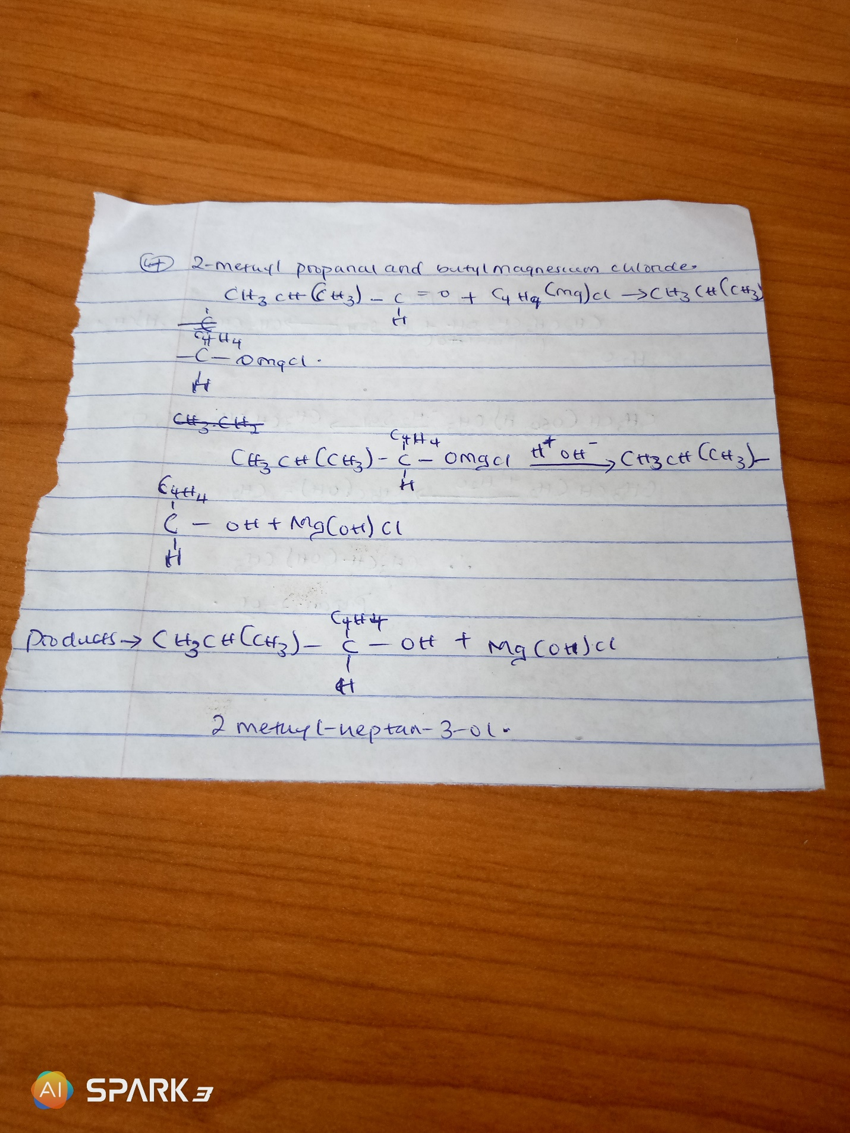

Question 5 and 6 are incorrect.

7. show the reduction of 2-methylpropanol

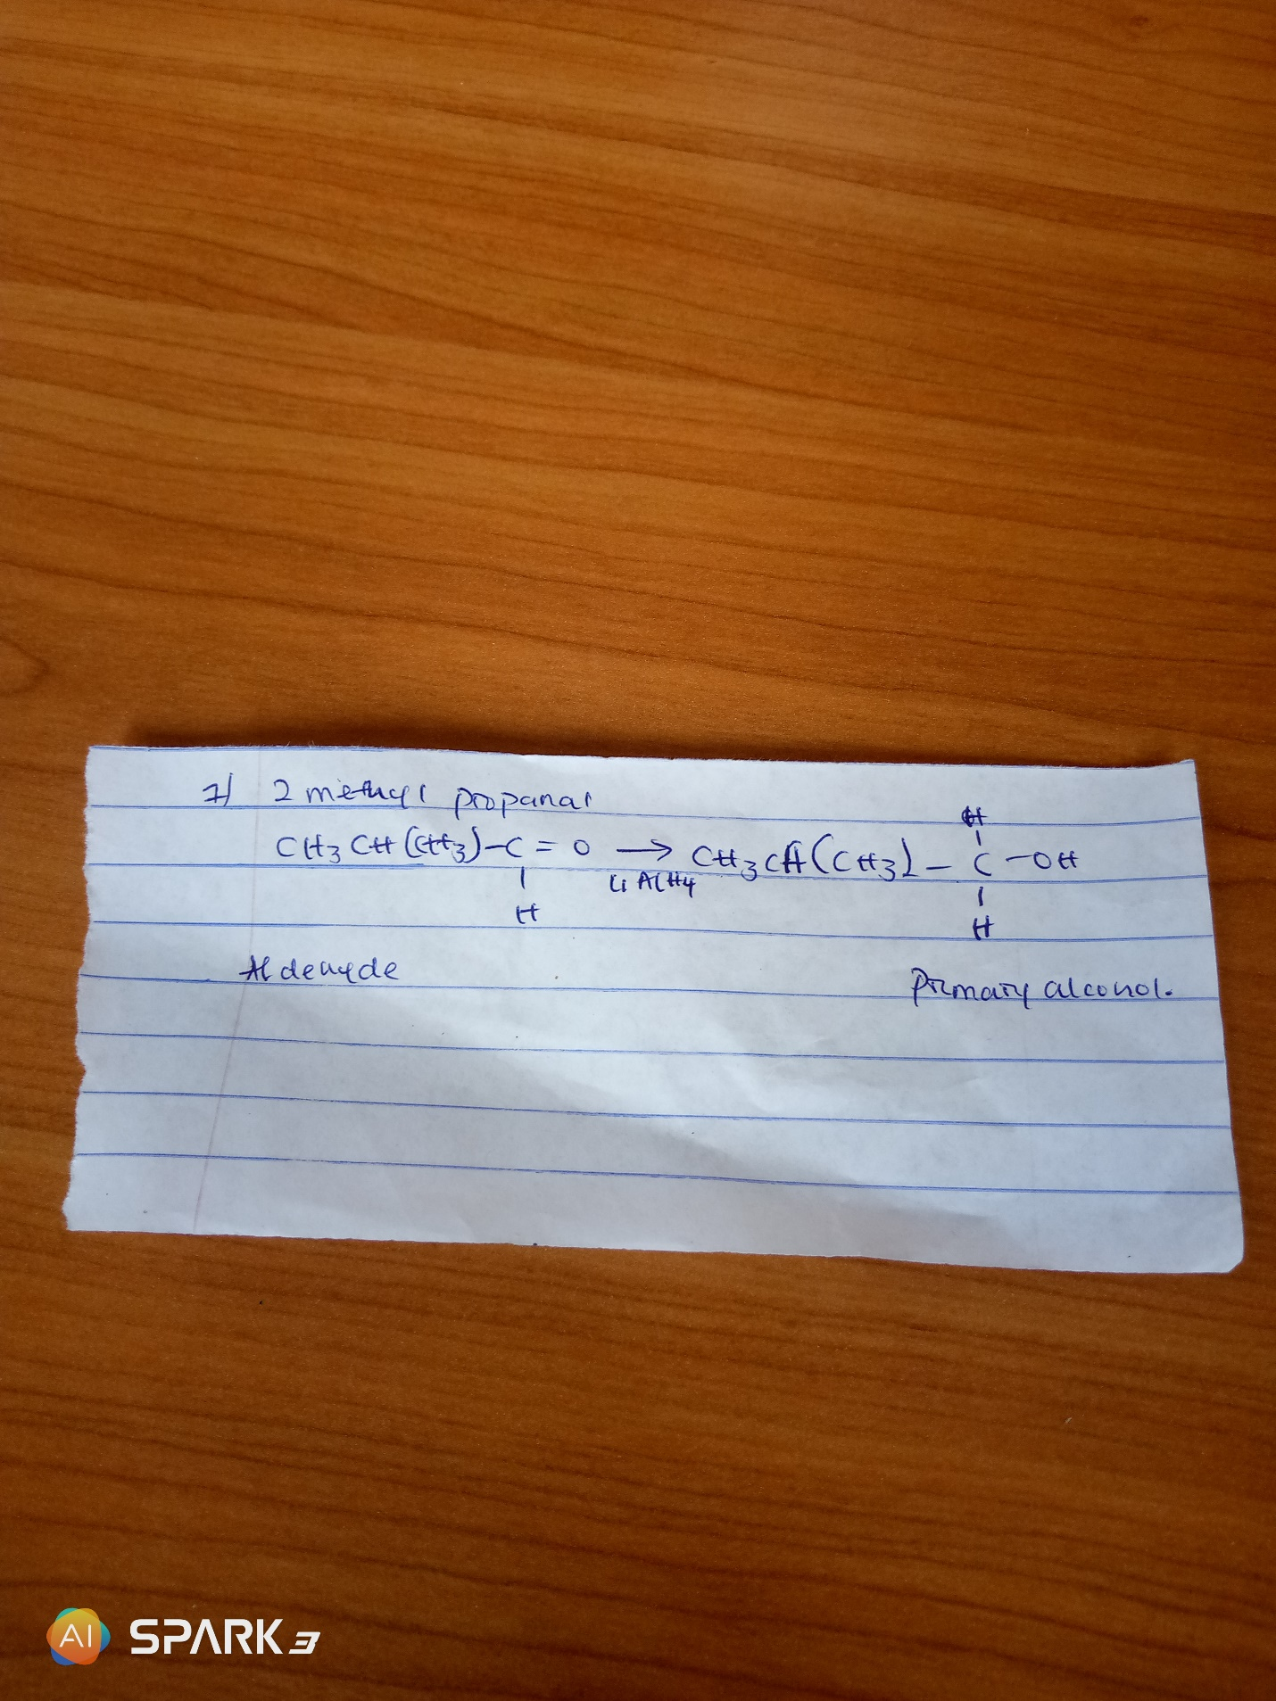

8. propose a scheme for the conversion of propan-1-ol to propan-2-ol.

